Dr. Pratibha Bezwada MBBS, MD Psychiatry Consultant Psychiatrist Reg No 2004/ 03/1623

LIVWELL Panel Consultant with

Ruby Hall Clinic, Hinjewadi



(Mon and Wed 6.30pm-7.30pm) International Member of

Mental Health Centre & Day Care Royal College of Psychiatry, UK (RCPsych)

UHID : LC-000490  Name : **MR. RUPESH** LOHAR

Age /Sex : 27Year / Male(955224270 9) Address : KHUSGAON

**Consultant :Dr PRATIBHA BEZWADA**

Date : 27-Jan-2024

 

1 ) TAB MAXDULIN (75/20)

: 1 - 1 -

# 1—0—1 - 30

60

2) TAB SIZODON 0.5 MG



3 ) MEGANEURON-OD PLUS CAP

Comoosition : METHYLCOBALMIN & ALPHA I.IPOIC ACID CAP

1 - ,

23 February 2024 t

# 0—0—1

0—0—1



- 30 

# 30

-30 

# 30

Dr PRATIBHA BEZWADA

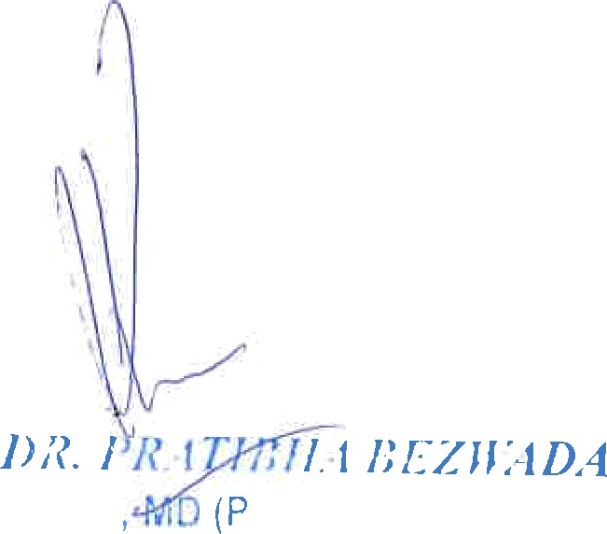

M* US

sy‘chiatry)

Reg. No.: 2004/03/1623





Livwellhappierminds.com

Reg No. 2004/03/1623

For appointment : Phone 9172078857



El*s* D• Livwell Happier Minds, Shop No. 106 - 110, White Square, Above Vijay sales, Hinjewadi - Wakad Road, Pune - 411057 " (Mon - Sat 10.00 am - 1.30 pm and 4.00 pm -7.00 pm) Sunday closed.

Livwell Clinic, A08/05, Saffron, Megapolis, Hinjewadi Phase 3, Pune - 411 057 (Consultation Timings : Tues and Fri 6.30 pm - 7.30 pm)