Name: Shruti Debnath Mark _____________________/50

[**Instructions**: Remove everything that is not a heading below and fill in with your own diagrams, etc.]

## **Brief introduction __/3**

I am also responsible for the menu UI. The menus will be designed to make the game play as smooth as possible with all other necessary features like play, quit, pause, resume, settings. The menus will allow the user to control the game and make several game option choices and view game information as well as their profile like achievements and status.

## **Use case diagram with scenario __14**

### **Use Case Diagrams**

### **Scenarios**

**Name:** Menus

**Summary:** The player uses the menu to customize the game and to choose options like play and quit and also customize the game setting. They can also view their stats and achievements through the menu.

**Preconditions:** Game has been launched.

**Basic sequence:**

**Step 1:** The game has been launched and the player chooses the *play* option.

**Step 2:** If the *Play* option is chosen, the game starts and transitions to the gameplay screen..

**Step 3:** If the *Settings* menu is chosen, the player can adjust game settings (e.g., sound, graphics).

**Step 4:** If the *Quit* menu is chosen, the player will exit the game.

**Exceptions:**

**Step 1:** If the player chooses the Stats and achievements option, they will be prompted with a new screen to review their game stats and achievements.

**Step 2:** The player will not return to the main menus again until they exit from the stats and achievements section.

**Post conditions:** Depending on the options chosen the player will be red created to their respective screens.

**Priority:** 2*

**ID:** C01

*The priorities are 1 = must have, 2 = essential, 3 = nice to have.

## **Data Flow diagram(s) from Level 0 to process description for your feature _______14**

### **Data Flow Diagrams**

### **Process Descriptions**

1. The main menu accepts player input (e.g., Start, Settings, View Stats, Quit). Routes the player’s action to the appropriate submenu or action.
2. If the player chooses Play, it will initiate the Game Start/Quit Processing.
3. If the player chooses Stats, it will query Player Data to show progress or achievements.
4. If the player chooses Quit, it will exit the game.

## **Acceptance Tests ________9**

**Goal :** Ensure the game menu system is functioning correctly, including selecting options (Play, Settings, Stats, Quit), adjusting settings, and starting/ending the game.

**Steps :**

1. Launch the game.
2. Open the main menu.
3. Select each menu option in turn (Play, Settings, Stats, Quit).
4. Verify the correct transition after each selection (e.g., starting the game, opening the settings menu, showing stats, quitting the game).

**Expected Results :**

1. The system should navigate to the correct screen when each menu option is selected.
2. The game should start when the Play option is selected.
3. The Settings menu should open when selected, and changes should be applied when saved.
4. The Stats menu should display the player's current stats and achievements.
5. Selecting Quit should prompt the player to confirm quitting and then exit the game.

**Menu feature**

| Test ID | Test Descriptions | Steps | Expected Results |
| --- | --- | --- | --- |
| T01 | Menu Navigation | 1. Launch the game.   2. Open the main menu.  3. Select each menu option (Play, Settings, Stats, Quit). | - System navigates to the correct screen for each menu option.  - Game starts, settings open, stats displayed, game quits. |
| T02 | Play option | 1. Select Play option from main menu | The player should be redirected to the game scene. |
| T03 | Quit option | 1. Select the Quit option from the main menu. | The player should exit the game. |
| T04 | Setting option | 1. Select *Settings* from the main menu.  2. Adjust sound and graphics settings.  3. Save changes and return to main menu. | - Settings changes are saved.  - Adjusted sound and graphics settings are applied. |
| T06 | Stats and achievement option | 1. Select *Stats* from the main menu.  2. Verify stats and achievements are displayed. | - Player’s stats and achievements are correctly displayed |

## **Timeline _________/10**

[Figure out the tasks required to complete your feature]

Example:

### **Work items**

| Task | Duration (PWks) | Predecessor Task(s) |
| --- | --- | --- |
| 1. Requirements Collection | 5 | - |
| 2. Screens Design | 6 | 1 |
| 3. Button Design | 6 | 1 |
| 4. Connect the buttons with next steps | 2 | 2, 3 |
| 5. User Documentation | 6 | 4 |
| 6. Programming | 5 | 4 |
| 7. Testing | 3 | 6 |
| 8. Installation | 1 | 5, 7 |

### **Pert diagram**

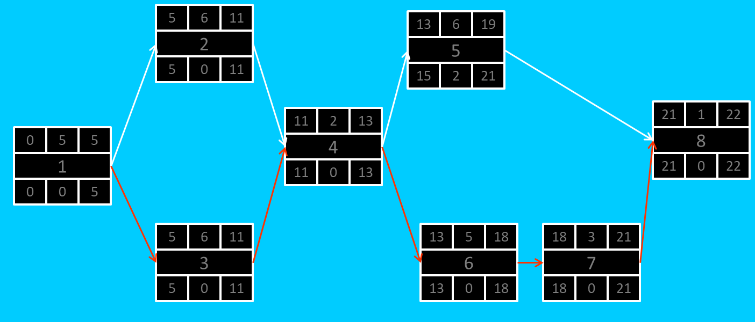

### Gantt Chart

### 