**Introduction**

This dataset contains 9 different seafood types collected from a supermarket in Izmir, For each class, there are 1000 augmented images and their pairwise augmented ground truths. The dataset includes gilt head bream, red sea bream, sea bass, red mullet, horse mackerel,

black sea sprat, striped red mullet, trout, shrimp image samples.

I divided this dataset into three different categories: train, test, validation.

Link to the dataset: [A Large Scale Fish Dataset | Kaggle](https://www.kaggle.com/crowww/a-large-scale-fish-dataset)

Link to the work folder: <https://drive.google.com/drive/folders/1z3nUtnWNKL0GFzXSkkiRpRQD2n1gIHRg?usp=sharing>

**Model**

I have used the Convolution Neural Networks for fish classification. The model contains six convolutional layers (including activation and pooling) plus two fully connected layers with a softmax as output layer. The size of an input image is 64*64*3 and training is set to 50 epochs with a learning rate of 0.0001 and added to the early stopping so that if validation accuracy is not improving training will stop.

**Results**

Due to the early stopping training stopped after 12 epochs with training accuracy of ~93% and validation accuracy of ~97%, which can be shown from figs 1 and 2. Also, I have added the testing result in fig 3.

**Loss and Accuracy curve**

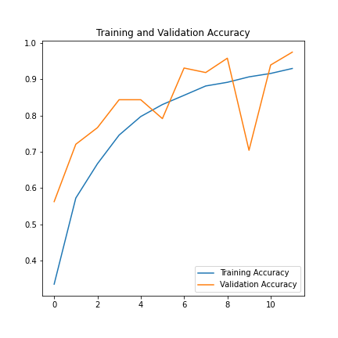

Fig 1: Training and validation Accuracy.

Fig 2: Training and Validation Loss.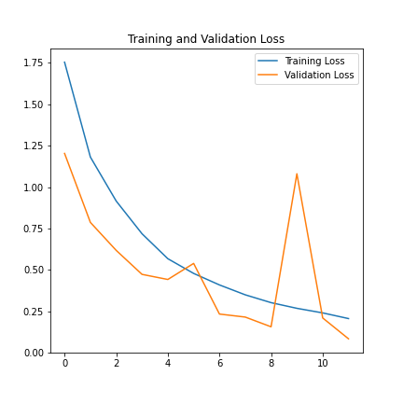

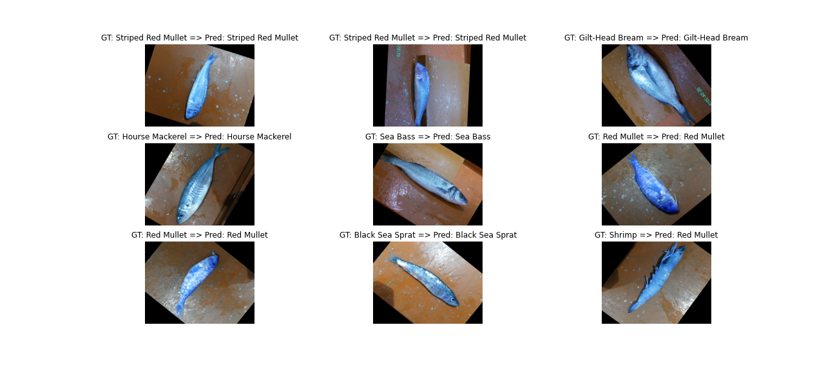

Fig 3: Testing result