**Create the AKS cluster (2 nodes, smallest size VM) and deploy any two services on it. Services should be accessible from the internet**

1. Go to portal.azure.com and click on Azure Kubernetes Service.

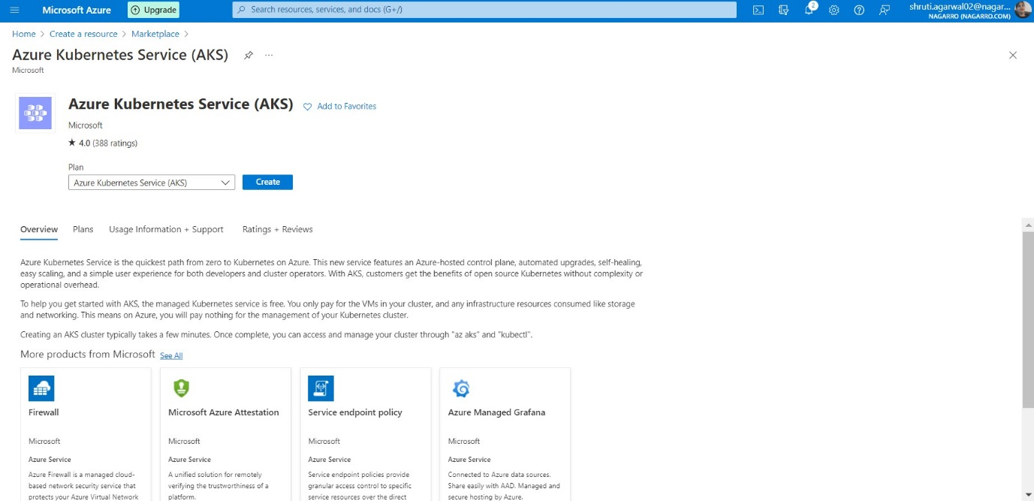

1. Then select the subscription, resource group and fill the cluster details

1. Now we will change Node size to B2s.

1. Now we will change the Node Count to 2 and click on review + create button

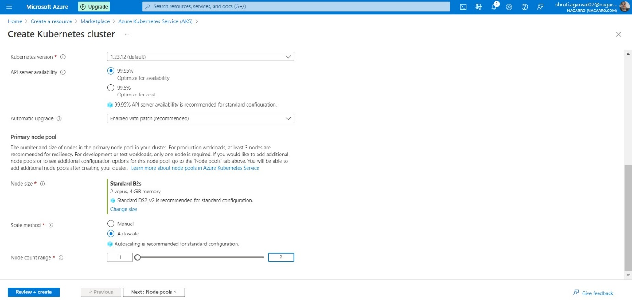

1. Now, click on create button and wait till it gets deployed.

1. Now, it is deployed and click on go to resource.

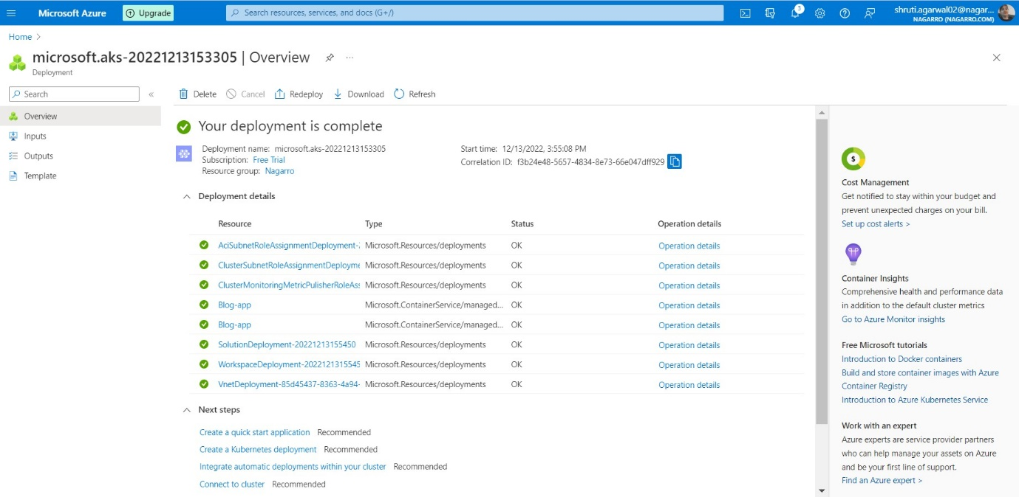

1. Now, click on cloud bash and click on connect.

1. Now copy the command to connect.

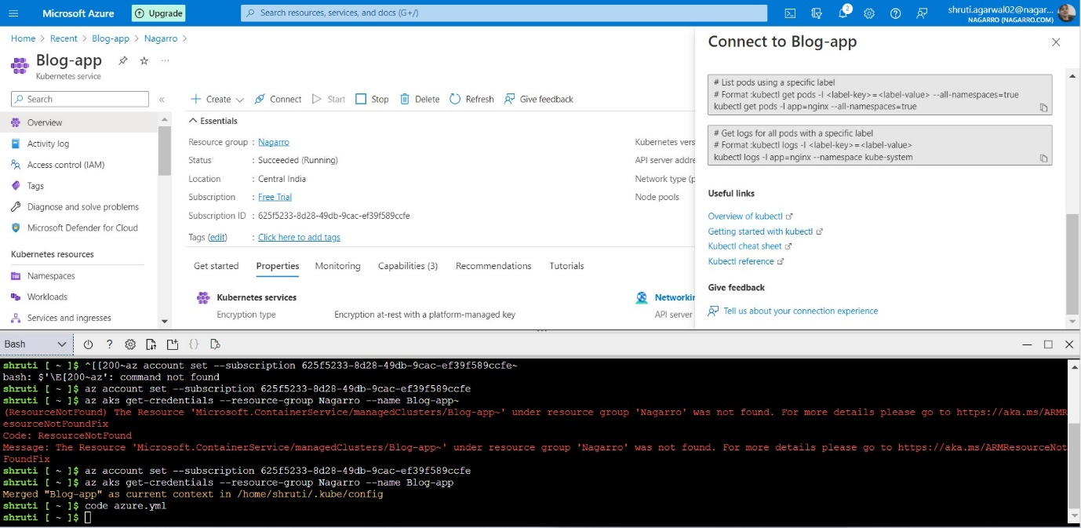

1. Now create an azure-app.yml file with code azure-app.yml command and paste configurations and save the file.

1. Now, type kubectl apply -f azure-app.yml to get services and deployments deploy

1. Now we can check services and pods by following commands:

- kubectl get pods

- kubectl get services

- kubectl get nodes

- kubectl get deploy

1. So, this is the external Ip on which we can check our deployed apps and backend

