**Create an Azure function that should trigger as soon as you upload a file in the blob storage. Function should be able to print the name of the file uploaded in the function**

1. Go to portal.azure.com and click on storage accounts

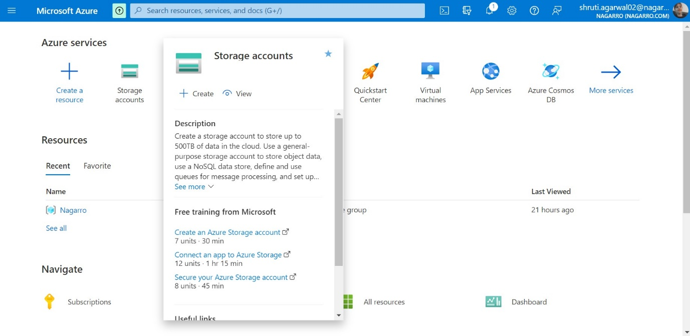

1. Then select the subscription, resource group and scroll down

1. Then give the name of the account, select the region and then under the Redundancy section select Locally redundant storage and move to Review

1. Then click on Create button and wait for it to get deployed

1. Then click on Go to resource

1. Then click on Containers from side menu and the create a container

1. Give the name of container as blog-container and change the access level to Container and click create

1. Now we will create a Function App Graphical user interface, text, application, email

   Description automatically generated
2. Then fill the required details under basic section then click on Review and create button

1. Now Click on create and wait for app to deploy

1. Now, click on Go to resource button

1. Now, click on create button to create a function

1. Then give the details required and select your storage account and click create

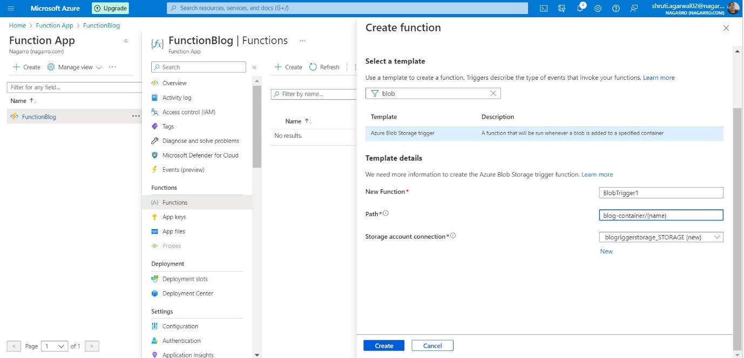

1. Then click on Configuration from the side menu and copy your storage account configuration detail value

1. Then click on + New application Setting button and give the name as AzureWebJobsStorage and paste the copied value in the value section and click ok.

1. Now, save the changes

1. Now click on function and click on Code + test.

1. Now, check the body It should be blog-container/{name} and hit run

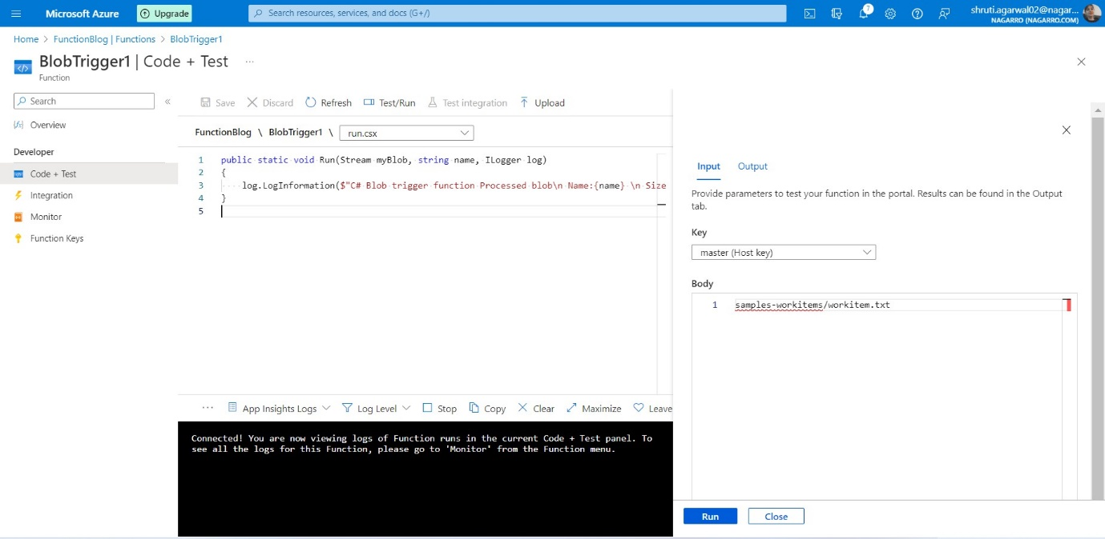

1. Now, it is connected, and we can see logs.

1. Now we will upload file in a container and see the logs it will show the name of file

1. Now the file is uploaded

1. We can see the name of file as shown below

