1. **Create freestyle Jenkins job to download code from Git**
2. Text

   Description automatically generatedTable

   Description automatically generated

**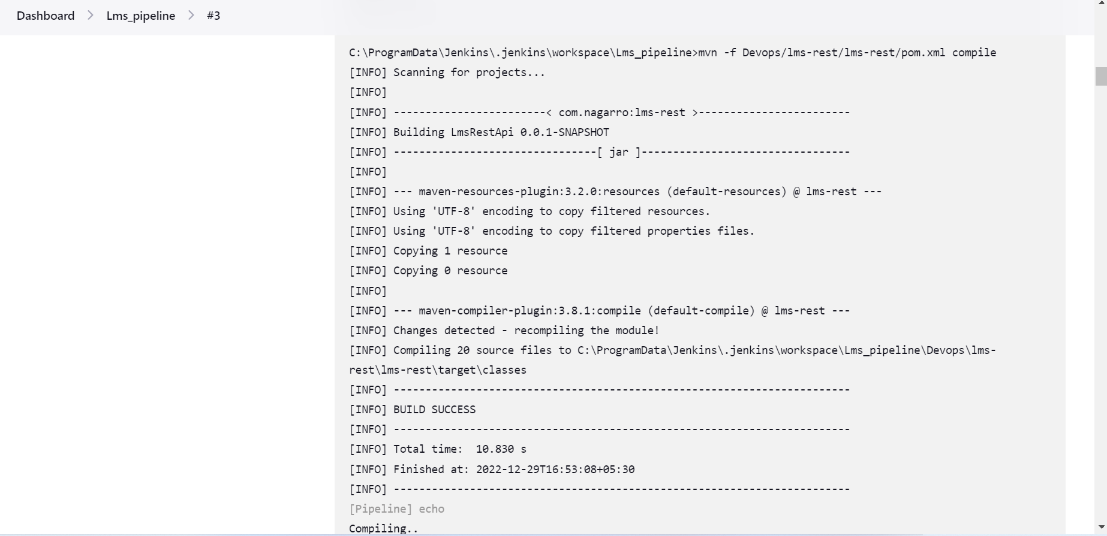

**3. Create freestyle Jenkins pipeline to build and deploy a spring boot API/Web App using Docker**

