**e-DELPHYN**

Blood Banking Information System

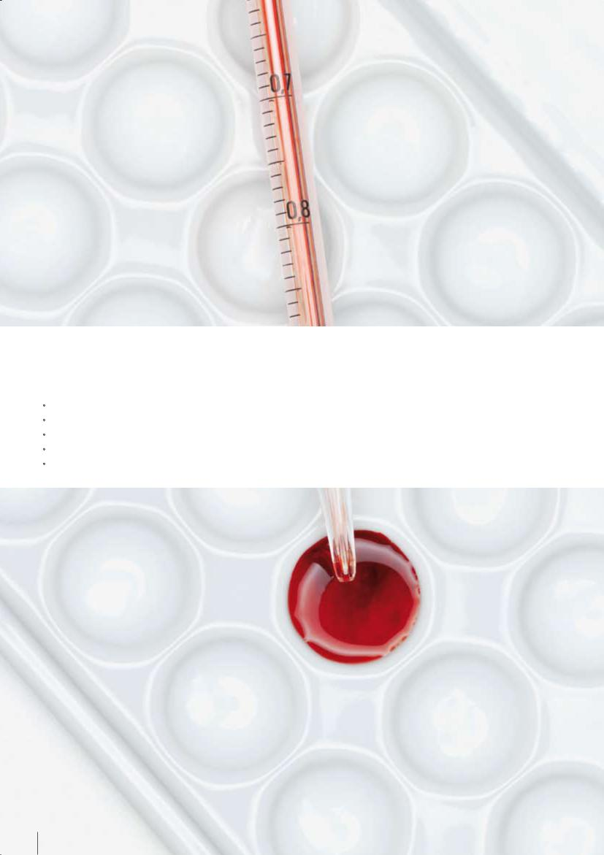

e-Delphyn Blood Banking Information System offers a fully integrated blood banking information system with the following features:

* Blood Drive Administration
* Donor/Donation Management
* Laboratory Management for Donors/Patients
* Transfusion Management for Patients
* Inventory Management of Blood Units

02

**Blood saves lives and it is always needed.**



**Barely a fraction of**

**those who are suitable**

**blood donors donate**

**blood. There may be a**

**time in which we may**

**face with adversity, in**

**need of blood to save**

**lives, often unexpected.**

A unit of blood can be processed into various blood products to treat a variety of medical conditions such as patients receiving treatment for leukemia, cancer, Thalassemia and catastrophic victims undergoing emergency surgery. More than 29 million units of blood components are transfused every year* due to the efforts of international blood drive organisers who hold on to their strong conviction of continually driving blood donations.

When faced with emergencies where every second is crucial, patients’ lives are dependent on the efficiency of the Blood Banks to deliver blood to them. e-Delphyn Blood Banking Information System is designed to increase the efficiency and productivity of your donor recruitment and transfusion service operations, in compliance with the International Standard for Blood Transfusion.

* Statistics provided by AABB

03





Highlights of e-DELPHYN Blood Banking

Information System:

* Allows for the digitalisation of records of deferred/accepted donors and patients
* Allows for a search on destroyed and expired blood
* Manages the complete inventory of blood units
* Provides blood group typing and confirmation
* Captures and maintains donor profile types
* Provides software support from installation and training to the implementation of system

04

**Blood Banking Management**

* Provides a complete vein-to-vein workflow managing operations from donor recruitment to patient transfusion
* Ability to capture and trace donors, blood units and transfusion history of patients
* Provides a laboratory module for patients and donors
* Allows for haemovigilance tracking
* Ability to register all incidents of blood component preparation and transfusions
* Manages the inventory of blood units received and distributed
* Compliance with standard international codes, standards and protocols such as ISBT 128 Labeling and HL7 communication protocol

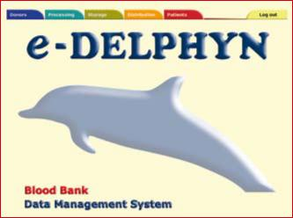

Modules of the e-DELPHYN Blood Banking Information System

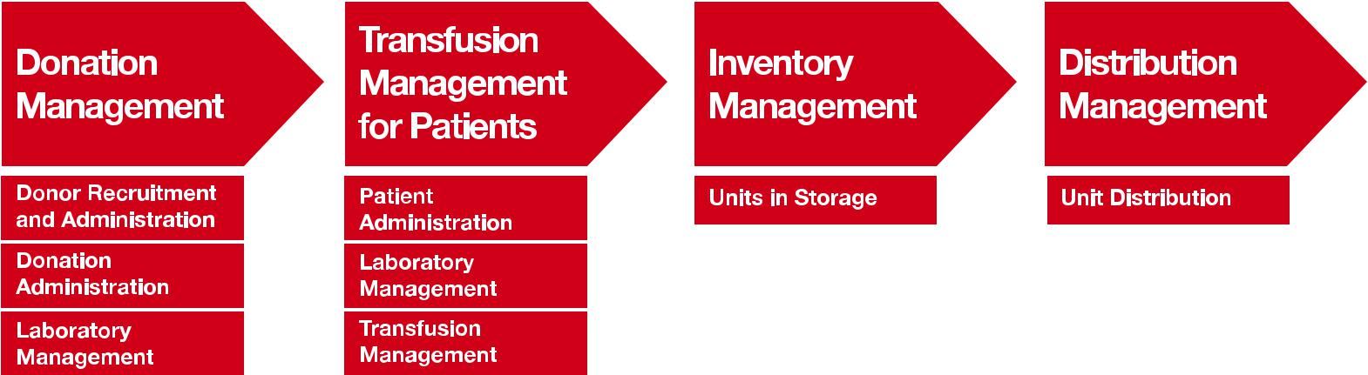

05



Donor Recruitment and Administration: Registers donors’ information.

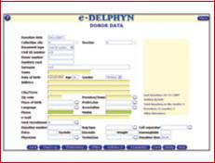

Donation Administration: Registers medical records for donors.

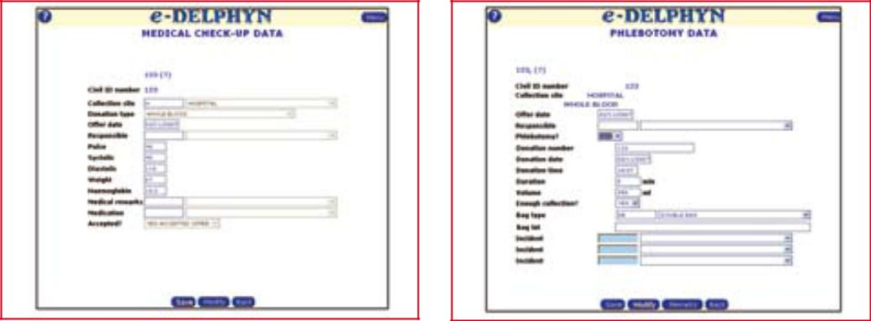

Laboratory Management for Donors:

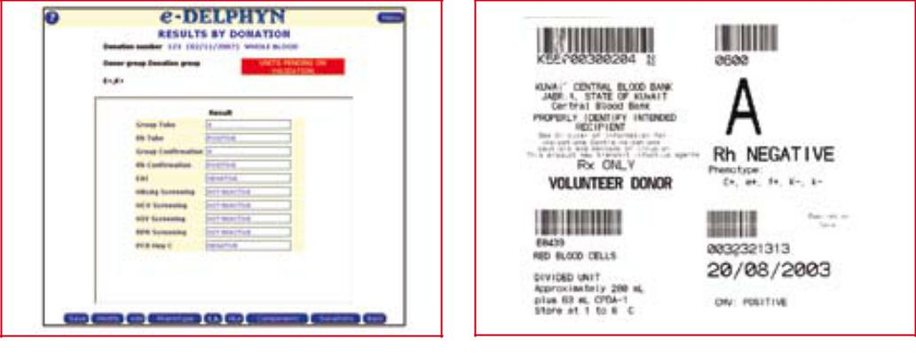

Registers the results of laboratory test and printing of labels.

Modules of the e-DELPHYN Blood Banking Information System

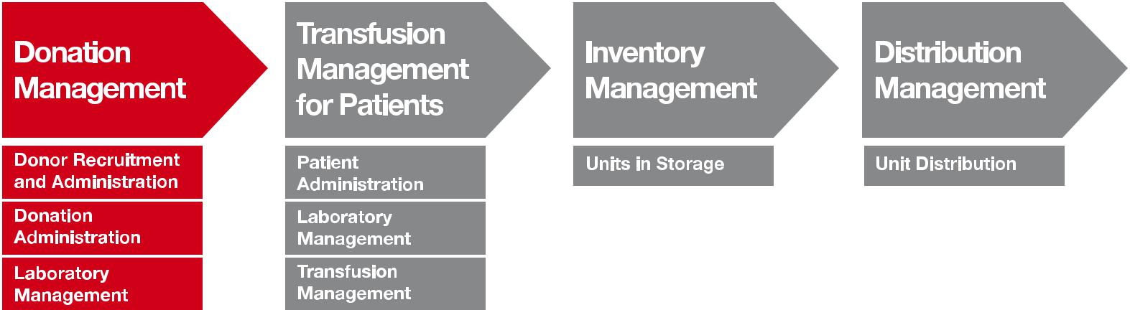

06



**Donation Management**

Donor Recruitment and Administration

* Manages the recruitment of new donor from mobile collection sites, hospitals or central blood centre using a unique identification number
* Allows for a search to be performed on existing donors’ eligibility. Donors’ eligibility status are indicated with a colour-coded system to differentiate between temporary and permanent deferrals. Information can be shared among hospitals
* Captures donors’ preferences such as donation period, donation type and preferred donation location



Donation Administration

* Faciliates the registration of donor from the filling in of medical questionnaire via online or hardcopies, to medical check-up and phlebotomy
* Captures and records the registration of various donation types (e.g. whole blood, plasmaphaeresis, cytaphaeresis, bone marrow, stem cells, tissue)
* Captures pre-donation tests (Hb, Hct, etc.)
* Allows for online access to donation and blood unit status
* Captures and records any blood collection and blood bag incidents
* Designed to interface with most of the automated laboratory test devices available in the market
* Allows for the creation and generation of customised reports and donation statistics



Laboratory Management for Donors

* Allows integration between internal and multiple offsite laboratories
* Laboratory tests can be configured at this module such as Immuno-haematology, Virology and HLA
* Allows for the configuration of a new test without

the need to change the source code

* Performs automatic test request by phlebotomy type
* Allows for the manual input of results
* Performs automatic test request by time period e.g. Biochemistry requested every X donation or X months for Aphaeresis donors
* Supports the option for an online interface with automated instruments or LIMS system
* Allows the tracking of reagent used per test
* Prints the donor cards after validation of results
* Allows for the creation and generation of user defined reports and statistics such as worksheets and test results
* Qualitative or quantitative results are configurable to each test
* Supports the ISBT 128 blood component labelling, definitive labels in compliance with ISBT

128 standards can be printed after validation

* Automatically request for supplementary testing e.g. repeat HIV screening from initial screen reactive



07



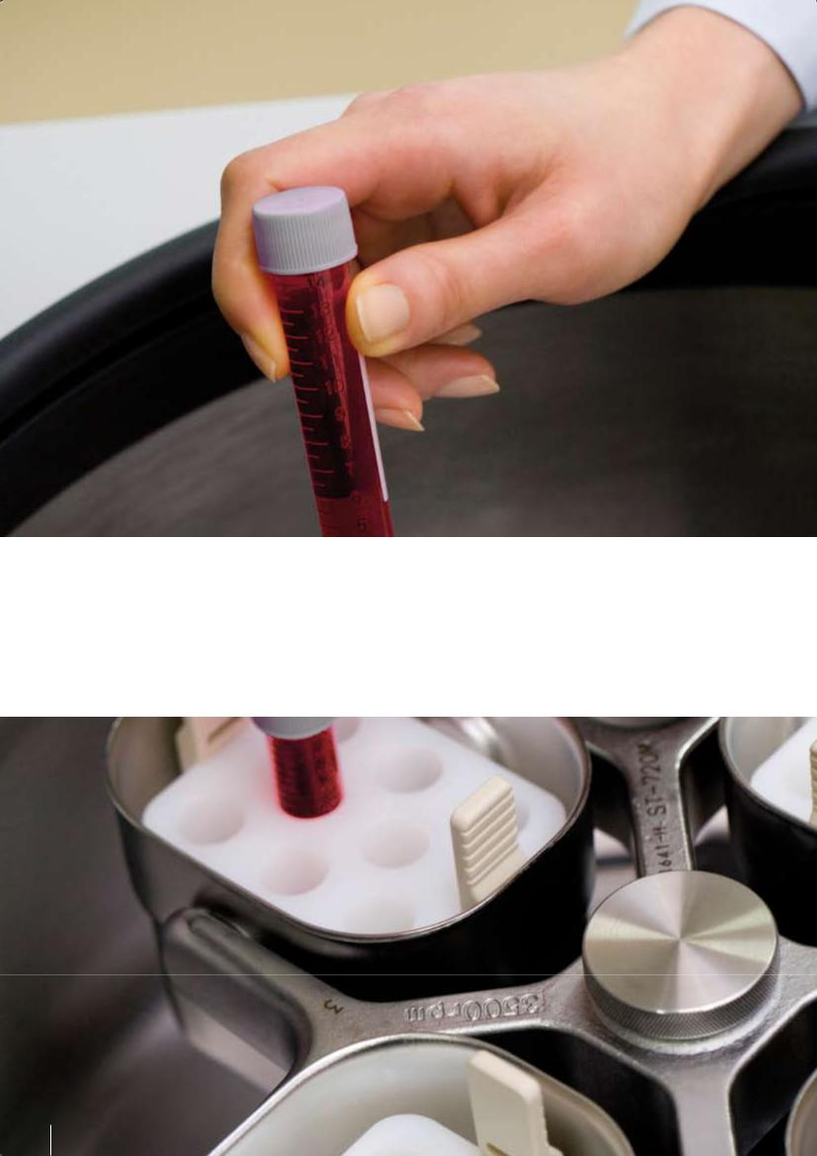

Transfusion Management Module for

Patients helps you register patients and

manage their transfusion requirements. It

is able to interface with other laboratory

testing devices in capturing patient’s test

results.

08

**Transfusion Management for Patients**

Patient Administration

* Facilitates the patient registration process and manages request for blood units from departments and hospital wards
* Designed with the ability to interface with the hospital information system in using the common patient identification
* Allows the printing of sample identification labels

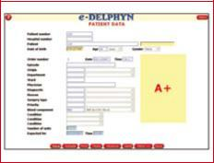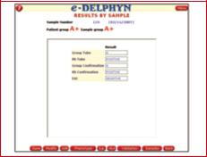

Laboratory Management for Patients

* Laboratory module for patients includes Immuno-haematology, Virology and HLA tests
* Requested analyses are entered either by batch or individually
* Ability to interface with laboratory testing devices (online, bi-directional or batch)
* Provides integration with multiple laboratories
* Management for antibodies screenings with consideration of last AS tested, last AS positive and identification, and all known antibodies
* Allows the medical validation of results
* Provides cross-matching of results
  + Compatible, incompatible and least incompatible results can be recorded

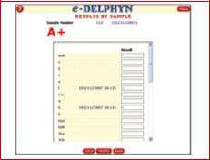

Transfusion Management

* Reserves blood units based on compatibility results from patient’s sample
* Prints blood group cards and transfusion records
* Records the number of blood units expected
* Selects and reserves products prior to delivery
* Special labels can be printed and attached to the unit when a reservation is confirmed, including labelling control procedures to ensure that the correct product has been labelled
* Performs transfusion confirmation and record incidents if any
* User defined time frame can be established to cancel reservations on products

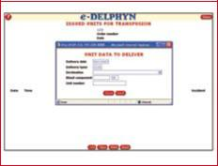

Modules of the e-DELPHYN Blood Banking Information System

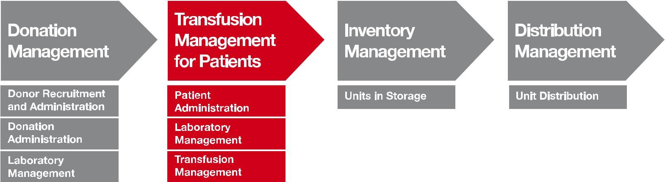

09





Transfusion Management Module helps you manage the transfusion process which allows you to reserve blood units prior to delivery, print blood group cards and transfusion records.

10

**Inventory Management**

Units in Storage

* Ability to manage multiple inventory facilities
* Provides real-time inventory status and location
* Provides consolidated status of blood units’ availability for large demand situations
* Manages imported products, product exchanges, discarded products and any return of unused products
* Provides any reconciliation of the application inventory with physical inventory
* Manages the inventory supplies such as bags, reagents and filters
* Allows the selection of products by location
* Allows review of work in progress inventory
* Allows review of inventory online by ABO/Rh, phenotype and expiry date

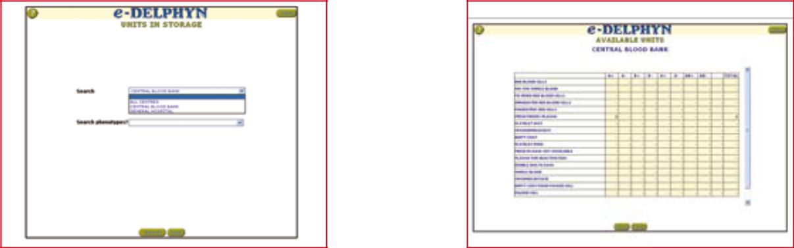

Modules of the e-DELPHYN Blood Banking Information System

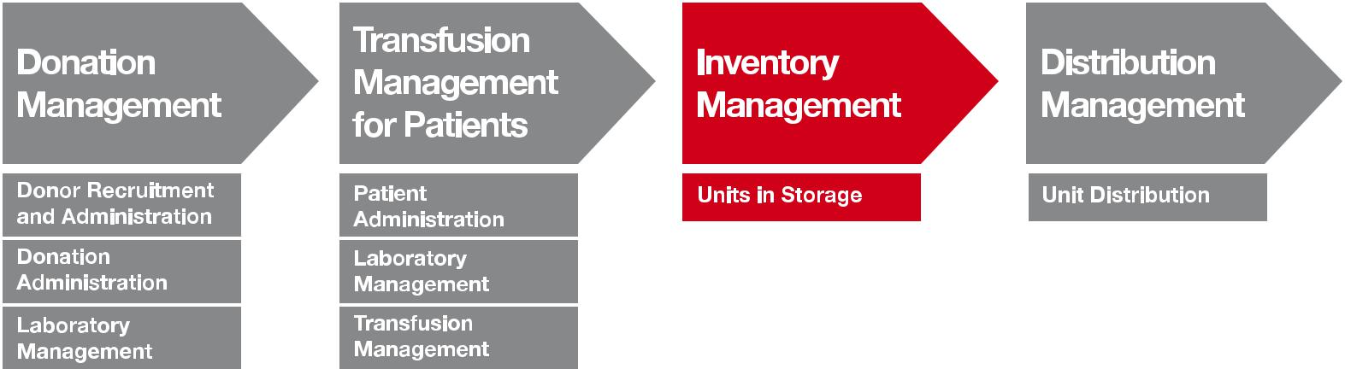

11



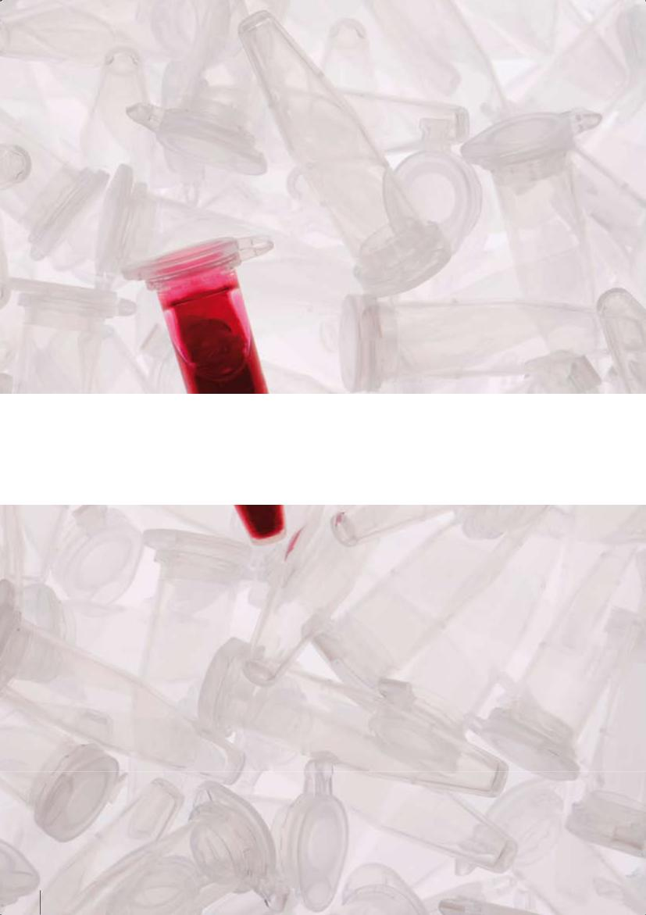

Unit Distribution Management Module

supports the online ordering between sites.

It generates shipping documents and

supports direct interface with the users’

billing module.

12

**Distribution Management**

Unit Distribution

* Supports the online ordering between sites e.g. hospital ordering blood units from blood centre or hospital to hospital ordering of blood units
* Site-to-site delivery of blood units. User assistance

for the selection of products for a patient (e.g. antibodies, expiration date, ABO/Rh, patient protocols-CMV negative, irradiated products)

* Supports electronic cross-matching
* Generates shipping documents such as print order, delivery and assignment slips, and patient’s historical transfusion data
* Online display of orders during shipment process
* Products under lookback/recalls, deferrals, consumable recalls are blocked from shipping. The module only allows for suitable products to be shipped
* Direct interface with users’ billing module

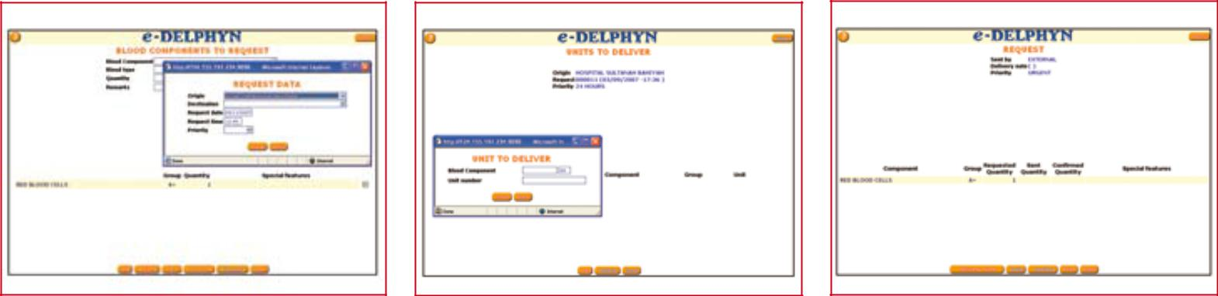

Modules of the e-DELPHYN Blood Banking Information System

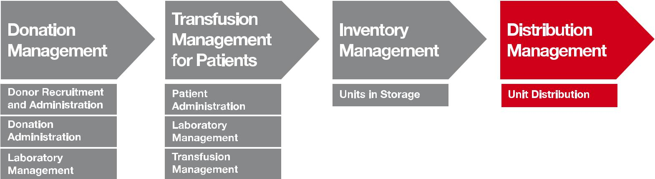

13



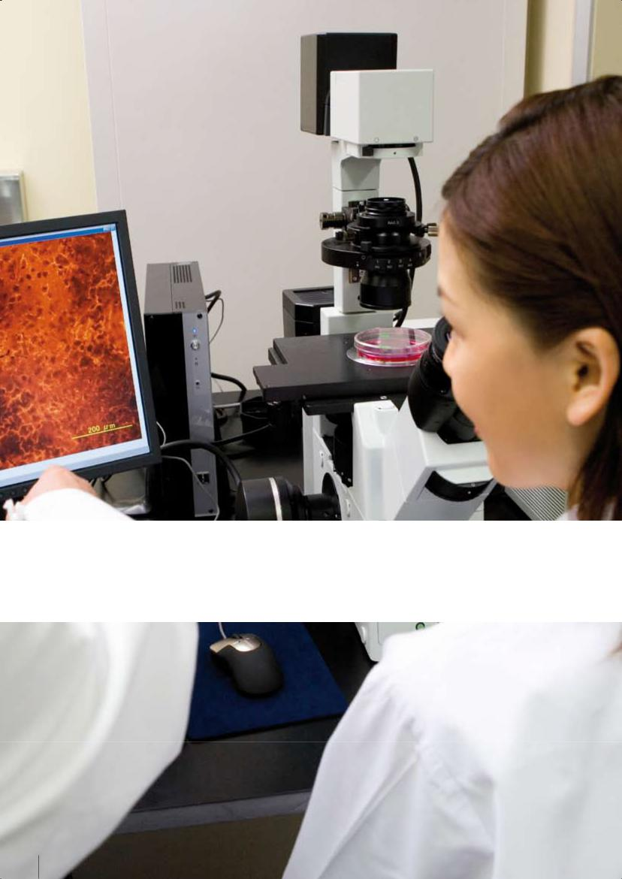

e-DELPHYN Blood Banking Information System offers you a system with benefits such as usability, security, scalability and advanced technology.

14

**Product Benefits**

Usability

* Centralised data storage that allows for sharing of information and functionalities between blood bank centres and hospitals
* Web-based application with self-explanatory user interface
* Multi-language provided in English, Spanish, Chinese, Portuguese, French, Polish, Arabic, Thai, Malay and Vietnamese
* Configuration module to configure system based on the legislation of each country
* Unified reports with analytical tests can be generated and sorted by patients and donors



Security

* Encrypted password
* Multi-level user access rights configuration for each module
* Audit trail on the activities and data changed for each record by each individual user

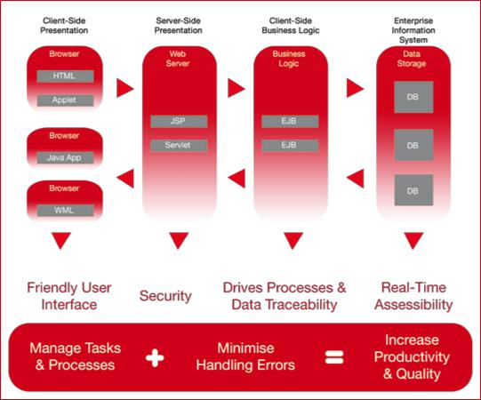

Scalability & Technology

* Designed with the flexibility to add on satellite hospitals or centres if required
* Allows for the fast deployment of mobile collection sites and hospitals
* Ability to integrate with analysers and bar-code scanners
* Available on web-based application or Windows-based client application
* Designed with the flexibility to run on most operating system platform



15



**You may also be interested to**

**explore our other related**

**products:**

* Laboratory Information System
* Anatomical Pathology
* Prenatal Screening



Hemasoft Asia offers specialised software solutions for

the medical sector in areas such as Blood Banking,

Donor Management and Transfusion, Clinical

Laboratory Management and Pathology Data

Management. Our solutions are designed to help our

customers improve their productivity, streamline

processes and facilitate better data collaboration.

192 Pandan Loop #06-20

Pantech Industrial Complex

Singapore 128381

Tel: +65 6303 9811

Fax: +65 6778 2578

hmasales@hemasoftasia.com

www.hemasoft.com



Copyright © 2007 Hemasoft Asia Pte Ltd. All rights reserved.