GUIDE TOPICS

1. **CORE JAVA**
2. Java 8 Features
3. Stream API
4. Give distinct string from String s="AAABBAAACDDD" using Java Streams

String s="AAABBAAACDDD";  
IntStream intStream=s.chars();  
//converting into stream of characters  
Stream<Character> characterStream=intStream.mapToObj(c->(char)c);  
//Converting every character into String and then joining  
String str=s.chars().mapToObj(c->(char)c).distinct().map(String::*valueOf*).collect(Collectors.*joining*());  
System.*out*.println(str);

1. Lambda Expressions and Functional Interfaces
2. Multithreading and Lock Strategies
3. String Class
4. Static Keyword(blocks, classes, variables)
5. Global Instance Variables
6. Java Memory Model
7. Collections (All, HashMap - synchronised and other types)

* Using model Classes as keys in HashMap or Set

1. Design Patterns (Singleton, Factory, Observer etc.)
2. SOLID Principles
3. Abstract Class and Functional Interfaces(example based questions)
4. Operator Precedence
5. Constructor Chaining
6. Basic Java Application Errors and Exceptions related to simple apps,multithreading and other practical examples

1.Compile Time Errors:-Syntax Errors,Missing imports(packages)

2. DATABASES

3. SPRINGBOOT

4. MICROSERVICES

5. DEPLOYMENT CI/CD

**MISCELLENEOUS**

1.Abstraction vs Encapsulation

Abstraction=>showing essential features to consumer Using=>abstract keyword and interface

Encapsulation:-Bundling of data variables and methods into single unit i.e is class and restricting direct access of some of object components for security Using=> access modifiers and getters and setters methods for controlled access.

2.HashMap Working and implementation:-

3.What is Spring Initializer?

Web based tool which allows us to customize our projects by selecting build like maven and gradle java versions and packaging type(jar and war).

Web-interface:-start.spring.io

Intellij Ultimate and eclipse supports spring initializer.

4.TwoSUM

MySQL Questions:-

1.Update the salary by 50%

update EmployeeSalary

set Salary=Salary *1.5;

2.Commands in SQL

* **DDL**– Data Definition Language
* **DQL**– Data Query Language
* **DML**– Data Manipulation Language
* **DCL**– Data Control Language
* **TCL**- Transaction Control Language

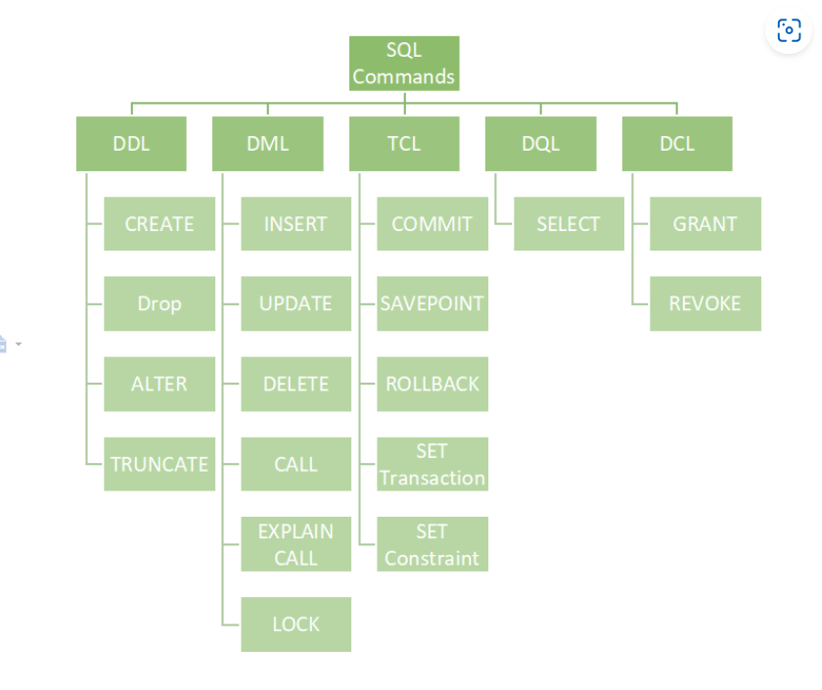

2.Difference between where and having in mysql?

3.Highest Salary in each department

select max(salary) from department

group by department_id;

# 4. SQL Query to find Employees With Higher Salary than Their Department Average?

# Without using JOIN();

# Using JOIN()