**HPC Assignment 5**

**Approximating value of PI using trapezoid rule (using Open MPI)**

**Submitted by:**

**Shruti Singh 201301452**

**Saumya Bhadani 201301100**

**1. Problem statement : Approximate value of pi**

* We have to calculate the value of PI using the trapezoid rule.We compute the value of pi using definite integral of 4/(1+x^2) in the interval [0, 1].
* This can be visualised as dividing the area under the function 4/(1+x^2) into n rectangles and then finding the summation of area of all rectangles.

We implement the above method in three ways. We write a purely serial code, and two parallel codes, using OpenMP and Open MPI parallel directive.

We compare the running times of the above three algorithms and record the observations and speedup as follows.

* **Complexity :**

Complexity of the serial algorithm is O(n), where n = number of divisions, the interval [0, 1] is divided into(i.e. problem size).

Complexity of the parallel algorithm is O(n/p), where p = number of cores on the machine.

* **Possible speedup(theoretical) :**

Speedup S = 1/ (P/n + s)

n – number of cores

P – percentage of code that can be parallelized

s – percentage of serial code(which is not parallelized)

For our code, P ~ 1 and s ~0

n=4, So theoretical speedup = 4

* Optimization strategy

For the naive parallel code using OpenMP

We have four cores, so the code can be parallelized into 4 segments. The interval of x, i.e. [0,1] if divided into n steps, then n/4 iterations can be performed by each thread. Theoretically, this will increase the speedup of the process 4 times the serial code.

* Open MPI

Open MPI is a [Message Passing Interface](https://en.wikipedia.org/wiki/Message_Passing_Interface) (MPI) library project. Here, different processes communicate with each other using MPI communication protocol. MPI codes run on shared-memory multi-processors, distributed-memory multicomputers, cluster of workstations, or heterogeneous clusters of the above.

The six main functions of MPI are:

MPI_Init() MPI_Comm_rank()

MPI_Finalize() MPI_Recv()

MPI_Comm_size() MPI_Send()

**2. Hardware details:**

CPU : Intel® Core™ i5-4200U CPU @ 1.60GHz × 4

Compiler : gcc

Precision : Double

Peak performance = 4 FLOPs/cycle * 1.6GHz * 4 = 25.6 GFLOPS

**3. Output:** The value of pi approximated by the machine. The time taken for computation of the value.

For 8 cores:

|  |  |  |  |  |
| --- | --- | --- | --- | --- |
| **Problem Size** | **Serial Time**  **(seconds)** | **Naive parallel Time OpenMP**  **(seconds)** | **Parallelization**  **using Open MPI** | **Value of pi approximated** |
| 1000 | 0.000023; | 0.000083 | 0.000161 | 3.1415927369 |
| 4000 | 0.000081; | 0.000121 | 0.000863 | 3.1415926588 |
| 10000 | 0.000196; | 0.000236 | 0.000909 | 3.1415926544 |
| 40000 | 0.000783; | 0.000714 | 0.000423 | 3.1415926536 |
| 100000 | 0.001954; | 0.002511 | 0.000884 | 3.1415926536 |
| 400000 | 0.008733; | 0.007107 | 0.002828 | 3.1415926536 |
| 1000000 | 0.019460; | 0.020635 | 0.006725 | 3.1415926536 |
| 4000000 | 0.077808; | 0.094888 | 0.013651 | 3.1415926536 |
| 10000000 | 0.194256; | 0.160862 | 0.051374 | 3.1415926536 |
| 40000000 | 0.776629; | 0.353436 | 0.137977 | 3.1415926536 |
| 100000000 | 1.941913; | 0.421661 | 0.340176 | 3.1415926536 |
| 400000000 | 7.767228; | 0.509591 | 1.362883 | 3.1415926536 |
| 1000000000 | 19.422764; | 0.703818 | 3.386835 | 3.1415926536 |

4 cores

|  |  |  |  |  |
| --- | --- | --- | --- | --- |
| **Problem Size** | **Serial Time**  **(seconds)** | **Naive parallel Time OpenMP**  **(seconds)** | **Parallelization**  **using Open MPI** | **Value of pi approximated** |
| 1000 | 0.000023; | 0.000424; | 0.000139; | 3.1415927369 |
| 4000 | 0.000081; | 0.000449; | 0.000072; | 3.1415926588 |
| 10000 | 0.000196; | 0.002377; | 0.000229; | 3.1415926544 |
| 40000 | 0.000783; | 0.003479; | 0.000721; | 3.1415926536 |
| 100000 | 0.001954; | 0.013778; | 0.001387; | 3.1415926536 |
| 400000 | 0.008733; | 0.025040; | 0.004886; | 3.1415926536 |
| 1000000 | 0.019460; | 0.195865; | 0.007495; | 3.1415926536 |
| 4000000 | 0.077808; | 0.601682; | 0.028812; | 3.1415926536 |
| 10000000 | 0.194256; | 1.193032; | 0.070461; | 3.1415926536 |
| 40000000 | 0.776629; | 5.251369; | 0.268422; | 3.1415926536 |
| 100000000 | 1.941913; | 20.53164; | 0.673055; | 3.1415926536 |
| 400000000 | 7.767228; | 21.000424; | 2.707683; | 3.1415926536 |
| 1000000000 | 19.422764; | 25.000449; | 6.601967; | 3.1415926536 |

**Speedup**

1. Serial Vs Open MPI

|  |  |
| --- | --- |
| **4 cores** | **8 Cores** |
| 0.16547 | 0.142857 |
| 1.125 | 0.093859 |
| 0.8559 | 0.215622 |
| 1.08599 | 1.851064 |
| 1.4088 | 2.210407 |
| 1.78735 | 3.088048 |
| 2.5964 | 2.89368 |
| 2.70054 | 5.699802 |
| 2.75693 | 3.781212 |
| 2.89331 | 5.628684 |
| 2.88522 | 5.708554 |
| 2.86859 | 5.699116 |
| 2.94197 | 5.734783 |

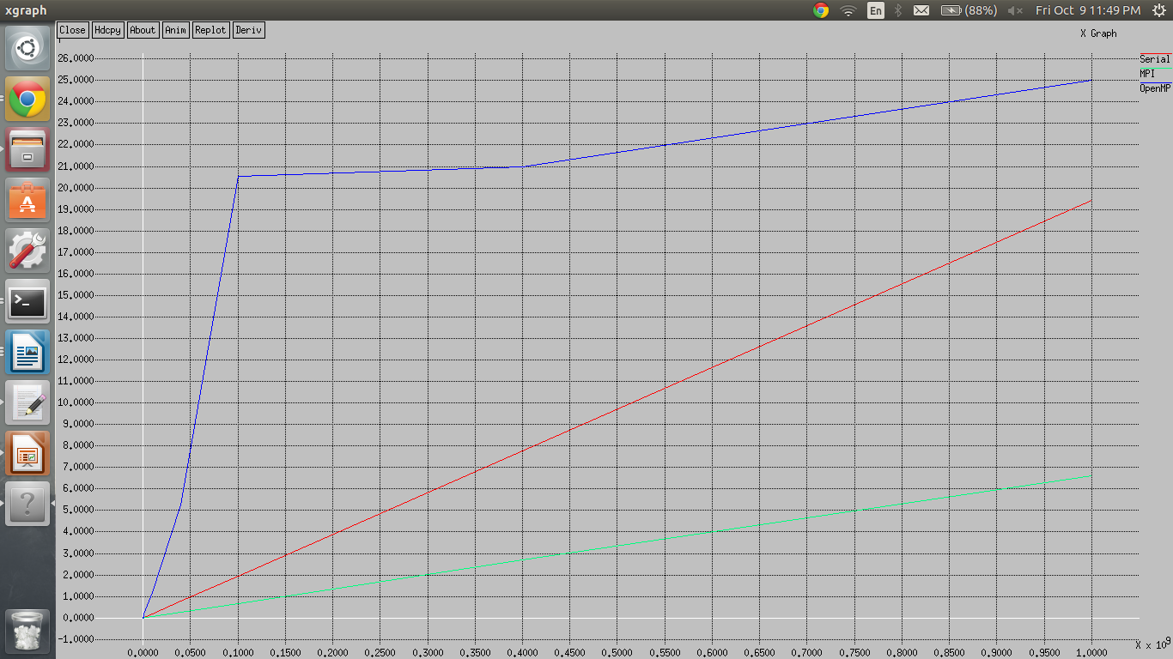

Speedup Vs ProblemSize