CONTEXT

PROBLEM DESCRIPTION

1. We were given an image file which we had to store in a matrix and write a serial and parallel algorithm to modify the matrix and convert it back to a image file, such that the image is twisted/ warped.

2. We had to perfom filtering on an image
Filtering : Consider an image neighborhood surrounding each pixel is defined, and the median value (filter in this case) of this neighborhood is calculated and is used to replace the original pixel in the output image by using the following filter:

Imed [x,y] = median (Iorig [I, j] ; i, j belongs to nbor [x,y])

for a half-width of n, the number of pixels in the neighborhood would be (2n+1)^2.

COMPLEXITY OF ALGORITHM

1. O(n) where n is the number of pixels, O(h*w), where h=height and w=width
2. O(n) where n is the number of pixels, O(h*w), where h=height and w=width

POSSIBLE SPEEDUP

Speedup S =1/ (P/n + s)
n – number of cores
P – percentage of code that can be parallelized
s – percentage of serial code(which is not parallelized)
For our code, P ~ 1 and s ~0
n=4, So theoretical speedup = 4

OPTIMIZATION STRATEGY

In the first question, we had to rotate every pixel and in the second question we had to create a matrix of neighbouring pixels, for each pixel and find the median of the matrix. In both we parallelized the for loop, so that every thread got equal number of pixels to rotate or to filter. There was no loop based dependency.

The formula, we used to twirl was :
rmax = maximum radius to twirl.
(xc,yc) = center of twirl circle
(xp,yp) = initial coordinates of a particular pixel
x = xc + r*cos(theta) for r<=rmax
xp for r>rmax

y = yc + r*sin(theta) for r<=rmax
yp

r = sqrt((xp-xc)^2+(yp-yc)^2)
theta = arctan((xp-xc)/(yp-yc)) + alpha*((rmax-r)/rmax)
where alpha is the rotation angle

PROBLEMS BASED IN PARALLIZATION AND POSSIBLE SOLUTIONS

We faced a big problem with reading the image.

The warped image obtained from serial code was much more clear than the parallel version of it.

The same was the case with filtered image. The serial version was much more accurate than the parallel version.

Also, the warp algorithm was not working for image of size 128*128 ans 225*225 but it was working for 256*256 and 512*512.

HARDWARE DETAILS

Memory 3.7 GiB
Processor Intel® CoreTM i7-4702MQ CPU @ 2.20GHz × 8
OS type 64-bit
Disk 103.5GB

INPUT AND OUTPUT INFORMATION

1. Input is a greyscale image with 8-bit pixels.
Output is an image file with warped/twisted image.

2. Input is a greyscale image with 8-bit pixels.
Output is an image file with filtered image.
Width of filter : 3, i.e. 49X49 neighbouring matrix

1. PROBLEM SIZE VS TIME FOR SERIAL WARPING

X axis = log2(problemSize)(log in the base 2) Y axis = Time (in seconds * 10^-3)
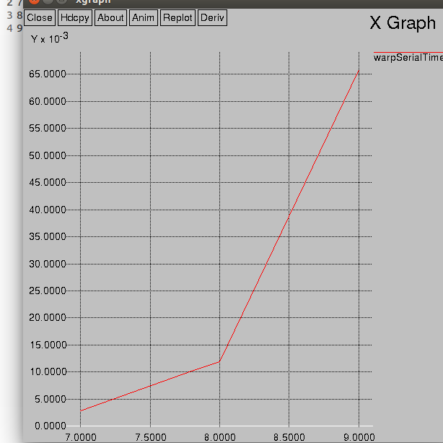

PROBLEM SIZE VS TIME FOR PARALLEL WARPING

X axis = log2(problemSize)(log in the base 2) Y axis = Time (in seconds * 10^-3)

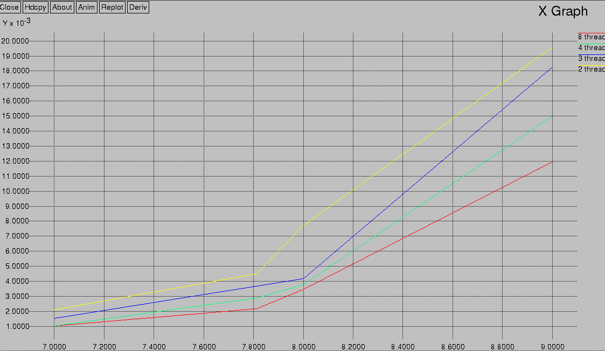

PROBLEM SIZE VS SPEED UP

Y axis : speed up X axis : log2(problemSize)

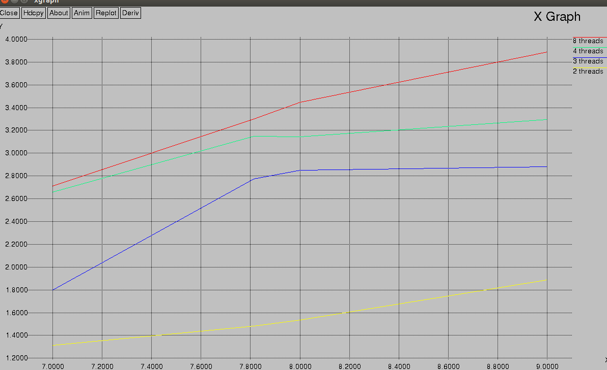

2. PROBLEM SIZE VS TIME FOR SERIAL FILTERING

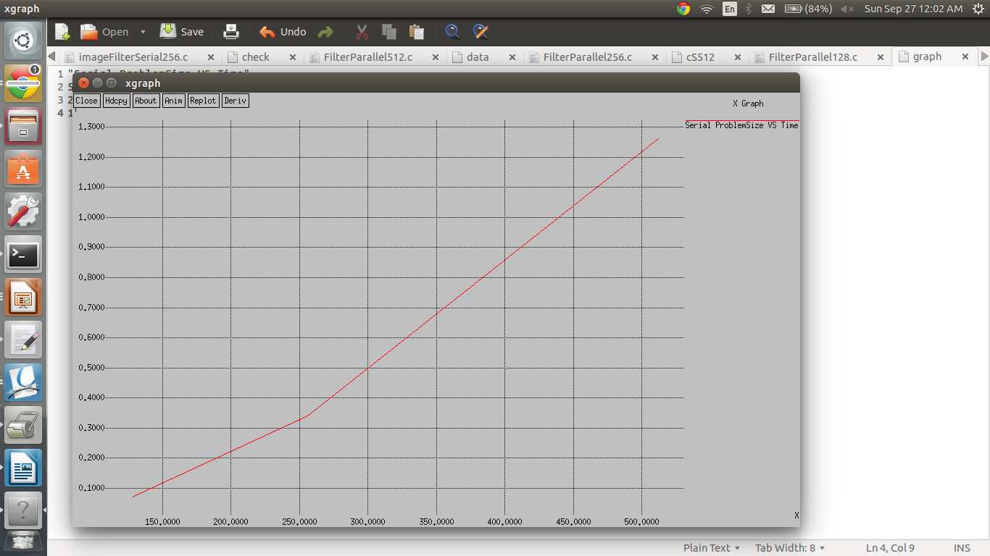
PROBLEM SIZE VS TIME FOR PARALLEL FILTERING
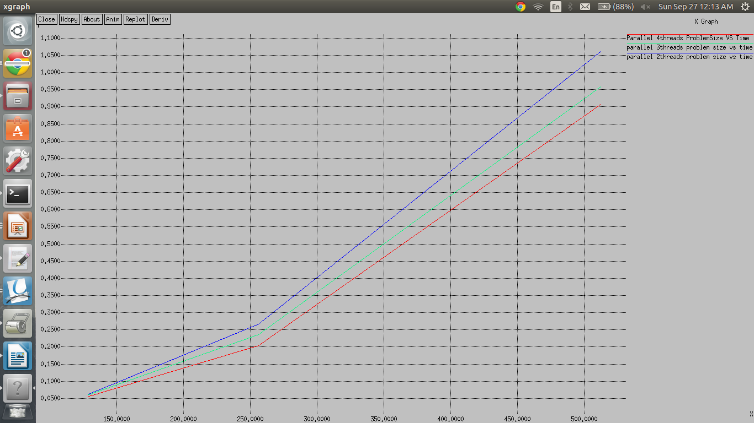

PROBLEM SIZE VS SPEED UP
