Problem Description
1.We need to calculate value of PI using the following series

PI = 4*[1-1/3+1/5-1/7+.....]
We have to implement both serial and parallel algorithm for the same.

2. We need to generate N fibonacci numbers for large value of N using parallel and serial algorithm.

3. We need to implement bubble sort and odd even sort using serial and parallel algorithm.

Complexity of Algorithm
1. For problem 1, the complexity of the serial algorithm is O(n), where n is the number of terms considered while calculating the value pi.

2. For problem 2, the complexity of the serial algorithm is O(n), where we need to calculate the nth fibonacci number.

3. For problem 3, the complexity of the serial algorithm is O(n^2), where n is the number of elements that have to be sorted.

Possible speedup(theoretical) :
Speedup S =1/ (P/n + s)
n – number of cores
P – percentage of code that can be parallelized
s – percentage of serial code(which is not parallelized)
For our code, P ~ 1 and s ~0
n=4, So theoretical speedup = 4

Optimization Strategy

1. For the calculation of pi, we used the reduction clause.
In this problem, we need to combine values into a single accumulation variable, but there is a true dependence between the loop iterations that can't be trivially removed.

This problem can be solved through reduction.

reduction(op:list) op=operator list = variable that is shared

If there is a local copy of list, the compiler updated the local copy using “op”. Than the local copies are reduced into a single value and combined with th original global value.

2. For the calculation of Fibonacci series using parallel algorithm, we used the following expression :

Fib(n+k)=Fib(n+1)*Fib(k)+Fib(

We stored the first 5 Fibonacci numbers. Now
taking k=5 and n=1,2,3,4, we calculated
6th(5+1), 7th(5+2), 8th(5+3), 9th(5+4) Fibonacci numbers. For this we used threads. The 1st 2nd 3rd and 4th thread calculated the 6th 7th 8th and 9th numbers respectively.

Next we took k=9 and n=1,2,3,.....8. Thus the 1st thread calculated 10th and 11th numbers, 2nd thread calculated 12th and 13th numbers and so on.

3. Here we did the odd even sort using threads.
Suppose we need to sort 8,7,6,5,4,3,2,1 using odd
even sort, we first compared 7 and 6, 5 and 4, and so on, and we get 7,8,5,6,3,4,1,2. Next we compare 8 and 5, 6 and 3, 4 and 1.
We have designed the above algorithm in such a way that 1st thread arranges 7 and 6, while 2nd arranges 5 and 4 and so on.

Problems faced in possible parallelizations

1. For the second problem, the values were very large for large n and for n=10^7 and above, there was segmentation fault. Also, the serial algorithm proved to be more efiicient for n<10^5.

2. For the third problem(odd even sort), the parallel algorithm was not very efficient for small n, and for large values of n, both the serial and parallel algorithms failed to produced output.

Hardware Details

Memory 3.7 GiB
Processor Intel® Core™ i7-4702MQ CPU @ 2.20GHz × 4
OS type 64-bit
Disk 103.5GB

Input and Output Information

1. For question 1, the input is N, and output is value of pi with
summation till N

2. For question 2, the input is N, and output is fibonacci sequence till Nth fibonacci number.

3. For question 3, the input is and unsortes array of integers and output is the sorted array.

For calculation of PI using Series

Problem size vs Time for Serial implementation

X-axis = time(seconds)
Y-axis = log(ProblemSize)
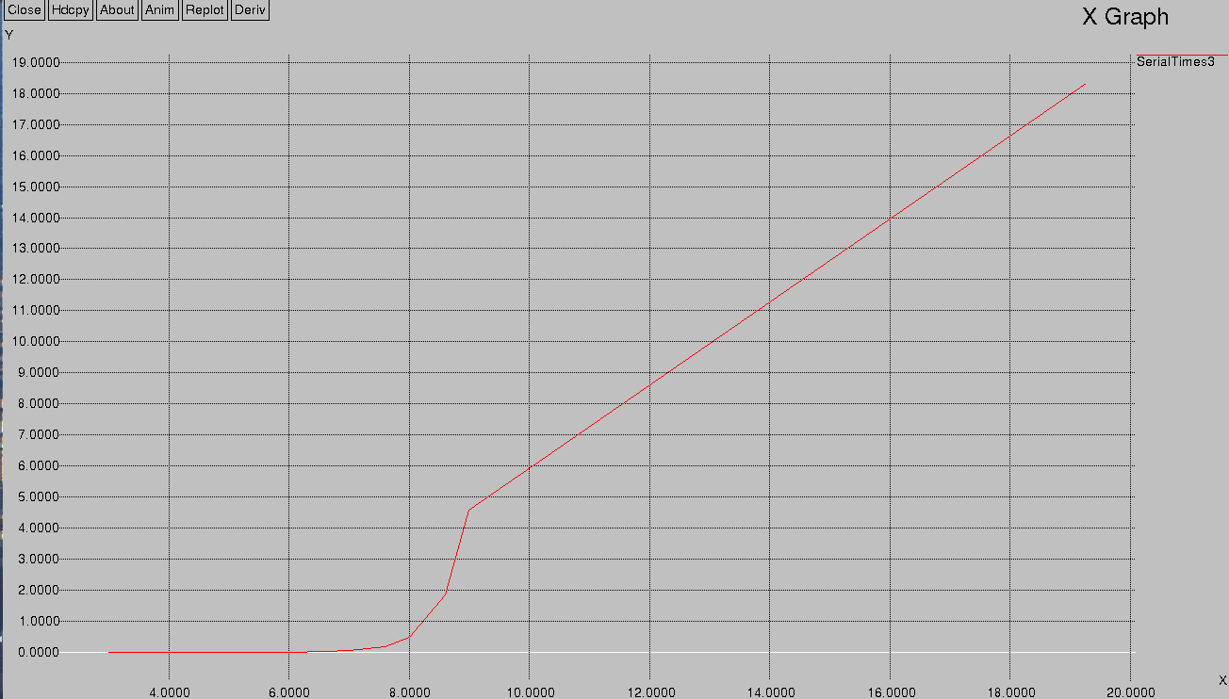
log(problemSize)

Problem size vs Time for Parallel implementation
X-axis=time(seconds)
Y-axis=log(ProblemSize)
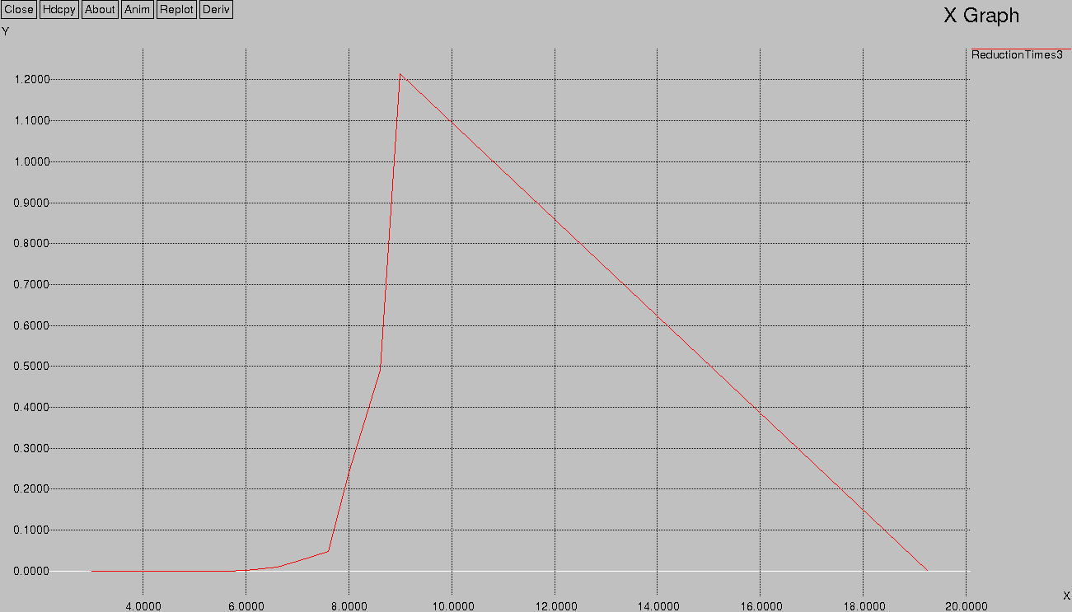
log(ProblemSize)
Speedup Vs ProblemSize
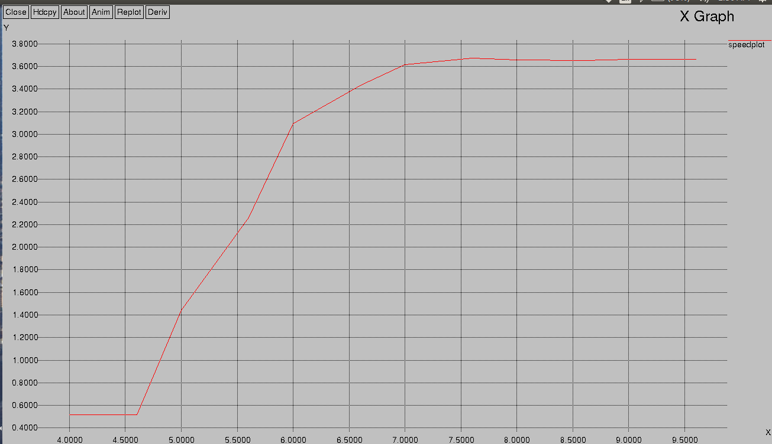
Y-axis=Speedup X-axis=log(ProblemSize)

SpeedUp VS number of cores
Y-axis = Speedup
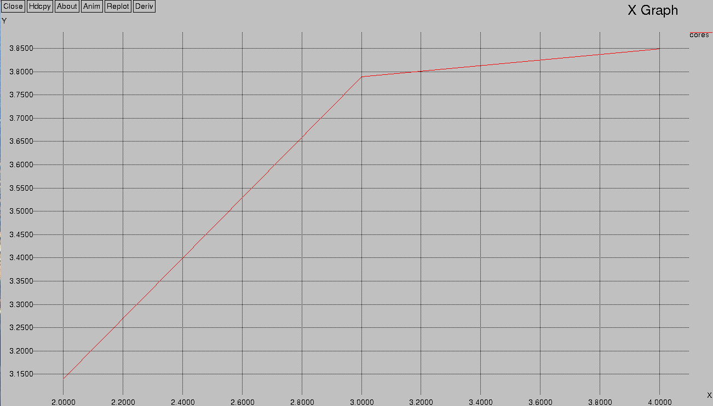
Number of cores

For calculation of Nth Fibonacci number

Problem size vs Time for Serial implementation
Y-axis=Time(seconds)
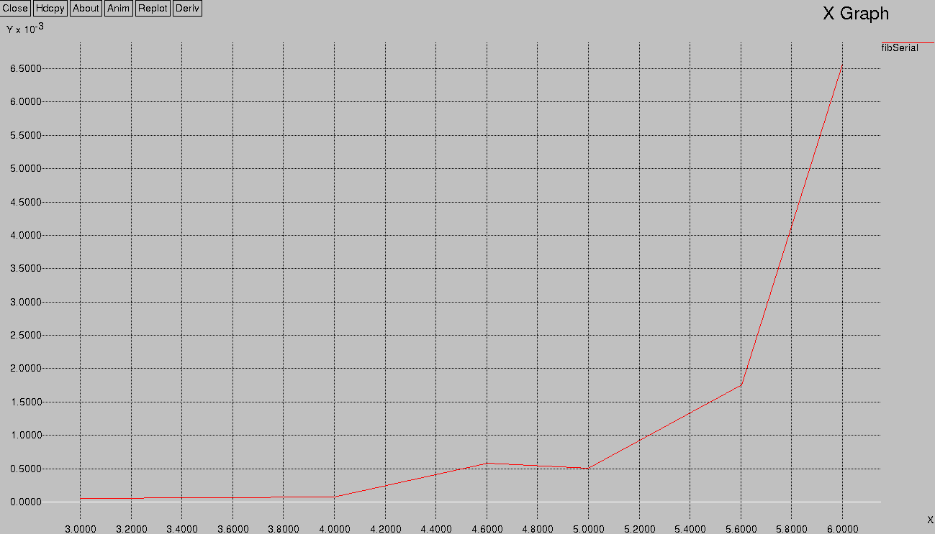
log(ProblemSize)

Problem size vs Time for Parallel implementation
Y-axis=Time(seconds)
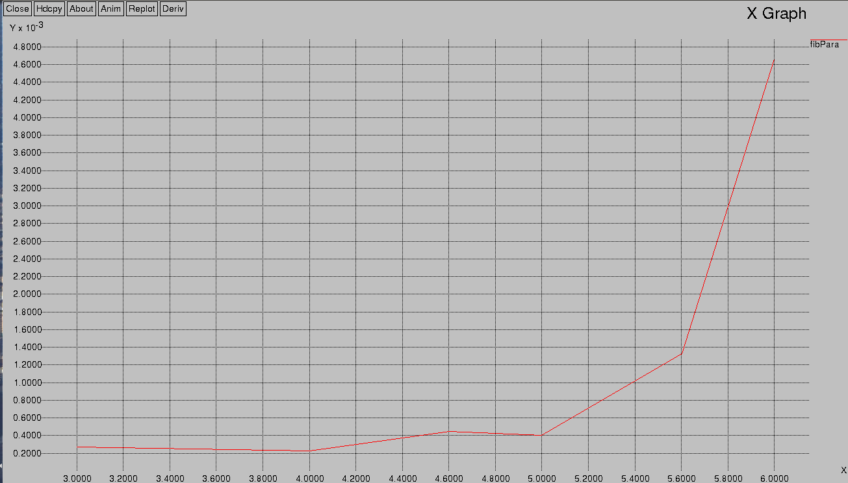
log(ProblemSize)
Speedup Vs ProblemSize
Y-axis=speedup
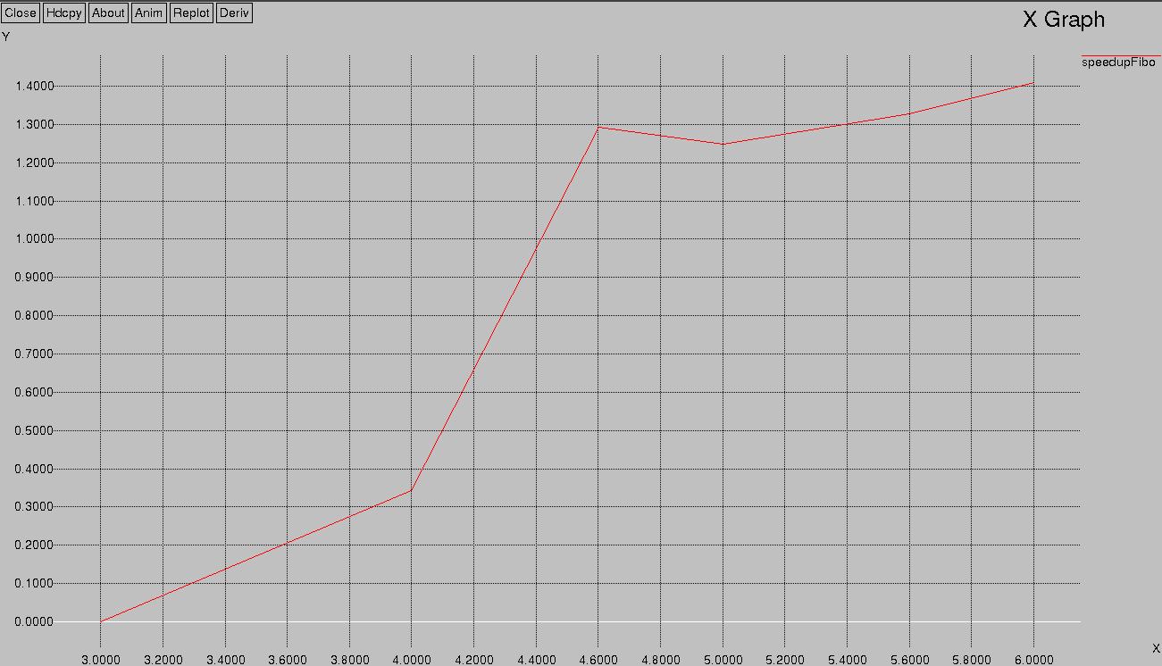
log(ProblemSize)

For sorting Algorithm

Problem size vs Time for Serial implementation
Time(in seconds)
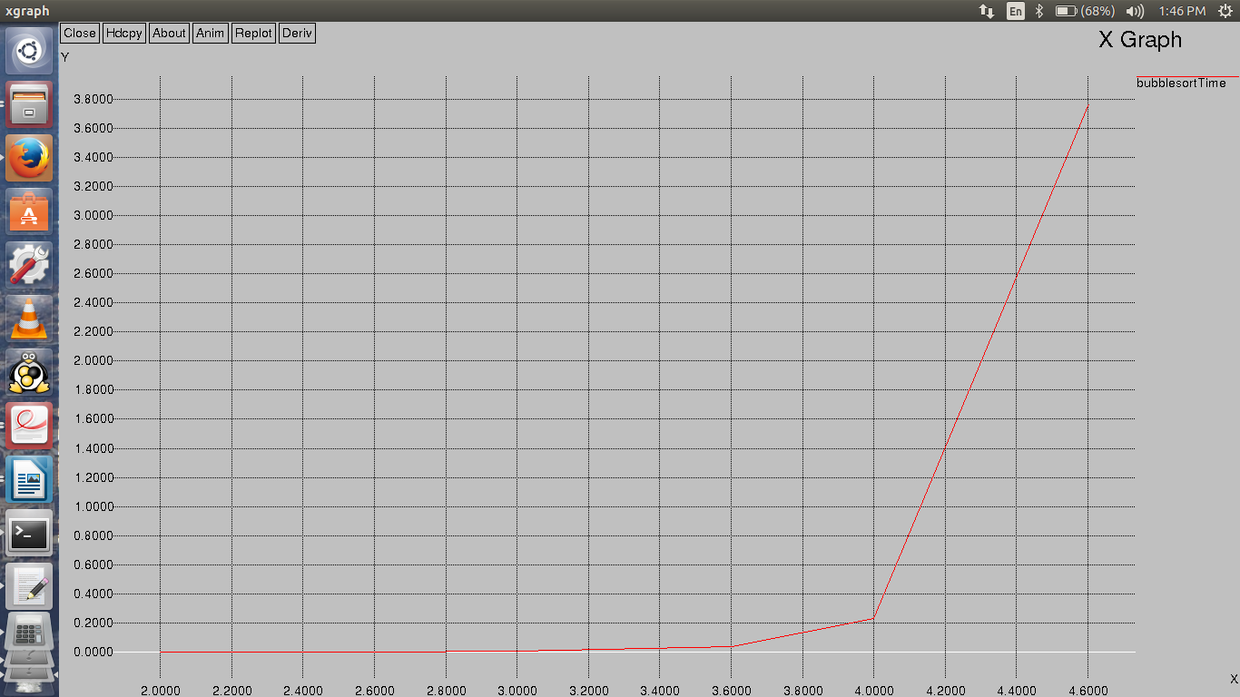
log(ProblemSize)

Problem size vs Time for Parallel implementation

Y-axis Time(seconds)
X-axis log(ProblemSize)
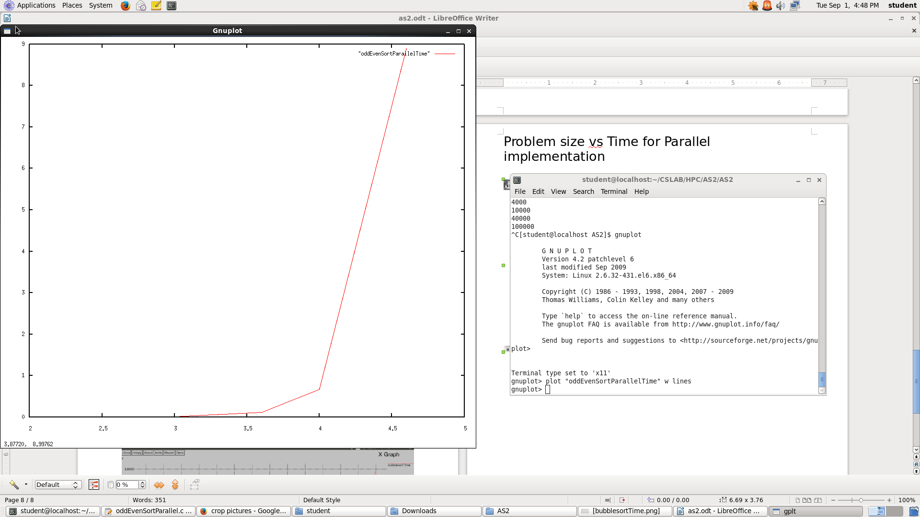

Speedup Vs Problem Size
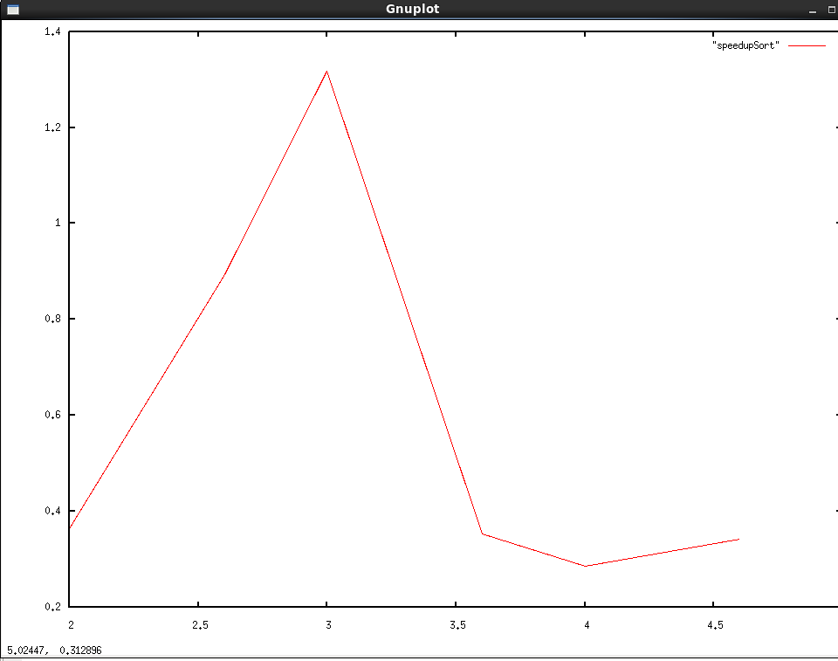
Number of cores = 4

X-axis=Speedup
Y-axis=log(ProblemSize) for 2, 3 and 4 threads
