**AIM: DEVELOP XML WEB PAGE USING DTD AND XSL (STORE DETAILS OF 3 EMPLOYEES). Take tags like empid,ename,salary,dob,doj,address, department, designation**

**empexternal.xml**

<?xml version="1.0"?>

<!DOCTYPE studentdetails SYSTEM "note1.dtd">

<?xml-stylesheet type="text/xsl" href="empinternal.xsl"?>

<employeedetails>

<employee>

<empid>001</empid>

<empname>Vinay</empname>

<salary>300000</salary>

<dob>09/11/1995</dob>

<doj>01/07/2017</doj>

<address>Borivali Mumbai</address>

<deptname>IT</deptname>

<designation>Project Manager</designation>

</employee>

<employee>

<empid>002</empid>

<empname>Niraj</empname>

<salary>400000</salary>

<dob>01/12/1992</dob>

<doj>01/07/2017</doj>

<address>Virar West</address>

<deptname>Accounts</deptname>

<designation>Accounts Officer</designation>

</employee>

<employee>

<empid>003</empid>

<empname>Raj</empname>

<salary>500000</salary>

<dob>05/10/1998</dob>

<doj>04/08/2017</doj>

<address>Dahisar West</address>

<deptname>Accounts</deptname>

<designation>Accounts Officer</designation>

</employee>

</employeedetails>

**DTD file**

**note1.xml**

<?xml version="1.0"?>

<!ELEMENT employeedetails (employee)>

<!ELEMENT employee (empid,empname,salary,dob,doj,address,deptname,designation)>

<!ELEMENT empid (#PCDATA) >

<!ELEMENT empname (#PCDATA) >

<!ELEMENT salary (#PCDATA) >

<!ELEMENT dob (#PCDATA) >

<!ELEMENT doj (#PCDATA) >

<!ELEMENT address (#PCDATA) >

<!ELEMENT deptname (#PCDATA) >

<!ELEMENT designation (#PCDATA) >

**OUTPUT-**

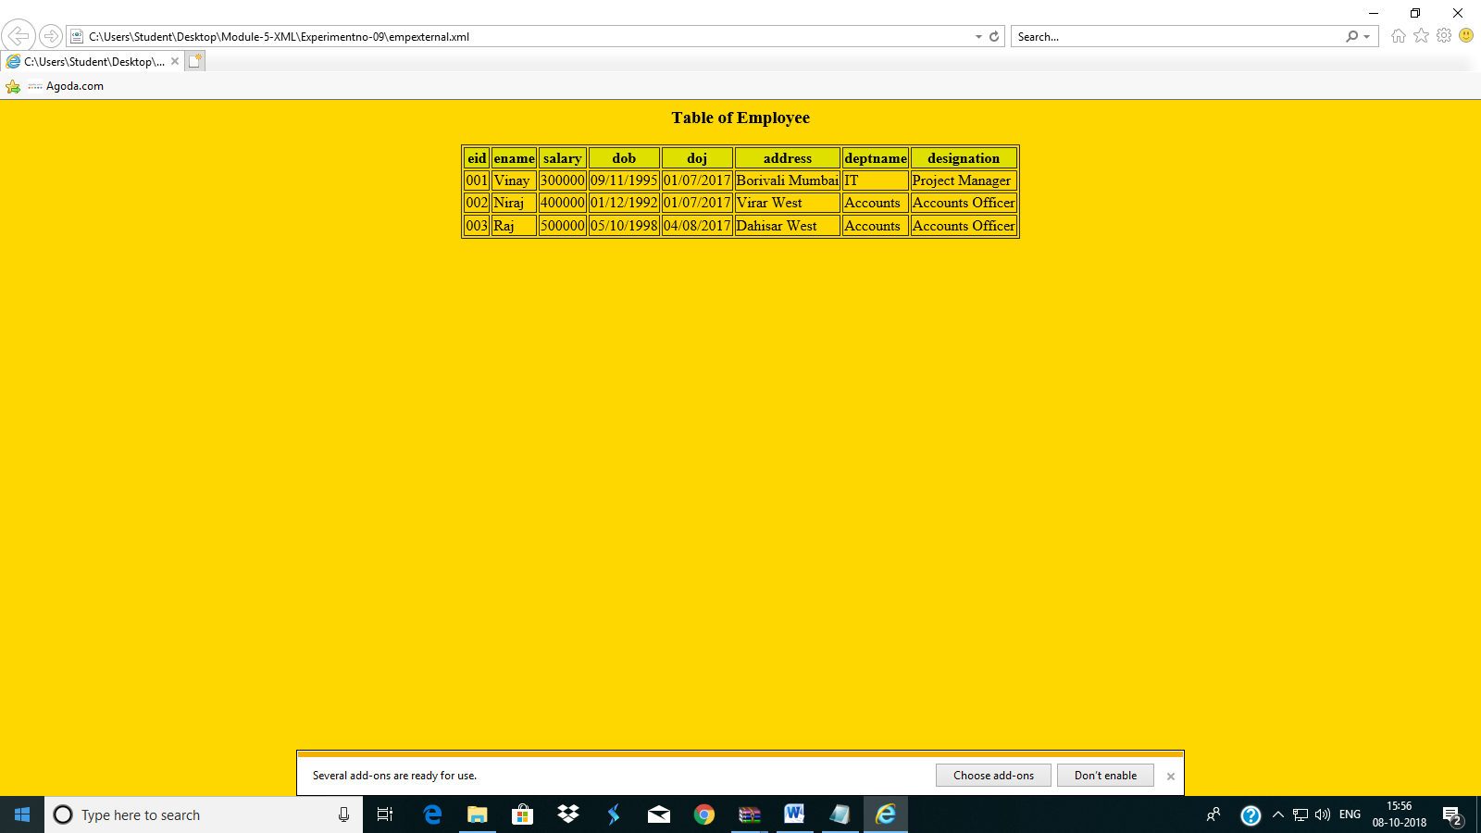

**empinternal.xml**

<?xml version="1.0"?>

<!DOCTYPE employeedetails[

<!ELEMENT

studentdetails (employee)>

<!ELEMENT employee (empid,empname,salary,dob,doj,address,deptname,designation)>

<!ELEMENT empid (#PCDATA)>

<!ELEMENT empname (#PCDATA)>

<!ELEMENT salary (#PCDATA)>

<!ELEMENT dob (#PCDATA)>

<!ELEMENT doj (#PCDATA)>

<!ELEMENT address (#PCDATA)>

<!ELEMENT deptname (#PCDATA)>

<!ELEMENT designation (#PCDATA)>

]>

<?xml-stylesheet type="text/xsl" href="empinternal.xsl"?>

<employeedetails>

<employee>

<empid>001</empid>

<empname>Vinay</empname>

<salary>300000</salary>

<dob>09/11/1995</dob>

<doj>01/07/2017</doj>

<address>Borivali Mumbai</address>

<deptname>IT</deptname>

<designation>Project Manager</designation>

</employee>

<employee>

<empid>002</empid>

<empname>Niraj</empname>

<salary>400000</salary>

<dob>01/12/1992</dob>

<doj>01/07/2017</doj>

<address>Virar West</address>

<deptname>Accounts</deptname>

<designation>Accounts Officer</designation>

</employee>

<employee>

<empid>003</empid>

<empname>Raj</empname>

<salary>500000</salary>

<dob>05/10/1998</dob>

<doj>04/08/2017</doj>

<address>Dahisar West</address>

<deptname>Accounts</deptname>

<designation>Accounts Officer</designation>

</employee>

</employeedetails>

**empinternal.xsl**

<?xml version="1.0"?>

<xsl:stylesheet version="1.0" xmlns:xsl="http://www.w3.org/1999/XSL/Transform">

<xsl:template match="/">

<html>

<body bgcolor="gold">

<center><h3>Table of Employee</h3></center>

<table border="1" align="center">

<tr bgcolor="kenneth">

<th>eid</th>

<th>ename</th>

<th>salary</th>

<th>dob</th>

<th>doj</th>

<th>address</th>

<th>deptname</th>

<th>designation</th>

</tr>

<xsl:for-each select="employeedetails/employee">

<tr>

<td><xsl:value-of select="empid"/>

</td>

<td><xsl:value-of select="empname"/>

</td>

<td><xsl:value-of select="salary"/>

</td>

<td><xsl:value-of select="dob"/>

</td>

<td><xsl:value-of select="doj"/>

</td>

<td><xsl:value-of select="address"/>

</td>

<td><xsl:value-of select="deptname"/>

</td>

<td><xsl:value-of select="designation"/>

</td>

</tr>

</xsl:for-each>

</table>

</body>

</html>

</xsl:template>

</xsl:stylesheet>

**OUTPUT-**

