Week 6 – Hands on

**React**

1. **ReactJS-HOL**

Code:

import React from 'react';

function App() {

return (

<div>

<h1>Welcome to the first session of React</h1>

</div>

);

}

export default App;

output:

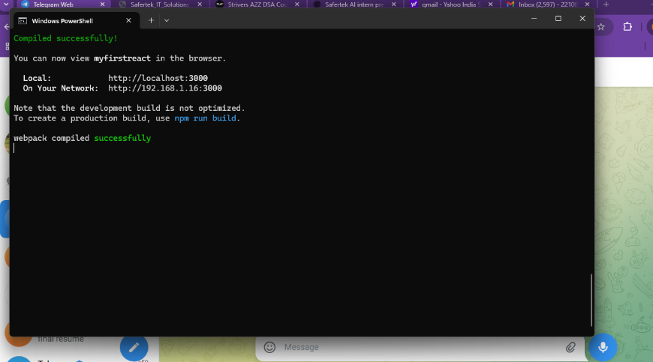

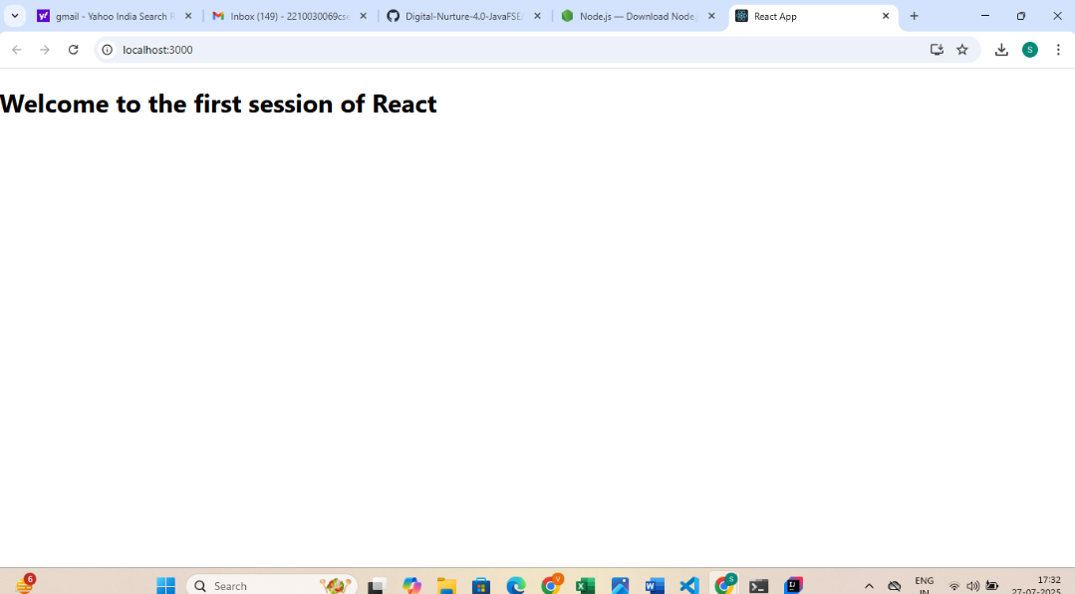

1. **ReactJS-HOL**

Code:

**src/Components/Home.js**

import React, { Component } from 'react';

class Home extends Component {

render() {

return (

<div>

<h2>Welcome to the Home page of Student Management Portal</h2>

</div>

);

}

}

export default Home;

**src/Components/About.js**

import React, { Component } from 'react';

class About extends Component {

render() {

return (

<div>

<h2>Welcome to the About page of the Student Management Portal</h2>

</div>

);

}

}

export default About;

**src/Components/Contact.js**

import React, { Component } from 'react';

class Contact extends Component {

render() {

return (

<div>

<h2>Welcome to the Contact page of the Student Management Portal</h2>

</div>

);

}

}

export default Contact;

**src/App.js**

import React from 'react';

import Home from './Components/Home';

import About from './Components/About';

import Contact from './Components/Contact';

function App() {

return (

<div>

<Home />

<About />

<Contact />

</div>

);

}

export default App;

**Run the App**

In terminal:

cd studentapp

npm start

**output:**

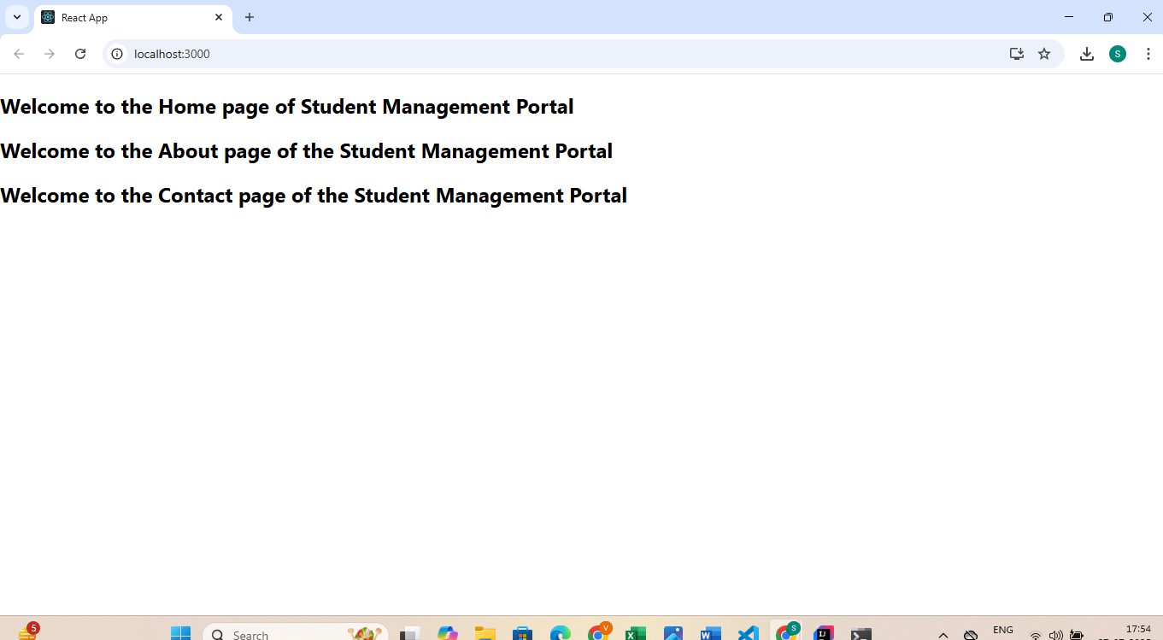

1. **ReactJS-HOL**

**Code:**

**src/Components/CalculateScore.js**

import React from 'react';

import '../Stylesheets/mystyle.css';

function CalculateScore() {

const name = "Shruti Vemula";

const school = "ABC International School";

const totalMarks = 450;

const goal = 500;

const average = (totalMarks / goal) * 100;

return (

<div className="score-container">

<h2>Student Score Calculator</h2>

<p><strong>Name:</strong> {name}</p>

<p><strong>School:</strong> {school}</p>

<p><strong>Total Marks:</strong> {totalMarks}</p>

<p><strong>Goal:</strong> {goal}</p>

<p><strong>Average Score:</strong> {average.toFixed(2)}%</p>

</div>

);

}

export default CalculateScore;

**src/Stylesheets/mystyle.css**

.score-container {

background-color: #f0f8ff;

border: 2px solid #0077cc;

padding: 20px;

border-radius: 10px;

width: 400px;

margin: 50px auto;

text-align: left;

font-family: Arial, sans-serif;

box-shadow: 2px 2px 8px rgba(0, 0, 0, 0.1);

}

.score-container h2 {

text-align: center;

color: #0077cc;

}

.score-container p {

font-size: 16px;

line-height: 1.5;

}

**src/App.js**

import React from 'react';

import CalculateScore from './Components/CalculateScore';

function App() {

return (

<div>

<CalculateScore />

</div>

);

}

export default App;

**Run the App**

In terminal:

cd scorecalculatorapp

npm start

Then open:

http://localhost:3000

**output:**

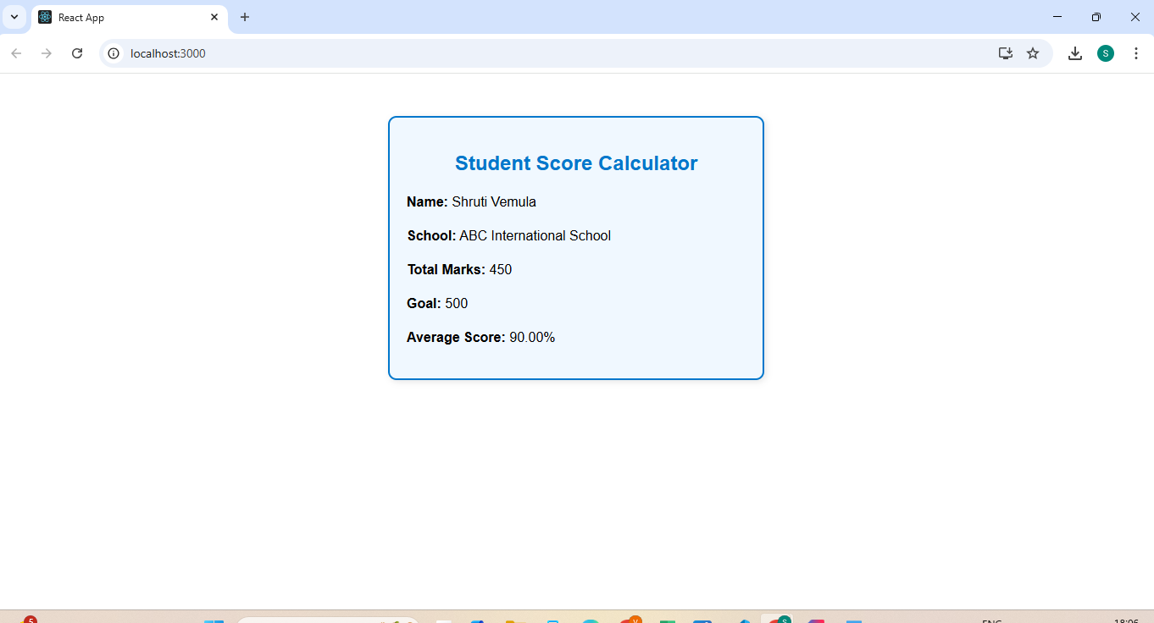

1. **ReactJS-HOL**

**Code:**

**src/Components/CalculateScore.js**

import React from 'react';

import '../Stylesheets/mystyle.css';

function CalculateScore() {

const name = "Shruti Vemula";

const school = "ABC International School";

const totalMarks = 450;

const goal = 500;

const average = (totalMarks / goal) * 100;

return (

<div className="score-container">

<h2>Student Score Calculator</h2>

<p><strong>Name:</strong> {name}</p>

<p><strong>School:</strong> {school}</p>

<p><strong>Total Marks:</strong> {totalMarks}</p>

<p><strong>Goal:</strong> {goal}</p>

<p><strong>Average Score:</strong> {average.toFixed(2)}%</p>

</div>

);

}

export default CalculateScore;

**src/Stylesheets/mystyle.css**

.score-container {

background-color: #f0f8ff;

border: 2px solid #0077cc;

padding: 20px;

border-radius: 10px;

width: 400px;

margin: 50px auto;

text-align: left;

font-family: Arial, sans-serif;

box-shadow: 2px 2px 8px rgba(0, 0, 0, 0.1);

}

.score-container h2 {

text-align: center;

color: #0077cc;

}

.score-container p {

font-size: 16px;

line-height: 1.5;

}

**src/App.js**

import React from 'react';

import CalculateScore from './Components/CalculateScore';

function App() {

return (

<div>

<CalculateScore />

</div>

);

}

export default App;

**Run the App**

In the terminal:

cd scorecalculatorapp

npm start

Then open:

<http://localhost:3000>

**Output:**

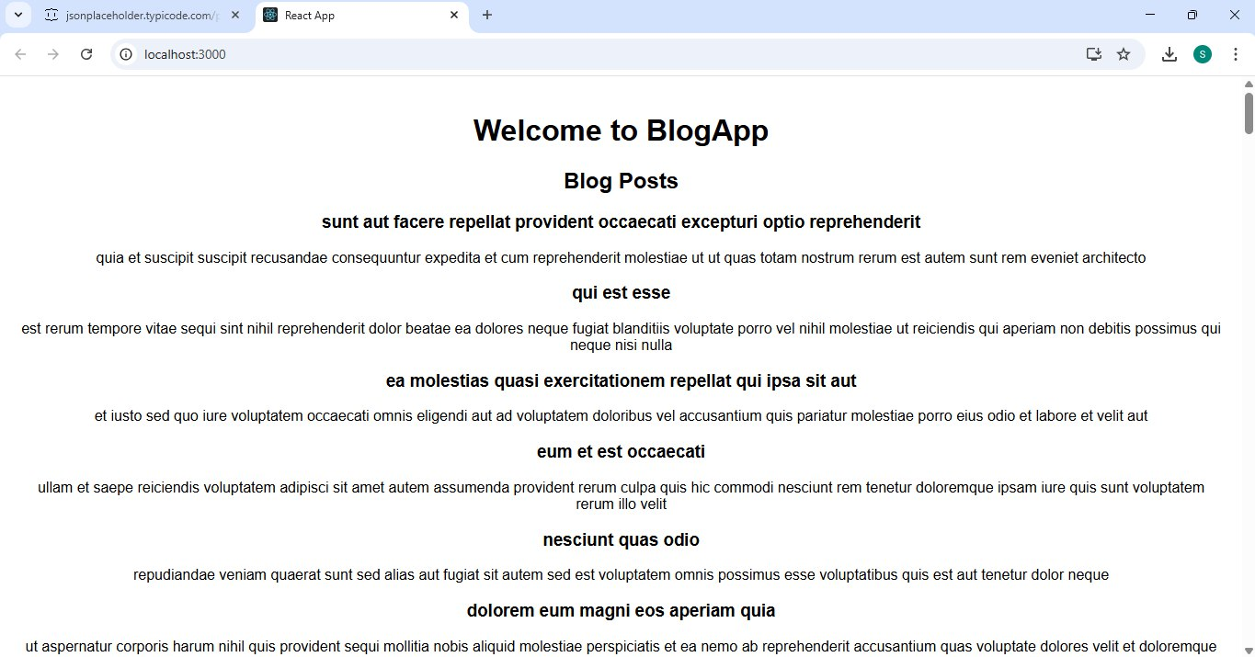

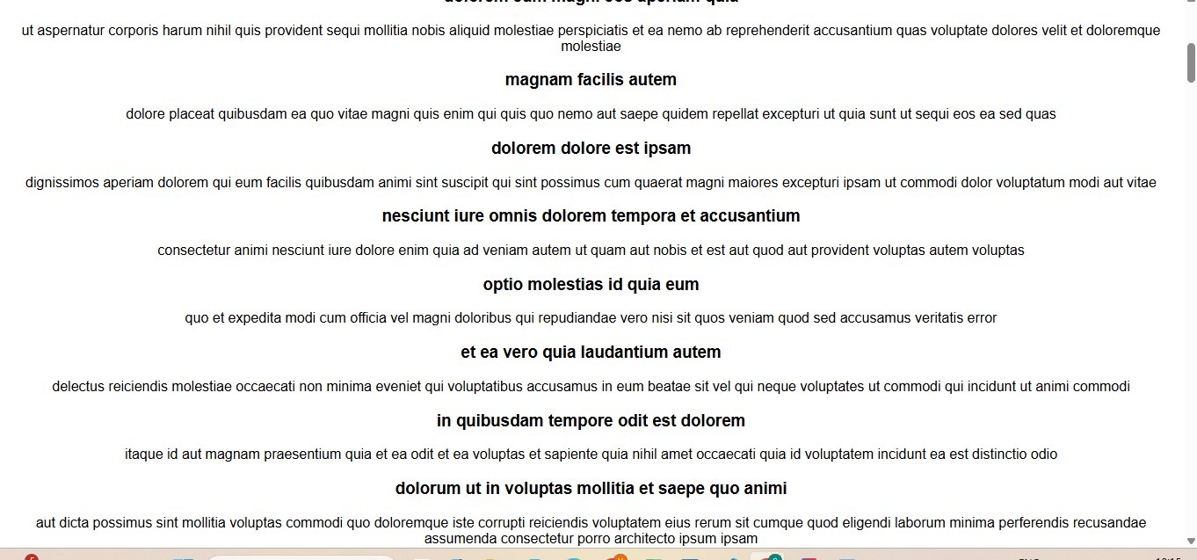

1. **ReactJS-HOL**

**Code:**

**src/components/CohortDetails.js**

import React from 'react';

import styles from './CohortDetails.module.css';

function CohortDetails(props) {

const { name, status, trainer, duration } = props;

const headingStyle = {

color: status.toLowerCase() === 'ongoing' ? 'green' : 'blue',

};

return (

<div className={styles.box}>

<h3 style={headingStyle}>{name}</h3>

<dl>

<dt>Status:</dt>

<dd>{status}</dd>

<dt>Trainer:</dt>

<dd>{trainer}</dd>

<dt>Duration:</dt>

<dd>{duration}</dd>

</dl>

</div>

);

}

export default CohortDetails;

**src/components/CohortDetails.module.css**

.box {

width: 300px;

display: inline-block;

margin: 10px;

padding: 10px 20px;

border: 1px solid black;

border-radius: 10px;

}

dt {

font-weight: 500;

}

**Sample Usage in App.js**

import React from 'react';

import CohortDetails from './components/CohortDetails';

function App() {

return (

<div>

<CohortDetails

name="React Mastery"

status="Ongoing"

trainer="Shruti Vemula"

duration="6 Weeks"

/>

<CohortDetails

name="Data Science Bootcamp"

status="Completed"

trainer="Ankit Mehta"

duration="8 Weeks"

/>

</div>

);

}

export default App;

running the app:

npm start

**Output:**

