**Report It**

“Report It” application will be available as an android application to the users. SQL Azure is used as backend exposed to the application as a WCF service in an Azure Web Role.

User specific data is stored in user preferences and SQLLite.

**WCF service hosted in Azure Web Role:**

We have hosted a WCF service in Azure web Role. This service would be called by the android application for complaint creation and retrieve requests. The service uses SQL Azure hosted Database.

It exposes 4 methods:

1. CreateComplain(Complain complain): Creates a Complaint.
2. CreateComplaintAction(ComplaintAction action) : Creates an action record for each action taken for a complaint logged.
3. GetComplains() : Retrieves the complaints logged by category, user or a random text search on complaint description.
4. GetComplainActions() : retrieves actions taken for a given Complaint ID.

**Android Application:**

Screenshots for new Complain and Search Page:

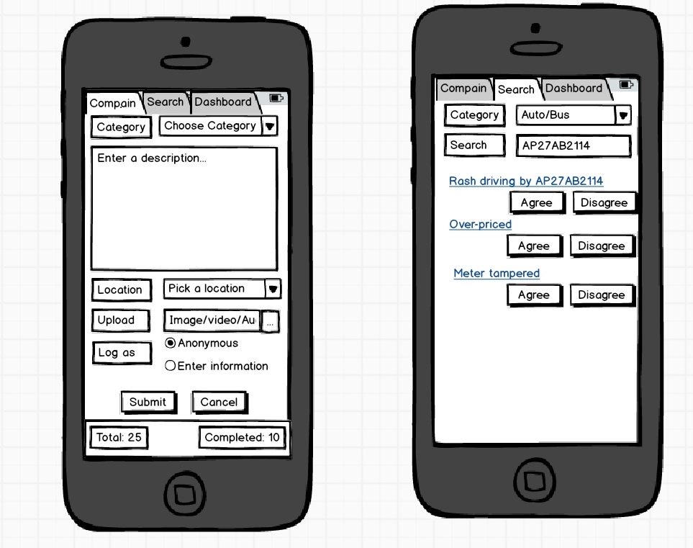

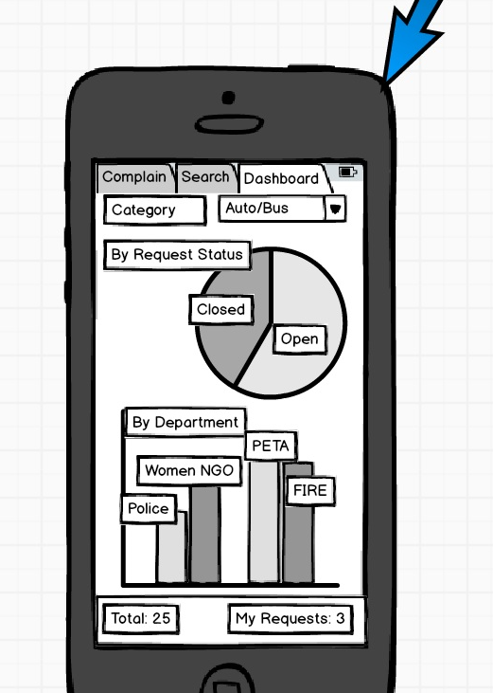

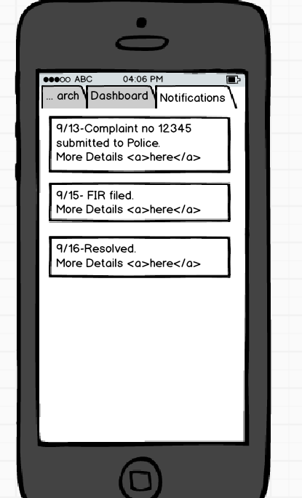

TODO:

1. Update the application to call the WCF service. Currently, the application is using SQL Lite got data storage. WCF service is ready, we are currently working on integrating it with android application.
2. Android application UI improvements.
3. Encrypt connectionstrings in WCF service and code cleanup.