SCM Assistant
Supply Chain RAG Chatbot using Flowise

1. Introduction
This project focuses on building a Retrieval-Augmented Generation (RAG) chatbot using Flowise Cloud to answer questions related to a supplier network. The chatbot is designed to analyze and respond to queries using two provided data sources:
- supplier_performance_data.csv – Contains supplier performance information such as OTD rate, defect rate, compliance score, sustainability score, disruption flags, risk level, purchase order value, etc.
- SupplyChain_Governance_Policy_v3.2.pdf – Contains supplier governance rules, service level agreements (SLAs), penalty policies, disruption response procedures, audit rules, sustainability requirements, and certification criteria.
The goal of the chatbot is to answer supply chain and supplier-related questions accurately by retrieving information from these two documents instead of generating generic responses.
2. Objective of the Project
The main objective of this chatbot is to provide meaningful answers to supplier network-related questions by combining:
- Structured supplier data (CSV)
- Business governance rules (PDF policy)
Instead of a traditional chatbot that answers from general knowledge, this chatbot retrieves relevant information from uploaded company documents and generates grounded responses.
For example:
User Question:
Which suppliers are on Supplier Watch List (SWL)?
The chatbot retrieves:
- Compliance Score information from CSV
- SWL rule from PDF policy
Then combines both to generate the answer.

3. Why RAG Was Used
A normal chatbot model often gives hallucinated or incorrect answers because it depends only on pretrained knowledge.
In this case, the chatbot needs to answer based on company-specific supplier data and governance rules. Therefore, Retrieval-Augmented Generation (RAG) was used.
Why RAG?
RAG helps the chatbot:
- Answer using uploaded documents
- Avoid hallucinations
- Retrieve exact policy thresholds
- Use supplier-specific information
- Combine multiple sources for reasoning
Working of RAG
The RAG process works in the following way:
User Question
↓
Retriever searches uploaded documents
↓
Relevant chunks retrieved
↓
Gemini 2.5 Flash processes retrieved data
↓
Final answer generated
For example:
Question:
Which Tier-3 suppliers have active disruption flags?
The chatbot retrieves:
From CSV:
- Tier-3 supplier data
- Active disruption fields
From PDF:
- Policy section for disruption response
Then combines them and provides the final answer.
4. Technology Stack Used
The following technologies were used to build the chatbot:
Component | Technology Used
Framework | Flowise Cloud
Large Language Model (LLM) | Gemini 2.5 Flash
Embedding Model | gemini-embedding-001
Vector Database | In-Memory Vector Store
Data Files | CSV + PDF
Deployment | Flowise Public Chatbot URL
Why Gemini 2.5 Flash?
Gemini 2.5 Flash was selected because:
- Fast response time
- Good reasoning capability
- Better understanding of retrieved context
- Supports structured business-related questions
Why gemini-embedding-001?
The embedding model was used to convert document text into vectors so semantic search could be performed.
This helped the chatbot understand meaning instead of exact keyword matching.
Example:
These are treated similarly:
supplier disruption
and
active disruption flag
Why In-Memory Vector Store?
The In-Memory Vector Store was selected because:
- Easy to configure
- Lightweight
- Suitable for this assignment
- Works well with Flowise Cloud
5. Understanding the Dataset
5.1 Supplier Performance CSV File
The CSV dataset contains supplier-related operational and performance metrics.
Some important columns include:
- Supplier ID
- Supplier Name
- Region
- Risk Level
- OTD Rate
- Defect Rate
- Compliance Score
- Sustainability Score
- Purchase Order Value
- Disruption Flags
- Product Category
This file provides quantitative supplier performance information.
5.2 Governance Policy PDF
The PDF contains supplier governance policies.
Important sections include:
- Supplier tier classification
- SLA requirements
- Penalty structure
- Risk escalation protocols
- Sustainability requirements
- Supplier Watch List rules
- Disruption response procedures
- Alternate supplier activation rules
This file provides business rules required for decision-making.
6. Flowise Implementation Process
The chatbot was built using Flowise Cloud.
Step 1: Creating Flowise Account
A free account was created on Flowise Cloud.
After logging in, the Flowise dashboard was opened to create document stores and chatflows.
Step 2: Creating Document Store
A new document store was created to upload and process the data files.
Purpose of Document Store:
- Store uploaded files
- Convert text into embeddings
- Enable retrieval for chatbot
Step 3: Uploading Files
Two file loaders were used.
CSV Loader
Used to upload:
supplier_performance_data.csv
Purpose:
To make supplier performance data searchable.
PDF Loader
Used to upload:
SupplyChain_Governance_Policy_v3.2.pdf
Purpose:
To make governance policy searchable.
Step 4: Text Splitting
The uploaded documents were divided into smaller chunks.
Configuration used:
Chunk Size = 1000
Chunk Overlap = 200
Why Text Splitting Was Needed?
Large documents cannot be searched effectively as one block.
Therefore, Flowise divides documents into smaller sections called chunks.
Example:
Instead of loading an entire policy PDF at once:
Whole document
it becomes:
Chunk 1 → Tier Classification
Chunk 2 → OTD Policy
Chunk 3 → Defect Rate Rules
Chunk 4 → SWL Rules
Chunk 5 → Disruption Response
Why Chunk Overlap Was Used
Chunk overlap preserves context between chunks.
Without overlap, important information could get split between two chunks.
Step 5: Adding Embedding Model
The embedding model used:
gemini-embedding-001
Purpose:
To convert text into vectors.
The chatbot searches using meaning rather than exact words.
Example:
Question:
Which suppliers are problematic?
Even if the word “problematic” does not exist in data, the chatbot can relate it to:
- High Risk
- Active Disruption
- Low Compliance
Step 6: Configuring Vector Store
The selected vector database was:
In-Memory Vector Store
Purpose:
To store embeddings generated from uploaded files.
This acts as the chatbot’s searchable knowledge base.
Step 7: Upserting the Documents
After configuring the embeddings and vector store, documents were upserted.
What is Upserting?
Upserting means:
Read documents
↓
Split into chunks
↓
Create embeddings
↓
Store in vector database
This process makes the uploaded data searchable.
Without upserting, the chatbot cannot retrieve information from uploaded files.
Step 8: Creating Chatflow
A chatflow was designed to define how the chatbot works.
The architecture used:
CSV Loader ───────┐
│
PDF Loader ───────┼──> In-Memory Vector Store
│
Embeddings ───────┘
↓
Conversational Retrieval QA Chain
↓
Gemini 2.5 Flash
↓
Chat Output
Why This Architecture?
This architecture allows:
- Retrieval from CSV
- Retrieval from PDF
- Combining policy + supplier data
- Context-aware responses
7. How the Chatbot Works
When a user asks a question:
Example:
Which suppliers are on SWL status?
The chatbot performs the following steps:
Step 1: Convert Question into Embedding
The question is converted into vectors.
Step 2: Retrieve Relevant Chunks
Retriever searches:
- Supplier performance data
- Governance policy
Step 3: Send Context to Gemini
Relevant chunks are passed to Gemini 2.5 Flash.
Step 4: Generate Final Answer
Gemini combines retrieved data and produces the final response.
8. Testing the Chatbot
The chatbot was tested using sample validation questions provided in the assignment.
Questions included:
- Tier-3 suppliers with active disruptions
- Suppliers qualifying for rebate program
- Region with highest PO value
- Suppliers on SWL status
- Product category with highest defect rate
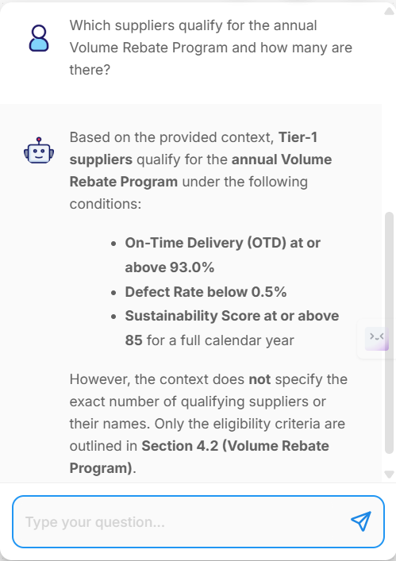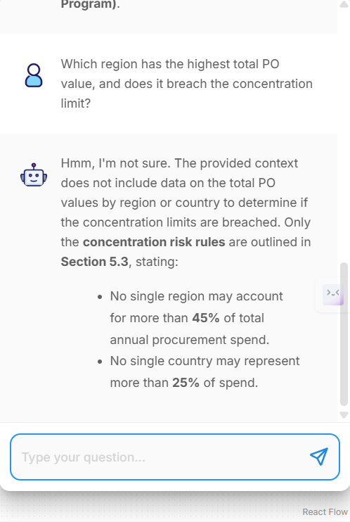

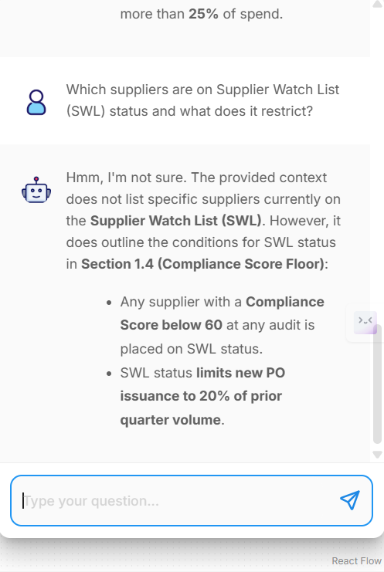

9. Public Deployment
The chatbot was deployed publicly using Flowise Share Chatbot feature.
Steps followed:
- Open Share Chatbot
- Turn Make Public = ON
- Set chatbot title as:
SCM Assistant
- Copy public chatbot URL
- Test in incognito mode
This made the chatbot accessible through a public URL.
10. Challenges Faced
Some challenges were encountered during development.
Challenge 1: “Hmmm. I’m not sure.”
Reason:
Retriever was not configured correctly or data was not upserted.
Solution:
- Fixed retriever connections
- Completed document upserting
11. Future Improvements
Future improvements that can be made:
- Add better structured querying for CSV calculations
- Use persistent vector database
- Add advanced supplier analytics
- Add conversation memory
- Improve UI design

12. Conclusion
This project successfully demonstrates how a RAG-based chatbot can be built using Flowise Cloud for supplier network analysis.
By combining:
- structured supplier data (CSV)
- governance policy rules (PDF)
the chatbot can provide accurate, grounded and context-aware answers.
The use of Gemini 2.5 Flash, gemini-embedding-001, and In-Memory Vector Store enabled efficient retrieval and meaningful responses, making the chatbot useful for supplier governance and procurement-related analysis.

