***29-01-2026***
1.
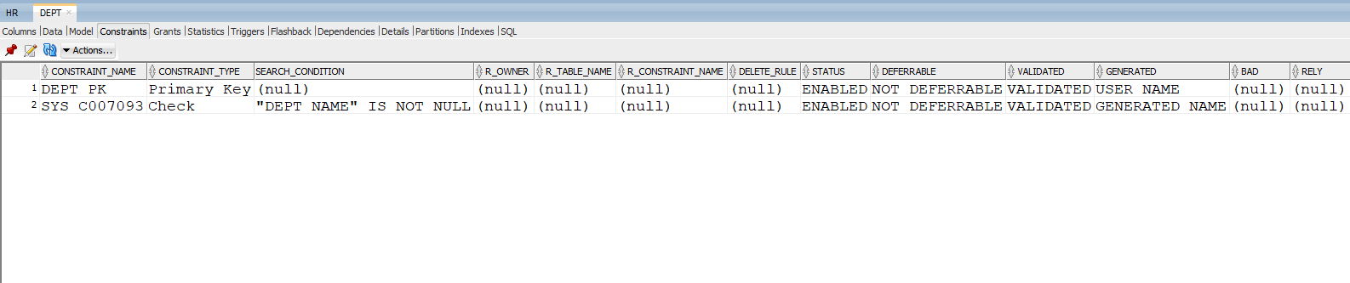

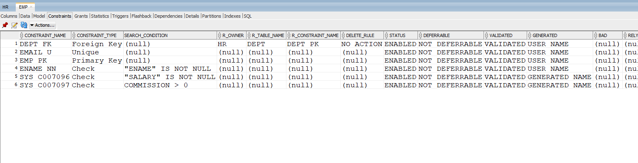

- CHECK CONSTRAINT VIOLATION
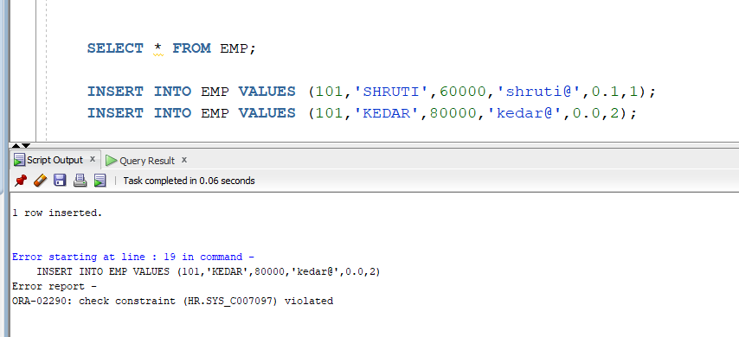
- PK VIOLATION (UNIQUE CONSTRAINT)

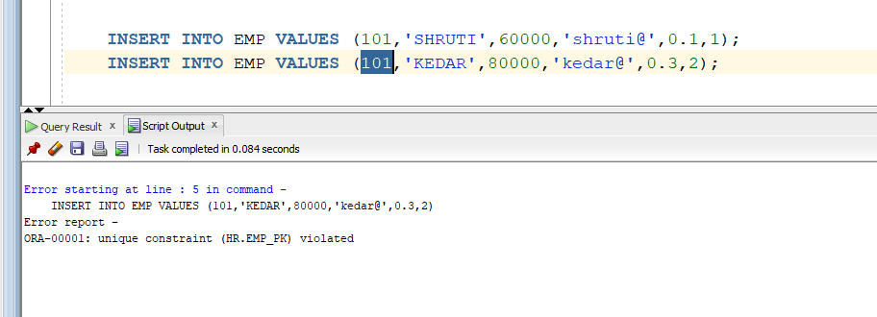
- NOT NULL CONSTRAINT VIOLATION

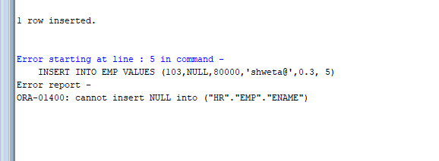
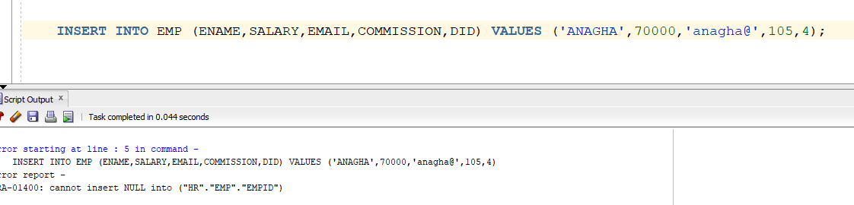
2.
A.
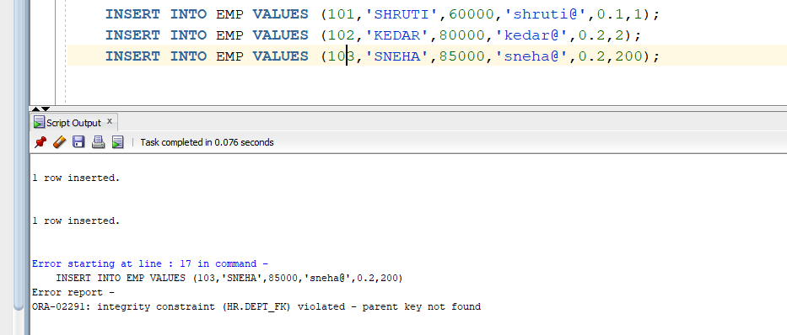
B.
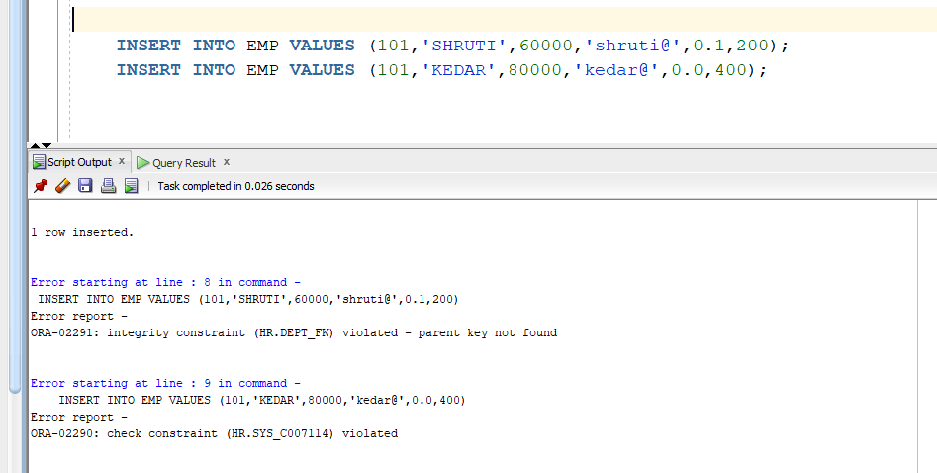
3. A. VIOLATION OF CONSTRAINTS IN UPDATE
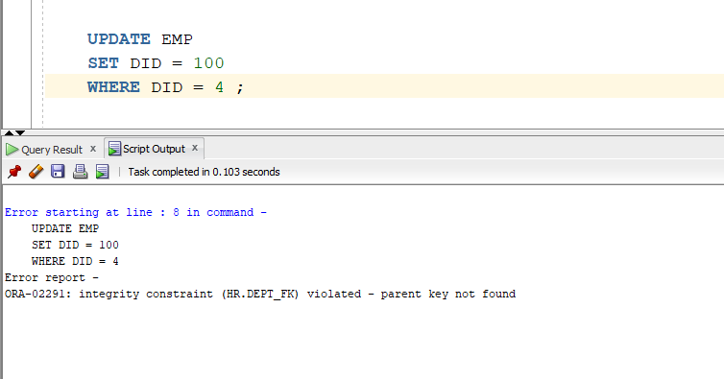
3.B. NO VIOLATION IN UPDATE
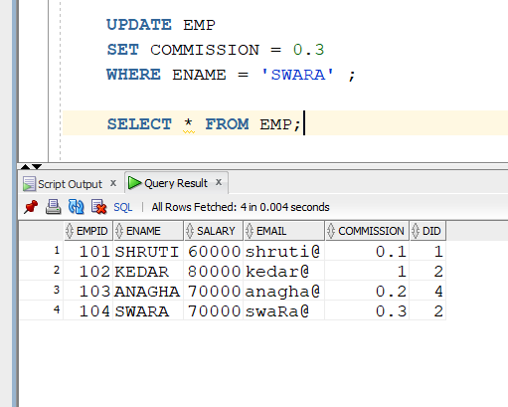
4. A. SIMPLE INSERTION OF ALL COLUMNS IN VIEW (NO VIOLATION)
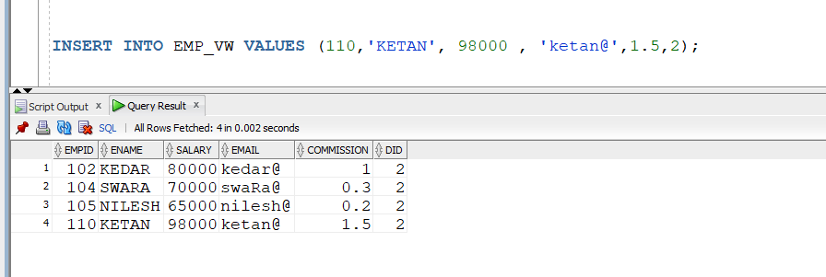
4. B.
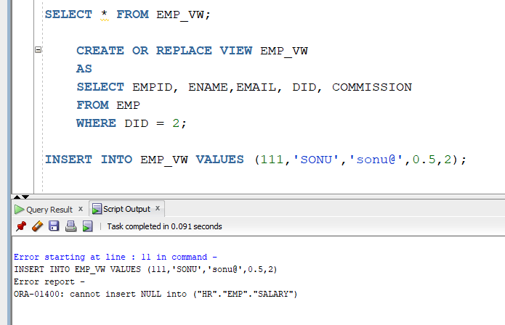
5.
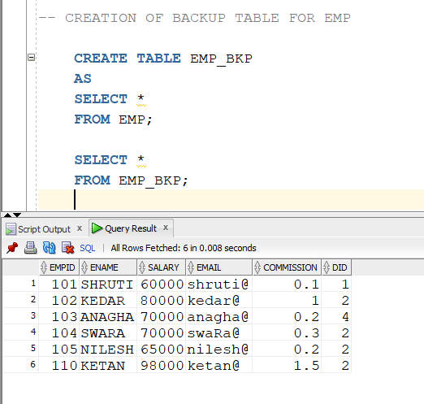
CONSTRAINTS ON BACKUP TABLE
1.EMP_BKP ONLY NOT NULL CONSTRAINT
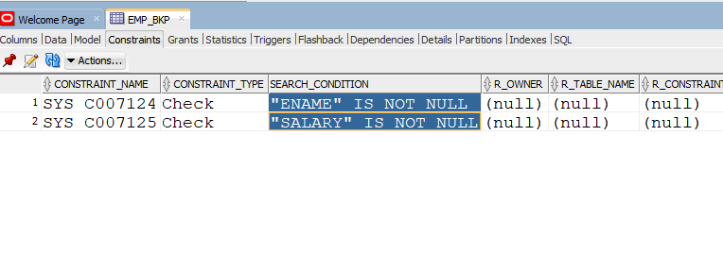
2.DEPT_BKP ONLY NOT NULL CONSTRAINT



