Urban Heat Island Intensity Analysis of Kolkata (2015–2025)
Shruti Chatterjee
Department of Geography (Independent Research Project)

ABSTRACT
This study analyzes the temporal variation and intensity change of Urban Heat Islands (UHIs) in Kolkata over a decade, from 2015 to 2025, using satellite-derived Land Surface Temperature (LST) data. Landsat 8 (2015) and Landsat 9 (2025) thermal bands were processed in QGIS to derive LST and assess spatial patterns of surface temperature. A change detection analysis identified areas of significant warming across the city, with temperature increases of up to approximately 6°C observed in the central and eastern urban sectors. Mean surface temperature rose by 2.57°C, and the area under high to very high UHI zones expanded by about 13.7%. These findings highlight the growing thermal stress associated with rapid urban expansion in Kolkata and underscore the need for sustainable planning measures such as vegetation enhancement, cool roofing, and wetland preservation to mitigate future heat effects.
Keywords: Urban Heat Island, Land Surface Temperature, Kolkata, Remote Sensing, QGIS, Sustainable Urban Planning

1. INTRODUCTION
Urban Heat Island (UHI) refers to the phenomenon where built-up city areas exhibit higher surface and air temperatures than their rural surroundings due to impervious surfaces, limited vegetation, and anthropogenic heat release. Kolkata, a major metropolitan city in eastern India, has undergone rapid urbanization in the last decade, resulting in significant alterations to its surface energy balance. Monitoring UHI intensity helps in understanding the relationship between urban growth and climate variability.
Previous studies across Indian cities such as Delhi, Mumbai, and Hyderabad have shown similar thermal intensification trends, yet few have examined Kolkata's decadal dynamics using consistent Landsat datasets. This study bridges that gap by analyzing temporal changes in LST between 2015 and 2025 and correlating them with urban expansion patterns.

2. STUDY AREA AND DATA
Kolkata, located along the eastern bank of the Hooghly River, lies between latitudes 22°31′N to 22°57′N and longitudes 88°17′E to 88°25′E. It is characterized by a tropical wet-and-dry climate with distinct pre-monsoon heat waves. Rapid population growth and industrialization have led to an increase in impervious surfaces. The study utilizes Landsat 8 and 9 imagery for the years 2015 and 2025 respectively, both sourced from the USGS Earth Explorer portal.

3. METHODOLOGY
The study followed a remote sensing and GIS-based workflow including data acquisition, preprocessing, LST derivation, UHI classification, and change detection. Radiometric and atmospheric corrections were applied, followed by conversion of digital numbers (DN) to top-of-atmosphere radiance and brightness temperature. Land Surface Temperature (LST) was calculated using emissivity-corrected equations within QGIS 3.40. The resulting maps were classified into five UHI intensity levels
. 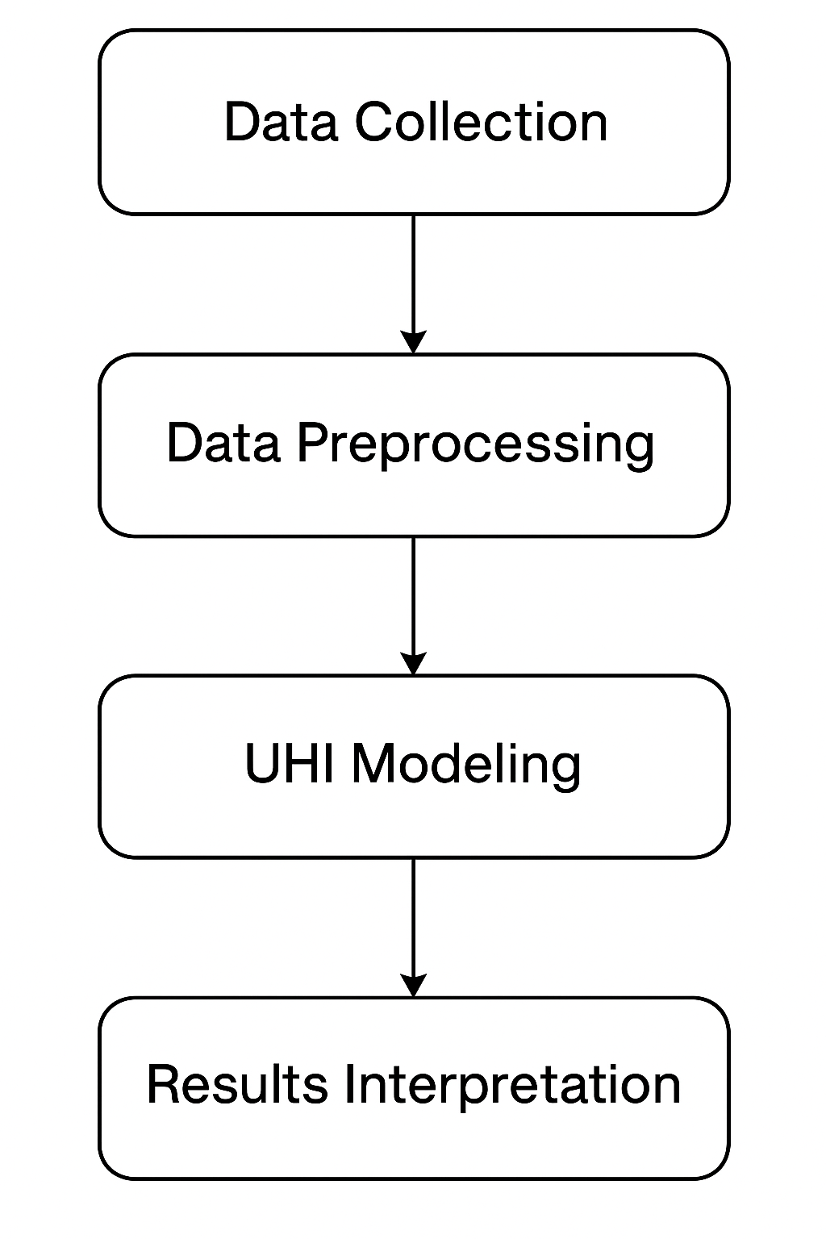
Workflow Diagram for UHI Analysis
Tables 1–6 summarize the satellite data, temperature statistics, UHI classification, spatial distribution, mitigation strategies, and decadal temperature changes.

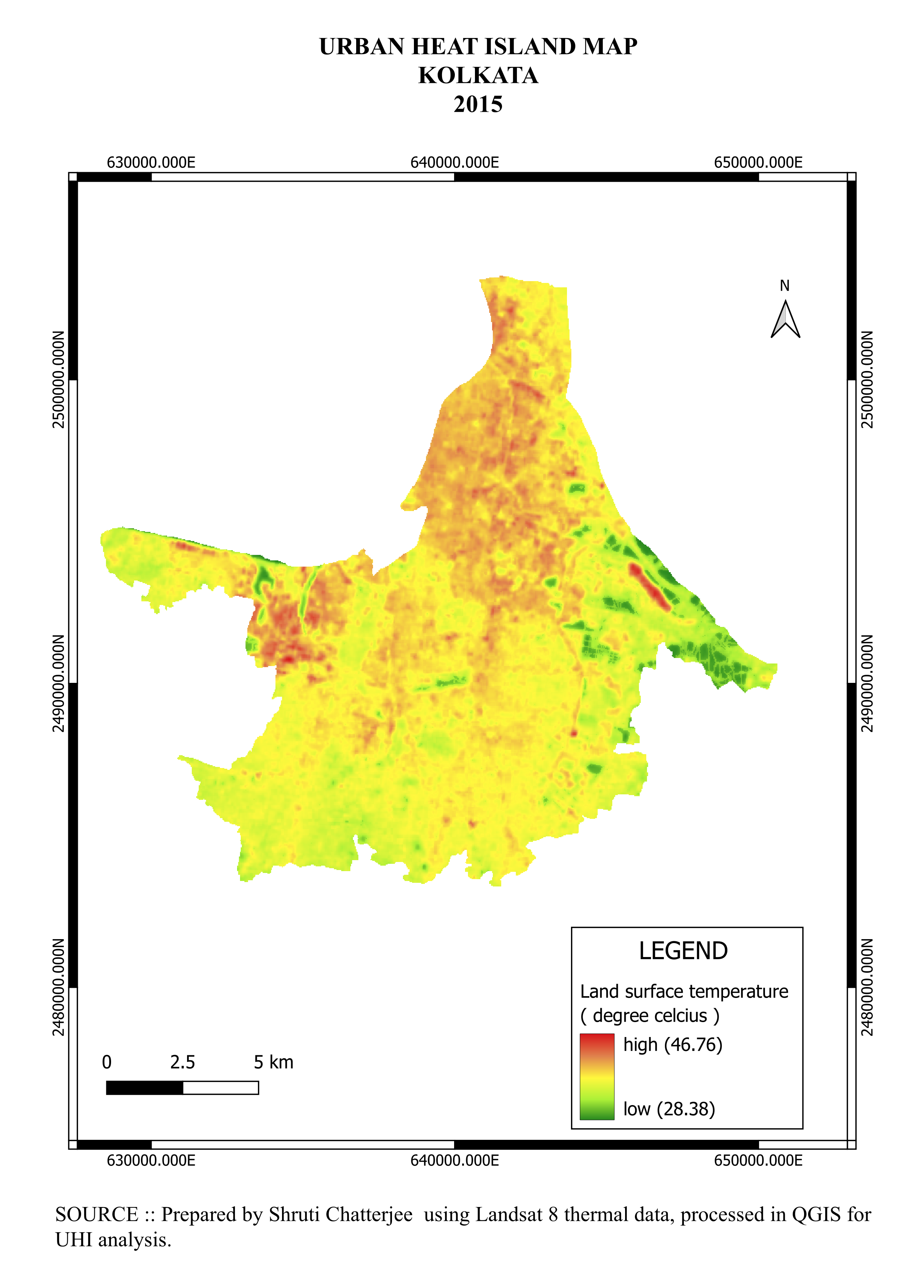

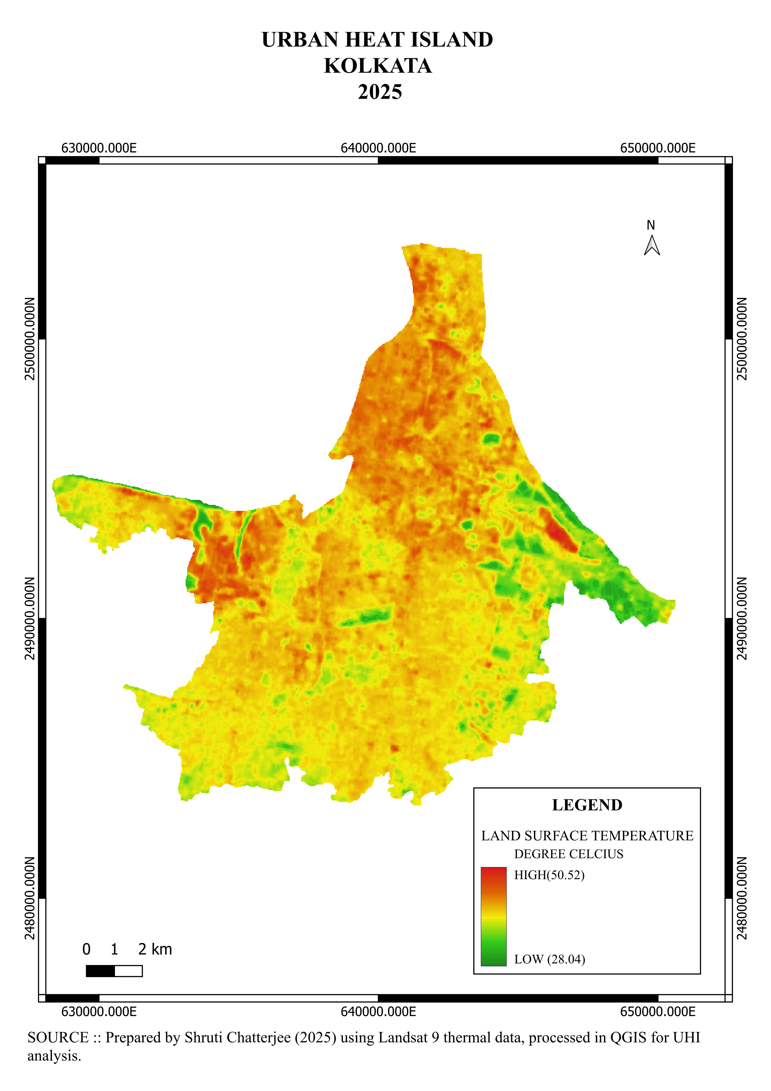
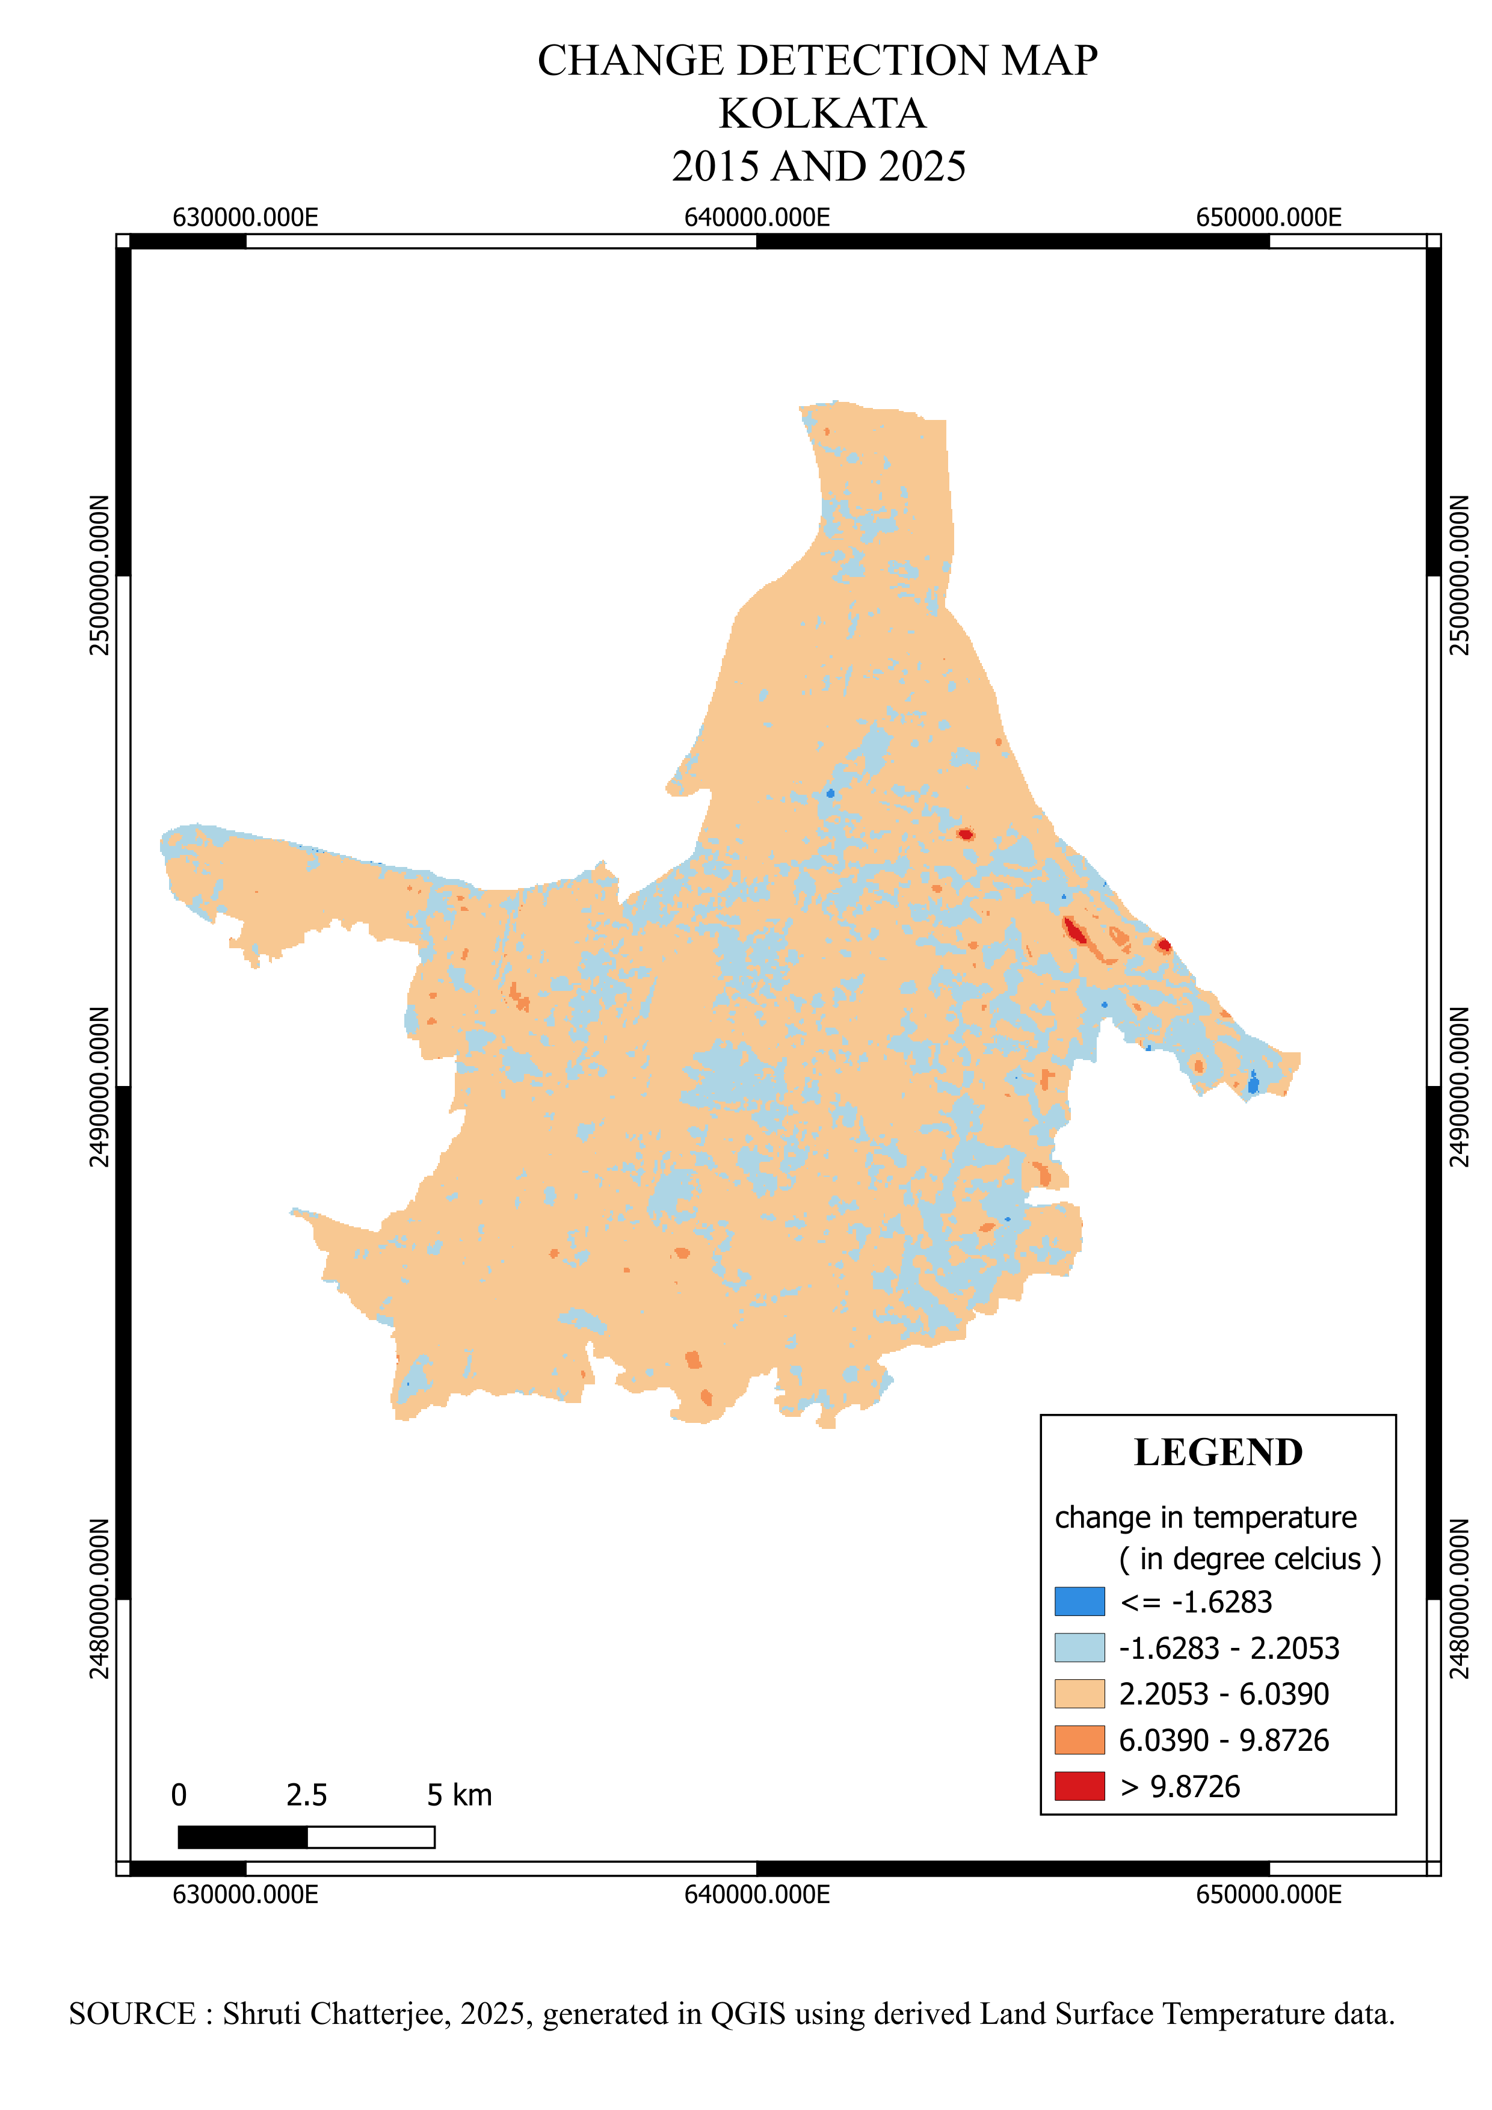

4. RESULTS AND DISCUSSION
The UHI map of 2015 reveals a spatial LST variation between 28.38°C and 46.75°C, while the 2025 map shows a range between 28.56°C and 50.52°C. High-temperature zones are concentrated in the core and eastern sectors of the city. Change detection indicates an average surface temperature increase of 2.57°C, with substantial expansion in high-intensity heat zones.
Year | Satellite | Sensor | Path/Row | Acquisition Date | Spatial Resolution (m) | Thermal Band Used
2015 | Landsat 8 | TIRS | 138/44 | May 2015 | 30 (resampled) | Band 10
2025 | Landsat 9 | TIRS-2 | 138/44 | May 2025 | 30 (resampled) | Band 10
Table 1. . Satellite Data Overview
Year | Minimum LST (°C) | Maximum LST (°C) | Mean LST (°C) | Standard Deviation (°C)
2015 | 28.38 | 46.75 | 37.56 | 4.22
2025 | 28.04 | 50.52 | 40.13 | 5.06

Table 2: Showing land surface temperature (2015 and2025)
UHI Category | Temperature Range (°C) | 2015 Area (%) | 2025 Area (%) | Change (Δ%)
Very Low | <30 | 22.4 | 15.3 | -7.1
Low | 30–34 | 28.7 | 22.5 | -6.2
Moderate | 34–38 | 25.1 | 24.7 | -0.4
High | 38–42 | 17.8 | 24.9 | +7.1
Very High | >42 | 6.0 | 12.6 | +6.6

Table 3. Showing UHI category
Zone Type | Key Locations | Observed Trend (2015–2025) | Likely Cause
Core Urban | Burrabazar, Esplanade, South Kolkata | Significant rise (up to +6°C) | Dense built-up area, high vehicular emission
Eastern Sector | Salt Lake, Rajarhat | Moderate rise | New residential and IT infrastructure
Southern Fringe | Jadavpur, Garia | Slight increase | Expanding residential zones
River-adjacent | Along Hooghly River | Stable / cooling | Presence of water and green buffers

Table 4. Showing zonal characteristics
Parameter | 2015 | 2025 | Decadal Change
Mean Surface Temp (°C) | 37.56 | 40.13 | +2.57
Maximum Surface Temp (°C) | 46.75 | 50.52 | +3.77
Area under “High” & “Very High” UHI (%) | 23.8 | 37.5 | +13.7

Table 5 : Showing decadal changes
Spatial patterns demonstrate that central commercial and residential regions experienced the greatest temperature increase, attributed to high impervious surface density and limited vegetation. Conversely, river-adjacent and wetland zones exhibited cooling trends, reflecting the influence of hydrological and vegetative features.

5. CONCLUSION AND POLICY IMPLICATIONS
The comparative analysis confirms a notable rise in UHI intensity across Kolkata between 2015 and 2025. The expansion of high-temperature zones correlates with unregulated urban growth and vegetation loss. Key mitigation measures include expanding green belts, implementing cool roofing systems, and protecting wetlands.
The study aligns with the objectives of Sustainable Development Goal (SDG) 11 – Sustainable Cities and Communities, and SDG 13 – Climate Action. Future research can integrate socio-economic parameters and field-based temperature validation to enhance model accuracy.

REFFERENCES
- Oke, T. R. (1982). The energetic basis of the urban heat island. *Quarterly Journal of the Royal Meteorological Society*, 108(455), 1–24.
- Voogt, J. A., & Oke, T. R. (2003). Thermal remote sensing of urban climates. *Remote Sensing of Environment*, 86(3), 370–384.
- Rasul, G., et al. (2017). Monitoring of urban heat island effect in Delhi using Landsat data. *Environmental Monitoring and Assessment*, 189(4), 161.
- USGS. (2023). Landsat Surface Temperature Science Product (Collection 2). United States Geological Survey.
- Singh, R. B., & Grover, A. (2015). Urban heat island effect analysis using Landsat data: A case study of Delhi. *Geography Journal*, 2015, 1–12.
- Chakraborty, S., & Maitra, A. (2020). Impact of urbanization on surface temperature in eastern India: A remote sensing approach. *Urban Climate*, 34, 100707.
- UNDP. (2022). Sustainable Development Goals: Goal 11 and Goal 13. United Nations Development Programme.

