Assinment1 run httpd start httpd and dploy index.html

Creating new job and shell script for httpd

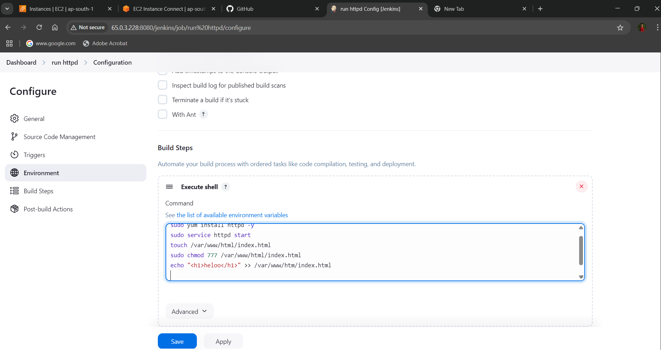

Consol output

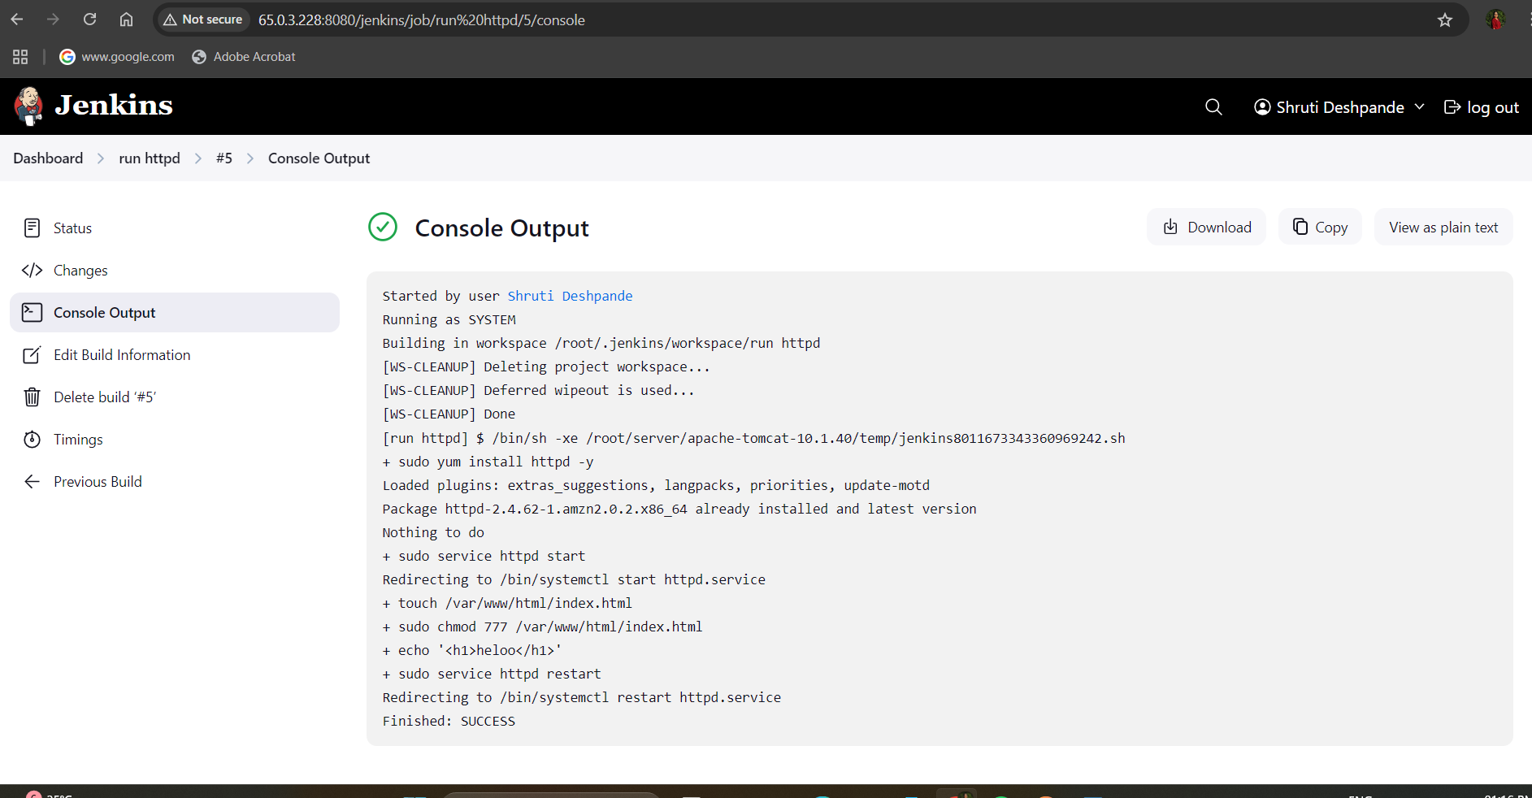

Index.html output

