
Department of Computer Science & Engineering
(Artificial Intelligence & Machine Learning)

DEVOPS LAB
Regulation R22
IV B. Tech – I Semester
LAB PROJECT REPORT

Student Attendance Management System Using DevOps Tools

Name : _______________________
Roll No. : _______________________
Section : _______________________

STUDENT ATTENDANCE MANAGEMENT SYSTEM USING DEVOPS TOOLS

1. Abstract
This project is a web application that takes the paperwork out of classroom attendance. A faculty member can pick a date, mark each of the seven daily periods for every student, save the result, and later pull up a monthly summary that shows attendance percentages and flags students who have fallen behind. The summary can also be downloaded as a CSV file.
The interface is written in HTML, CSS and JavaScript and talks to a Node.js and Express.js server. Records are kept in a single JSON file, so no separate database needs to be installed. Around the application sits a small DevOps toolchain: Git and GitHub hold the source code, Jenkins runs the build job, Docker packages the app into an image, and Kubernetes runs that image and exposes it on a local port.
Overall, the work shows how an ordinary web application can be taken from source code to a running, containerized deployment using standard DevOps practices.

2. Introduction
Colleges depend on attendance data to follow how regularly students take part in classes. Keeping that data in paper registers works for a single day, but it becomes tedious once a teacher has to total up periods across several weeks and work out who is under the required limit.
The Student Attendance Management System addresses this with a browser-based screen where students are listed, periods are marked as Present or Absent, and a day’s record is saved against its date. Monthly totals and percentages are generated from the saved records, students under 75% are highlighted, and the report can be exported for later use.
The development side uses HTML, CSS and JavaScript with Node.js and Express.js, and the data lives in a JSON file. On the DevOps side, the code is versioned with Git and hosted on GitHub, Jenkins runs a build job, Docker produces the container image, and Kubernetes deploys it. Building the project gave hands-on practice with both application development and the tooling used to ship it.

3. Problem Statement
Recording attendance by hand is slow, and it gets worse when records must be kept period by period. Adding up a month of entries is error-prone, spotting students with low attendance means scanning every row, and finding an older record in a stack of registers takes effort.
The goal here is to build a simple web system that records attendance for each period, stores it by date, calculates monthly percentages, points out students below the threshold, and exports the results to CSV. A second goal is to show that the same application can be managed with DevOps tools, from version control and build automation to containerization and Kubernetes deployment.

4. Objectives
- Build a lightweight web application for managing student attendance.
- Allow attendance to be marked for seven periods per student per day.
- Save records by date and load them back when needed.
- Produce a monthly summary with present and absent counts and percentages.
- Highlight students whose attendance is below 75%.
- Provide CSV export of the monthly report.
- Maintain the code in a Git repository hosted on GitHub.
- Use Jenkins to run the configured build job.
- Package and run the application as a Docker container.
- Deploy the container on Kubernetes and open it in a browser.

5. Functional Modules

5.1 Student Management
This module shows the list of registered students with their roll number, name and department, and lets new students be added from the interface. The same list feeds the daily attendance sheet, so every registered student automatically appears when attendance is taken.

5.2 Daily Attendance
Here the faculty member chooses a date and sets each of the seven periods to Present or Absent through a drop-down. To avoid clicking through every cell, the page offers Mark All Present and Mark All Absent buttons. Once the sheet looks right, Save Attendance sends the entries to the server, which writes them to the JSON file.

5.3 Monthly Summary and CSV Report
This module summarizes a chosen month. For each student it counts present and absent periods, works out the percentage, and labels the student as Satisfactory or Below 75%. The Export CSV button lets the report be downloaded and kept outside the application.

6. Technologies and Requirements
Technology | Purpose
HTML | Builds the structure of the web pages.
CSS | Handles layout, colours and styling.
JavaScript | Runs the interactive behaviour in the browser.
Node.js | Runtime for the backend application.
Express.js | Web framework that receives and answers requests.
JSON file (attendance.json) | Holds student and attendance data.
Git | Tracks changes to the source code.
GitHub | Hosts the project repository online.
Jenkins | Runs the configured build job.
Docker | Builds the image and runs the container.
Kubernetes | Runs and exposes the application through a Pod and a Service.
Docker Desktop | Supplies the local container engine and Kubernetes cluster.
Windows Command Prompt | Used to run project and DevOps commands.

7. System Design

7.1 Architecture
The system follows a straightforward client–server design. Students, faculty and administrators reach the application through the web interface. The Node.js and Express.js backend contains the attendance logic, monthly calculation, user handling and data validation, and it reads from and writes to attendance.json. Fig. 1 shows the application layers together with the deployment pipeline that carries the code from GitHub to a running service.
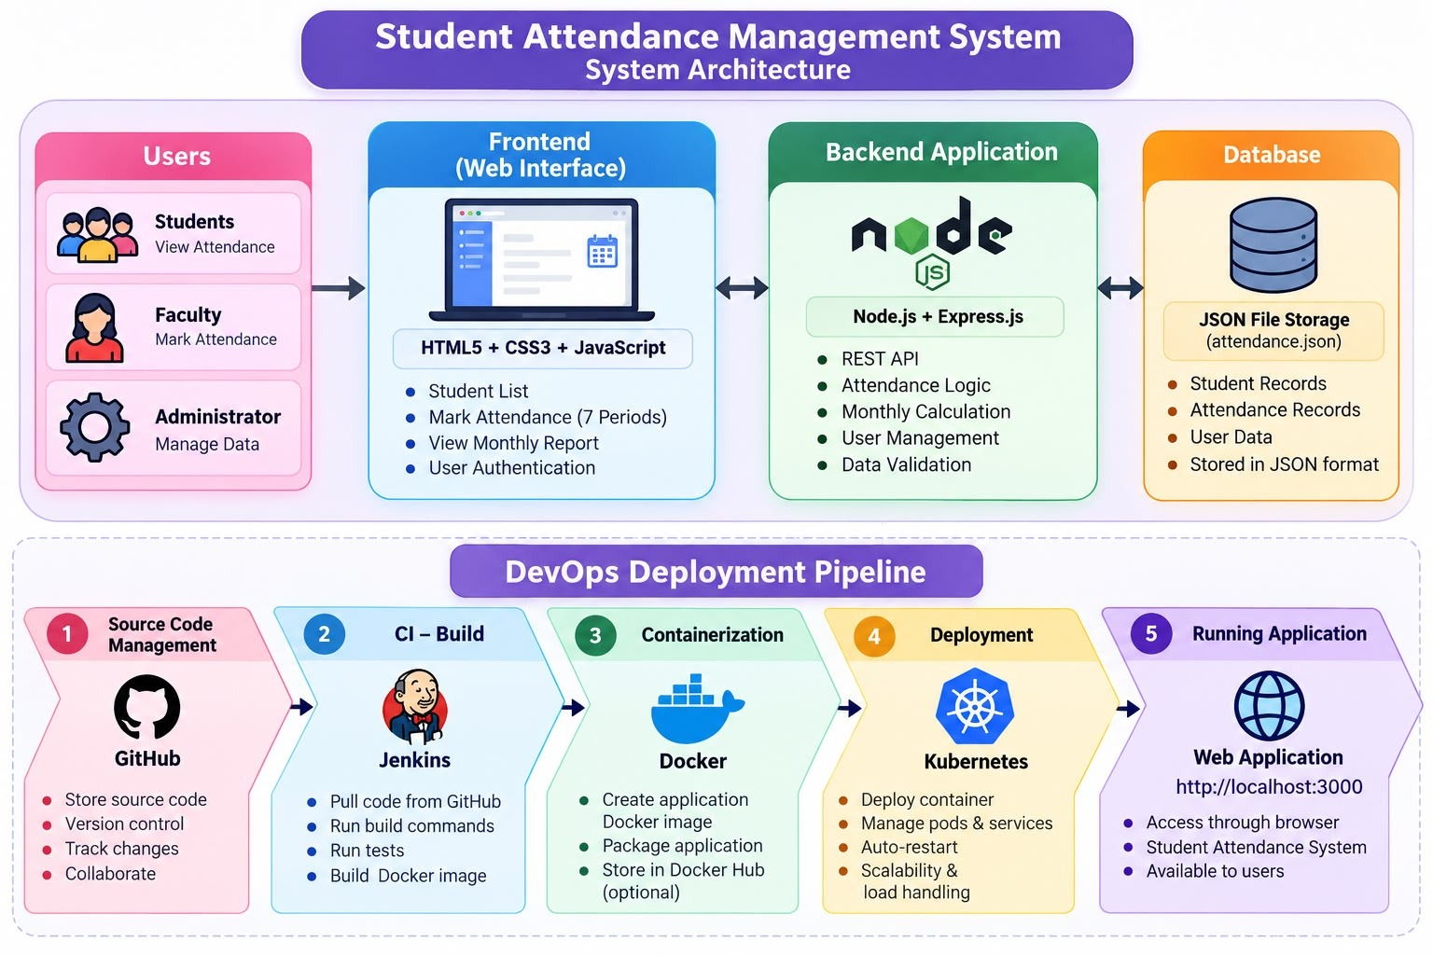
Fig. 1 – Architecture of the Student Attendance Management System

7.2 Attendance Calculation
Attendance is expressed as the share of recorded periods in which a student was present:
Attendance % = (Present Periods ÷ Total Recorded Periods) × 100
For example, in the monthly report shown later in Fig. 7, Meera Shah was present for 4 of 7 recorded periods, which gives (4 ÷ 7) × 100 = 57.14%. Because this is under 75%, she is flagged as Below 75%. A student with 6 present periods out of 7 reaches 85.71% and is marked Satisfactory.
Only periods that have actually been saved count towards the total. A period for which nothing was recorded is not treated as an absence.

7.3 Application Endpoints
The browser communicates with the server through HTTP requests. These cover reading the student list, submitting a day’s attendance, loading a saved date, and generating the monthly report. The precise route names are those defined in server.js.

8. Implementation

8.1 Frontend
The frontend is a single page built with HTML, CSS and JavaScript. It lets the user see students, choose a date, set the seven period values, save, and switch to the monthly report. The bulk buttons make it quick to record a normal day where most students are present.

8.2 Backend
The backend is a Node.js application using Express.js. It receives the requests from the page and carries out the student, attendance and report operations. By default it listens on port 3000, so the app can be opened in a browser once the server is running.

8.3 Data Storage
All data is saved in attendance.json. The server reads this file when it needs records and writes back to it after every save. This keeps the project simple, since no database server has to be set up, although it is less suited to large or multi-user deployments.

8.4 Running the Application
- Open the StudentAttendanceDevOps project folder.
- Start Command Prompt inside that folder.
- Install the dependencies with npm install.
- Start the server using the start command configured for the project.
- Open http://localhost:3000 in a browser when running directly on the machine.
- Select a date, mark the seven periods and save.
- Open the monthly report and export a CSV file if needed.

9. DevOps Workflow
The workflow moves the project through six stages, from the application files to a running service, as summarized in Fig. 2.
- Source code: the application files, including server.js, package.json and attendance.json, form the starting point.
- Version control: Git records every change and GitHub stores the repository.
- Continuous integration: a Jenkins job fetches the code from GitHub and runs the build commands.
- Containerization: Docker builds an image holding the Node.js app and its dependencies.
- Orchestration and deployment: Kubernetes starts the container in a Pod and a NodePort Service exposes it.
- Running application: the finished system is opened in a web browser.
The local Kubernetes cluster provided by Docker Desktop was used for deployment. Once the Service was created, the application was reachable on the node port assigned to it (30567, as shown in Fig. 5).
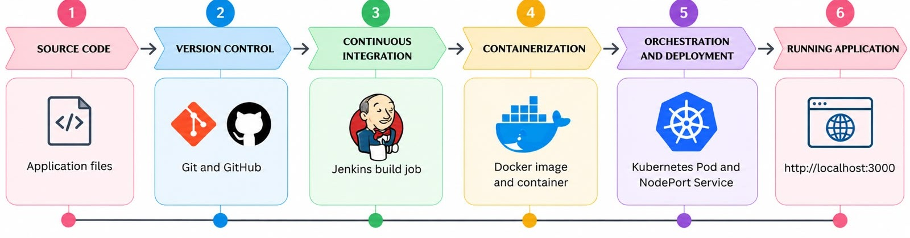
Fig. 2 – DevOps Workflow of the Project

10. DevOps Tools and Their Role

10.1 Git and GitHub
Git was used to commit changes as the project developed, and GitHub serves as the shared remote copy. Fig. 3 shows the private StudentAttendanceDevOps repository on the main branch with three commits. It holds the application files (server.js, package.json, package-lock.json, attendance.json), the Dockerfile, ignore files, a README describing the project, and a .github/workflows folder.
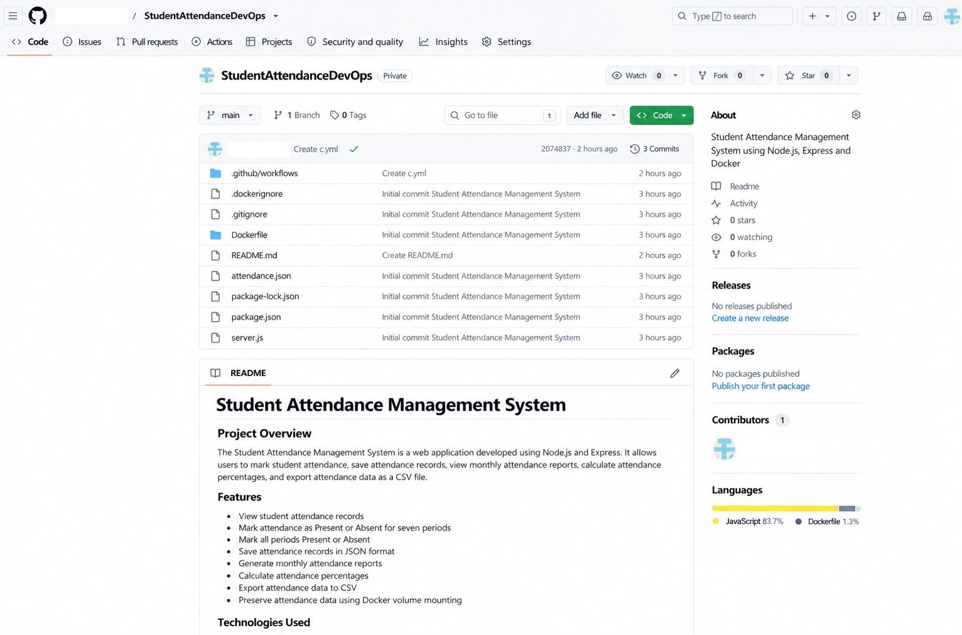
Fig. 3 – Student Attendance Management System Repository on GitHub

10.2 Jenkins
A Jenkins job named StudentAttendance-CI was created to pull the code from GitHub and run the configured build commands. The job page in Fig. 4 lists four builds, #1 to #4, run within a few minutes of each other, and each one is marked as successful.
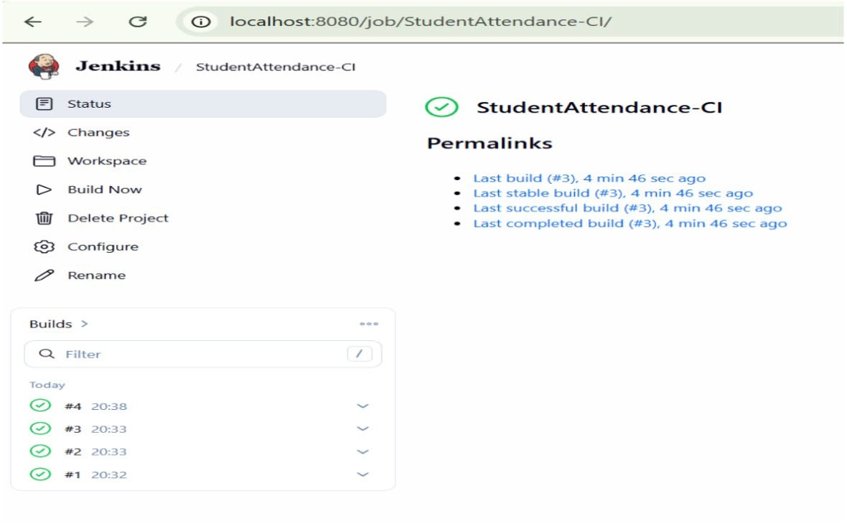
Fig. 4 – Jenkins Build Result

10.3 Docker
Docker was used to turn the application into a portable image. The Dockerfile selects a Node.js base image, sets the working directory, installs the dependencies, copies in the project files and defines the start command. The image built without errors and the application ran correctly inside a container.
The standalone container was managed through Docker Desktop and opened on host port 3001, which is mapped to the application’s internal port 3000.

10.4 Kubernetes
Kubernetes was responsible for running and exposing the container. A Deployment keeps the application Pod running, and a NodePort Service makes it reachable from outside the cluster. In Fig. 5, the student-attendance Pod shows 1/1 Ready, status Running and zero restarts, and student-attendance-service is of type NodePort, forwarding port 3000 to node port 30567.
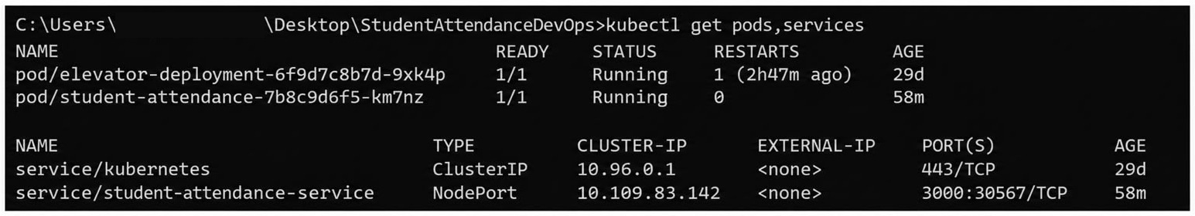
Fig. 5 – Kubernetes Pod and Service Status

10.5 Automated Testing
Testing so far has been manual. The application was opened in a browser, the student list was checked, attendance was marked and saved, and the monthly report was generated. Automated browser testing with Selenium WebDriver has not been added yet and is listed as future work.

11. Results – Daily Attendance Interface
Fig. 6 shows the Daily Attendance page for 24-10-2026. Each of the five students appears with roll number, name and department, followed by seven drop-downs, P1 to P7, set to Present or Absent. The Load Date, Mark All Present, Mark All Absent and Save Attendance buttons sit above the table, and a green message prompts the user to review the sheet and save.
The page loaded correctly in the browser, and the same interface was reachable through the Kubernetes deployment.
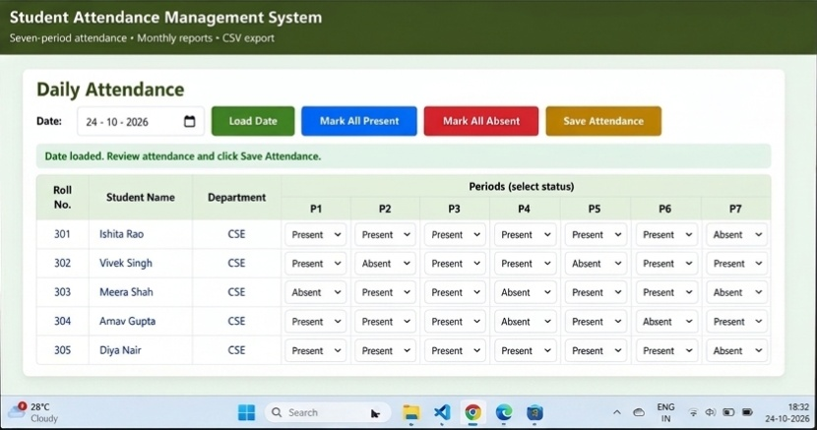
Fig. 6 – Daily Attendance Interface

12. Results – Monthly Attendance Summary
The monthly report in Fig. 7 is for October 2026. The summary cards show 5 registered students, 1 saved attendance day and 35 attendance records (5 students × 7 periods). The table then lists present, absent and working periods for every student along with the percentage and a status.
Two students (Ishita Rao and Diya Nair) reached 85.71% and are marked Satisfactory, while the other three (Vivek Singh, Meera Shah and Arnav Gupta) fall below 75%. A note under the table explains that working periods are counted only from saved attendance records, and the Export CSV button downloads the report.
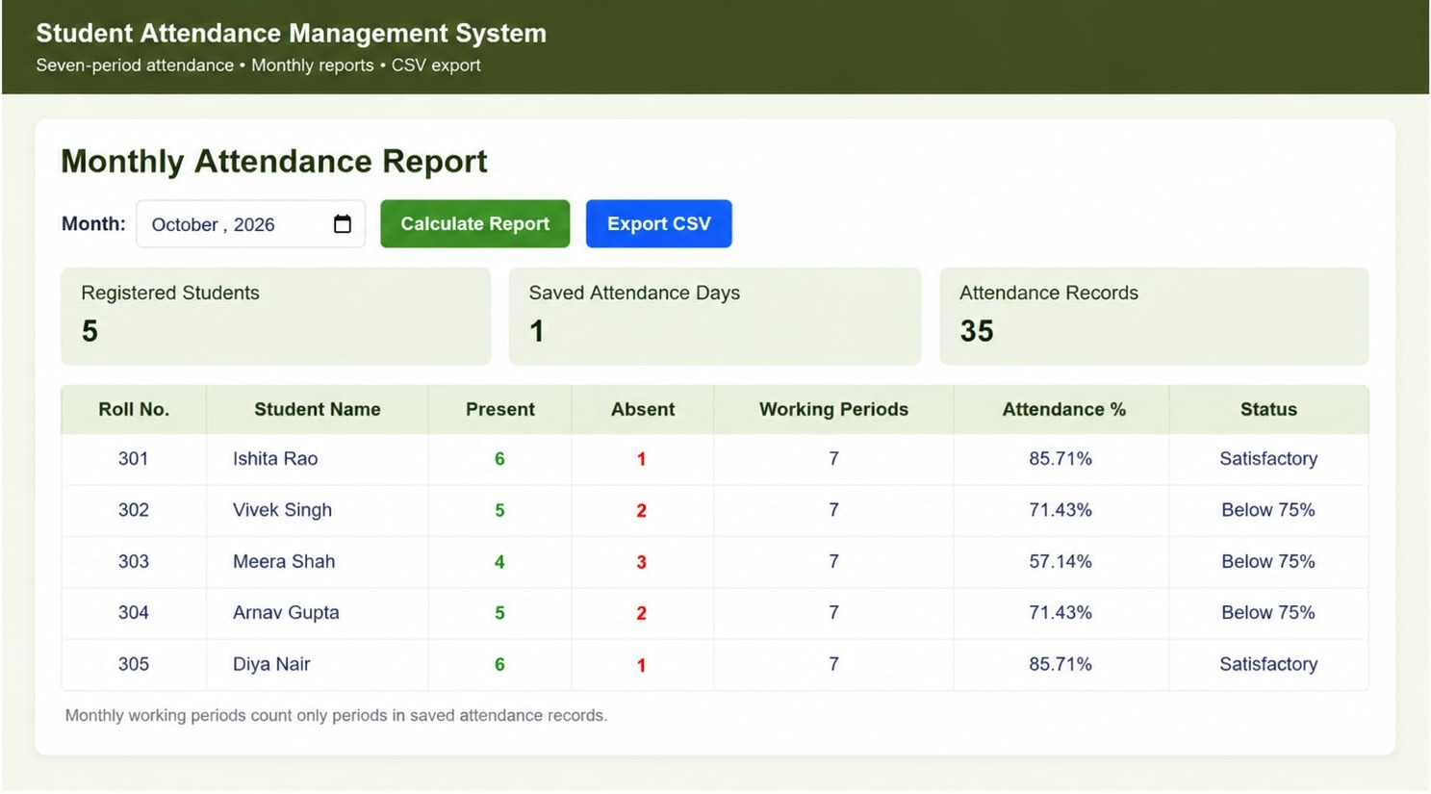
Fig. 7 – Monthly Attendance Summary

13. Testing and Results
The system was checked by using it through the browser and by running the DevOps commands. The outcomes are listed below.
Test Case | Expected Result | Status
Open the application | Attendance page loads | Passed (Fig. 6)
View student records | Student list is displayed | Passed (Fig. 6)
Mark seven periods | Present/Absent can be chosen for P1–P7 | Passed (Fig. 6)
Save attendance | Records are stored for the date | Passed (1 saved day in Fig. 7)
Generate monthly report | Summary with percentages is shown | Passed (Fig. 7)
Export CSV | Report downloads as a CSV file | Button available; download not shown in figures
Build Docker image | Image builds without errors | Passed
Deploy with Kubernetes | Pod runs and Service is created | Passed (Fig. 5)
Jenkins build | Configured job completes | Passed (Fig. 4)
Selenium automated tests | Browser tests run automatically | Not implemented

In summary, the application ran successfully through both Docker and Kubernetes, and the interface could be opened in a browser. Jenkins completed its builds successfully. Selenium-based testing was left out of the current version.

14. Limitations and Future Enhancements
The present version covers the basics of attendance handling and a local DevOps deployment. Several improvements could be made:
- Replace the JSON file with a database such as SQLite or MySQL.
- Add proper login and role-based permissions for faculty and administrators.
- Write Selenium WebDriver tests for marking attendance and generating reports.
- Use persistent storage in Kubernetes so attendance data survives Pod restarts.
- Extend the Jenkins pipeline to include testing and deployment stages.
- Host the application on a cloud platform for access from anywhere.

15. Conclusion
The Student Attendance Management System makes daily attendance entry and monthly analysis much simpler than a paper register. It manages student records, takes seven-period attendance, computes percentages, highlights students under 75% and exports reports as CSV.
It also served as a practical exercise in DevOps. Git and GitHub looked after the code, Jenkins ran the build job, Docker packaged the application, and Kubernetes deployed it, with the result opened successfully on the local cluster.
The project built experience in web development, build automation, containers and orchestration. Database integration, automated testing and cloud hosting are natural next steps.

16. References
- Node.js Documentation – https://nodejs.org/docs/
- Express.js Documentation – https://expressjs.com/
- Git Documentation – https://git-scm.com/doc
- GitHub Documentation – https://docs.github.com/
- Jenkins Documentation – https://www.jenkins.io/doc/
- Docker Documentation – https://docs.docker.com/
- Kubernetes Documentation – https://kubernetes.io/docs/

Appendix: Important Commands
Purpose | Command
Install dependencies | npm install
Start the application | Start command set in package.json
Build the Docker image | docker build -t student-attendance .
List containers | docker ps
List images | docker images
Check cluster nodes | kubectl get nodes
Apply the Kubernetes configuration | kubectl apply -f <manifest-file>.yaml
Check Pods | kubectl get pods
Check Services | kubectl get services
Check Deployments | kubectl get deployments
View application logs | kubectl logs deployment/student-attendance

