**LINUX COMMANDS**

1. pwd :

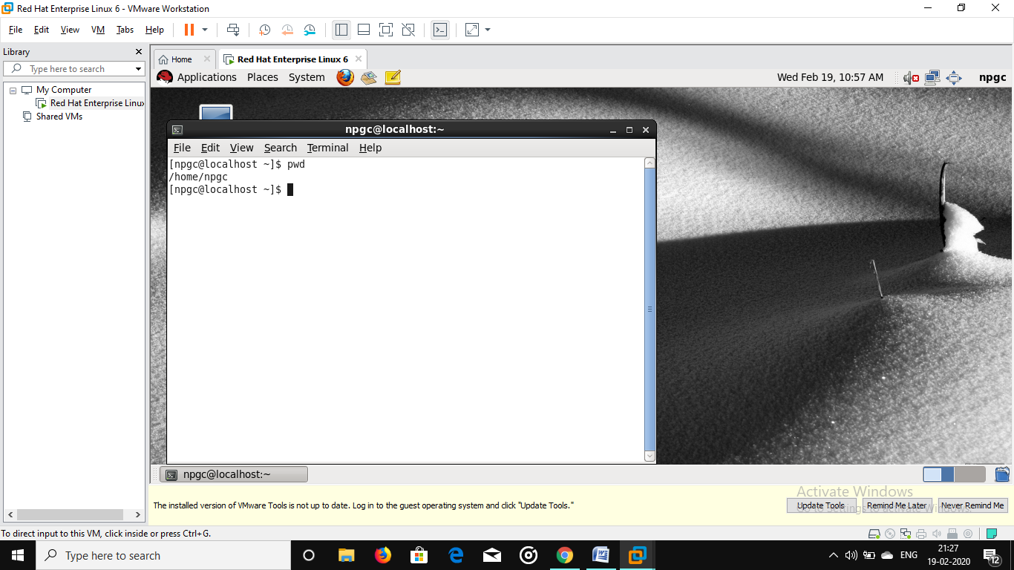

1. ls :

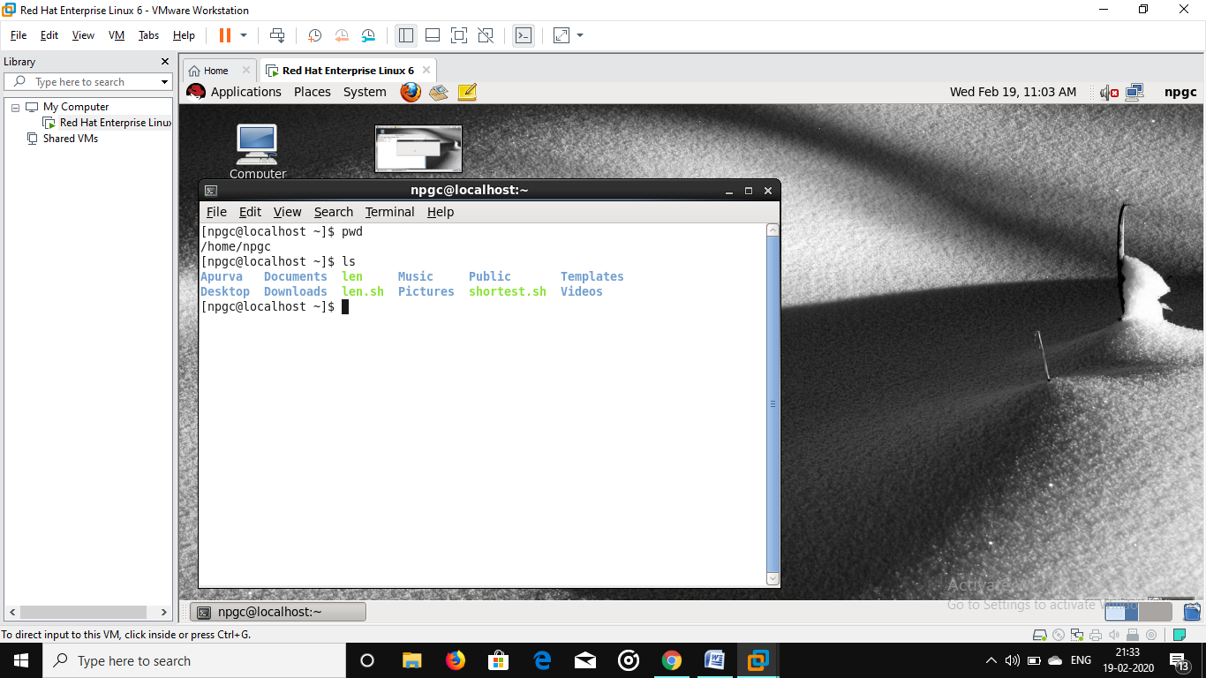

1. ls –al :

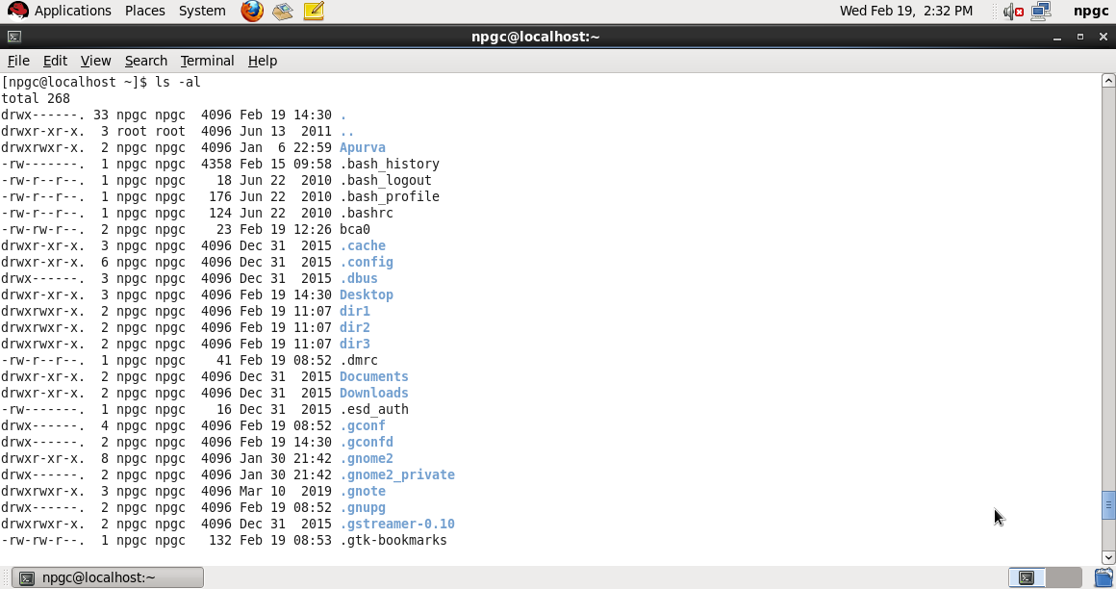

1. man :

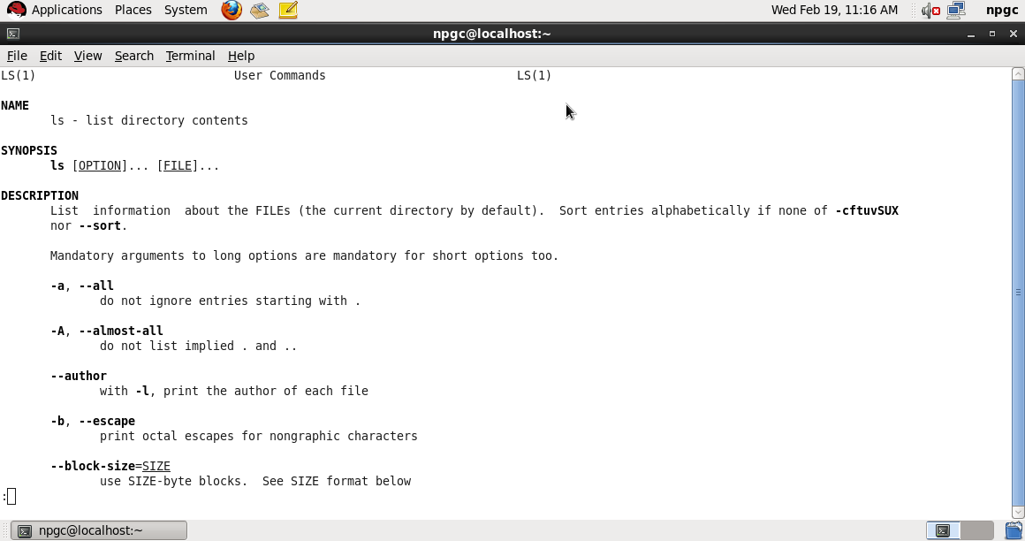

1. ls –lt | head : Displays the 10 newest files in the current directory.

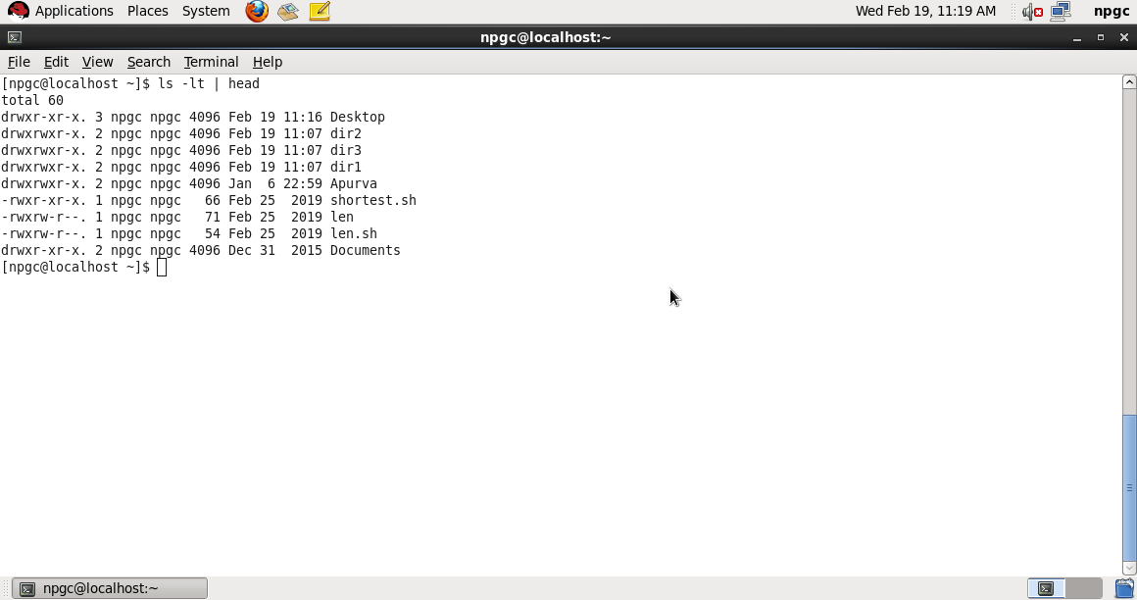

1. find . -type f -print | [wc](http://linuxcommand.org/lc3_man_pages/wc1.html) –l **:** Displays the total number of files in the current working directory and all of its subdirectories.

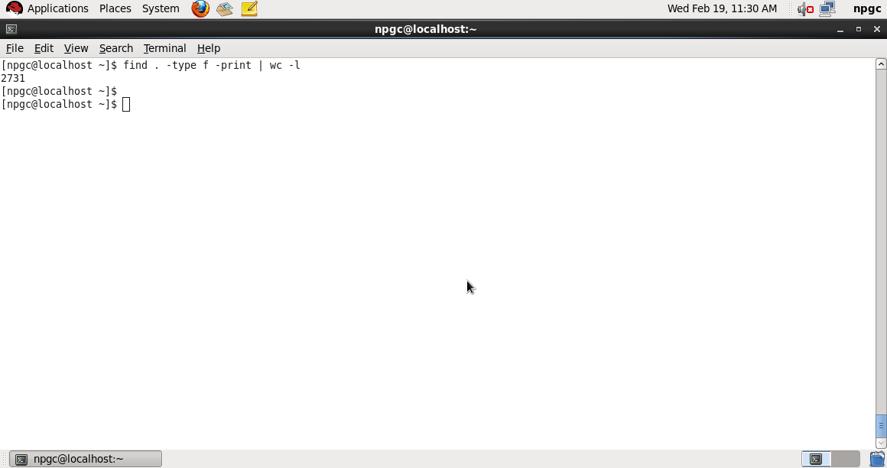

1. du | sort –nr : Displays a list of directories and how much space they consume, sorted from the largest to the smallest.

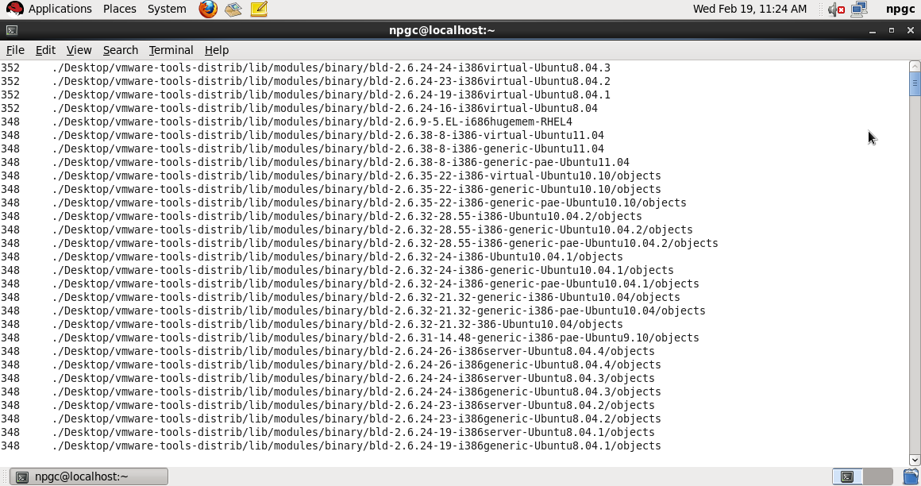

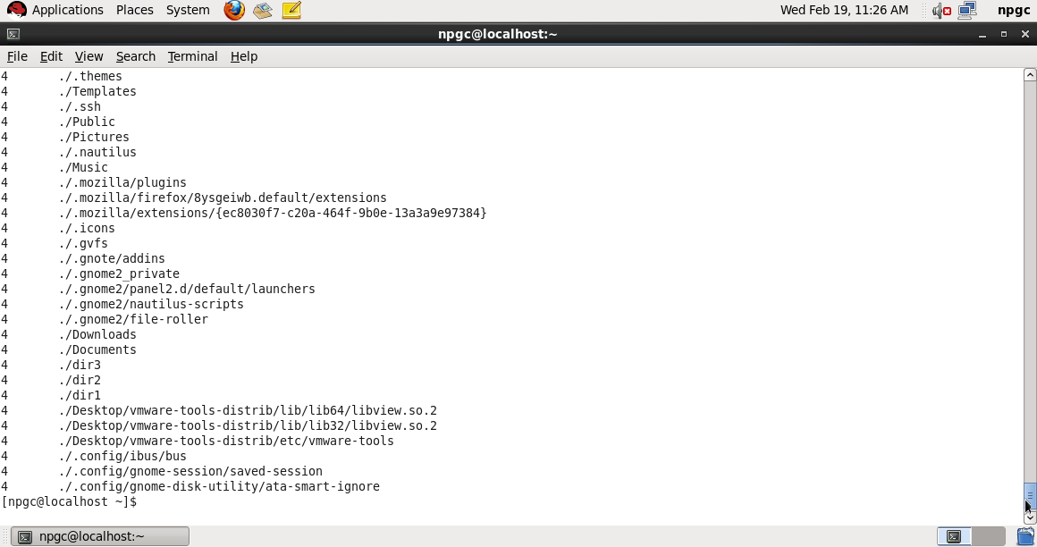

1. cat :

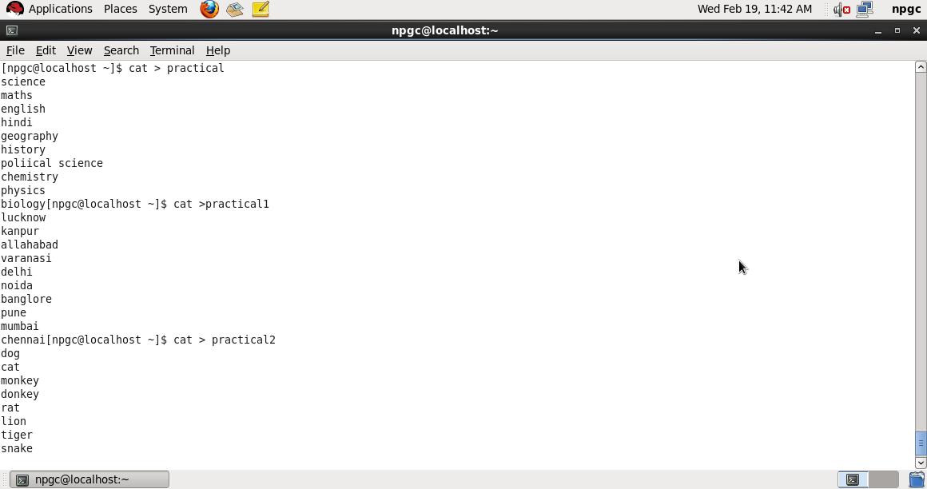

1. cat /etc/passwd : It will show contents of **/etc/passwd** file.

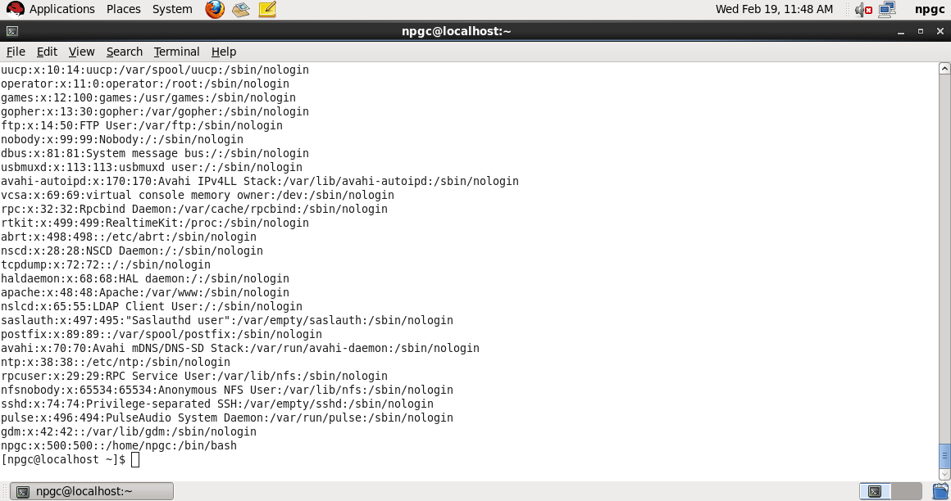

1. cat practical > practical3 :

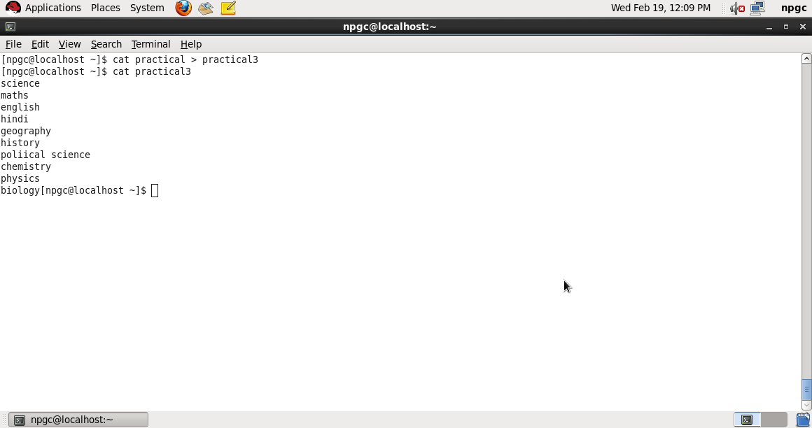

1. cat practical practical1 practical2 :

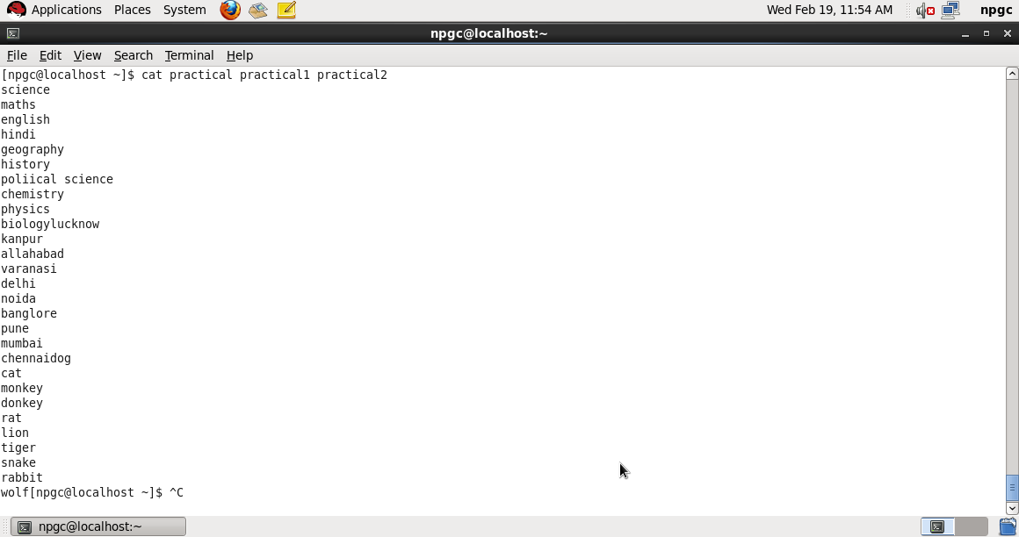

1. cat practical | more :

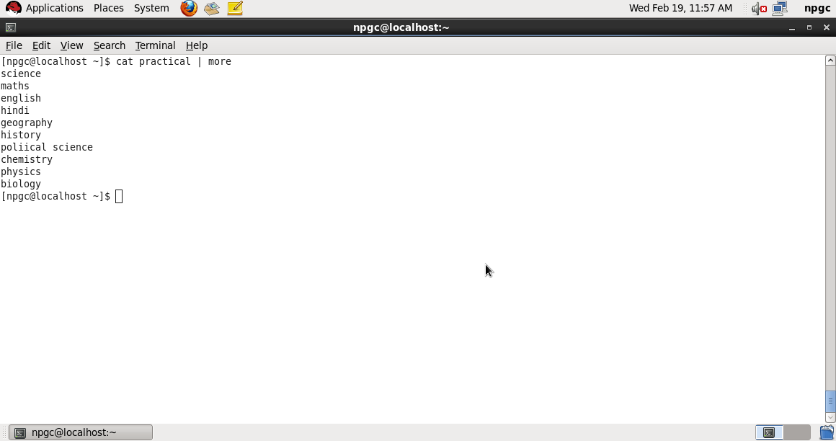

1. cat practical | less :

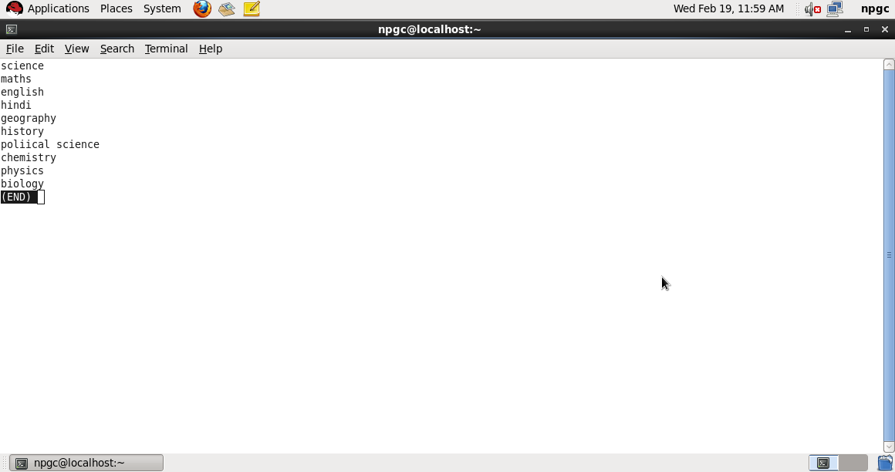

1. cat –n practical :

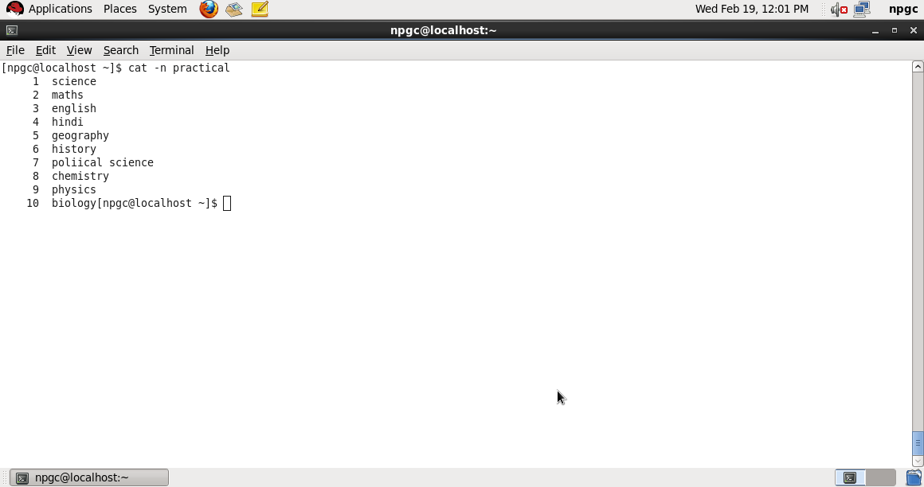

1. cat –e practical :

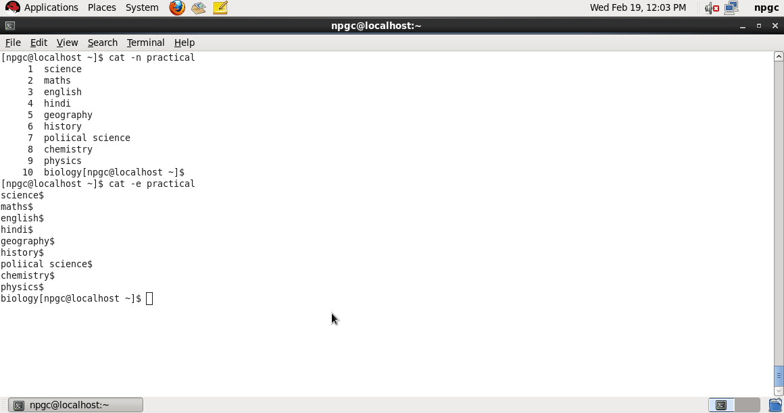

1. cat practical; cat practical1; cat practical2 :

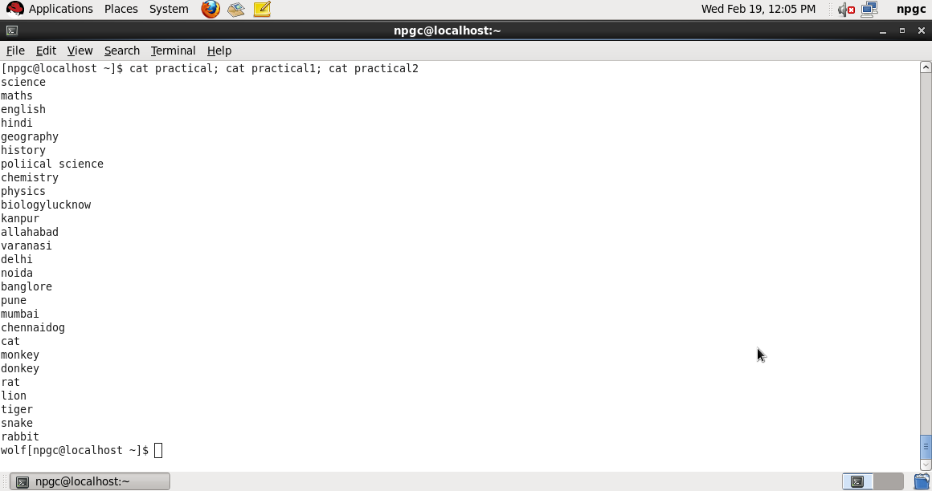

1. cat practical1 >> practical2 :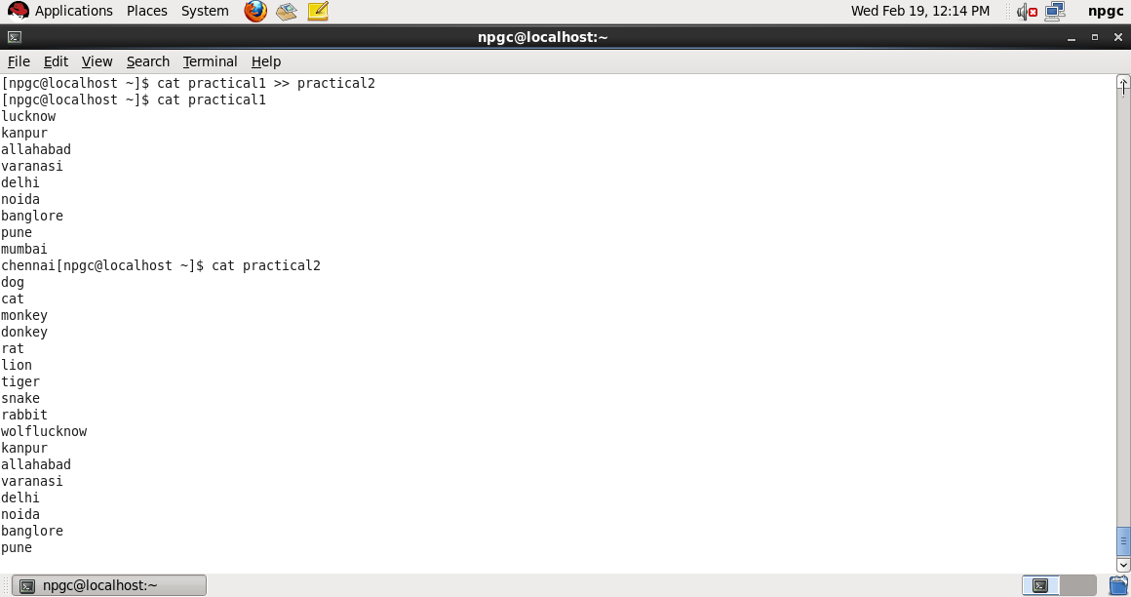
2. cat practical1 practical2 > practical5 :

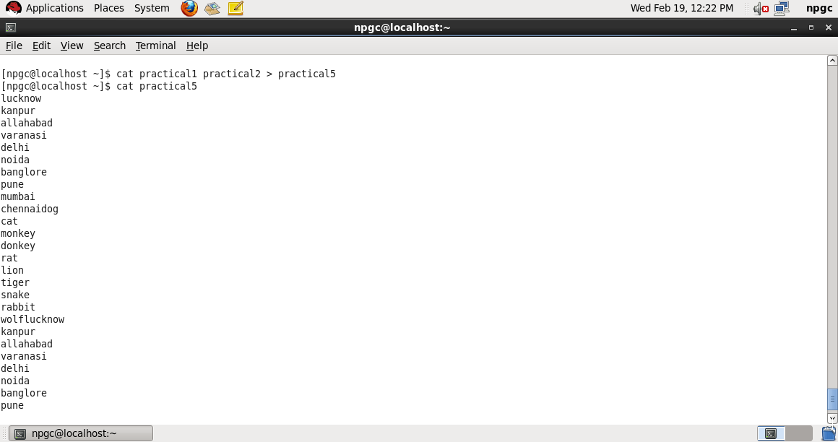

1. cat bca2 bca4 bca6 | sort > bca :

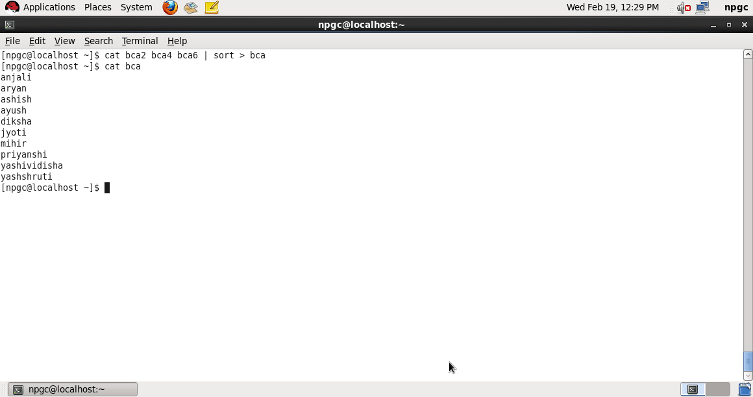

1. cp –a : archive files
2. cp –f : force copy by removing the destination file if needed
3. cp –i : interactive - ask before overwrite

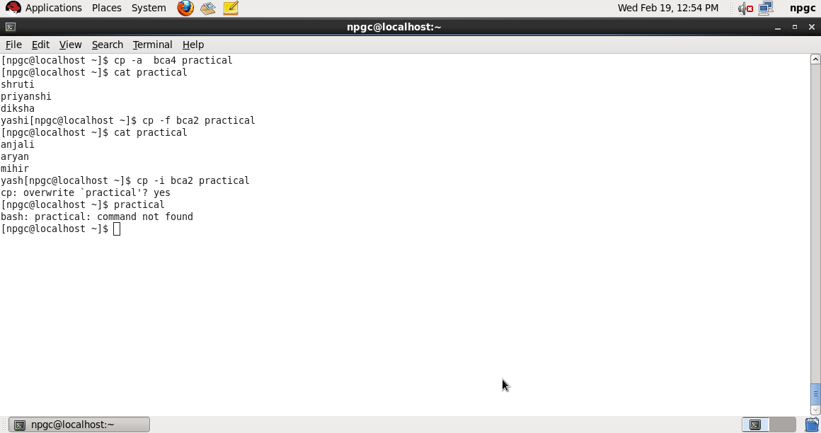

1. cp –l : link files instead of copy
2. cp –L : follow symbolic links
3. cp –n : no file overwrite
4. cp –R : recursive copy (including hidden files)

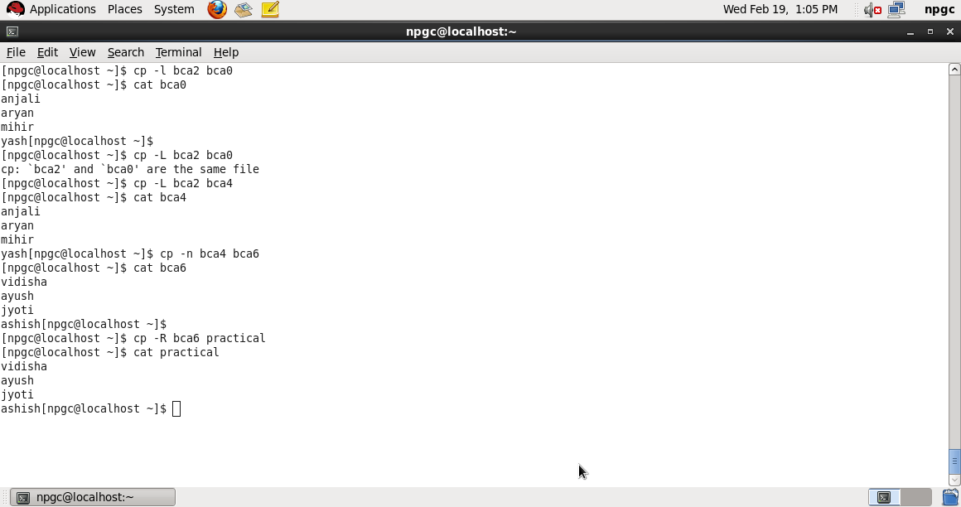

1. cp –u : update - copy when source is newer than destination
2. cp –v : verbose - print informative messages

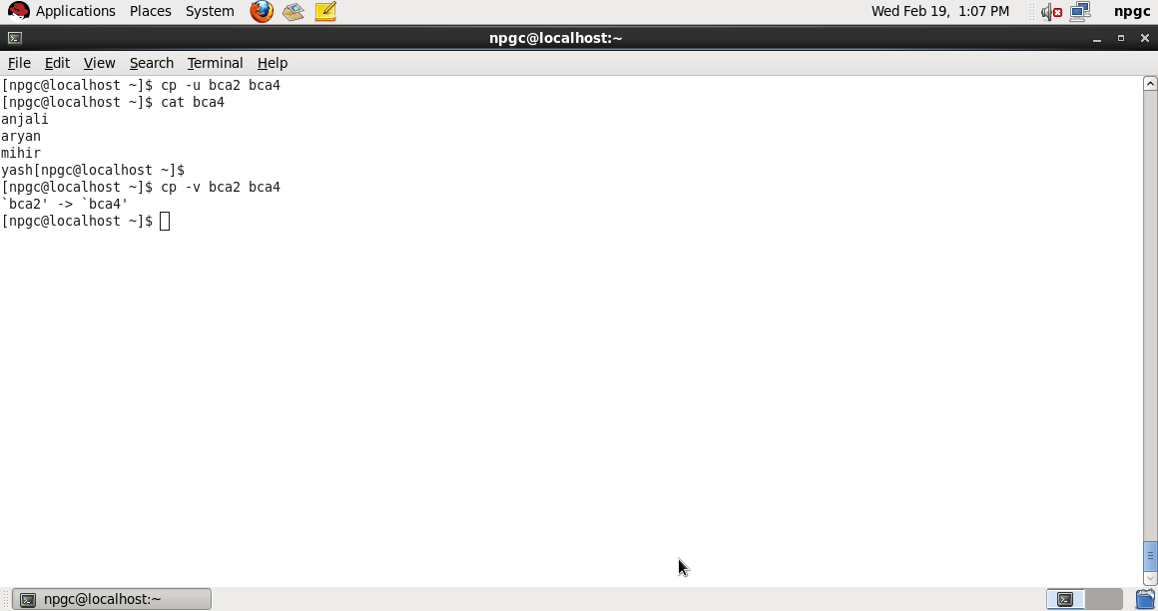

1. who :

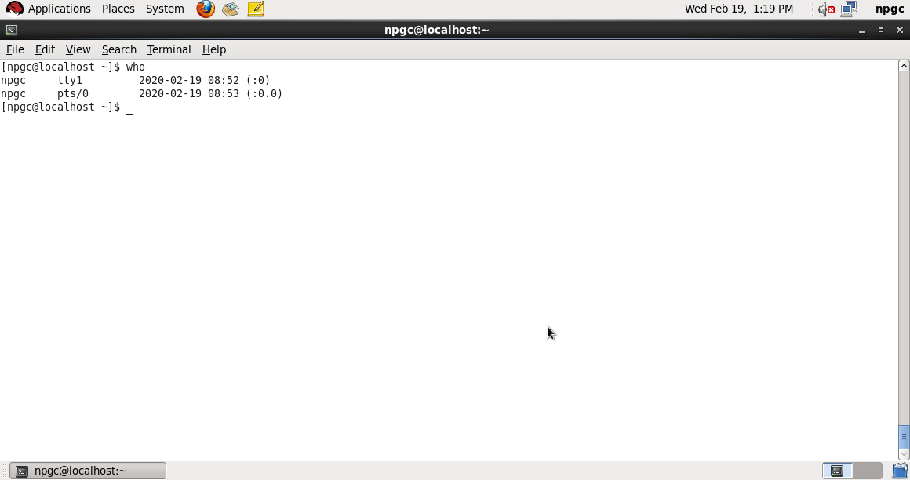

1. who am i :

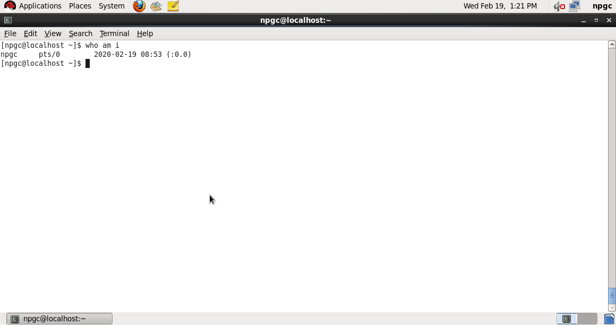

1. mv –f : force move by overwriting destination file without prompt
2. mv –i : interactive prompt before overwrite
3. mv –u : update - move when source is newer than destination
4. mv –v : verbose - print source and destination files

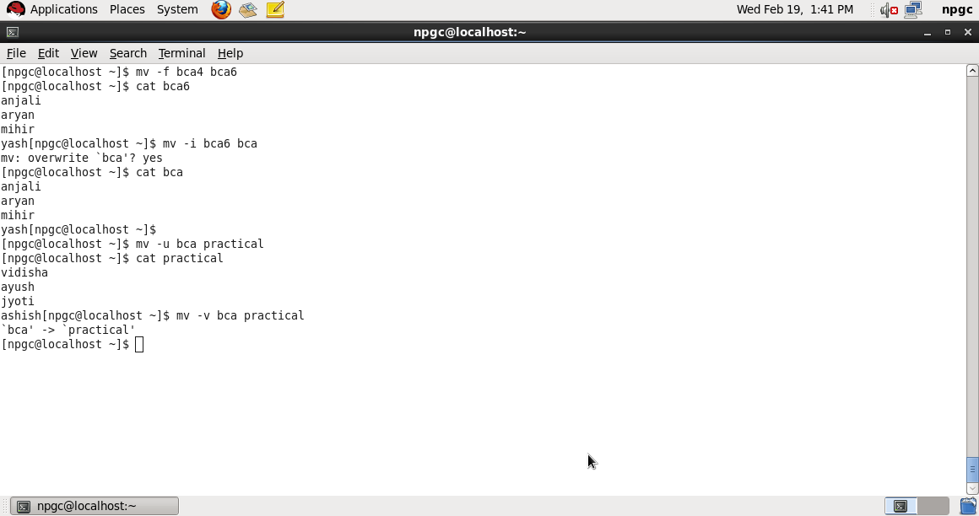

1. help :

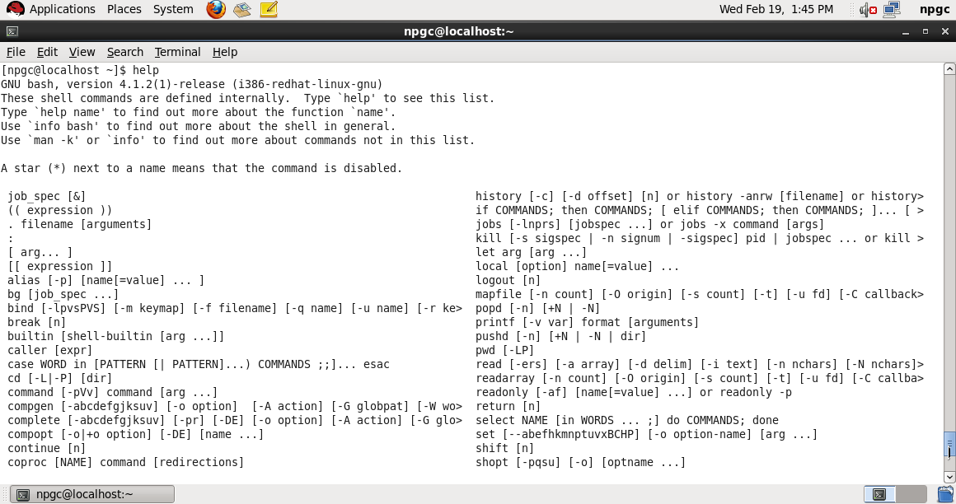

1. date :

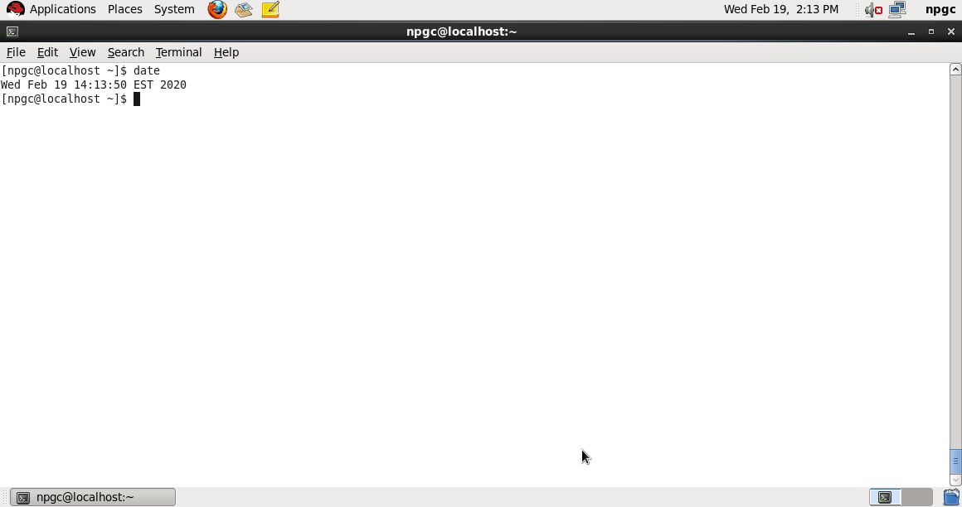

1. cal :

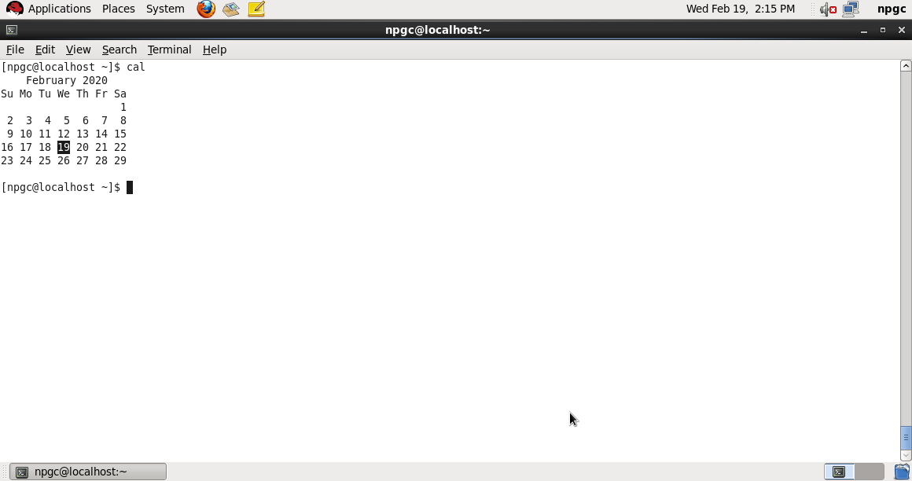

1. hostname :

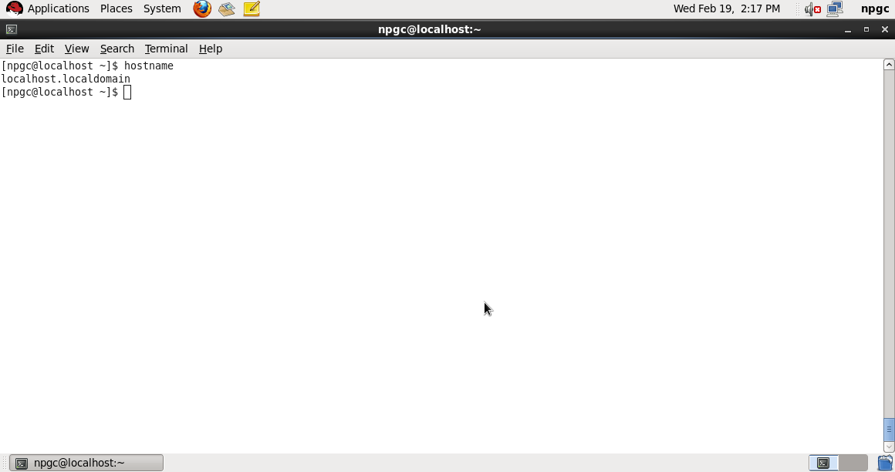

1. hostname –I :

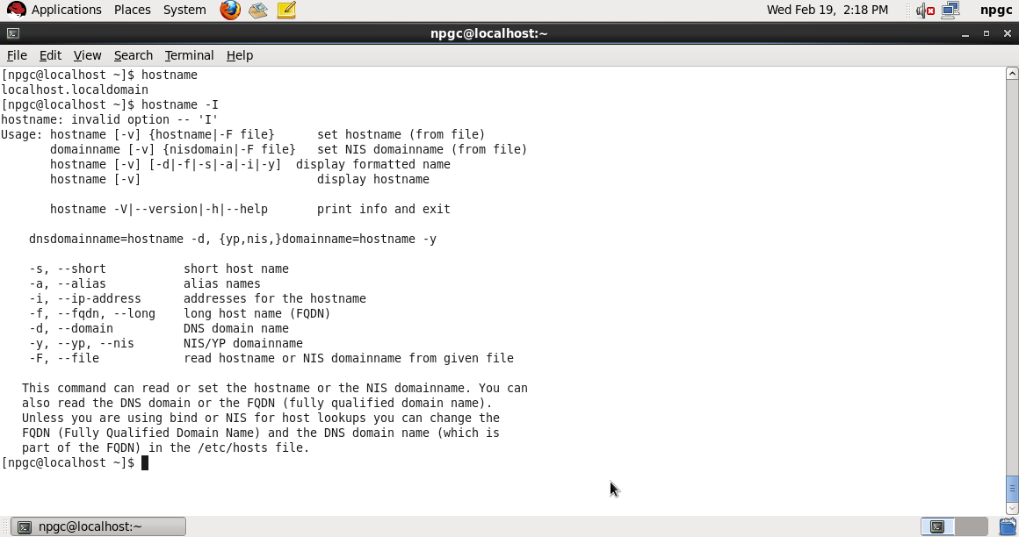

1. top :

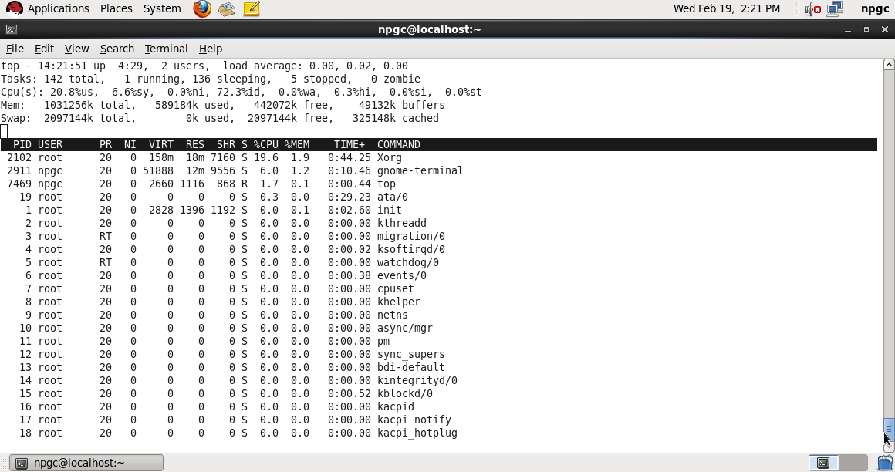

1. id :

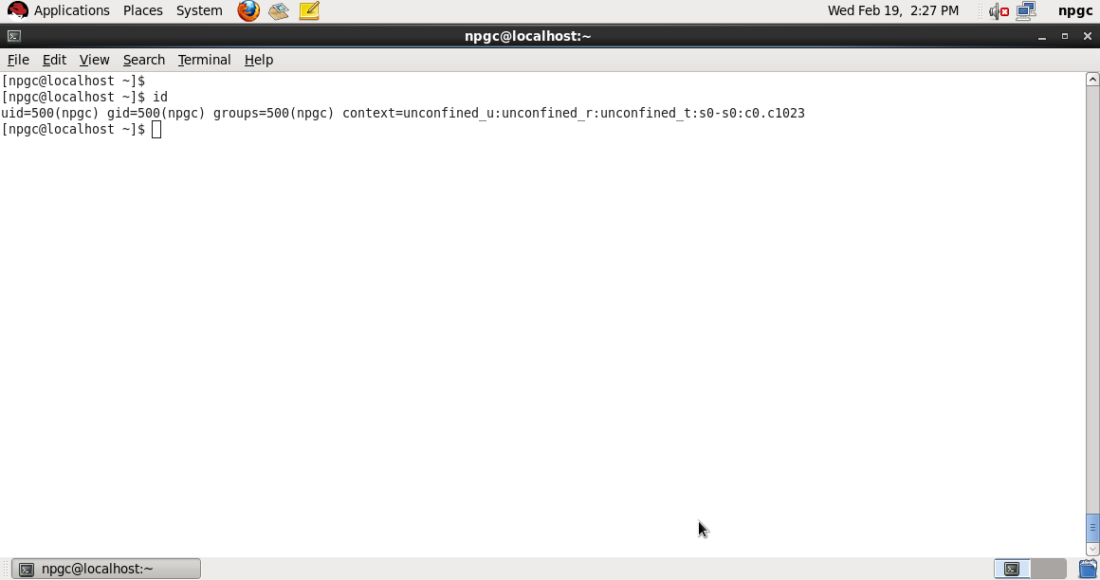

1. last : display the last users who have logged onto the system.

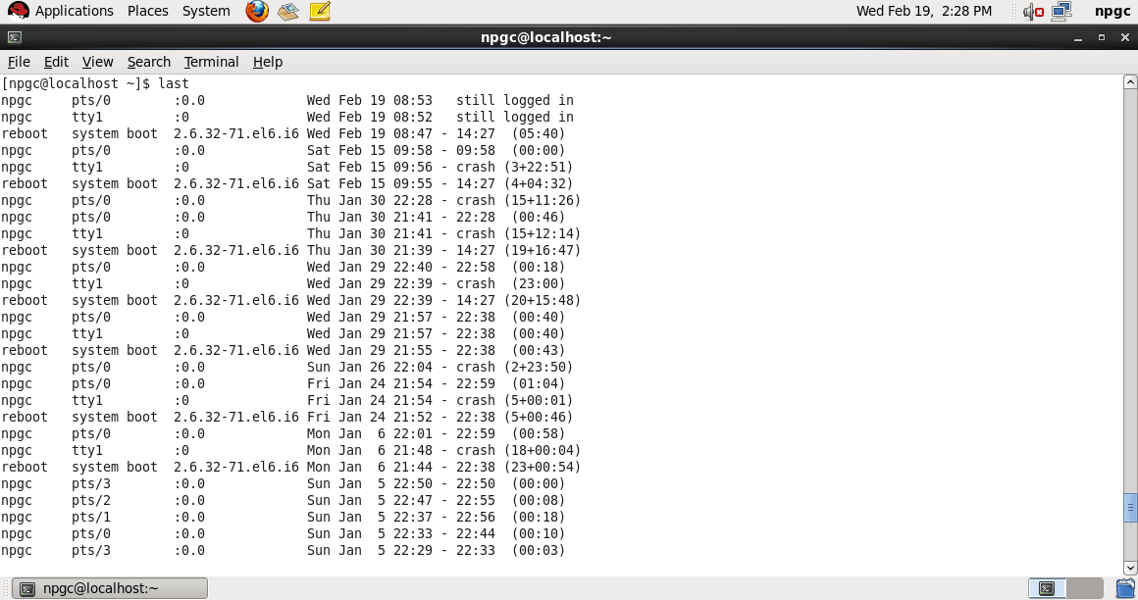

1. w : shows who is logged in and what they are doing.

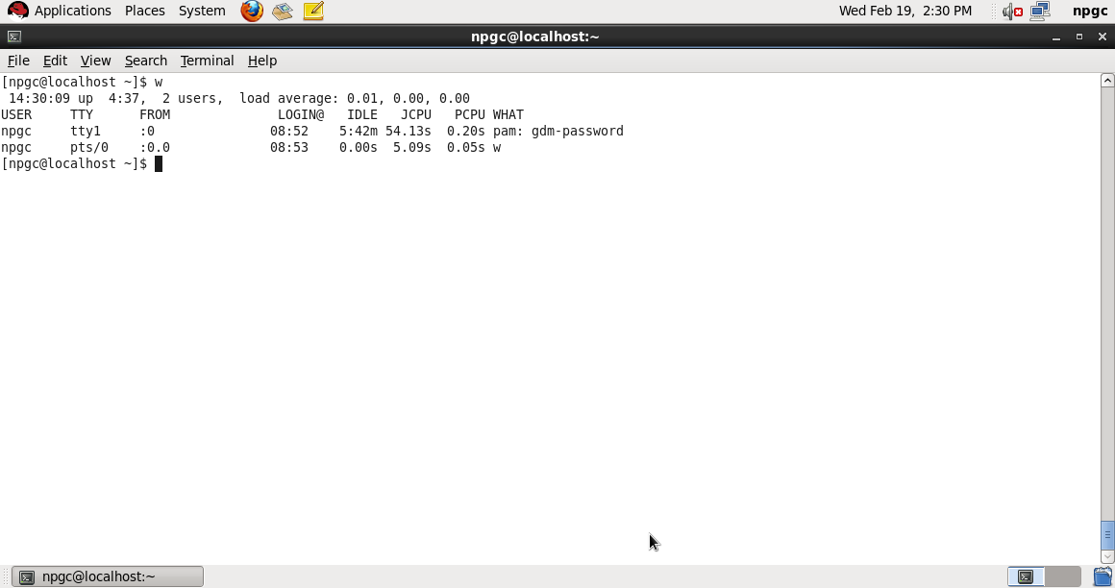

1. ps :

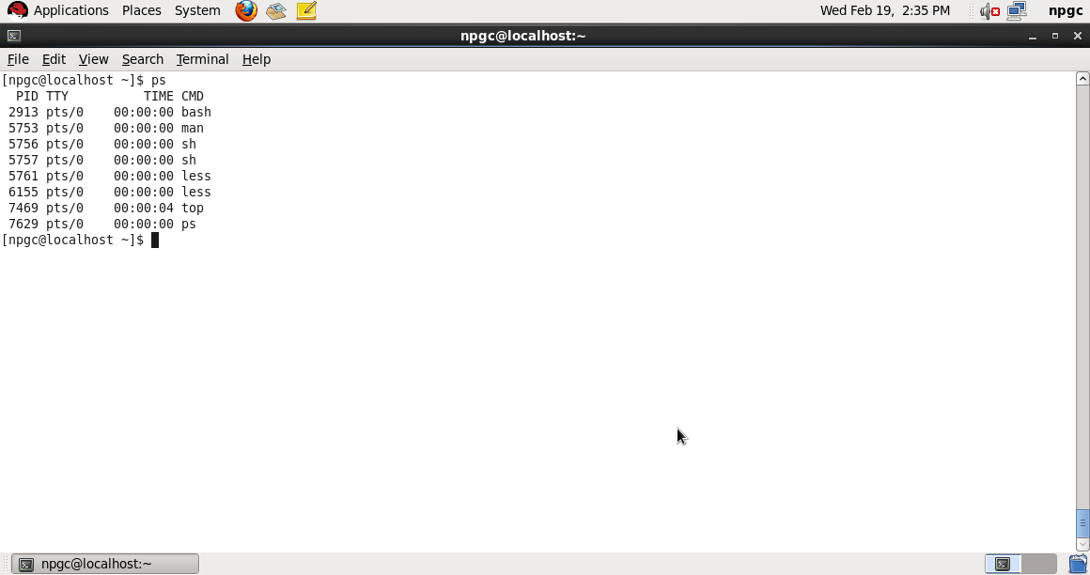

1. sort -r: Reverse the sorting order.

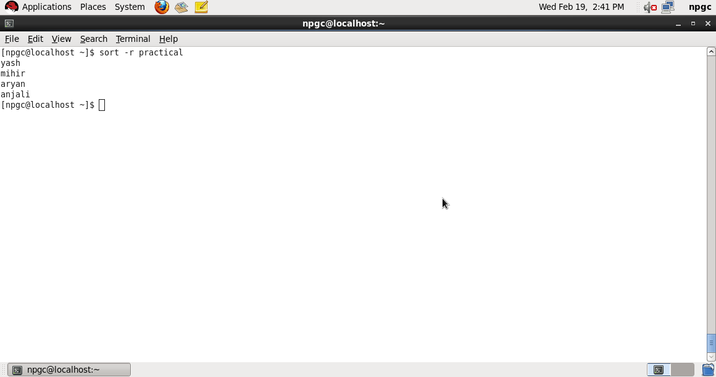

1. su:

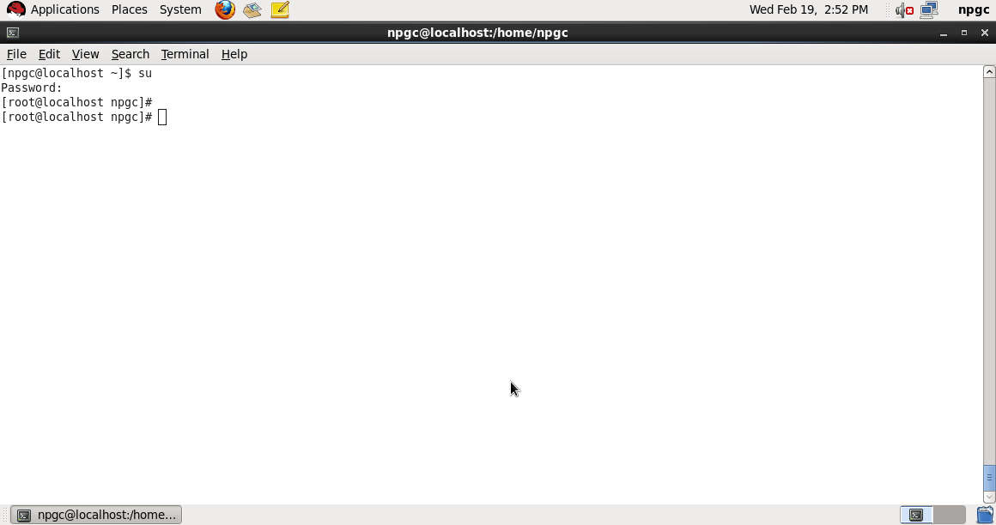

1. history:

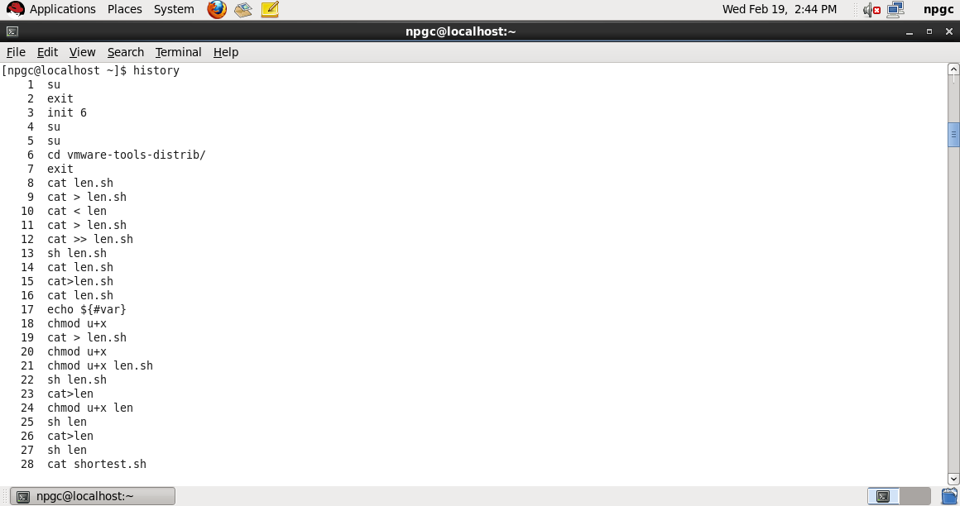

1. pr –n practical:

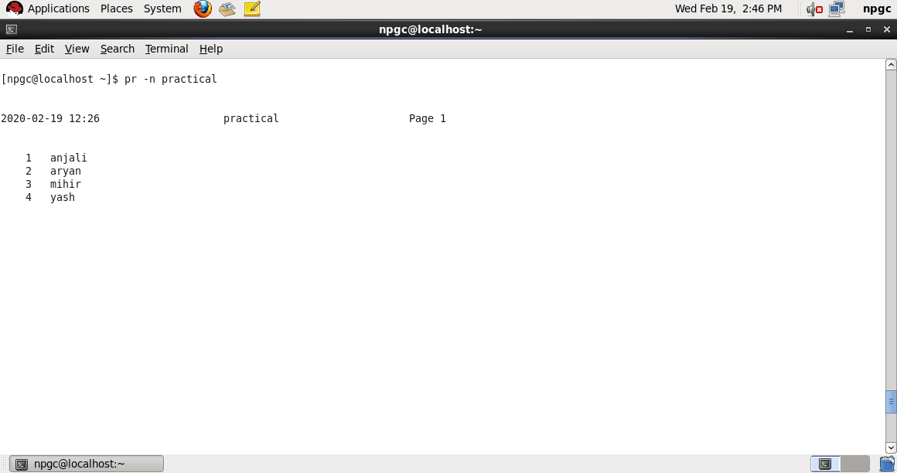

1. pr -3 practical3 :

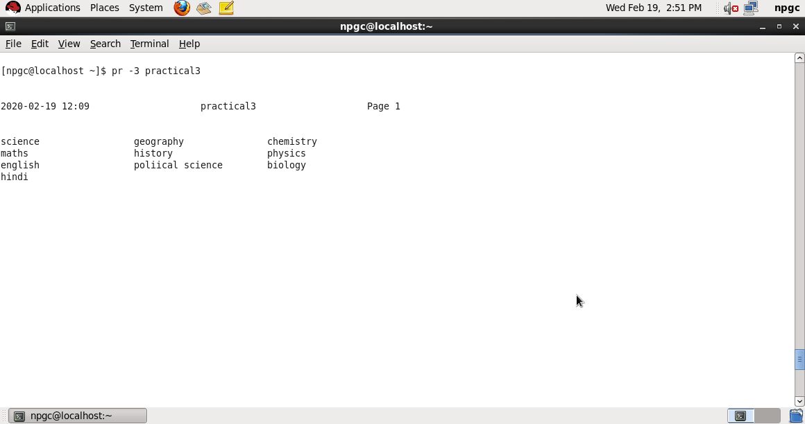

1. sudo :

