Day 9 ,Session-1  
Assignment

Data Structures

1. Linked list

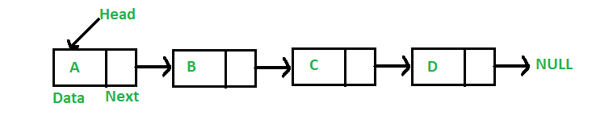

* It is a linear data structure which contains nodes.
* A node contain data and reference to next node.
* Elements are stored as in the memory availability
* It has linear fashion only.
* It’s size is Dynamic
* We can insert and delete in Linked list

1. Singly linked list

* It is a simple and linked list mention above.
* Node navigation is forward only.
* Node contain data and reference to next node.

1. Doubly Linked list

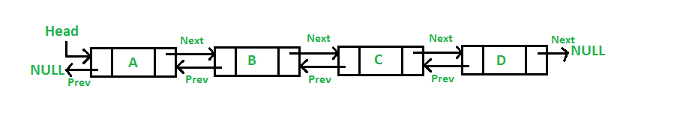

* Doubly Linked list is a complex type of LL in which a node contains a pointer to the previous as well as the next node in the sequence.
* A DLL can be traversed in both forward and backward direction.
* We can quickly insert a new node before a given node.

1. Circular linked list

* Circular Linked list is a LL where all nodes are connected to form a circle.
* There is no NULL at the end.
* It can be singly circular linked list or doubly circular linked list.
* Any node can be the starting point to traverse the list.
* They are used for implementation of advanced data structures like Fibonacci heap.

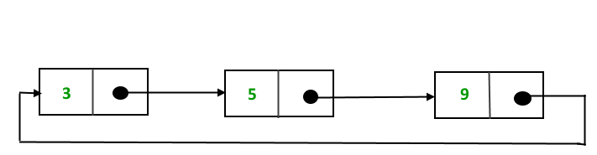

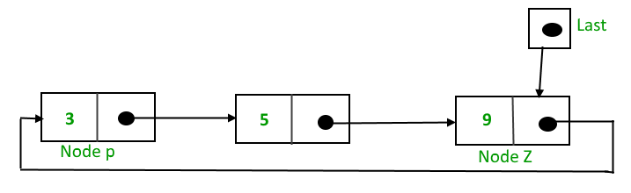

1. Circular doubly linked list

* Circular doubly linked list has properties of both doubly LL and circular LL in which two consecutive elements are linked or connected by previous and next pointer and the last node points to first node by next pointer and also the first node points to last node by the previous pointer.

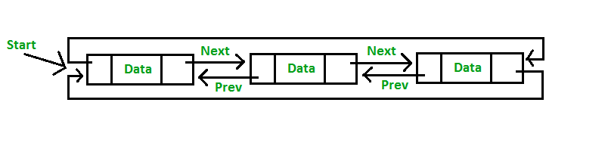

1. Node based storage with arrays
2. Stack

* Stack is a linear data structures.
* It follows Last In First Out(LIFO) ORDER
* ONLY top elements are available to be accessed
* Insertion and deletion takes place from the top
* Operations in stack are push, pop and peek
* push() is for insertion
* pop() is for remove/delete
* peek()is to get top most element
* isEmpty() to check if stack is empty

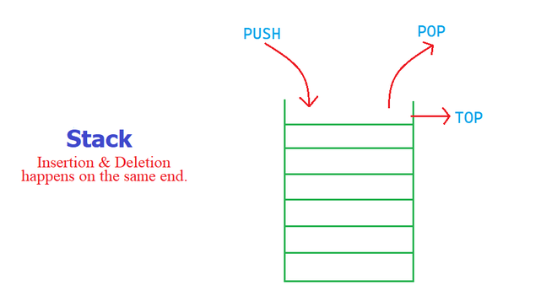

1. Queue

* Queue is a linear data structures.
* It follows the order FIRST IN FIRST OUT (FIFO).
* Insertion is takes place rear end
* Deletion takes place from front end
* enqueue()operation is for insertion.
* dequeue()is to remove.
* peekFirst()- it will get the first element
* peekLast() - to get the last element

