* API Gateway
* API Gateway Integration with Lambda Function

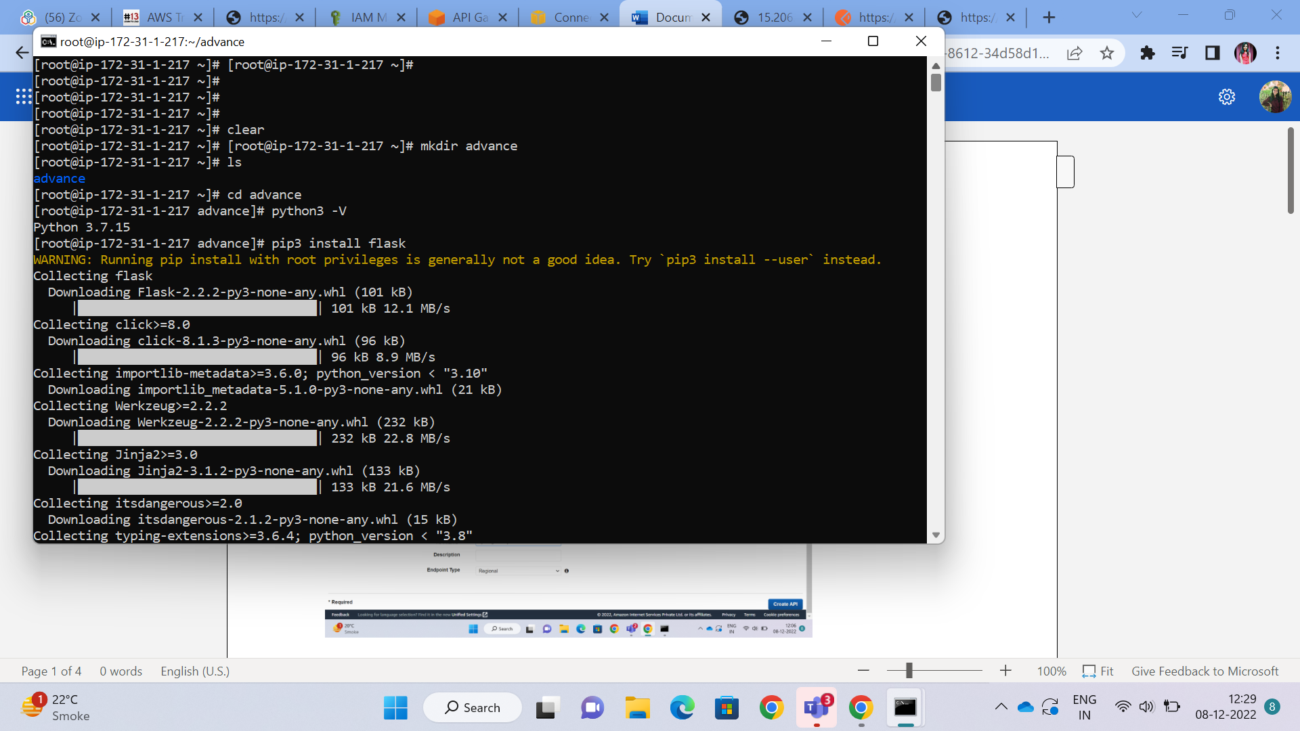

Created the API gateway

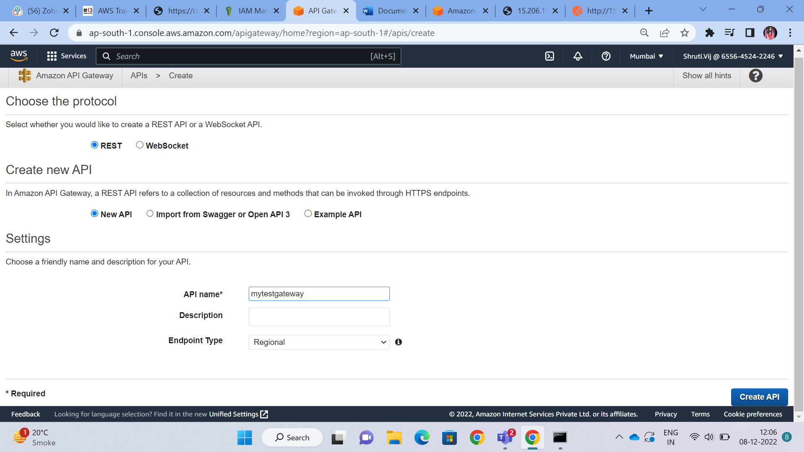

Create Resources – and add the resources , I created two resources, one is named as /data and second is /new

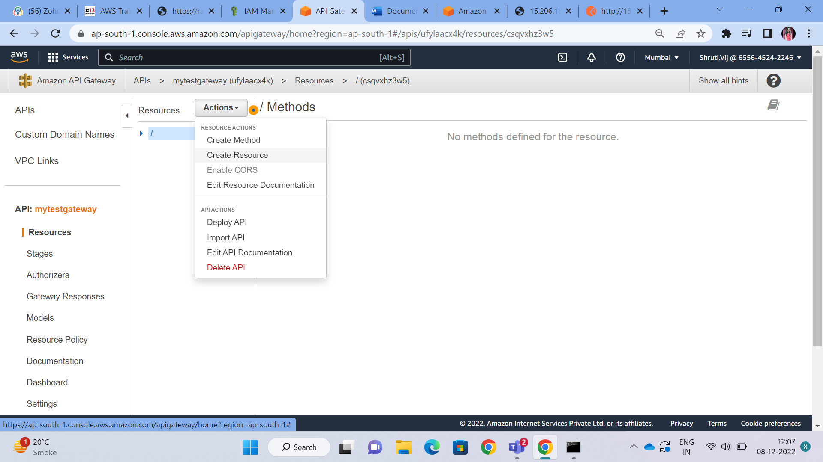

Add methods (GET,POST,DELETE,...) on the resources that we created.

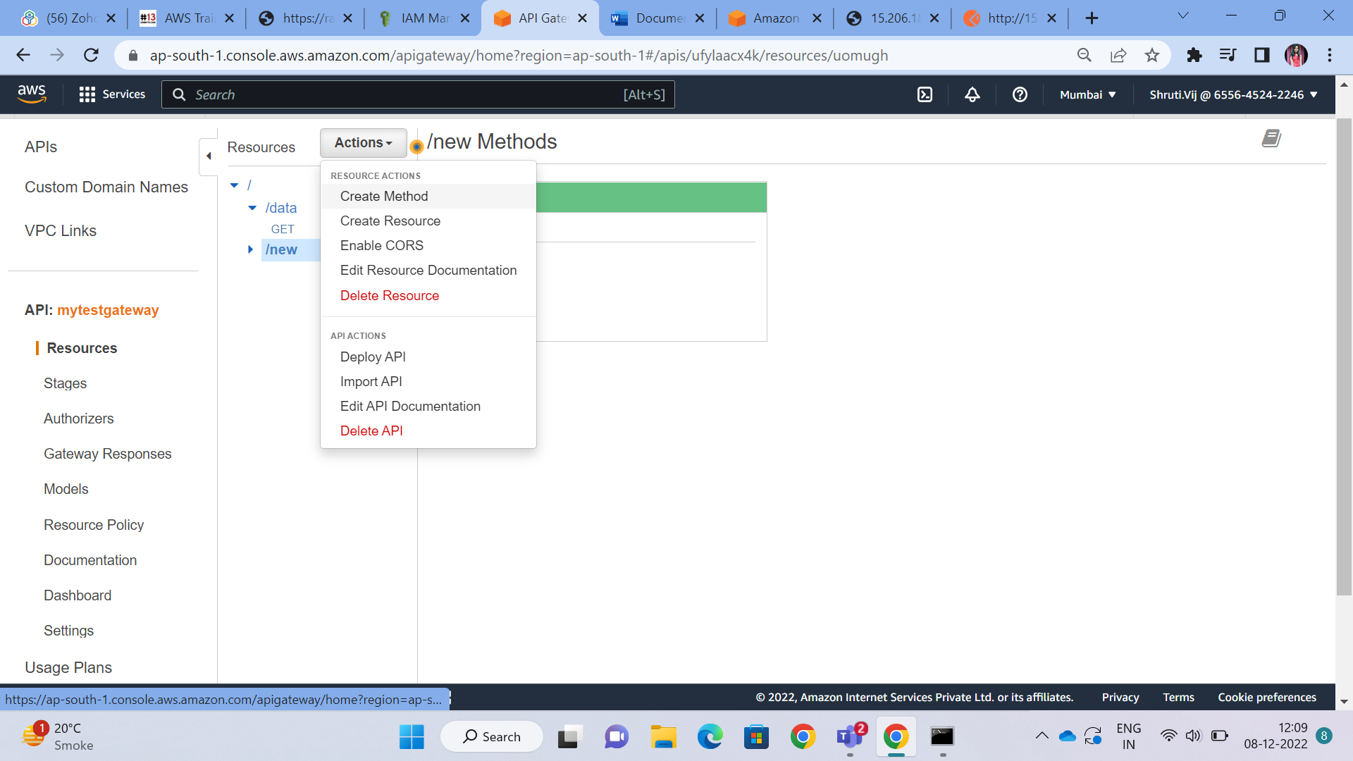

Attach the protocol, I created the simple flask application deployed on the EC2 , so I selected the http here, when we will create the Lambda function, we will select the Lambda here.

And In the Endpoint URL , put the URL, from where your Application is accessible

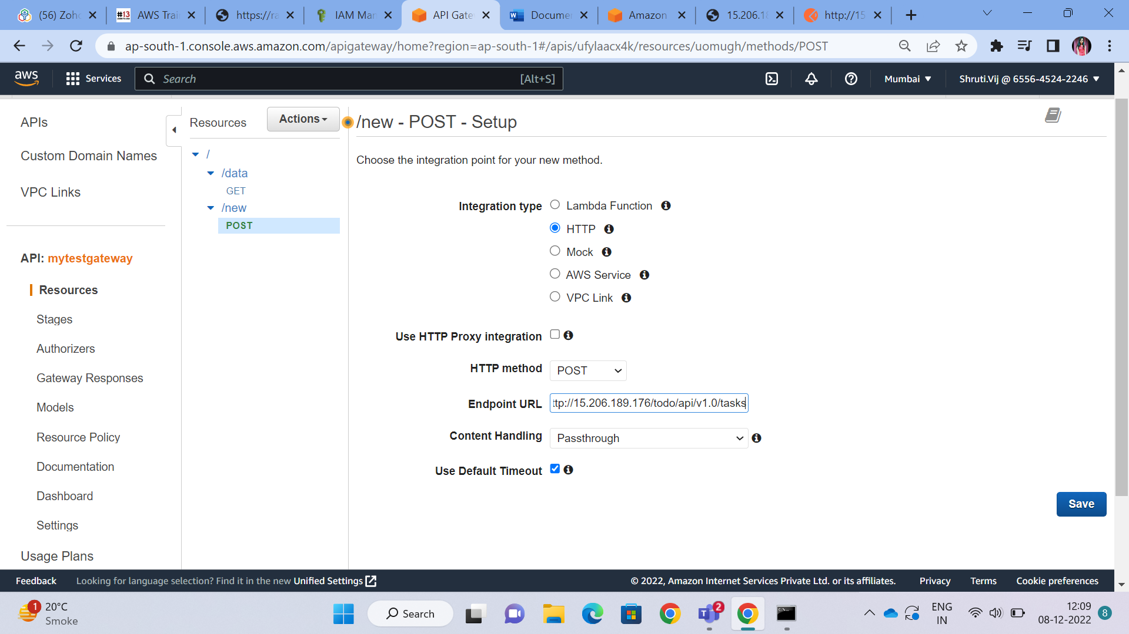

After setting Up the APIs , deploy the API , It will give you a DNS , through which we can access our application.

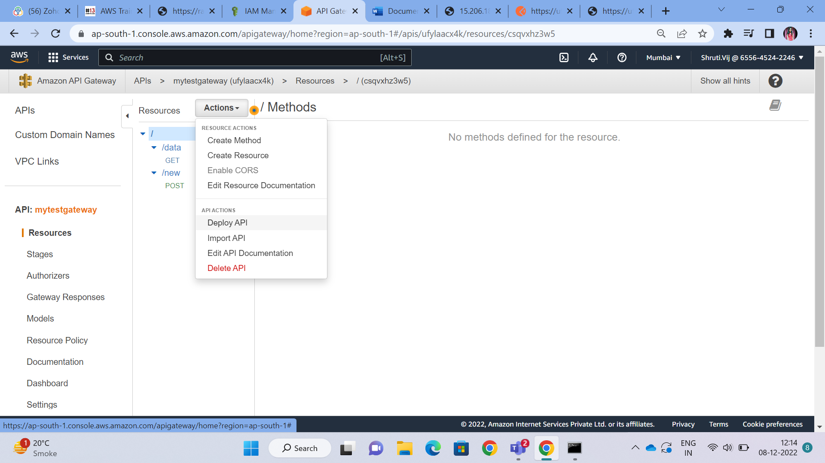

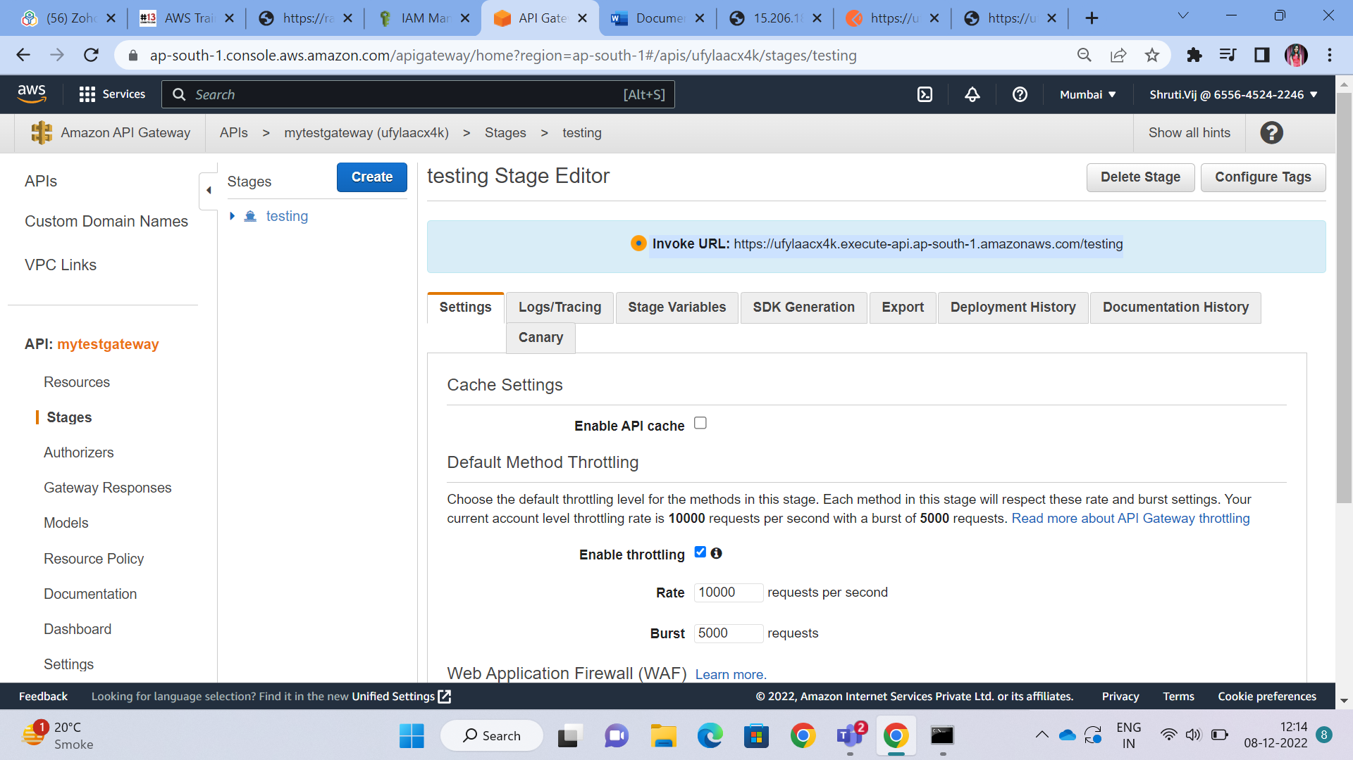

Check if the APIs are working or not using the postaman

Add the url -> select the method and check

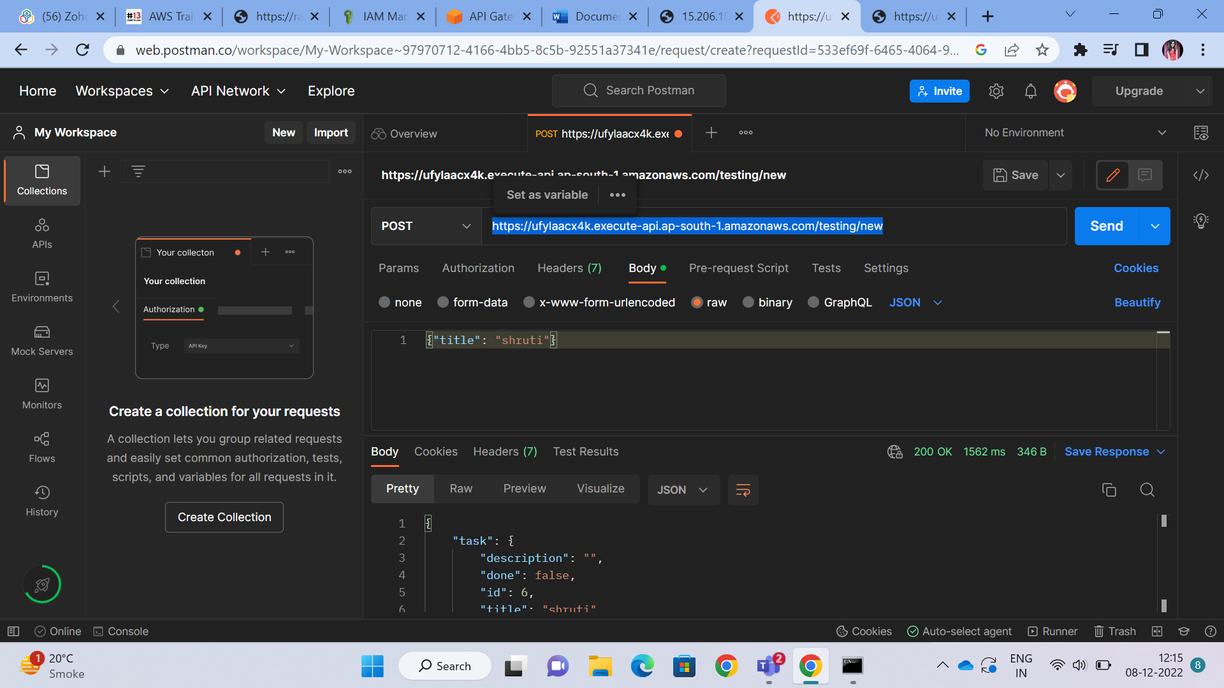

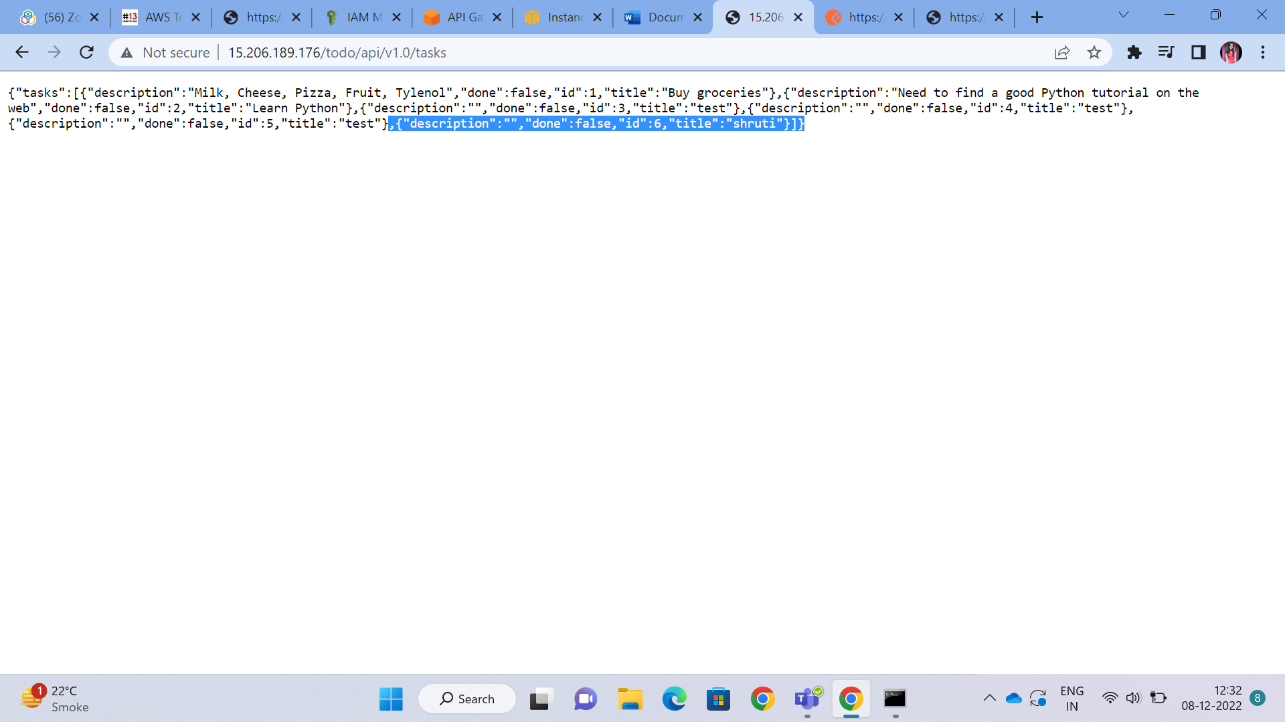

Now, we will connect the Lambda function with the API

Create the Lambda function simply by going into the Lambda console, till now I have the basic default code in my Lambda function

Then, come to the API, create API gateway -> create Resource -> create Method -> choose the Lambda function that you have created.

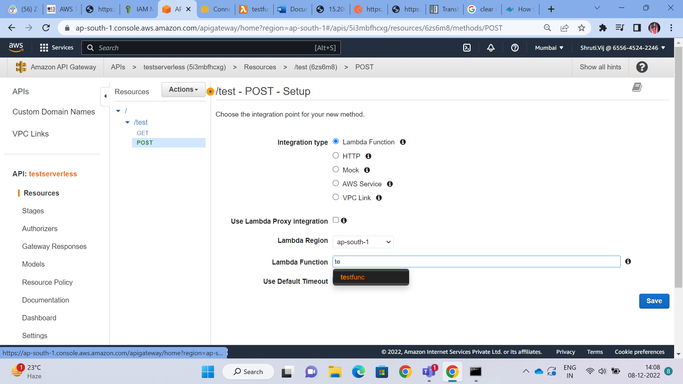

Now refresh the page, it will automatically create the API Gateway Trigger to the Lambda Function.

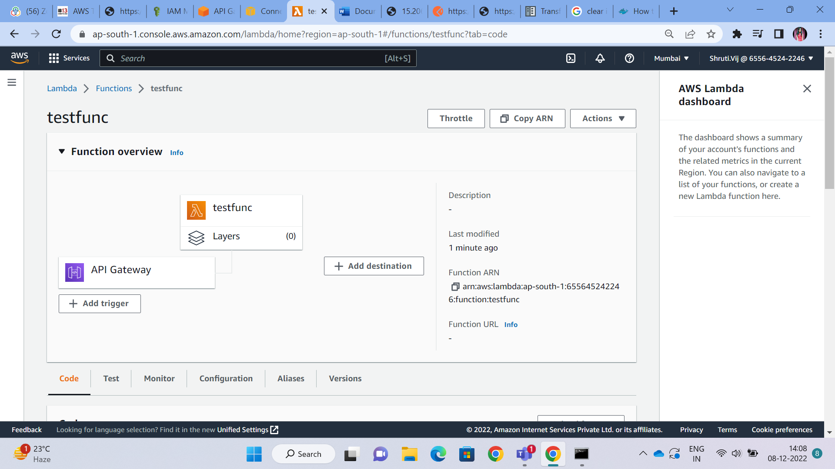

In Actions -> Deploy API

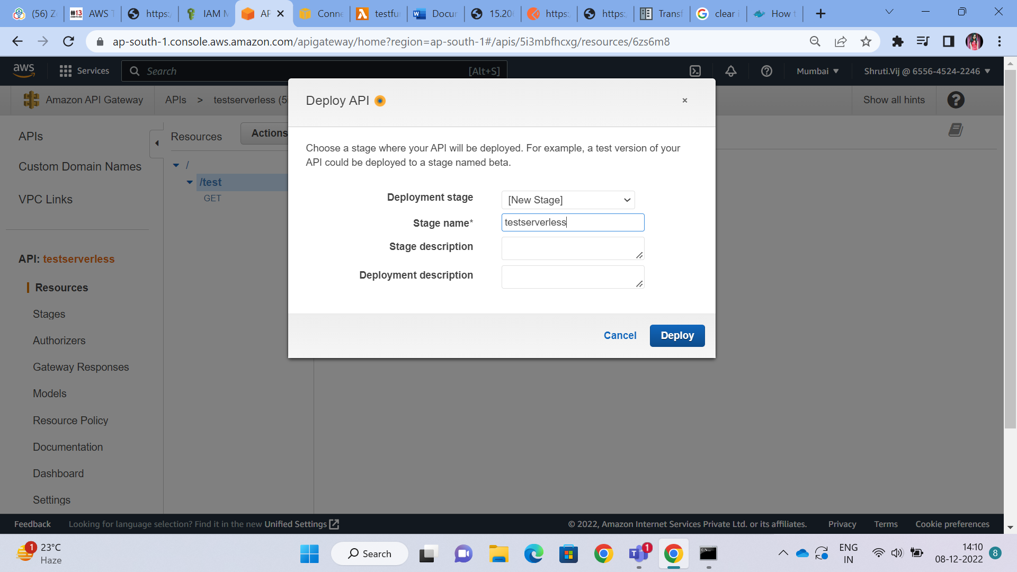

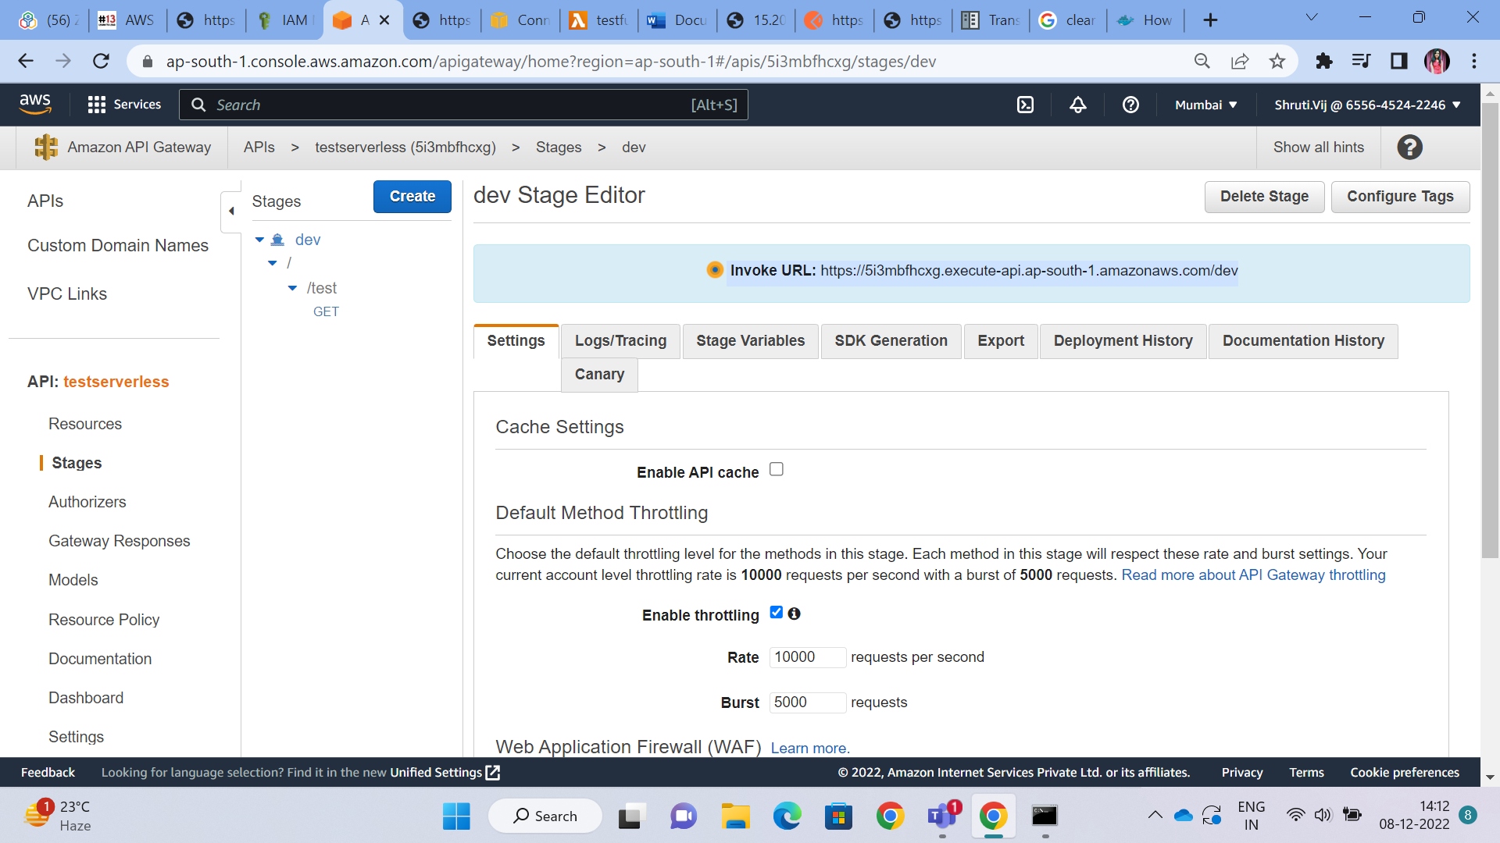

Now , from this DNS, we can see the application that is deployed on the Lambda