# Outputs of each Scenarios

## Filter.js

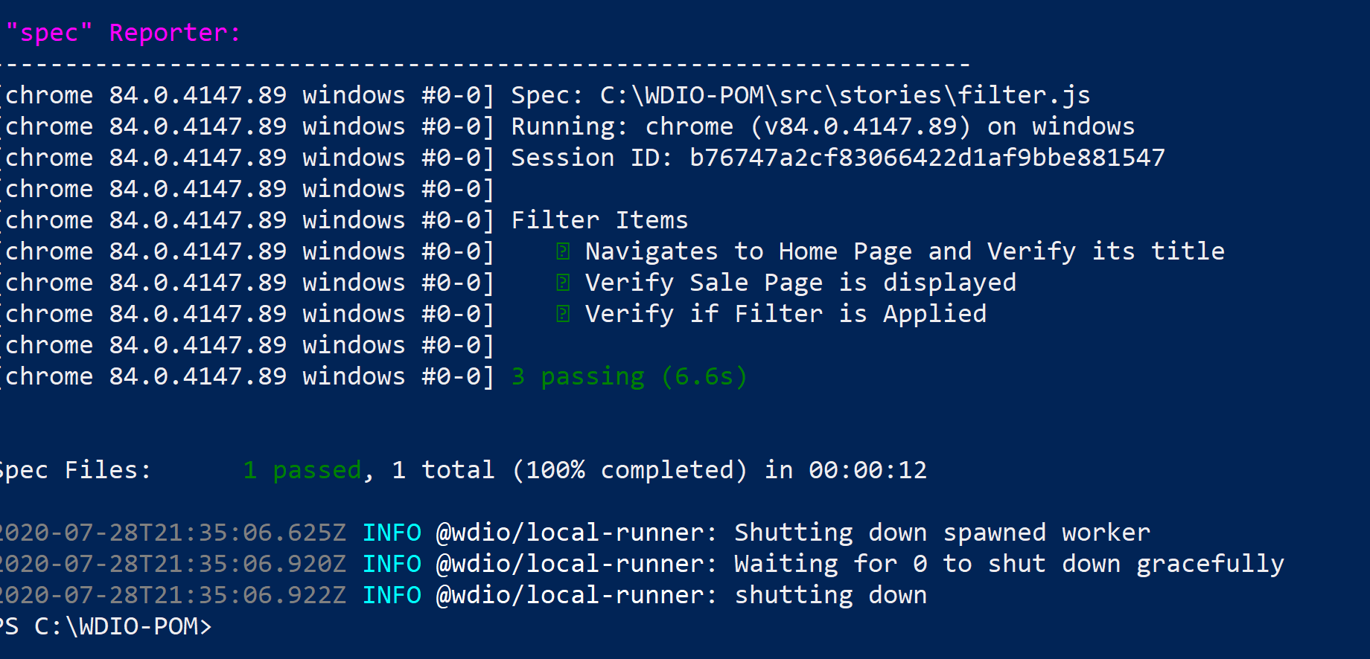

## login.test_InvalidCredentials.js

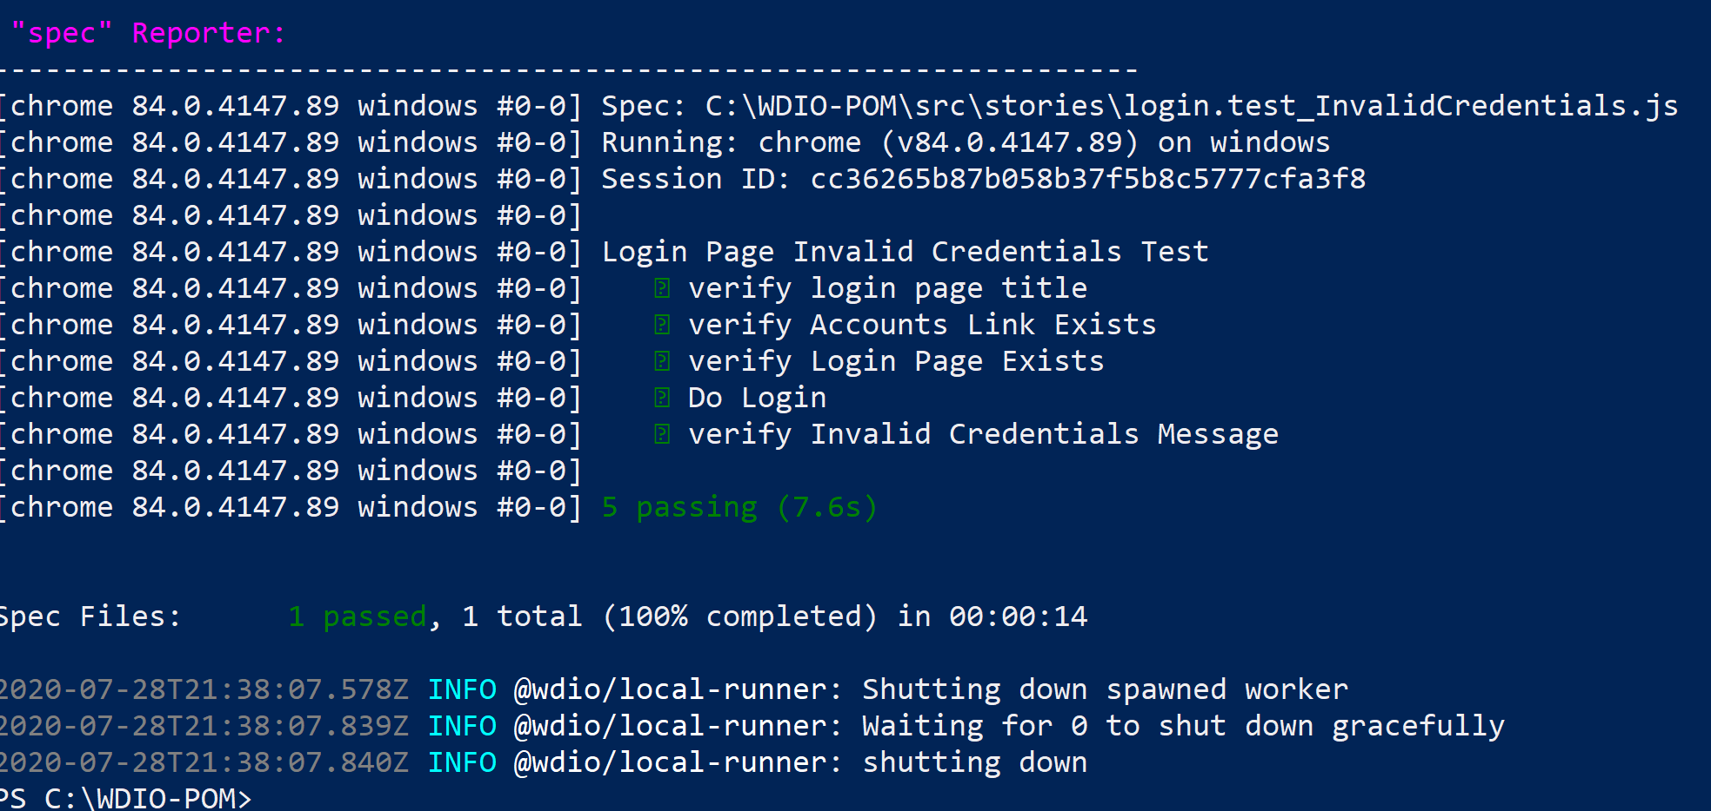

## login.test_RequiredFields.js

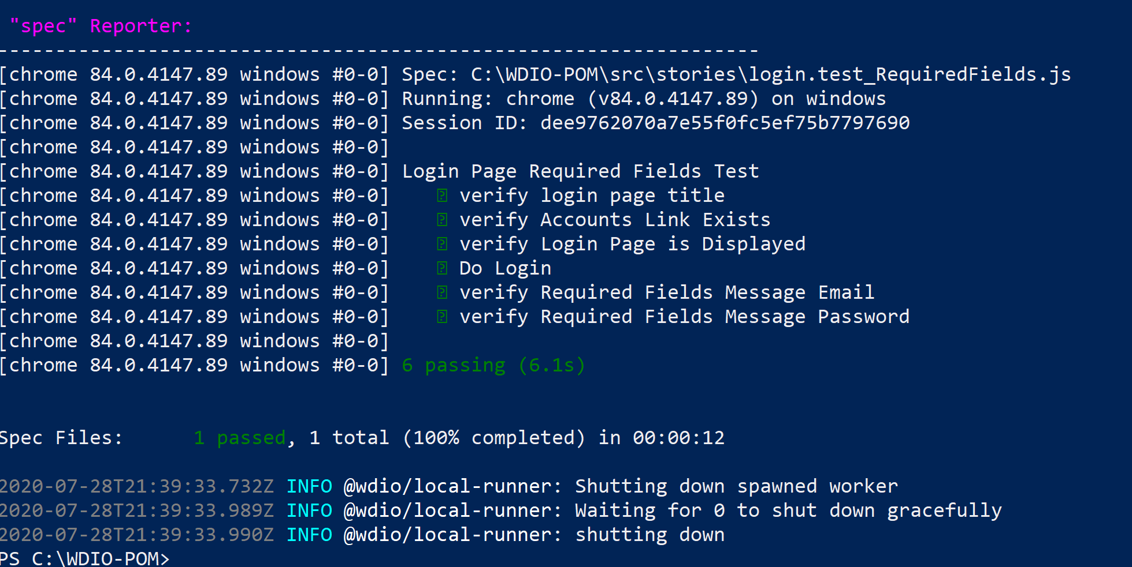

## Search-AddtoCart.js

