

What? A sign Language Learning Application

UX Design process

Reddy Sruthi Mada

# DESCRIBING OUR APP:

Our application is a fun and innovative way for people of all ages to learn some of the many different kinds of sign languages in the world right now. Communicating with a deaf or hard-of-hearing person can be frustrating for both parties when things get confusing. Our app will be able to teach the user their choice of sign language - may that be American, British, French, etc. - and will have daily reminders to continue their streak to help ensure the user really is learning. Our app will also have a social aspect that will encourage users to not only interact with their friends but also have them strive for better scores from games that teach so they can learn and play at the same time.

# WHAT MANUFACTURED ECOSYSTEM DOES IT SUPPORT AND HOW:

This app supports the Cultural Manufactured Ecosystem because it benefits the quality of life and community. More specifically, it falls under the subsection of Inspiration/Education. This comes from the education portion of the app which helps teach people how to learn sign language. The benefit of the Cultural Ecosystem service we targeted with this idea helps promote knowledge along with health and well-being (Ecosystem Services - nature's benefits 2023).

# WHAT APPS EXIST, AND HOW OURS IS DIFFERENT:

There are many apps available online for sign language, after doing some research we have found that most apps are either not free of charge(add reference), or just teach one sign language such as ASl or the app doesn’t allow for multiple users to share their progress and interact to create a community or they are only available for ios devices which create a barrier for people with financial difficulty and cannot afford expensive phones. Our app’s goal is to provide as many sign languages as possible, make it free and accessible for everyone while also creating a sense of community.

# WHY WOULD A USER WANT TO USE OUR APP (IN CONTEXT OF MANUFACTURED ECOSYSTEM):

The manufactured ecosystem that best fits our application is inspiration and education. This is the ecosystem for literature, art, and other forms of communication. Users will want to use our app because learning a new language is one of the best ways to communicate with others while also improving oneself. With changing times people want to develop relationships by making everyone feel seen. This could include taking efforts to learn a language someone is comfortable communicating with or gestures to show our love.Our app will teach users how to communicate with friends, family, and strangers, to have a more connected community regardless of the barriers.

# IDENTIFY HOW EACH PERSONA WILL USE EACH THING THAT THE USER WOULD LIKE TO DO WITH THE APP:

Our primary users are regular users who would like to learn sign language, improve their proficiency or learn a completely new language.The primary persona would essentially login to the app whenever they are free or when they are scheduled to learn and spend around 15 minutes average everyday to educate themselves, after which they might collect points according to their level of completion and use it change their avatars or they could spend time supporting their friends and family learning in the app by taking shared quizzes and sharing each other’s progress.

Secondary Users use the app less frequently 1-2x a week and spend an average of 5-10 minutes, they are learning sign language as a hobby or to communicate more efficiently with their closed ones.They are less likely to focus on getting points and change avatars but they might be more interested in recommending their friends to also join them.

SKETCH OF SCREENS IN THE APP:

# 



The above gif represents the character customization that is possible within our app. It will compromise different cosmetics which the user can earn by completing lessons faster than their friends and family.

## PRIMARY PERSONA: SARAH

|  | PRIMARY PERSONA |
| --- | --- |
| DEMOGRAPHICS | Our persona is a woman between the ages of 18 and 29, who identifies herself as deaf. She is a working woman, who is single and lives in a city.  Roughly 23% of Americans who rated themselves as “Deaf” confirmed that they were fluent in sign language, which is a considerably higher amount than the percentage of adults who rated themselves one higher on the scale. Of these, the most likely demographic to use sign language is between the ages of 18 and 29, however, no information could be gotten on ages below that as the study did not take minors into account. No information was given in regards to gender in deaf respondents specifically, though overall, those fluent in sign language are slightly more likely to be female. (Mitchell & Young, 2022)  There is no accurate data for Canadians, as any attempts to research this topic at this time have used terminology that excludes many deaf people (*Statistics on Deaf Canadians*, n.d.) |
| GOALS | She may want to learn sign language if she is not already fluent, and she may want to support her family or friends who may be using the app to learn. |
| CURRENT SOLUTIONS | There are apps that allow you to learn sign language, however, there are issues with them such as payment or videos not loading. As well, none seem to offer much social support in order to support friends and family learning through the app. Most apps that are known as the “best” in the market only teach ASL or offer only for IOS devices. |
| USAGE CONTEXT | She will likely use the app in the evening when she has time to study at home, or throughout the day in order to quickly offer support to her friends or family when they complete a lesson. |
| DEVICE PREFERENCES | She will likely want to use the app on her phone, as the ability to have notifications and portability would be beneficial. She is more likely to use an iPhone than an android (Howarth, 2023) |
| KEY FEATURES | She will want to be able to start her lessons at any level of fluency, instead of having it assumed that she is starting from the beginning, if she is using the app to learn. She will also want ways to support her family and friends who are using the app, such as sending over a "Congrats" upon completing a lesson, or a "poke" if they have not yet done their daily lesson.  She may also appreciate the use of the theme of the app featuring blue, as many consider blue to be the colour chosen to represent deaf people (*Colour Blue and the Deaf Community*, n.d.) |
| LEGAL ISSUES | AODA, Country based data protection acts, application best practices |
| DESIGN PREFERENCES | She will want there to be no necessary audio, and audio to be off by default. Visual feedback should be provided for everything that may rely on audio, such as submission of some information, getting an answer correct, or changing settings. Ways of contacting the developers in order to discuss bugs or other issues should be able to be done fully through text. (Roberts, 2023) |
| FEEDBACK / UPDATES | She will likely want a way to send feedback, both about the app's overall features, and about individual lessons in case there are oversights that are missed before they are available, such as the use of the wrong video or animation. She will want updates addressing these in a timely manner. She will likely not want updates that majorly change the app's appearance and/or function. |

## SECONDARY PERSONA: CHARLIE

|  | SECONDARY PERSONA |
| --- | --- |
| DEMOGRAPHICS | Large amount of secondary and postsecondary students learning due to convenience - courses offered in their school. Also expected to be very frequently learned for family members or occupations - with occupations benefitting from sign language being predominantly female. (Mitchell & Young, 2022)  Most parents of deaf children are hearing, with 95% of deaf children being born to hearing parents, meaning that they may want to learn ASL along with their child in order to better communicate. They may be more likely to use an app than attend a class if they are in a rural area with less availability (Weaver & Thad, 2012)  Hearing sign language users are predominantly female (51.75%), between 18 and 29 (21.18%), and rated their hearing as “excellent” (48.70%). (Mitchell & Young, 2022)  Based on this information, our secondary persona is a woman, between 18 and 29 years old, who rates her hearing as excellent. She may be learning sign language due to its availability through classes offered at her school and wants another way to study, or who feels it would benefit her in her career. She most likely lives in a rural area, and she may have a deaf child. |
| GOALS | Her goals would be to increase her fluency in sign language, possibly with the help of in person classes, and possibly with only the app, possibly to the point of being able to help clients, and possibly with the goal of being able to hold a basic conversation or read a book to her child. |
| CURRENT SOLUTIONS | There are currently apps available to learn sign language, however, some are buggy (video tutorials do not load), and many require payment, which can place a barrier before the knowledge and reduce desire to learn, especially if it is done with a subscription model and not a one time purchase. |
| USAGE CONTEXT | The app is likely to be used during the time she sets aside to study at home, likely in the late afternoon or early evening after work or school. She will have free time, however, she may be tired or unmotivated and struggle to do something too difficult at that time. She may also need to use it as a translator during work or school, in order to help her connect to her classmates or clients better. |
| DEVICE PREFERENCES | She is likely to use her phone to access the app, due to the ease of transportation and receiving of notifications. She is more likely to use an iPhone than an android (Howarth, 2023) |
| KEY FEATURES | She will be using the app primarily as a tool for learning, and will want easy access to all of the lessons, though she may want to input her specific goals in order to learn the topics she will need most first. She will also want easy access to a translation tool, in order to quickly learn phrases at work or school if she must communicate with a classmate or client quickly. She would also appreciate something to provide extrinsic motivation when she has had a rough day and is not motivated to learn herself, so including some kind of reward would be beneficial to her. |
| LEGAL ISSUES | AODA, Country based data protection acts, application best practices, End User License Agreement (EULA), |
| DESIGN PREFERENCES | She may want verbal instructions as well as visual, as she may learn better with multiple forms of instructions. She may also want ways to make the app feel more fun and less dry, such as the character customization and animated gestures instead of only videos offered. She may also want the option to have sound effects for stuff such as completing a lesson or changing a setting, and will want to have somewhere easy to find to turn that setting on. |
| FEEDBACK / UPDATES | She will likely want a way for her feedback to be heard, as well as updates with new lessons and character customization options. She will likely not want any updates that majorly change the app, in function or appearance. |

## NEGATIVE PERSONA:

|  | Negative PERSONA |
| --- | --- |
| DEMOGRAPHICS | People who have no interest in learning sign language. |
| GOALS |  |
| CURRENT SOLUTIONS |  |
| USAGE CONTEXT |  |
| DEVICE PREFERENCES |  |
| KEY FEATURES |  |
| LEGAL ISSUES |  |
| DESIGN PREFERENCES |  |
| FEEDBACK / UPDATES |  |

UX Research

FEEDBACK FROM THOSE OUTSIDE THE CLASSROOM: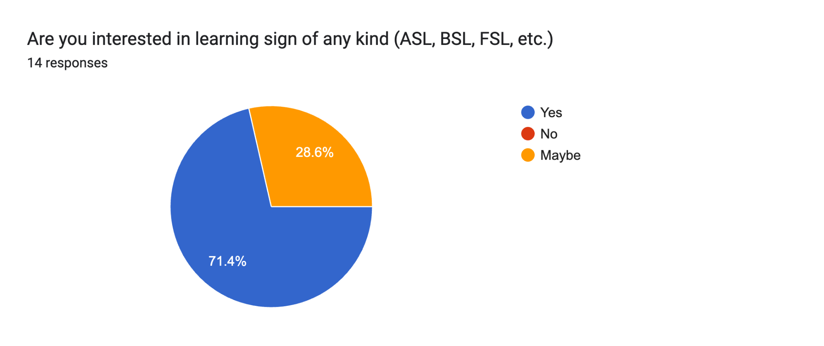

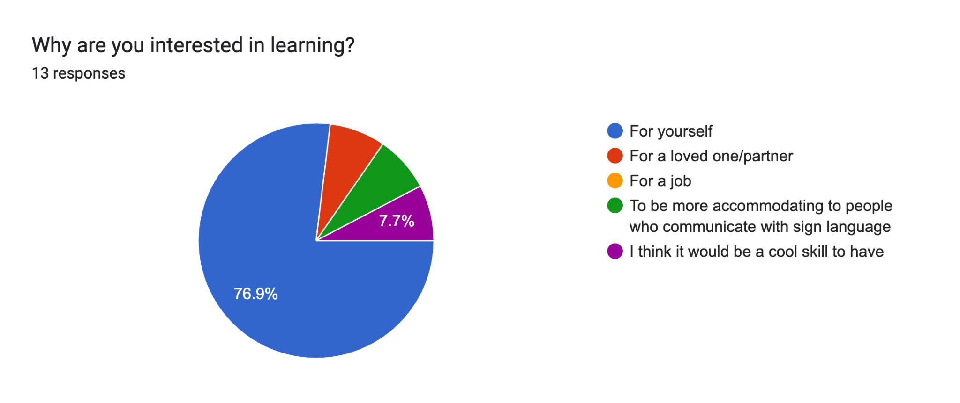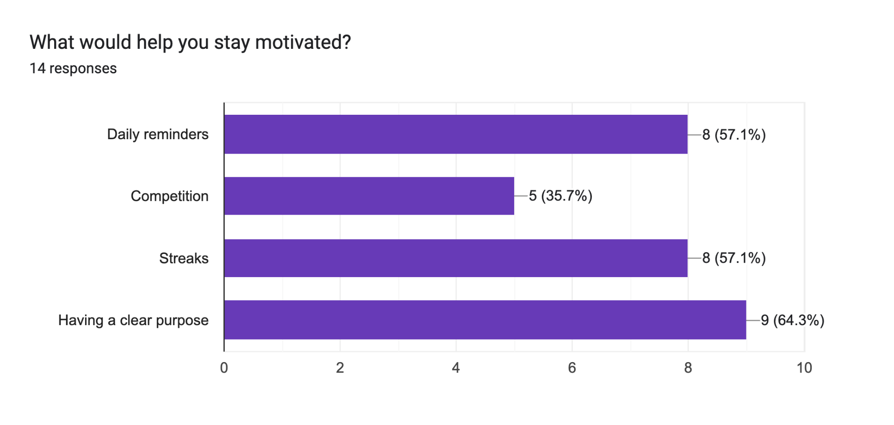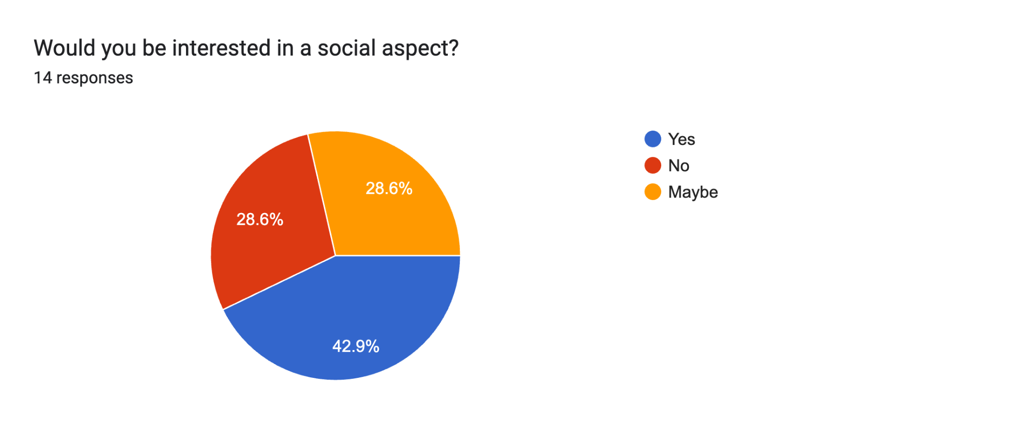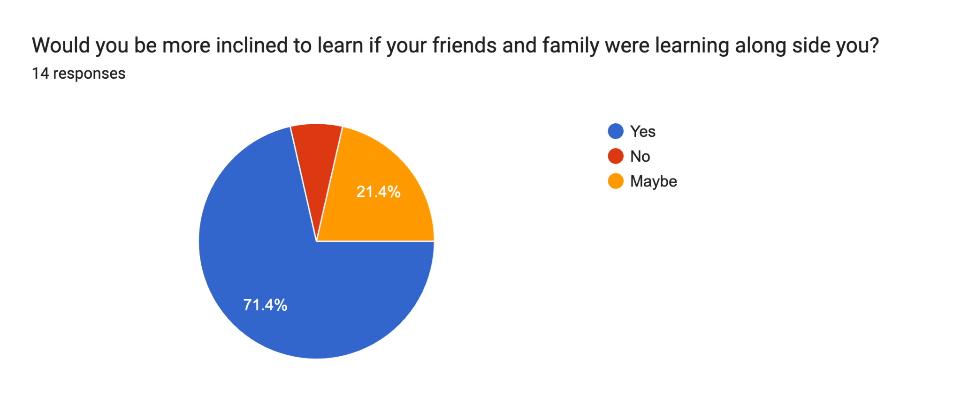

# How the app will support the manufactured ecosystem, with Academic Research:

Name of the app: What? (Sign Language Learning app)

The manufactured ecosystem chosen: Cultural Manufactured ecosystem.

The app falls under Cultural Manufactured ecosystem and under the Inspiration/Education subsection. Our existing applications for sign language learning involves traditional methods such as classes, online tutorials and book modules, these methods are still valuable but they can be limiting in terms of engagement and personalization. Our application will support the manufactured ecosystem education/Inspiration by providing a gamified version for users to learn sign languages in a fun and interactive way.

There also has been research showing the beneficial effects of gamification on the teaching and learning of new languages(Smith, K. (2018)). It has been demonstrated to enhance students' interaction with the material and boost their proficiency. Considering the inherent challenges in learning a new language, gamification emerges as a valuable strategy to enhance learner motivation.(Smith, K. (2018)).

Another study was conducted by researchers who collaborated with teachers and students from SK Pendidikan Khas Melaka.This study explores challenges faced by children with hearing disabilities, such as a lack of exposure to correct sign language and difficulties in focusing during learning(i-sign,2019). To address these issues, the study developed i-Sign, a learning application incorporating gamification, which was well-received in usability tests, showing promise as a tool to improve learning outcomes and promote sign language awareness.(i-sign,2019).

# Describe anything else your application might need

* Videos and picture resources from various sign language experts
  + This would feature all the types of sign languages that exist out there
* Access to the front camera to allow for the user to see themselves practice
* Access to contacts to suggest people to add their friends and family

# Identify use cases for the application:

1. View and complete a lesson in the Lesson/Home screen
   1. Opening a gift box after the lesson is done which you get a reward
2. Add a family member/friend as a connection and view that connection in the Connections screen
3. Customize your character in the Profile screen
4. View and navigate to a specific unit in the Units Map screen

# Evaluate your application with people outside the class, and discuss how this changed the app:

* Font in language selection is hard to read, have adjustable font size before that option
* Add a dark mode option
* Add a caption under the button to add a friend that says “add”
* Add text stating you’re adding a connection at the top of adding connection screen
* The button for adding a photo looks more like adding a profile photo than adding a contact, change instead to have a plus button next to family or friends heading
* X button after character customization doesn’t indicate saving changes
* Font on unit map screen is very small and difficult to read

Notes were taken during a session of user testing

# Wireframe Link:

<https://www.figma.com/file/AmpB2iU4283H5PscfqN4qO/alexanderbradshaw4's-team-library?type=design&node-id=0%3A1&mode=design&t=VuNQckdLfgYi8ZYL-1>

# Video Link:

<https://youtu.be/tot-Q9v4hnU>

# How the personas were considered:

The primary persona, Sarah, was considered in the design of the wireframe in the following ways:

* Sound effects are not the only method of providing feedback that the application uses, all feedback will be provided visually as well. Audio will be silent by default
* Both dark and light modes will be offered, as only light mode may be too bright to use later at night, when she may use the app
* She will be able to add and encourage her friends and family on the app
* The app will allow users to start out at a higher level of fluency, instead of being required to start at the beginning
* Blue will be used as the app’s main colour
* Contacting the developers about bugs or feedback will be offered fully through text

The secondary persona, Charlie, was considered in the design of the wireframe in the following ways:

* Lessons will be able to be downloaded in case of future unreliable internet
* Dark mode will be offered, in order to ease visibility at night when she may be using the app
* Motivation will be provided through rewards through the app in order to help her keep up with her studies
* She will be able to decide her goals from the beginning in order to learn vocabulary most relevant to her needs first
* Sound effects will be available to be turned on so that she can receive auditory feedback from the app, as well as visual

# Approaches to accessibility in the video:

* Closed captions were added to the video
* The video contains alternative text, with timestamps, for all visuals