PHASE 1: IDEATION PHASE
Customer Problem Statement Template
Date | 20 October 2026
Team ID
Project Name | HotelPro — Hotel Booking and Management Platform with AI Assistant
Maximum Marks | 2 Marks

Customer Problem Statement :
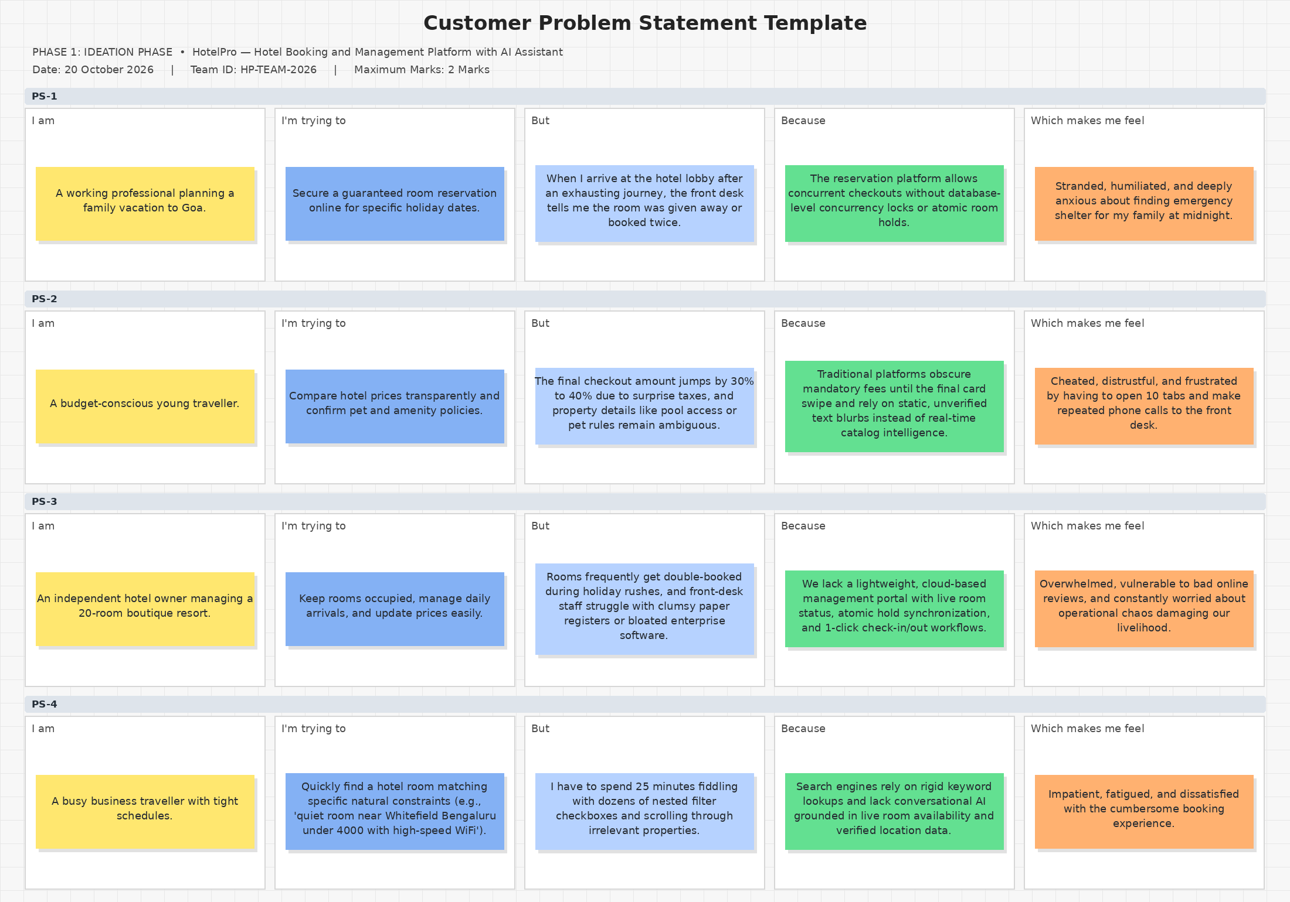

Problem Statement Formulation
Using the Miro Customer Problem Statement framework (I am / I'm trying to / But / Because / Which makes me feel):
PS No. | I am (Customer) | I'm trying to | But | Because | Which makes me feel
PS-1 | A working professional planning a family vacation to Goa. | Secure a guaranteed room reservation online for specific holiday dates. | When I arrive at the hotel lobby after an exhausting journey, the front desk tells me the room was given away or booked twice. | The reservation platform allows concurrent checkouts without database-level concurrency locks or atomic room holds. | Stranded, humiliated, and deeply anxious about finding emergency shelter for my family at midnight.
PS-2 | A budget-conscious young traveller. | Compare hotel prices transparently and confirm pet and amenity policies. | The final checkout amount jumps by 30% to 40% due to surprise taxes, and property details like pool access or pet rules remain ambiguous. | Traditional platforms obscure mandatory fees until the final card swipe and rely on static, unverified text blurbs instead of real-time catalog intelligence. | Cheated, distrustful, and frustrated by having to open 10 tabs and make repeated phone calls to the front desk.
PS-3 | An independent hotel owner managing a 20-room boutique resort. | Keep rooms occupied, manage daily arrivals, and update prices easily. | Rooms frequently get double-booked during holiday rushes, and front-desk staff struggle with clumsy paper registers or bloated enterprise software. | We lack a lightweight, cloud-based management portal with live room status, atomic hold synchronization, and 1-click check-in/out workflows. | Overwhelmed, vulnerable to bad online reviews, and constantly worried about operational chaos damaging our livelihood.
PS-4 | A busy business traveller with tight schedules. | Quickly find a hotel room matching specific natural constraints (e.g., 'quiet room near Whitefield Bengaluru under 4000 with high-speed WiFi'). | I have to spend 25 minutes fiddling with dozens of nested filter checkboxes and scrolling through irrelevant properties. | Search engines rely on rigid keyword lookups and lack conversational AI grounded in live room availability and verified location data. | Impatient, fatigued, and dissatisfied with the cumbersome booking experience.

