PHASE 1: IDEATION PHASE
Brainstorm & Idea Prioritization Template
Date | 20 October 2026
Team ID
Project Name | HotelPro — Hotel Booking and Management Platform with AI Assistant
Maximum Marks | 4 Marks

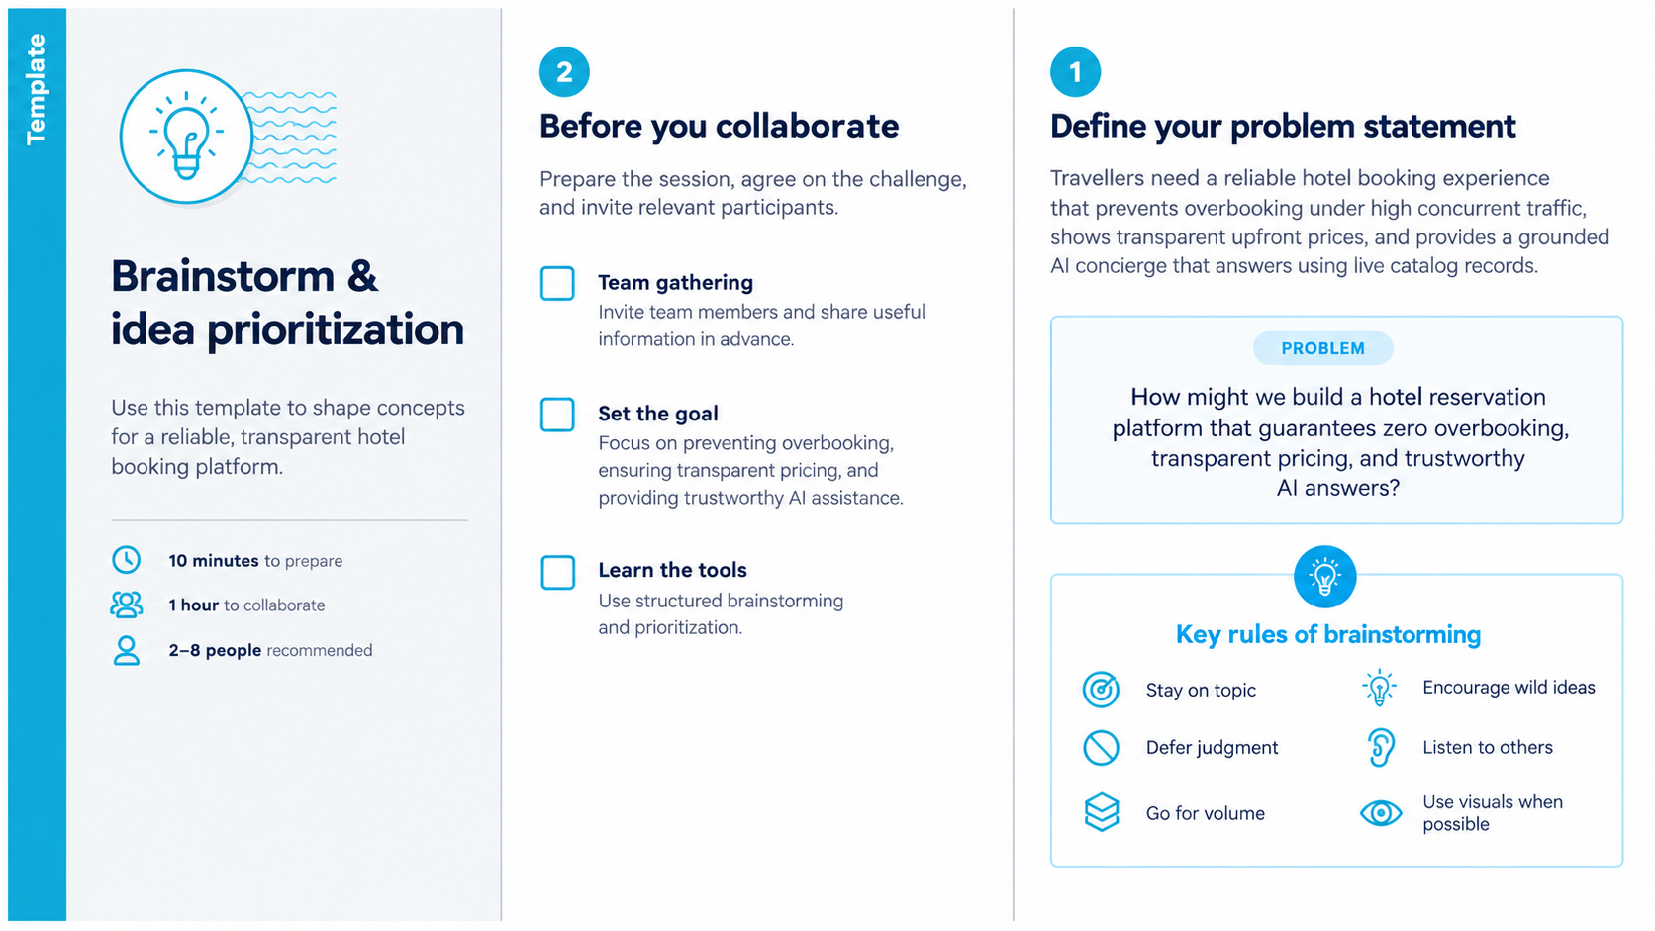
Step-1: Team Gathering, Collaboration and Select the Problem Statement
Step-2: Brainstorm, Idea Listing and Grouping
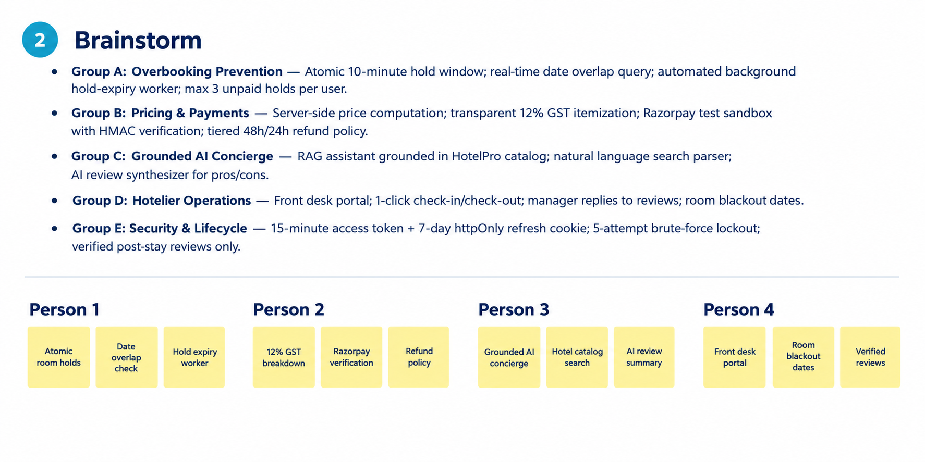
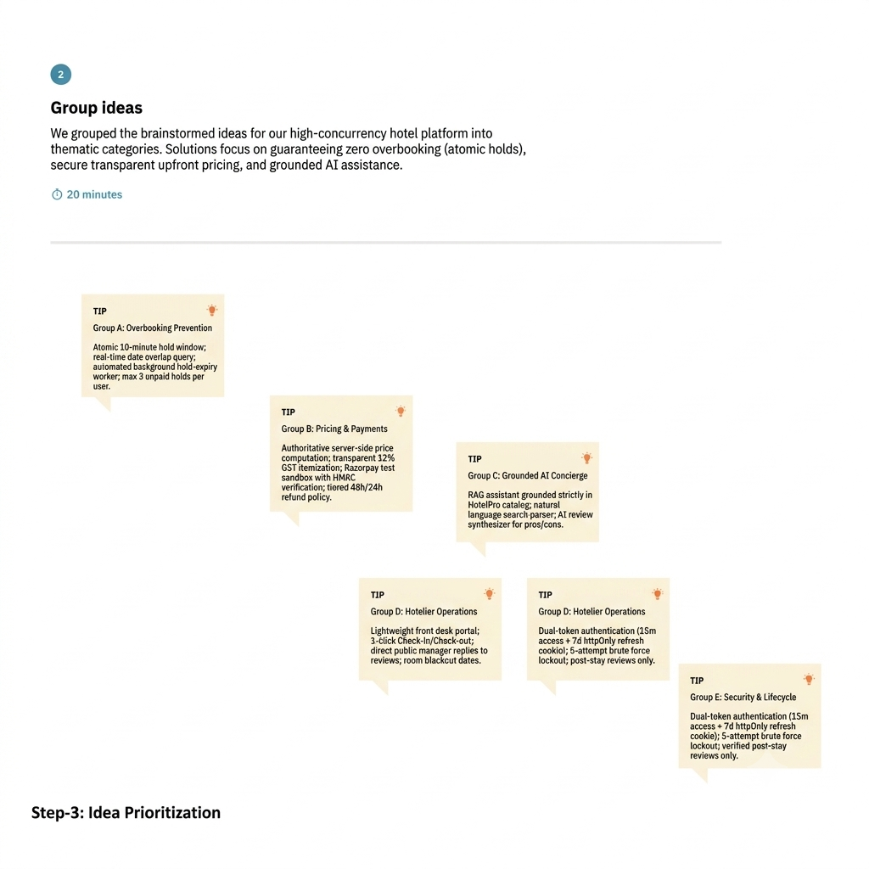
Step-3: Idea Prioritization
