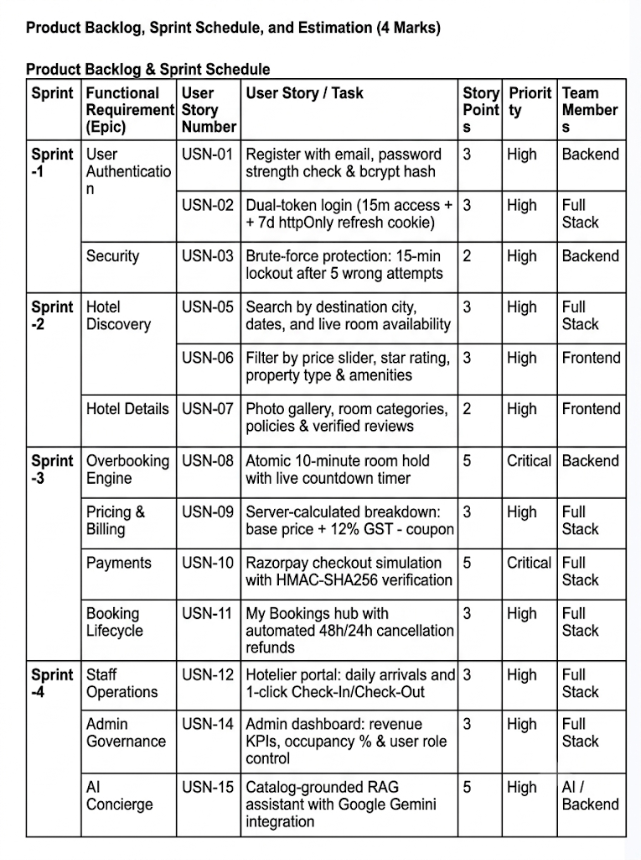
PHASE 2: PROJECT PLANNING PHASE
Project Planning Template (Product Backlog & Sprints)
Date | 20 October 2026
Team ID
Project Name | HotelPro — Hotel Booking and Management Platform with AI Assistant
Maximum Marks | 5 Marks

