PHASE 3: REQUIREMENT ANALYSIS PHASE
Solution Requirements (Functional & Non-Functional)
Date | 20 October 2026
Team ID
Project Name | HotelPro — Hotel Booking and Management Platform with AI Assistant
Maximum Marks | 4 Marks

Functional Requirements:
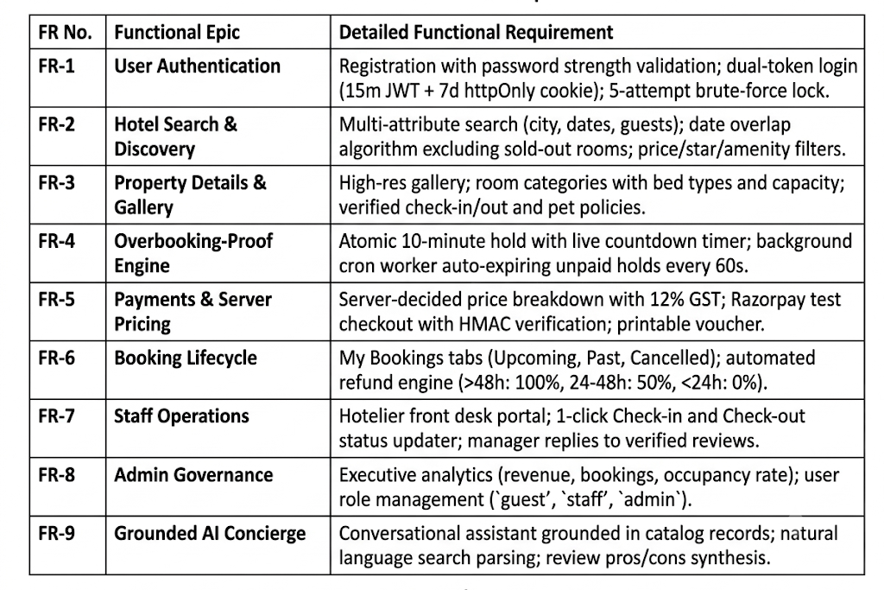
Following are the functional requirements of the proposed solution.

Non-functional Requirements:
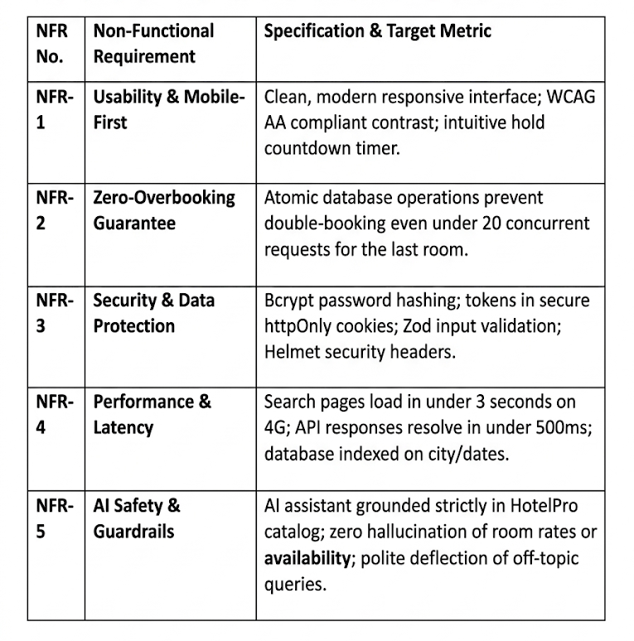
Following are the non-functional requirements of the proposed solution.

