PHASE 3: REQUIREMENT ANALYSIS PHASE
Data Flow Diagram & User Stories
Date | 20 October 2026
Team ID
Project Name | HotelPro — Hotel Booking and Management Platform with AI Assistant
Maximum Marks | 4 Marks

Data Flow Diagrams:
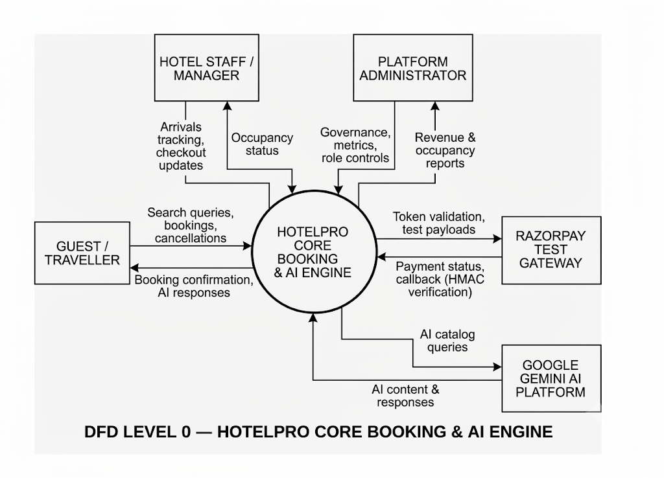
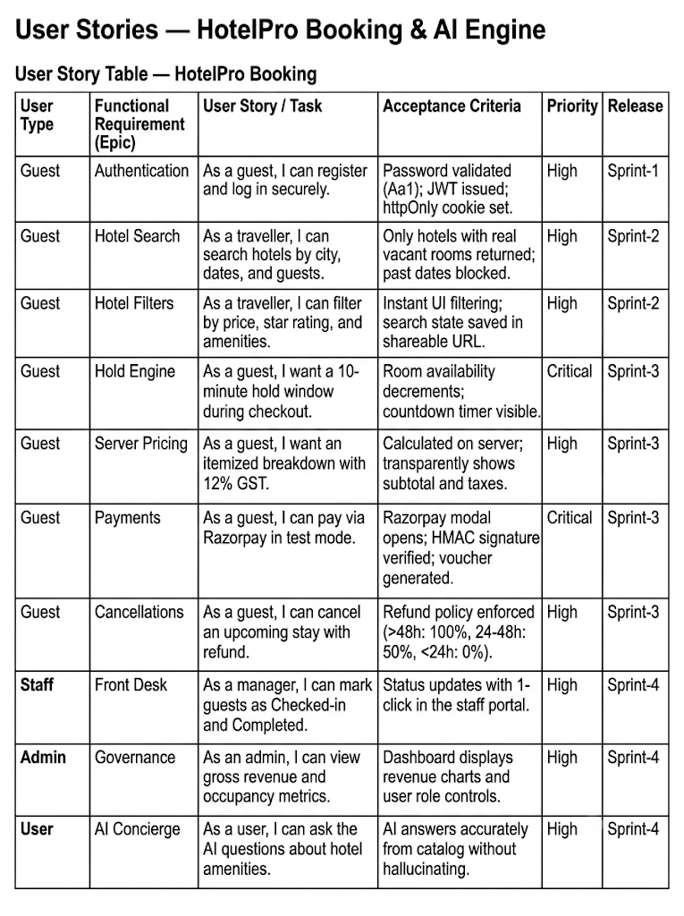
User Stories

