Git & GitHub — Quick Notes
What is Git?
• Git is a version control system.
• It tracks changes in code like a bank statement tracks transactions.
• It stores complete project history including additions, deletions, and modifications.
• It is the most popular version control tool worldwide.
• It is free, open-source, fast, scalable, and suitable for any project size.
Primary Uses of Git
- Tracking Code History
– Allows restoring previous versions easily.
– Prevents accidental code loss.
- Collaboration
– Multiple developers can work on the same project.
– Git keeps track of who made which changes.
What is GitHub?
• GitHub is a cloud-based platform that hosts Git repositories.
• Developers use GitHub to share, manage, and collaborate on projects.
• Repositories on GitHub are called “repos”.
• Used in resumes and portfolios to showcase projects.
Setting Up Git Locally
• Install VS Code (recommended editor).
• Install Git Bash (for Windows)
• Verify Git installation: git --version
Configure Git
• git config --global user.name "Your Name"
• git config --global user.email "your.email@example.com"
• git config --list to verify setup
Basic Git Commands
| Command | Purpose |
| git clone <repo_url> - Download a GitHub repo |
| cd - Change directory |
| ls / ls -a – Show all files / show all files including hidden ones | THIS IS SMALL “L”
| git status - Check changed files |
| git add <filename> - Stage files |
| git add . - Stage all files |
| git commit -m "message" - Save staged changes | -> record changes
| git push origin - Upload commits to GitHub |
Example:
git push origin main
Initializing a New Git Repository
Create a folder → open in terminal → git init → create files → git add → git commit → git remote add origin <repo_url> → git push -u origin main
Tip: Better to create repo on GitHub first and then clone it.
COMMANDS
- git init
- git remote –v (to verify remote)
- git branch (to check branch)
- git branch –M <bname> (to rename branch)
- git push origin main

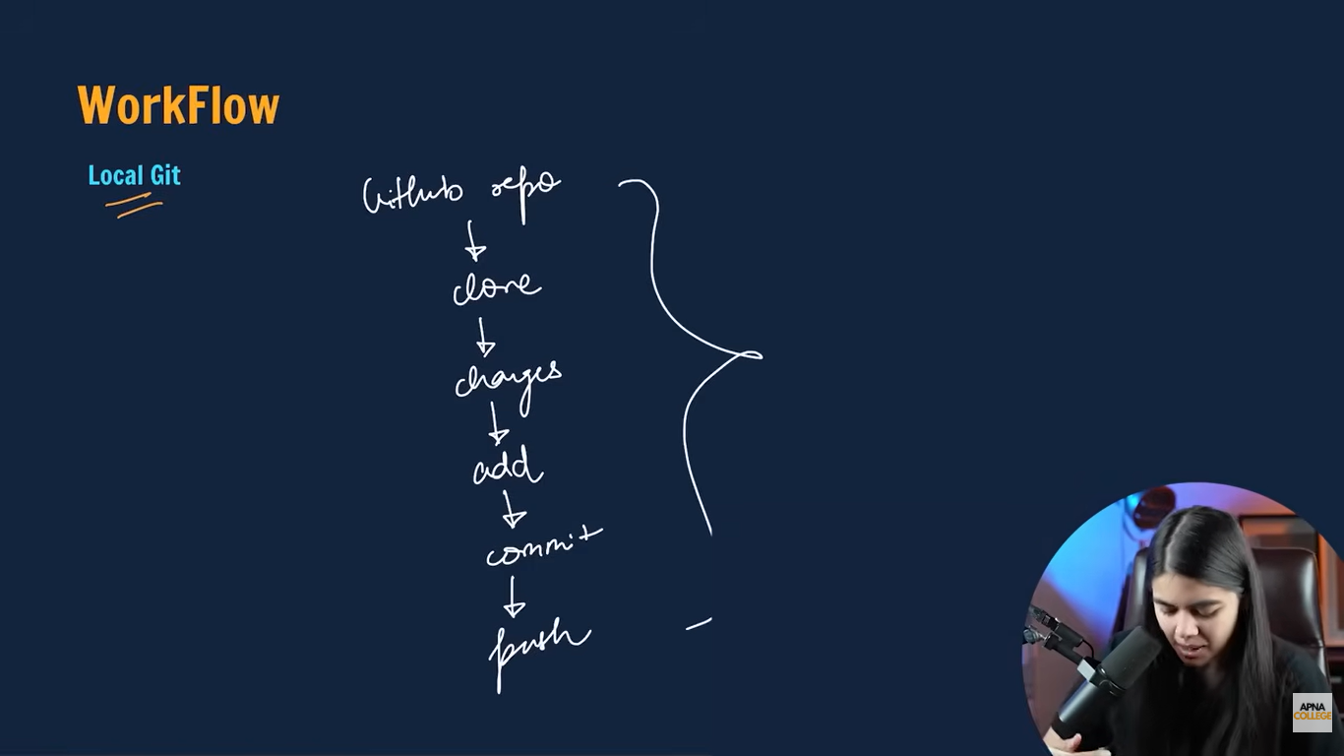
Branches in Git
• Branches allow working on new features without affecting the main project.
• git branch — list branches
• git checkout — switch branch
• git checkout -b <new_branch> — create and switch to new branch
• git branch -d <b-name>— delete branch
• git push origin — upload branch to GitHub
Merging and Pull Requests
Merging combines code from different branches.
git merge <b name> — merge branch into current branch
git diff <bname> - to compare commits, branches, files and more
Pull Request (PR) on GitHub allows code review before merging
- git pull origin main (used to fetch and download content from a remote repo and immediately update the local repo to match that content)

Merge Conflicts
• Happen when two developers edit the same part of a file.
• Conflicts must be fixed manually in the editor.
• After resolving conflict: git add + git commit
Undoing Changes
Unstage files
• git reset
• git reset (unstage all)
Undo last commit but keep changes:
• git reset HEAD~1
Undo last commit and delete changes:
• git reset --hard HEAD~1 (use with caution!)
See commit history:
• git log
Reset to a particular commit:
• git reset --hard <commit_hash>
Forking Repositories
• Forking creates your own copy of someone else’s repo on GitHub.
• Used to contribute to open-source projects.
• After making changes, submit a Pull Request to original repo.
Keyword and Meanings:
(if you can’t anything on local machine and it is not added to github then “git status” command will display.
Untracked – new files that git doesn’t yet track
Modified – changed
Staged – file is ready to be committed
Unmodified – unchanged
