**Task 1:**

**Design a Data model comments given by various users on stock symbols**

**COMPLETE OUTPUT AFTER TABLE CREATION🡪**

**Queries:**

**1.What are the various comments given by all the users?**

scan 'shrutihbase_db:stock_details', {FILTER => "ColumnPrefixFilter('Comment')"}

**2.What are the comments by user3?**

scan 'shrutihbase_db:stock_details', {FILTER => "ValueFilter( =, 'binary:user3')"}

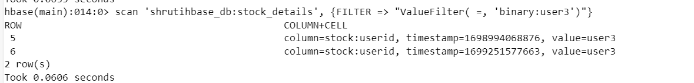

**3.Which users have inactive comments?**

scan 'shrutihbase_db:stock_details',{ FILTER => SingleColumnValueFilter.new(Bytes.toBytes('stock'), Bytes.toBytes('Active'), CompareFilter::CompareOp.valueOf('EQUAL'),

BinaryComparator.new(Bytes.toBytes('False')))}

