**Task 3:**

**Create a table album in hive with the following data**

1. **Create a table in Hbase (using hive-hbase integration) with proper row key design efficiently to load the data from hive to hbase.**

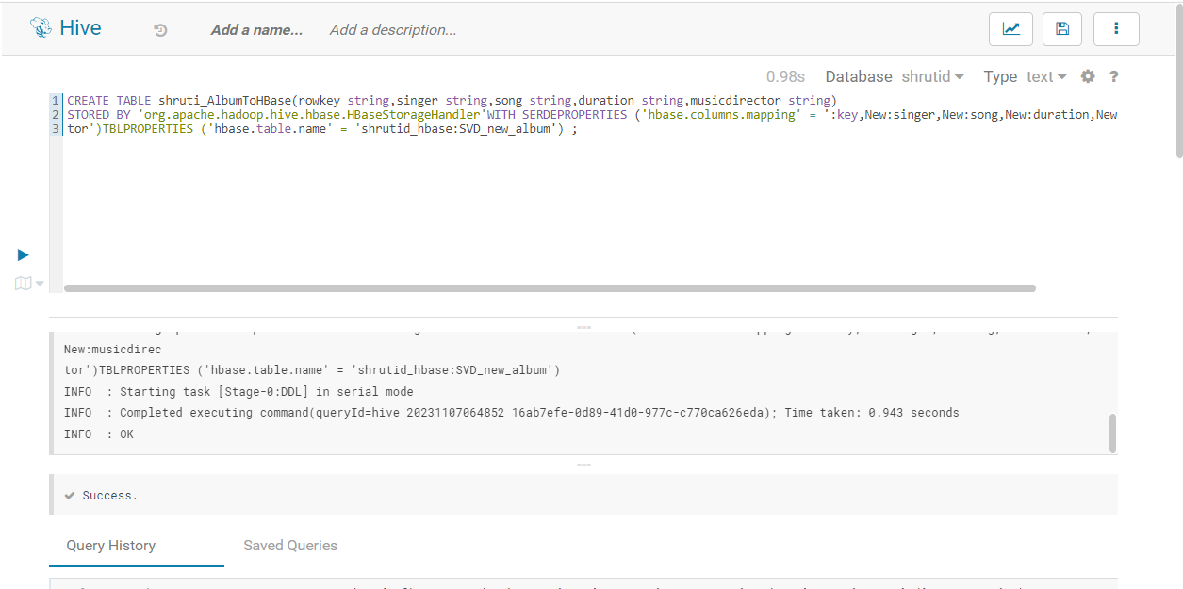

1. **There shoud not be any data loss when moving data from hive to hbase**
2. A screenshot of a computer

   Description automatically generated

**3. Run queries like**

**1) get all songs sung by a singer**

**2) Which singer sung for music director AK and what were the songs**

