**Create external tables for drivers and timesheet data and answer the following queries**

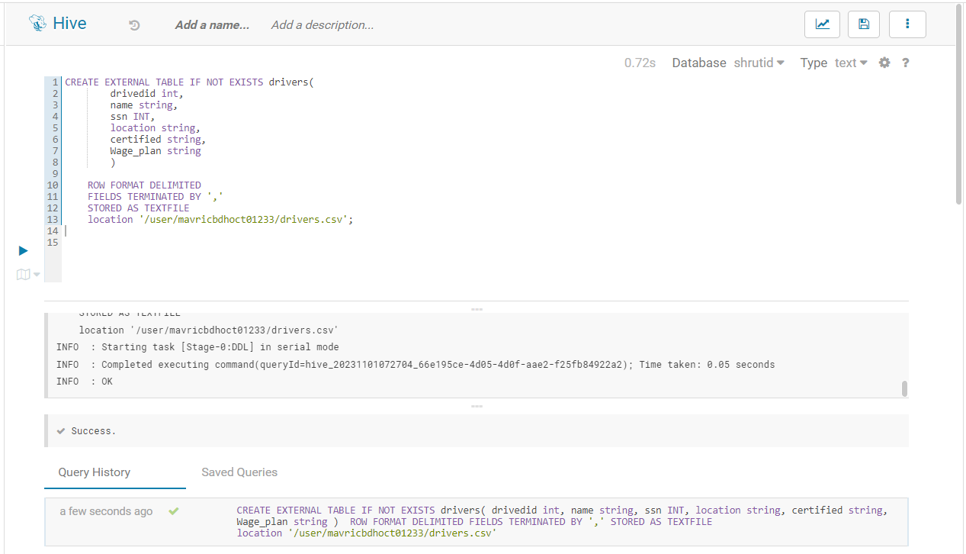

**Query: 1 How many total hours and miles logged by each driver?**

**Query:2 Print the name of the driver in the above query**

**Query: 3 Write the above query output in to hdfs directory**

