**Ques-1. Data Setup in HDFS**

Step 1: Copy the provided csv files in a directory named AirlinesOntimeAnalysis



Step 2: Unzip the contents for the bz2 files.

Step 3: Create the directories in hdfs where your data will reside

rawdata/airline/flights

rawdata/airline/planeinfo

rawdata/airline/airport

rawdata/airline/carriers

Step 4: copy the respective files to the above created hdfs structure

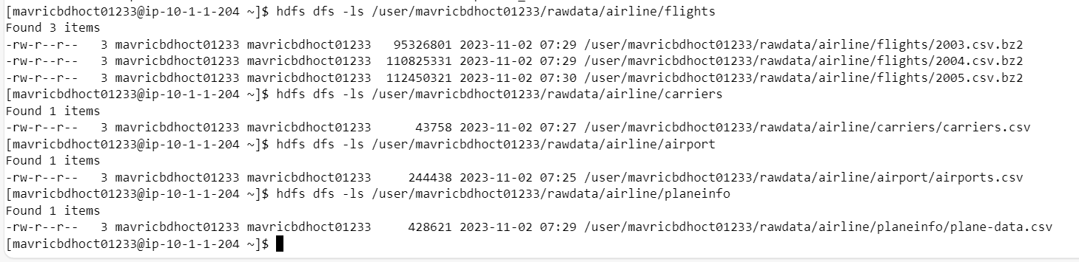

**Ques-2. Create tables using Hive**

**What is the average arrival delay and average departure delay in each month of the year 2004?**

**Ques-3. Improving the performance of Hive tables - Parquet format**

**CREATE EXTERNAL TABLE flights_pq**

**STORED AS PARQUET**

**LOCATION '/user/mavricbdhoct01233/output/airline/pq_flights'**

**AS**

**SELECT * FROM flights_stg;**