On 06-Aug-2015, at 5:06 pm, PC Chitalkar <[no-reply@evernote.com](mailto:no-reply@evernote.com)> wrote:

* **App 1 : Field Officers Checks / Conveyance**
  + Phase 1
    - Web App / Services
      * Create Sites
      * Create FO
      * Create SO
      * Create Guards
      * Associate Guards with Sites *** - not needed
      * Associate FO with sites - no route mapping - min alternate day - set by site
      * Reports
        + Guard check report
        + Conveyance per FO

Longest route by Google maps

Mark as paid

* + - Mobile
      * App scans QR
        + If QR = Site then logs geo location & time stamp
        + If QR = Guard then drop down list of options

OK - * rating

NOT OK - Turnout

NOT OK - Discipline

NOT OK - Sleeping

Photos to be taken on each option

Notes to be take on each option

* + - * All data to be stored on device, app should be 100% offline (Guard & Site QR data can be a sync via push notification - 1/2 times per week OR on demand)
  + Phase 2
    - Web
      * Recruiting documentation of Guards (SNG)
      * Finger print & photo recognition
    - Mobile
      * Crowdsource guard check
      * Public app - can download & scan site QR (every site will have one) OR Guard QR & enter response
      * Multi lingual (hindi / other indian languages)

From: **Ajit Maya** <[no-reply@evernote.com](mailto:no-reply@evernote.com)>  
Date: Tue, Aug 11, 2015 at 8:02 PM  
Subject: Security App

Company Hierarchy

* company (multi company)
* registered office (can be more than one)
* contacts - user / non user type (can be mapped with system roles)
* customer - who can have multiple sites
* region / zone ()
* branch
* site

OM (Operation Manager) - Mostly like super Admin

RM - can have 2 regions

guard will not have access to system

Guard - SNG duplicate from form entry

Site and Guard - any FO can submit report for any guard, (it may be possible that FO can inspect a guard who is not in his jurisdiction). Data model required and UI too

FO - temporal assignment of sites to FO and need to factor in the DB.

FO will have 3 activities,

* self attendance - geo location and time stamp
* site report -
  + form with question and and -
  + 4 field (but QA are not fixed and
  + QA differ from site to site
* Guard check -
  + scan QA of guard,
  + photo,
  + QA,
  + forms questions positive and negative

Reports

* conveyance report -
  + map,
  + sequence of location visited,
  + geo location delta from actual location of site.

|  |
| --- |
| **Secure App Client Review Feedback - Mobile Feedback Included (Updated 9th Oct 1PM)** |

* Mobile App
  + Clean up main screen
    - Make user name look better and cleaner, right now looks ametuer
    - Remove “enter scan code” text and replace with “Enter Code” and only keep it 1 time (inside the box) no need to label the box
  + Sync issues
    - We need a sync button on top that shows an error in case of a pending sync
    - Long tap on Sync button can show an option to email logs (from mail client on phone : to [support.secure@6degreesit.com](mailto:support.secure@6degreesit.com))
  + Flow issues
    - On Login we need a button that says “Attendance Mode” this will trigger the front camera based attendance flow
    - Guard audit options in the site are not needed at all. The QR will recognise a guard and ask the right questions. Please remove all those buttons (add image, remark etc)
    - Here is a document where I have detailed the flows <https://www.dropbox.com/s/r6eke6steg9lbn2/Security_App_Mobile_V2.pdf?dl=0>
* Physical Testing Issues
  + 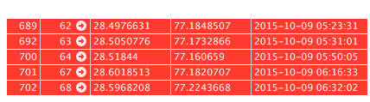 I did some testing this morning and 2 locations 66 & 65 did not post. 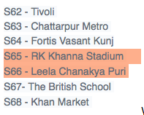We need to check what happened here
  + I think phone sync will clear this up
* Dashboard
  + Site title - no need to show address use a title for each site
  + Clean up UI
    - Reduce field size
    - Make the filters in 1 line
    - remove TYPE
    - make Survey response hyperlink
  + Role based security (company admin / users to limit to that company)
* Conveyance report - FIX as per dashboard
* Site List - Site name not showing
* Site Creation
  + Drop down list of Branches showing ALL Branches - not filtered by company 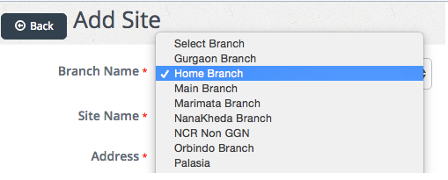
  + Longitude Spelling wrong
  + We need to clean up UI and TAB sequence
* Customer creation
  + Creation of customer has some illogical fields , pls review and fix
    - Add website
    - Add email
    - Add Primary contact
    - Zip = PIN / Zip
* Guard - Convert to wizard
  + This form needs to be saveable partially, it is too big to be stored in 1 shot
  + Documents will be at least 5-7
  + Incorporate previous company work experience (discussed with Amit) - reference to company table (enter without LISC code)
* Add user
  + Adding FO user directly shows site list - this needs to be filtered (company - region- branch) And I can assign him multple regions / branches
  + FO User can be limited to multiple branches and just give all sites under that . No need for site level mapping
  + Site area to have site name not address 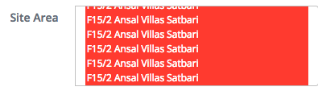
* New Features
  + Roles and permissions need to be tighter. Currently lot of things are not working.
  + Create custom checkin verification page - Separate page permission by company / region / branch
  + Change all drop downs to Type aheads (P2)
  + Guard profile page & PDF after all details are filled out ** (PC to provide fields)
  + Questions
    - Add a flag on the question response table “IS Alarm"
    - This flag will trigger a notification if on a condition
    - EG . Was Guard Drunk? On the YES response it will “IS Alarm"
    - Lets think more about it. maybe we need an alarm question type itself.
  + Site creation lat long move internal like TBD
  + Dashboard re-factor
    - Default load (1 day / ALL FO / ALL Branch / ALL Region)
    - Only single date selection & Single FO selection
    - Map to show route plus location plus delta
    - For multi FO or multi day report goto Conveyance report
  + Conveyance report
    - PDF Conveyance report with Map and list of movement - Will ONLY work for single FO
    - Group by FO and then Group by Day - collapse for total and expand for detailed listing of that day
    - Fields to match current dashboard
    - Survey questions to be hyperlink
    - Add Region  & branch filters
  + Check Roles & Permissions
  + Branding Changed to TRUE TRACE

-------- Forwarded Message --------

|  |  |
| --- | --- |
| **Subject:** | Secure App Client Review Feedback |
| **Date:** | Fri, 2 Oct 2015 13:58:09 +0000 (GMT) |
| **From:** | PC Chitalkar [<no-reply@evernote.com>](mailto:no-reply@evernote.com) |
| **Reply-To:** | PC Chitalkar [<p.chitalkar@6degreesit.com>](mailto:p.chitalkar@6degreesit.com) |
| **To:** | [ajit.maya@6degreesit.com](mailto:ajit.maya@6degreesit.com), [amit.bokde@6degreesit.com](mailto:amit.bokde@6degreesit.com), [abhishek.shukla@6degreesit.com](mailto:abhishek.shukla@6degreesit.com) |

* Call feedback
  + Date time on dashboard to be separate columns - group by date
  + Delta rename Distance / Difference
  + Site title - no need to show address use a title for each site
  + Search on dashboard
    - break up client / site in a dependent list
    - add region
    - search by site ID or title
    - FO
    - If possible do a combined search
  + Role based security (company admin / users to limit to that company)
  + Guard self attendance and guard audit module to be DEMOed next week
  + For FO module QA team to run physical checks next week in Indore
* New Features
  + Store LAT LONG when user is created using his address
    - When user logs in for the first time, we will start their day and also show delta form starting location to address lat long
  + Add 2 columns to site_visit take
    - Description
    - Verified by
  + Smartphone FO user will have a button saying “New Visit” - this will open up a text box for description (can be blank) - this will be saved as a row with SITE ID NULL (or another code) in site_visit table
    - Web user can see this in the list and verify it by changing the description
    - This will be used for random visits to other locations that is not a site (bank, official work etc)
* Report Logic - as discussed with Ajit sir & amit, this needs to be re-worked
* Site Creation
  + If lat long is not found in site add process it throws a DB error
  + If upload folder permission is missing in site creation, it throws PHP error.
* Company creation
  + Creation of company have some illogical fields , pls review and fix
  + Add Branch - this needs to have company filter - right now it is showing ALL region of ALL companies



* Customer creation
  + Creation of customer has some illogical fields , pls review and fix
* Guard - Convert to wizard
  + This needs to be broken into clear blocks
    - Bio Information - Name, Address, Phone
    - Qualification
      * Languages (Check box)
      * Experience
        + Skill / Years - 2 boxes with option to add more, skill drop down

Guard

Supervisor

Housekeeping etc — this list should be XML or come from DB

* + - * + Documents - Next
    - This form needs to be saveable partially, it is too big to be stored in 1 shot
  + Add user
    - Adding FO user directly shows site list - this needs to be filtered (company - region- branch) And I can assign him multple regions / branches

|  |
| --- |
| Security App Demo #2 |

* **Attendance Mode**
  + Attendance Mode UI option on login page is looking bad we need to fix it add a slider or make a better looking button Or maybe make a separate APK?
  + Camera (front) after OK on guard profile is inverted as a result images are getting loaded as inverted
  + On attendance screen we can load a smaller image
  + QR code will also load on front camera (or it should be optional to rotate the camera)
  + IN guard_attendance table there should be 2 column (recored by & verified by) currently we are showing directly verified, this will be a  web feature
  + 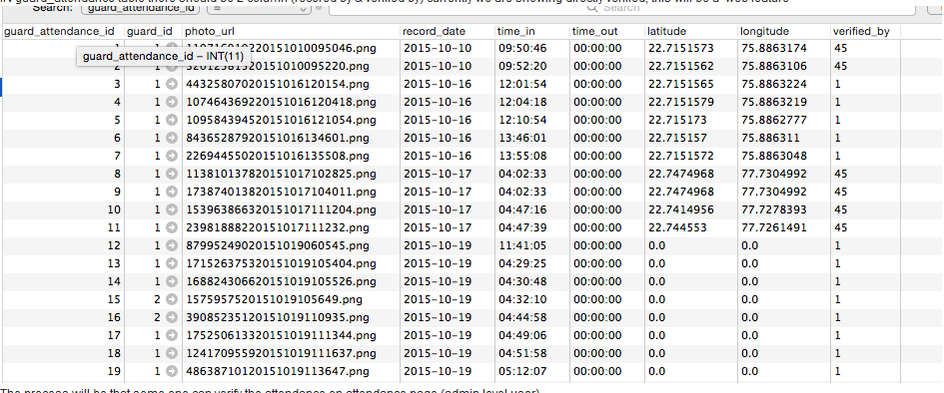
  + The process will be that some one can verify the attendance on attendance page (admin level user)
  + Remark column is also needed
  + NEW - SITE ATTENDANCE REPORT (NEW as per CAPSI requirement)
    - When Attendance mode login occurs we will scan SITE QR first to associate site with this will add “site ID” to each row in guard_attendance table
    - Instead of user name we will show client & site name in 2nd screen of app where user is scanning QR
    - WE will generate a report (daily / monthly) of all attended guards per site (ONLY showing present guards not showing absent guards (we do not know absent guards)
    - In monthly report it will be grouped by day
    - IN admin version of this report TIME of attendance will be shown and in CLIENT version of this report ONLY “P” will be shown to mark present
    - For each site time we will list 3 shift start times & a threshold time so If shift start time is 8AM and threshold time is 1 hour then attendance at 9.01 AM will NOT be recorded (no error message to guard) & it will show in a LATE report - where admin can manually change the time
* **WEB**
  + <http://secure.6degreesit.com/guard/survey/OTM1> - Needs formatting
  + IN guard model included Status flags (active, not recruited, retired, BLACK LIST)
  + For uploaded documents store key ID to make it searchable WITH a label, e.g. when you UPLOAD Adhar card you can enter Ahdar number & for PAN card PAN number
  + User needs to have a lisc code as well (sorted by company with a valid from & to  date)
* **GENERAL APK ISSUE**
  + NO logout button in APK (not working on Nexus 6)
  + SYNC error etc not showing, how can we test Offline mode - we need a way for the app to sync all company related data on initial login on the app. We can ask the user to make a first login in wifi.

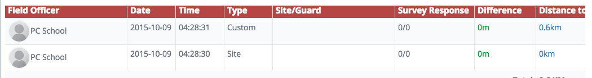

I found a small bug.

If you login and then do a custom check from the same place .. I moved maybe 20 steps

then it shows a difference of 400-500 meters

Not a big deal but interesting bug