Dissertation Submitted for the partial fulfillment of the **B.Sc. as a part of M.Sc. (Integrated) Five Years Program Data Science** degree to the Department of AIML & Data Science.

**Project Dissertation**

B2B Chatbot for Construction Industry

submitted to



By

**Shruti Hemant Agarwal Semester-VI**

**M.Sc. (Integrated) Five Years Program AIML/Data Science**

Department of AIML & Data Science.

School of Emerging Science and Technology Gujarat University

**June, 2022**

**DECLARATION**

This is to certify that the research work reported in this dissertation entitled “**B2B ChatBot for Construction Industry**” for the partial fulfilment of B.Sc. as a part of M.Sc. (Integrated) in Data Science degree is the result of investigation done by myself.

|  |  |
| --- | --- |
| Place: Ahmedabad | Shruti Hemant Agarwal |
| Date: 9th June, 2022 |  |

**ACKNOWLEGEMENT**

The success and final outcome of this project required a lot of guidance and assistance from many people and I am extremely privileged to have got this all along the completion of my project. A project is an extension among hypothetical and reasonable learning and with this thinking I chipped away at the project and made it effective because of convenient help and endeavors of all who helped me. All that I have done is only due to such supervision and assistance and I would not forget to thank them.

Firstly, I would like to thank Dr. Ravi Gor, co-ordinator of Department of AIML & Data Science, School of Emerging Science and Technology, Gujarat University for providing me an opportunity to do the project work and giving his support, resources and guidance for my project work. I'm incredibly appreciative to him.

Then I would like to regard and express gratitude towards my faculties Mrs. Rashmi Kumari & Mr. Eric Shah, for their enthusiasm, patience, insightful comments, helpful information, practical advice and unceasing ideas that have helped me tremendously at all times in my project which made me complete the project duly. Their colossal information, significant experience and expert skill has empowered me to effectively finish this project. Without their help and direction, this project could never have been conceivable. I could never have envisioned having superior coaches in my review.

I'm likewise grateful to the university admin staff for their consistent support and assistance. All that I have done is simply because of such management and help and I wouldn't neglect to say thanks to them.

Last but not least I would like to thank my friends and my parents for their encouragement and help in designing and making my project inventive. I am in debt of all these. Only because of them I was able to create my project and make it good and enjoyable experience.

Thanks everyone for all your encouragement & support.

~ Shruti Hemant Agarwal

**Table of Contents**

List of Figures 5

List of Abbreviations 5

Abstract & Key Words 6

Abstract 7

Key words 7

Chapter 1: Introduction 8

* 1. Background 9
     1. What is a ChatBot? 9
     2. Why Construction Industry? 9
     3. Why ChatBot in Construction Industry? 10
  2. Problem Definition 10
  3. Objective 11

Chapter 2: Basic Terminology & Concepts Used 12

Chapter 3: Literature review 14

Chapter 4: Methodology 16

* 1. Module Versions used for this project 17
  2. Project file structure 17
  3. Selection of OS 17
  4. Selection of Coding Language 17
  5. Creating a Chatbot 18
  6. Creating a Chat 18
  7. Pattern Matching 18
  8. Design 18
  9. Conversation 18
  10. Libraries Used 18
  11. Creating the dialog box 19
  12. Creating the GUI 19

Chapter 5: Data Analysis 21

* 1. Creating a database 22
  2. Attributes Used 22
  3. About Data 22
  4. Training Dataset 24
  5. Testing Dataset 25

Result & Discussion 26

Conclusion 28

Future Work 30

Bibliography 32

# List of Figures

Figure 1: A Glimpse of GUI Code 20

Figure 2: A Glimpse of the Dataset 23

Figure 3: A Glimpse of Training Code 24

Figure 4: A Glimpse of Successful running of Training Code 24

Figure 5: A Glimpse of Testing Code 25

Figure 6: Construct_bot Chatbot 27

# List of Abbreviations

AI – Artificial Intelligence GUI – Graphical User Interface IM – Instant Messaging

BIM – Building Information Modeling JSON - JavaScript Object Notation

Iot – Internet of Things B2B – Business to Business PC – Personal Computer

# Abstract & Key Words

## Abstract

Man-made consciousness based chatbots appear to be one of the main colleagues of construction site engineers. For a site engineer, it is hard to deal with the connection between plan, implementation and gear use. Consequently, continuous help will increase the usefulness. The subfields of Artificial Intelligence such as machine learning, natural language processing, deep learning have been applied to tackle complex problems and support decision- making for real-world construction problems. The project purposes a ChatBot in the Construction Industry which can access data about materials, Construction site action related photograph and progress tracking, Easy admittance to area related drawings and information, Easy viewing of project work, distribution center information, Publishing Day to day progress report effectively and precise, Tracking ongoing action, Easy admittance to development records and drawings. In this Chatbot project, an AI-based contextual chatbot is proposed that will maintain the context or in which sense of proportion the user is asking a query. Further using deep learning techniques in Python, a Sequential model is used for training sets of data. The intents, patterns, and responses are all used to train the chatbot. The user’s query is mapped to the intents class using neural networks, which maintains context and then return a response.

**Key words:** Chatbot, construction, artificial intelligence, contextual, query

# Chapter 1: Introduction

## Background

Chatbot is widely popular now-a-days and catching speed as an application of computer communication. Some programs respond intelligently like human. Chatbots play a crucial job for organizations as they can easily deal with a blast of client questions and messages with next to no log jam. Chatbots are also referred to as virtual assistants. They have without any assistance diminished the client care responsibility for us via computerizing a larger part of the cycle. They do this by using strategies supported with Artificial Intelligence, Machine Learning, and Data Science. Unfortunately, construction sector is not as successful as other sectors in technology usage. Especially low productivity in Construction Sector shows us there is a long way to go in the sector.

### What is a ChatBot?

A chatbot is an AI-based software designed to interact with humans in their natural languages. These chatbots are usually converse via auditory or textual methods, and they can effortlessly mimic human languages to communicate with human beings in a human-like manner. A chatbot is arguably one of the best applications of natural language processing. Chatbots can be categorized into two primary variants – Rule-Based and Self-learning. In this project, I will be making a Rule – Based Chatbot. The Rule-based approach trains a chatbot to answer questions based on a set of pre-determined rules on which it was initially trained. Chatbot is broadly famous now-a-days and getting speed as a utilization of PC correspondence. A few projects answer wisely like human. This kind of program is known as a Chatbot. Chatbots are PC programs that can take part in significant discussion with people. They can accurately comprehend and answer text, voice or even picture-based directions. Hence, chatbots could be utilized to robotize data search, trigger alarms and help you in performing undertakings on the web. ChatBots can oversee work processes to increment area-based collaboration with hardware and designers for arranging and cost control.

### Why Construction Industry?

Construction area isn't quite developed as different areas in innovation utilization. The development of the construction business is seriously restricted by the horde complex difficulties it faces. Additionally, construction industry is one the least digitized businesses on the planet, which has made it challenging for it to handle the issues it right now faces. As per Construction Industry Institute, esteem added exercises are only 10% of movements of every sort in the area. Innovation use in the area isn't quite as compelling as it ought to be. There are different arrangement utilizing in the area; notwithstanding, area needs imaginative area explicit arrangements and new businesses can accomplish that with their inventive methodology. One of the revolutionary ideas in this industry is use of chatbots.

### Why ChatBot in Construction Industry?

Construction can be defined as a complicated manufacturing process. We have a lot of internal and external data for the construction planning. In order to create an optimized solution to increase the productivity, we need AI based analysis and solutions. Chatbot offers a practical solution for engineers working in the construction industry, which can be easily integrated into the communication structure they are currently using. On the other hand, artificial intelligence can play important role to optimize the process. In order to do that we should create ChatBot based user friendly data sharing interface. ChatBot will learn the needs of the engineer and creates patterns to make proper decisions. ChatBots can manage workflows to increase location-based interaction with equipment and engineers for planning and cost control.

## Problem Definition

Consistently updating, analyzing, and managing construction-related information is one of the key success factors in project management. Quite a few construction projects have recently started to utilize instant messaging applications such as Slack, WhatsApp, and WeChat as a communication channel among project participants to share daily construction information due to easy accessibility. However, general contractors are still required to manually extract and integrate the data from instant messages to compose daily reports.

This is because the data inputted by subcontractors through IM applications are usually in an unstructured form and the IM application is not normally interoperable with the systems database especially developed for construction management. To solve this problem, this study proposes a chatbot-assisted construction data management system.

## Objective

* To create an interactive chatbot.
* To access Real time data about materials, Construction site action related photograph and progress sharing.
* For Easy admittance to area related drawings and information.
* To get distribution center information.
* For Publishing Day to day progress report effectively and precise.
* For Tracking ongoing action
* For Easy admittance to development records and drawings.

# Chapter 2: Basic Terminology & Concepts Used

* **Lemmatization:** the process of grouping together the different inflected forms of a word so they can be analyzed as a single item.
* **Map function:** used to link “Functions” with every element of the “Iterables” and return the generator.
* **Tokenizing:** the process of splitting a stream of texts like sentences into smaller chunks(tokens) like words.
* **Stemming:** the process of reducing words into their word stem i.e., root of the words.
* **Bag of words:** the process that one-hot encodes textual data and converts into a fixed-size vector length.
* **SGD optimizer:** a few samples are selected randomly instead of the whole data set for each iteration.
* **Function classify:** This function will predict the tag(classes) for the user’s query.

# Chapter 3: Literature review

An extant review of literature was conducted to identify the existing applications of artificial intelligence in the construction industry.

It was observed that most of the studies focused on using specific AI Techniques in achieving stated goals, hence, the need to focus our search on specific AI techniques.

The search was limited to articles in English.

All chatbots come under the NLP (Natural Language Processing) concepts. NLP is composed of two things:

* NLU (Natural Language Understanding): The ability of machines to understand human language like English.
* NLG (Natural Language Generation): The ability of a machine to generate text similar to human written sentences.

Many studies have suggested a system model for troubleshooting time- consuming and inefficient processes performed each day for collecting data and creating construction daily reports.

Russell et al. emphasized the importance of readily and reliably collecting data while presenting an early model of the computing system. Subsequently proposed system models were designed to allow subcontractors to enter construction daily report data.

The system model designed by Chin et al. would reduce a manager’s tasks and enable plan-completion management by entering detailed level of work items by subcontractors.

More recently, a number of BIM based cloud computing software programs, such as BIM360 and Procore, allow for effective construction project management by reflecting the system model.

However, while this software provides strong management functionality, it has a major issue in that the systems require users to have a high level of technical understanding.

Several factors, such as lack of education programs and low levels of subcontractor technical expertise, have been cited as the main cause of the problem with regards to using a unified platform.

# Chapter 4: Methodology

## Module Versions used for this project:

The versions which are used in this project for python and its corresponding modules are as follows:

* + - Python: 3.8.5
    - Tensorflow: 2.3.1
    - sklearn: 0.24.2
    - pickle: 4.0
    - numpy: 1.19.5
    - nltk: 3.2.5

## Project file structure

* + - intents.json – This file contains sets of tags, patterns, and responses. The intent of every class has a set and filter to check in which contexts the user query belongs to.
    - training.py: This file is used to create the model and train our python chatbot.
    - training_data.file: This file contains lists of words, patterns, and training sets in a binary format which we get when we train our chat bot model.
    - chatbot_model.h5: This file stores the trained model neurons weights and also the configuration of the model.
    - testing.py: This file is used to predict in which tag(classes) the user’s query belongs to and return a random response from that tag.
    - chatbot_gui.py: This file is the GUI for the Chatbot where users can interact with the bot.

## Selection of OS

Microsoft Windows was used for this project because it is user friendly & its also robust.

## Selection of Coding Language

Python is used as it is comparatively easy and user friendly.

## Creating a Chatbot

For creating a Chatbot, a program has to be written. The Chatbot is created in such a way to help the user, improve the communication and amuse the user.

## Creating a Chat

The chat is created using a pattern that is known to the user and could be easy to understand. Chat dialog box show up to create conversation.

## Pattern Matching

It is a technique of artificial intelligence used in the design of a Chatbot. The input is matched with the inputs saved in the database and corresponding response is returned.

## Design

The design of a Chatbot is very simple. It answers to the questions asked by the user or shows a predefined menu available.

## Conversation

The conversation follows a Basic English language and interacts in an easy- to-read manner. The conversation between the user and the Bot is entertaining. It is like talking to another person.

## Libraries Used

* + - **NumPy**: fundamental package for scientific computing in Python.
    - **Tkinter**: Python's de-facto standard GUI (Graphical User Interface) package.
    - **Json**: JavaScript Object Notation (JSON) is a standardized format commonly used to transfer data as text that can be sent over a network
    - **Nltk**: leading platform for building Python programs to work with human language data.
    - **Random**: in-built module of Python which is used to generate random numbers.
    - **Pickle**: the process whereby a Python object hierarchy is converted into a byte stream.
    - **TensorFlow**: a collection of workflows to develop and train models.
    - **Sklearn**: Scikit-learn (Sklearn) provides a selection of efficient tools for machine learning and statistical modeling including classification, regression, clustering and dimensionality reduction via a consistence interface in Python.

## Creating the dialog box

All the packages required for creating the dialog box are imported. The size of the dialog box and text area inside the dialog box is given. Vertical scrollbar is used so that the screen is scrolled as the conversation goes on.

## Creating the GUI

A graphical user interface (GUI) is an interface through which a user interacts with electronic devices such as computers and smartphones through the use of icons, menus and other visual indicators or representations (graphics).

In this project a GUI is created to chat with the bot. Firstly the training and testing files are imported along with other libraries then with the use of tkinter the specifications are made.

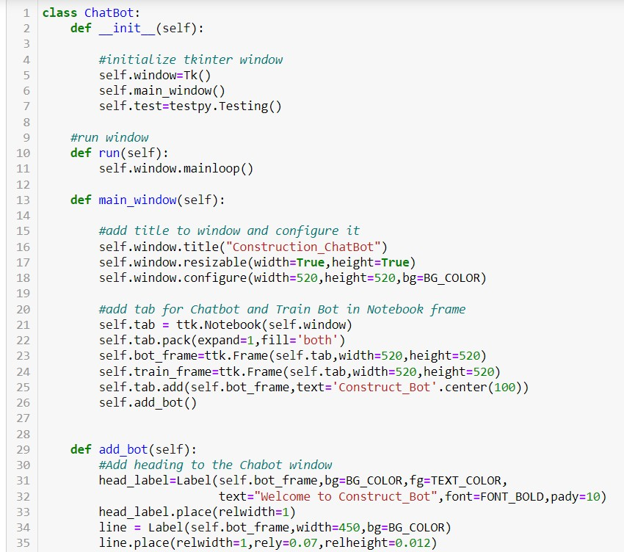

#### Figure 1: A Glimpse of GUI Code

# Chapter 5: Data Analysis

## Creating a database

A JSON file named “intents” was made from scratch using primary data. A JSON file is a file that stores simple data structures and objects in JavaScript Object Notation (JSON) format, which is a standard data interchange format.

## Attributes Used

The attributes used are ‘tag’, ‘patterns’ & ‘response’. Where tag is the name of the particular group of similar words. Patterns are the questions expected to be asked by the user. Response is the output given by bot.

## About Data

The data was gathered from different websites and then converted into appropriate format to be used.

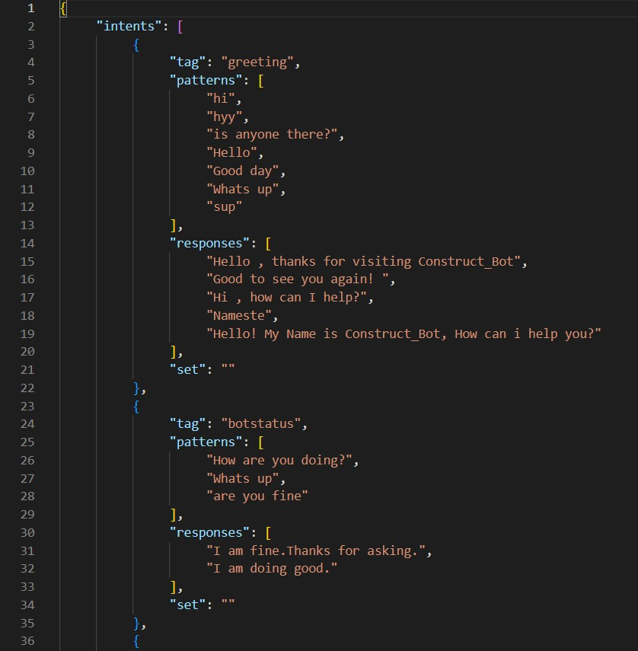

#### Figure 2: A Glimpse of the Dataset

## Training Dataset

The dataset is trained using various functions like sequential models.

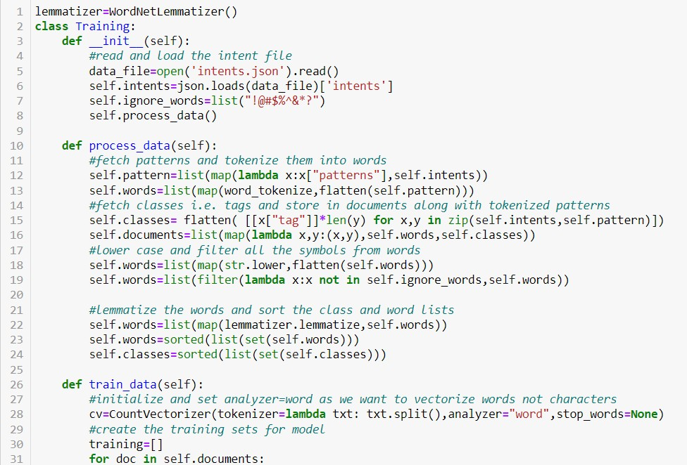

#### Figure 3: A Glimpse of Training Code

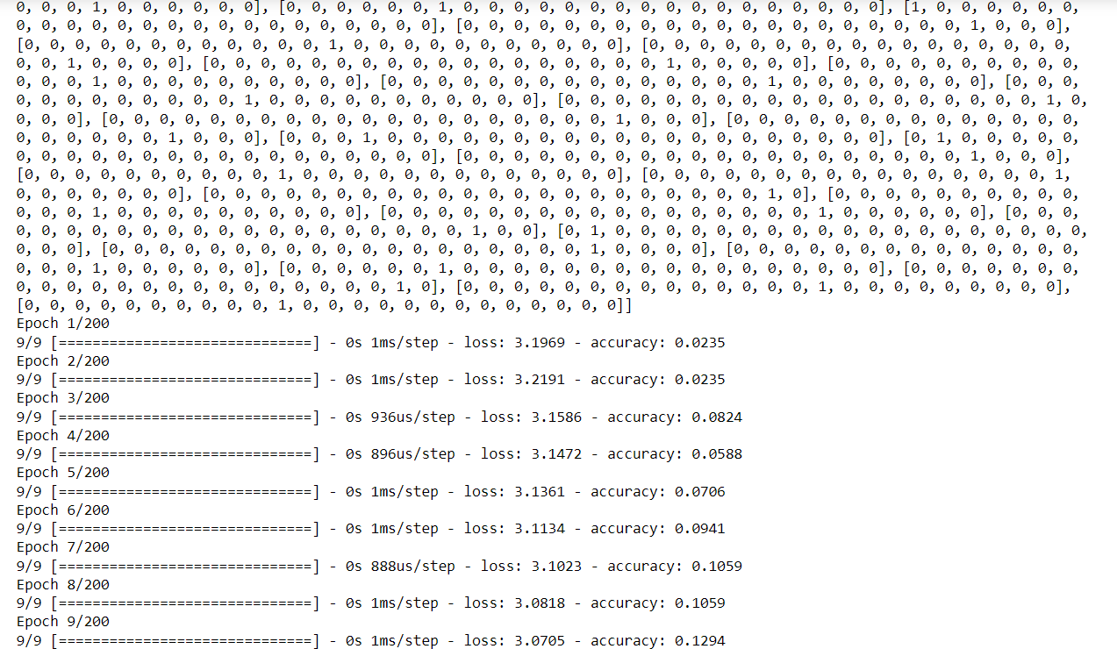

#### Figure 4: A Glimpse of Successful running of Training Code

## Testing Dataset

A testing class is prepared and different functions are defined inside it which are to be used further.

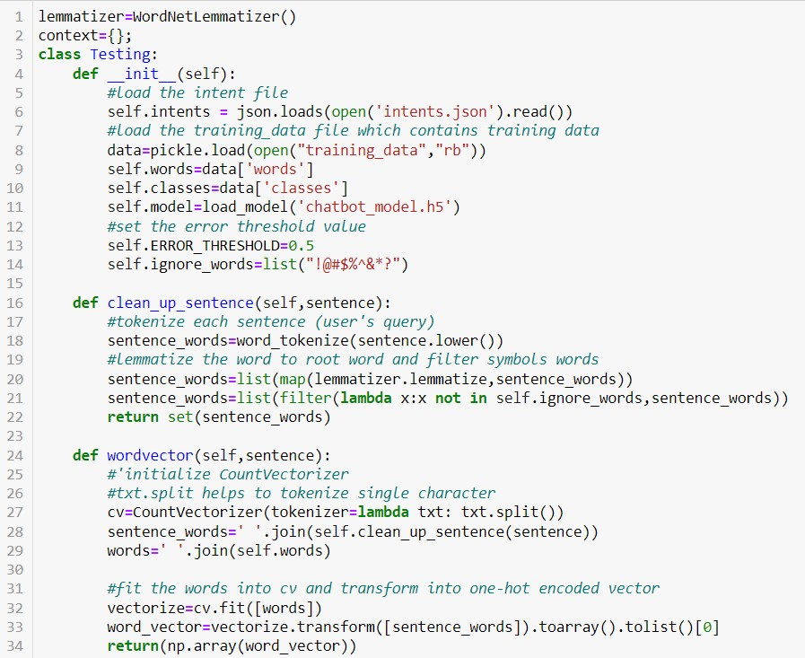

#### Figure 5: A Glimpse of Testing Code

# Result & Discussion

This study presents a chatbot system model that access information related to the construction work data.

The proposed system model includes a chatbot module and database. Several types of “intents” are defined as needed for the conversation between users and the chatbot, along with dialog models.

Detected information through the conversation between the user and chatbot could be utilized by the web application for data extraction and document generation using a database in future.

The prototype was developed to determine whether the chatbot system can perform functions related to the requirements of data and document.

The proposed system is expected to provide benefits for subcontractors in terms of ease of use and for general contractors with regards to reducing the effort to collect and document information from different source.

With the use of sequential model and other concepts the result obtained is a successfully working chatbot which can answer many queries with its pre- determined dataset. It can give answer to a pre-set menu of questions.

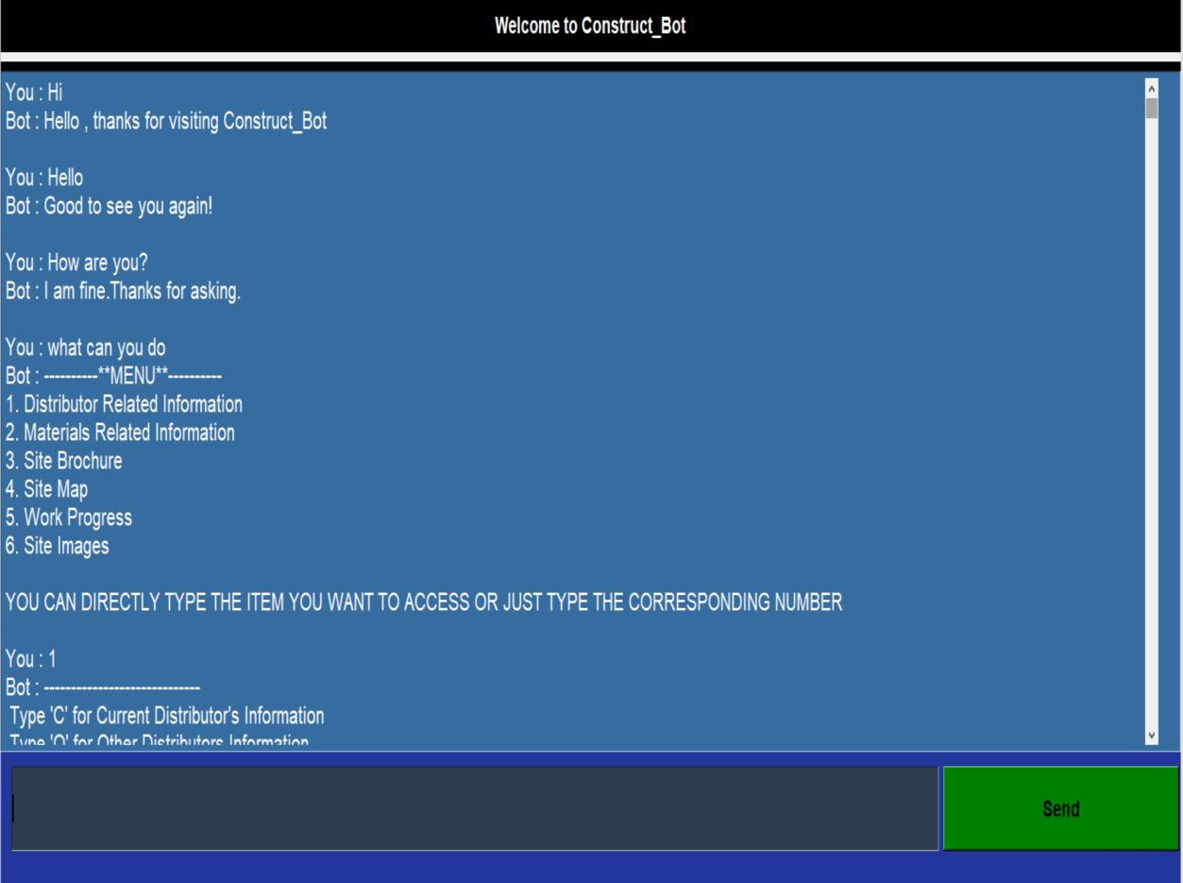

#### Figure 6: Construct_bot Chatbot

# Conclusion

Overall, the ChatBot:

* Is an AI driven B2B ChatBot that gives all the data connected with construction work on field and materials required.
* Is a quick and simple method for following the advancement and apparatus.
* Can team up everything at a solitary spot and access it with a couple of words or snaps.
* Can make work for Engineers and Coordinators easy.
* Can reduce the load of Sub-Engineer.
* Is an ease & Sorted system of information.

# Future Work

**A Dynamic & More Interactive ChatBot which can:**

* Connect with messaging tools
* Pair with Iot devices
* Generate real time data
* Automatically update data
* Work on all platforms

# Bibliography

*Artificial intelligence in the construction industry: A review of present status, opportunities and future challenges*. (2021, December ). Retrieved from https://[www.sciencedirect.com/.](http://www.sciencedirect.com/)

ChatbotNews. (2019, October 11). *How AI and chatbots are changing the face of the construction industry*. Retrieved from https://medium.com/: https://chatbotnewsdaily.com/how-ai-and-chatbots-are-changing-the-

face-of-the-construction-industry-cf57d3b3c71b

Goyal, K. (2020, July 27). *How to Make a Chatbot in Python Step By Step [Python Chatterbox Guide]*. Retrieved from https://[www.upgrad.com/:](http://www.upgrad.com/) https://[www.upgrad.com/blog/how-to-make-chatbot-in-](http://www.upgrad.com/blog/how-to-make-chatbot-in-) python/#ChatterBot_Library

Lee, J. C. (2019). *A Chatbot System for Construction Daily Report.* Retrieved from The International Association for Automation and Robotics in Construction: https://[www.iaarc.org/publications/fulltext/ISARC_2019_Paper_103.pdf](http://www.iaarc.org/publications/fulltext/ISARC_2019_Paper_103.pdf)

Mahajan, B. (n.d.). *Construction Materials Price List 2022 | Building Materials Price List | Building Materials List and Price*. Retrieved from https://civiconcepts.com/: https://civiconcepts.com/blog/construction- and-building-materials-market-price#Civil_Work_Rate_List_2022

Menal, D. (2017, May). *A Tool of Conversation: Chatbot.* Retrieved from INTERNATIONAL JOURNAL OF COMPUTER SCIENCES AND

ENGINEERING: https://[www.researchgate.net/profile/Menal-](http://www.researchgate.net/profile/Menal-) Dahiya/publication/321864990_A_Tool_of_Conversation_Chatbot/links/ 5a360b02aca27247eddea031/A-Tool-of-Conversation-Chatbot.pdf

Moussiades, E. A. (2020, May 29). *An Overview of Chatbot Technology*. Retrieved from https://link.springer.com/: https://link.springer.com/chapter/10.1007/978-3-030-49186-4_31

Özçekiç, A. F. (2017, June 20). *Construction sector needs ChatBots!* Retrieved from https://medium.com/: https://chatbotslife.com/construction-sector- needs-chatbots-cda97adc5c09

Shridhar, K. (2017, May 22). *Rule based bots vs AI bots*. Retrieved from https://medium.com/: https://medium.com/botsupply/rule-based-bots-vs- ai-bots-b60cdb786ffa

# The End

~ Shruti Hemant Agarwal