CI Pipeline Successful logs
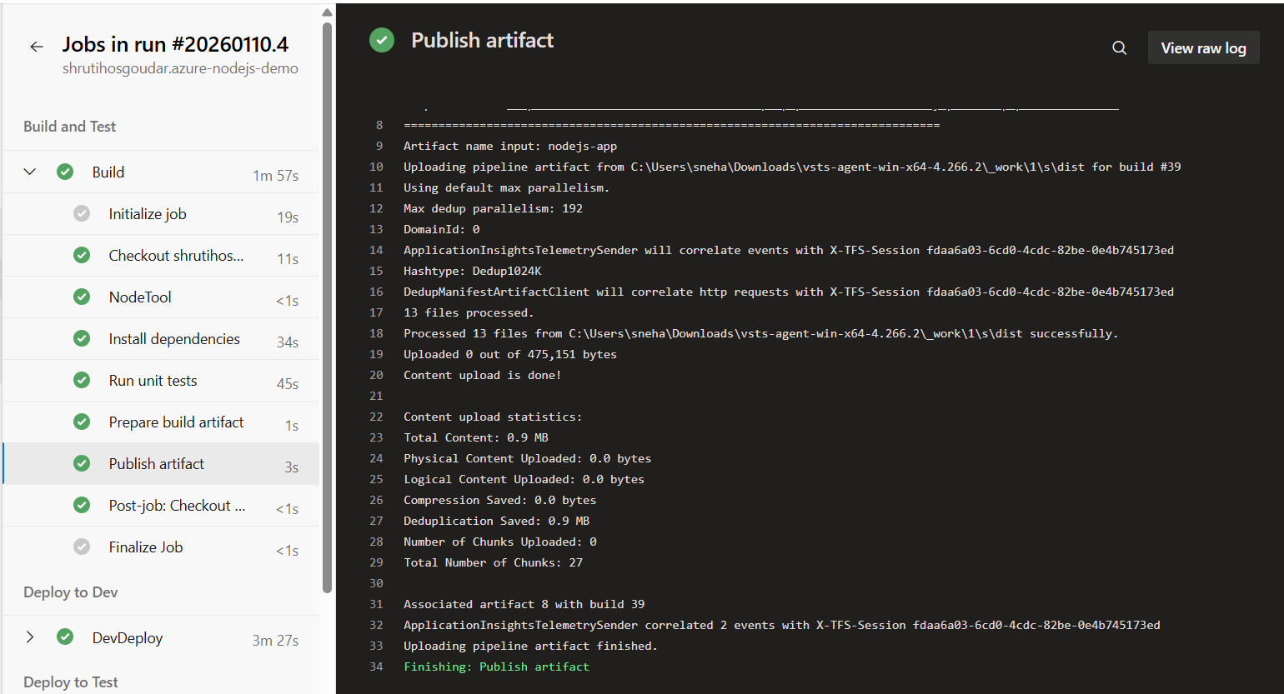
Artifacts Generated
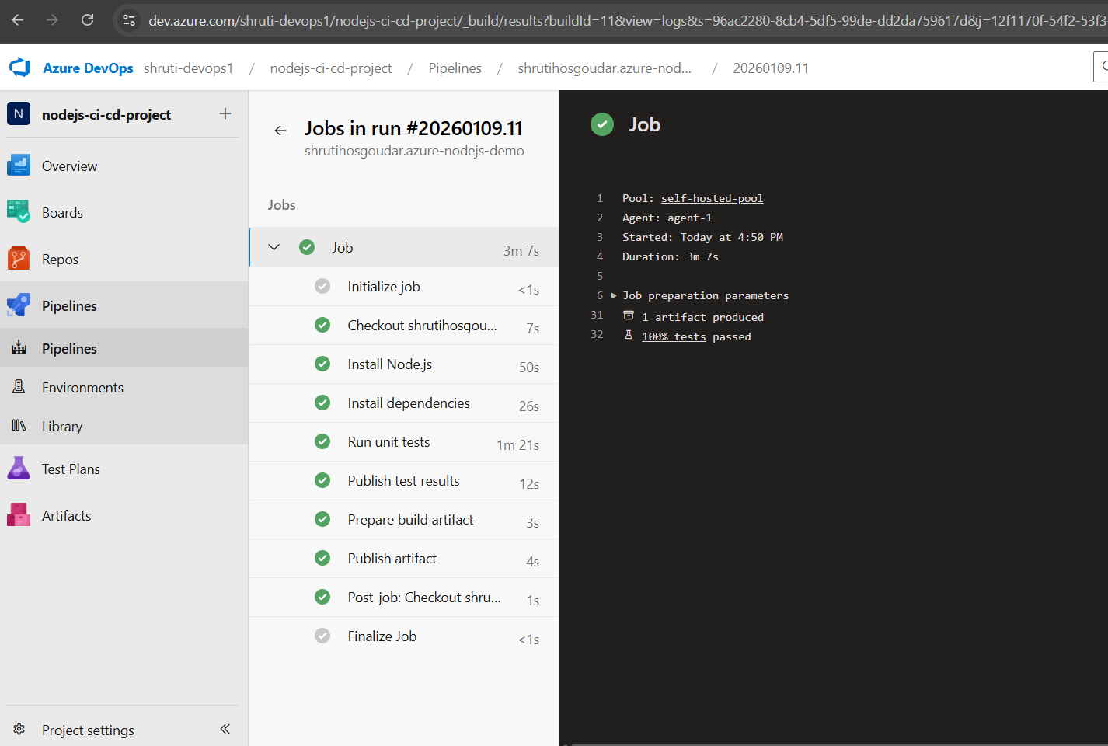

Approval gate for Production deployment
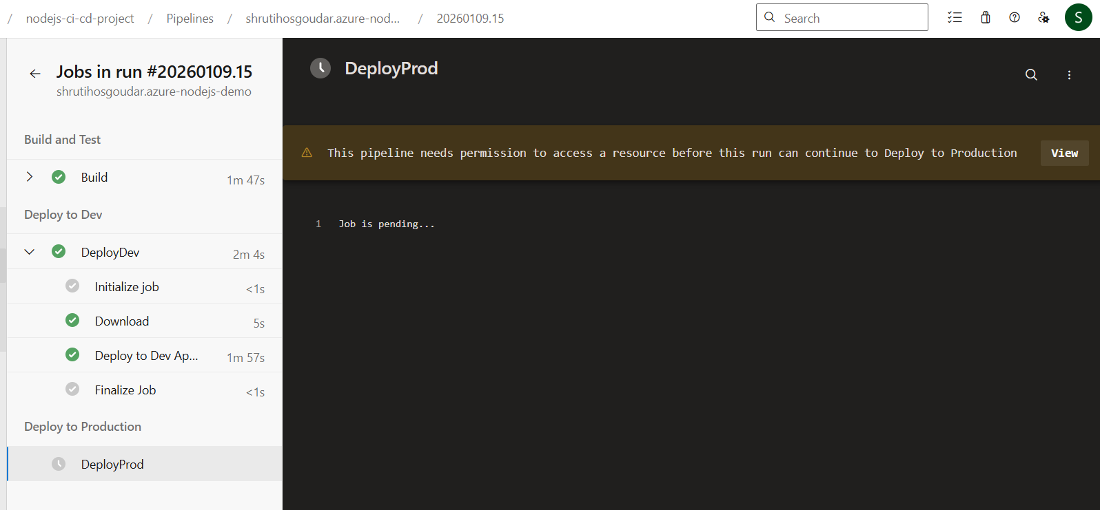
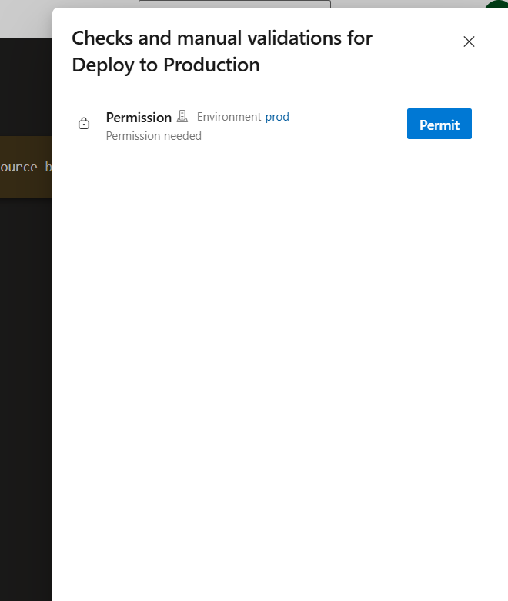
Successful Prod Deployment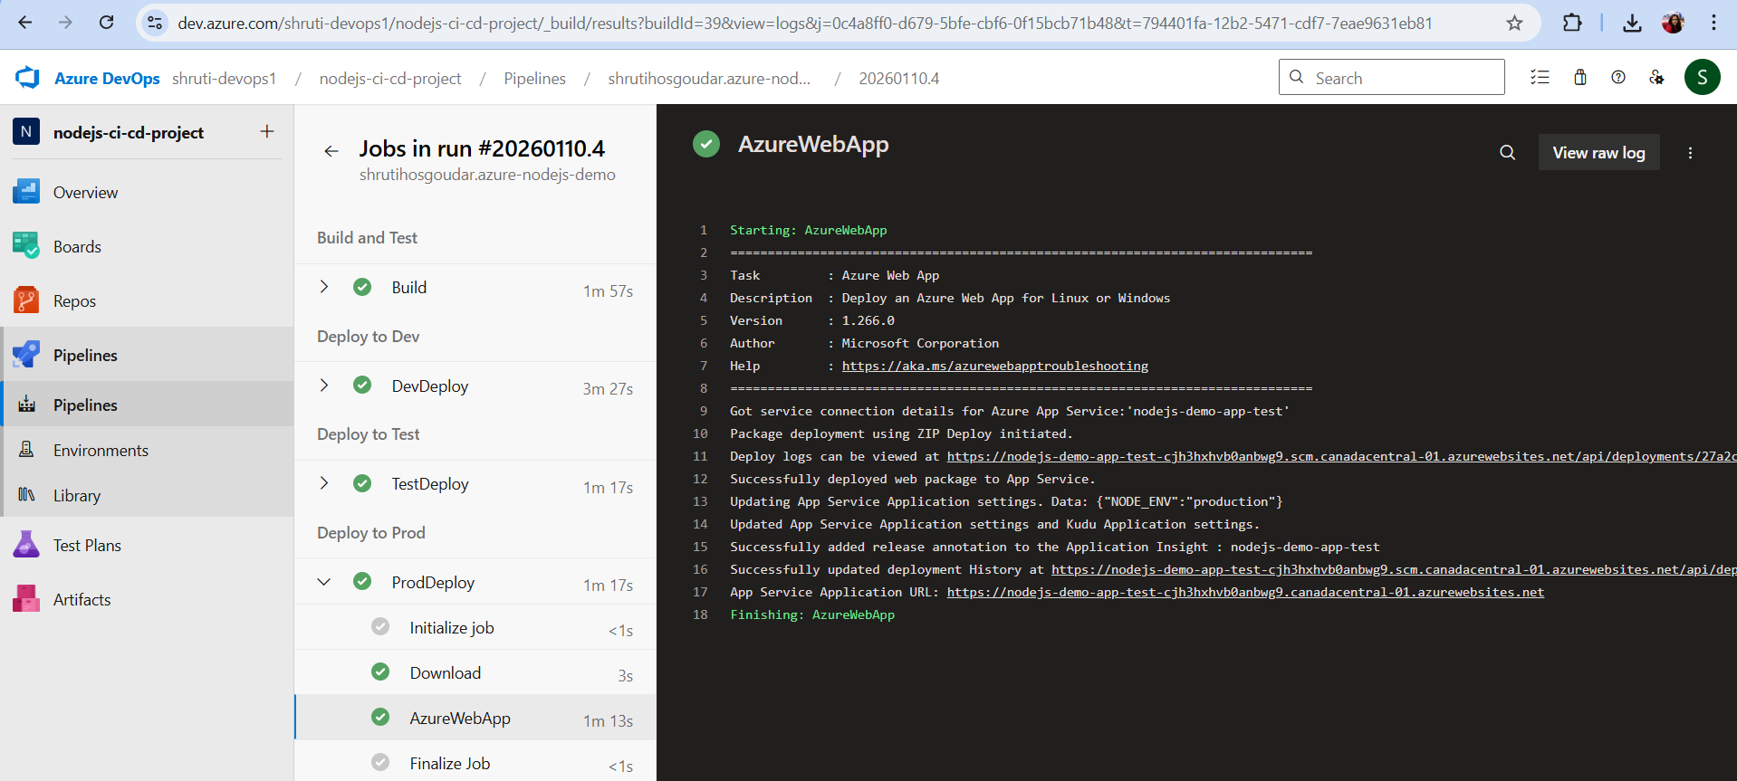
Multi stage build

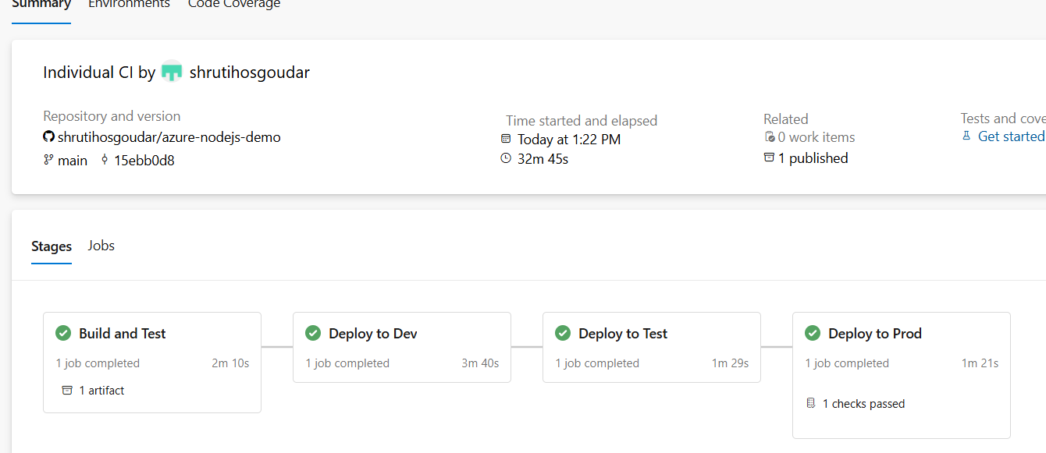
Git Branching Strategy (Main → Feature → Release)
Overview
We follow a main-centric branching strategy where:
- main is the stable, production-ready branch
- Feature development happens in feature branches
- Releases are prepared using release branches
- All changes ultimately flow back to main
Branch Types
main branch
- Represents production-ready code
- Always kept in a stable state
- Protected branch (PR required, no direct commits)
- CI pipeline runs on every merge

Feature branches (feature/*)
- Created from the main branch
- Used for developing new features or enhancements
- Short-lived branches
- Deleted after merge
Release branches (release/*)
- Created from the main branch
- Used to prepare a production release
- Allows final testing, bug fixes, and versioning
- Merged back into main after release
Branching Flow (Step-by-Step)
Step 1: Cut feature branch from main
git checkout main
git pull origin main
git checkout -b feature/aks-terraform
Step 2: Develop and commit changes
git add .
git commit -m "Add AKS provisioning using Terraform"
Step 3: Push feature branch
git push origin feature/aks-terraform
Step 4: Create Pull Request
- Source: feature/aks-terraform
- Target: main
- Code review + CI validation
- Merge after approval
Step 5: Merge feature branch into main
- Feature branch is merged into main
- Feature branch is deleted

Step 6: Cut release branch from main
git checkout main
git pull origin main
git checkout -b release/v1.0.0
Step 7: Release validation & fixes
- Final testing
- Minor bug fixes only
- No new features
Step 8: Merge release branch back to main
git checkout main
git merge release/v1.0.0
git push origin main
(Optional: tag the release)
git tag v1.0.0
git push origin v1.0.0
Branch Protection Rules
- No Direct commits to main
- Pull Requests is mandatory
- At least 1 reviewer required
- CI pipeline must pass before merge
- Feature branches deleted after merge
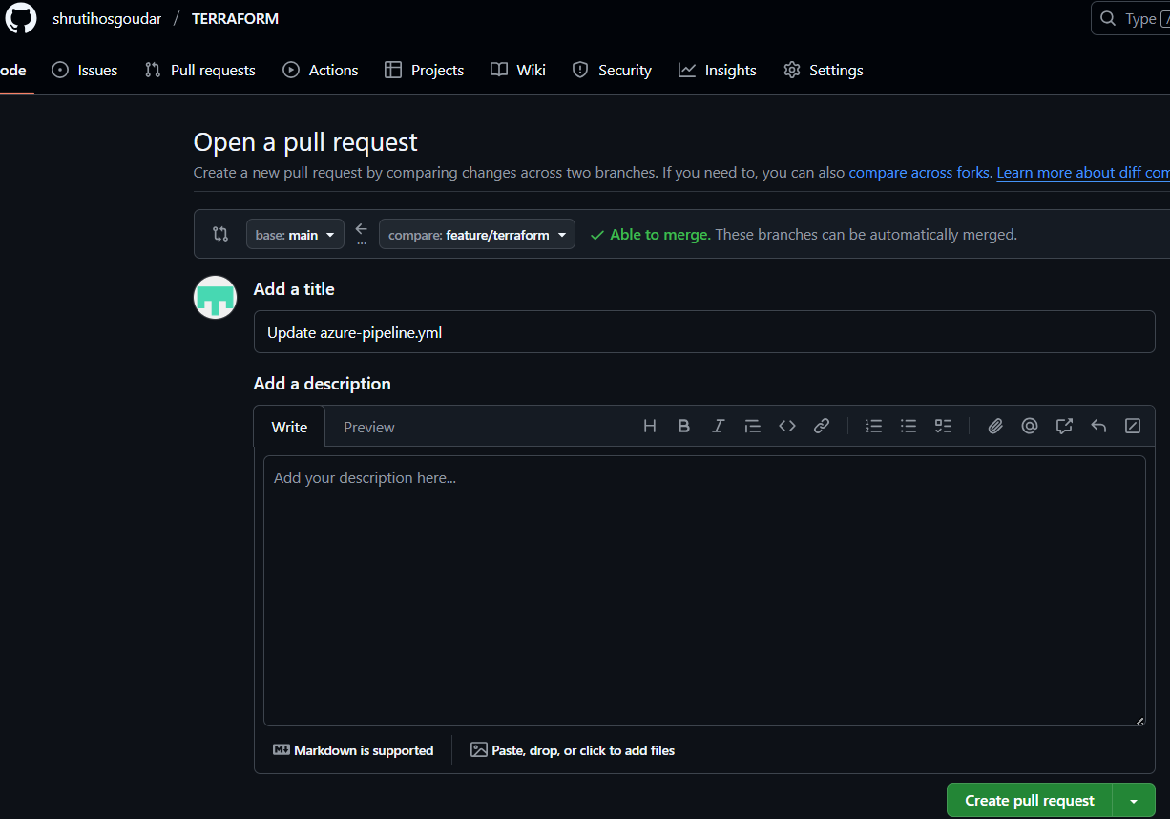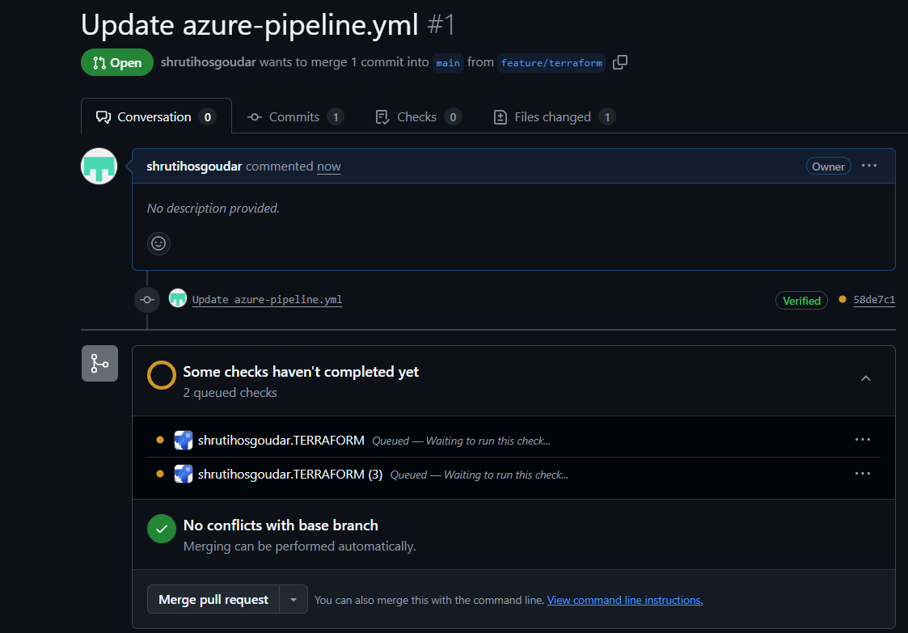

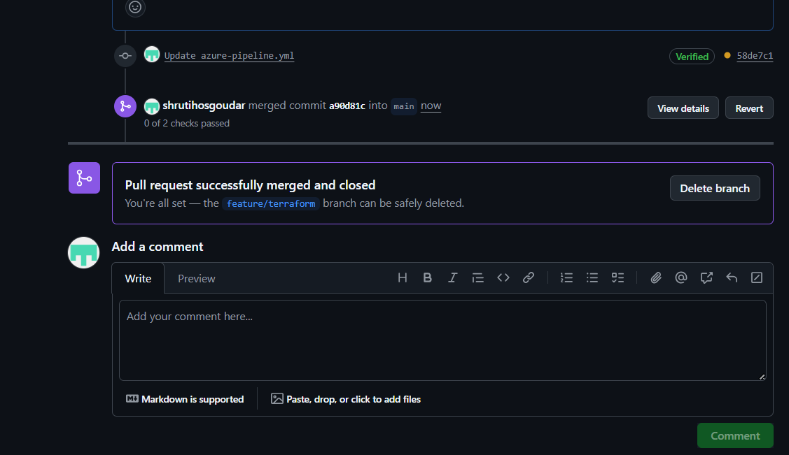

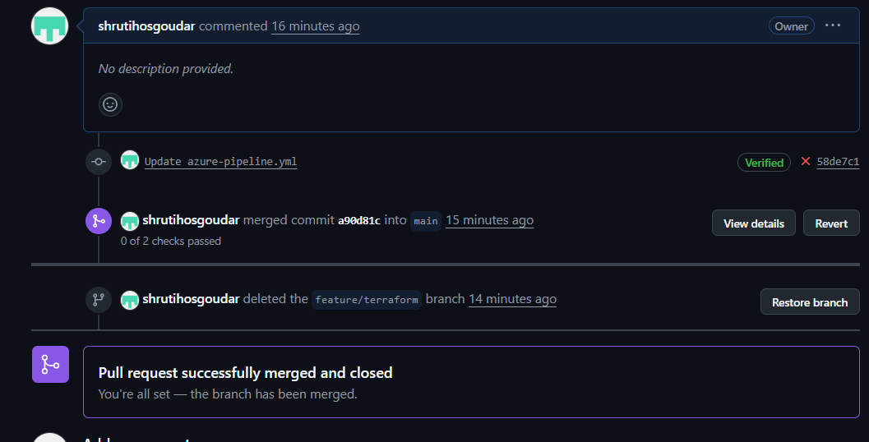
A hotfix branch is created from the main branch to quickly fix critical production issues and is merged back into main and release branches to ensure consistency

