Statistics — Part A
Theory & Definitions

Q1. Define the Following with Examples

1 a. Types of Data

Numerical (Quantitative) | Data expressed as numbers that can be measured or counted. Example: Age (25 yrs), Salary (₹50,000), Temperature (37°C), House price.
Categorical (Qualitative) | Data that represents categories or labels — no numeric meaning. Example: Gender (Male/Female), City name, Product rating (Good/Bad), Blood group.

1 b. Types of Statistics

Descriptive Statistics | Organises, summarises, and describes data collected from a sample or population. Example: Average marks of a class, percentage pass rate, histogram of ages.
Inferential Statistics | Uses sample data to draw conclusions or make predictions about a larger population. Example: Predicting election results from a survey of 1,000 voters.

1c. What is Descriptive Statistics?

Descriptive statistics is the branch of statistics that summarises and organises raw data into meaningful information using measures of central tendency, spread, and graphical representations. It describes what the data looks like — without making predictions.

Key tools include: Mean, Median, Mode, Range, Variance, Standard Deviation, histograms, and box plots.

Q2. Key Statistical Measures

2a. Mean, Median & Mode

Mean | The arithmetic average of all values. Formula: x̄ = (Σx) / n Example: Data = {4, 7, 8, 5, 6} → Mean = 30/5 = 6
Median | The middle value when data is sorted in ascending order. Not affected by outliers. Example: Sorted = {4, 5, 6, 7, 8} → Median = 6 (For even count, average of two middle values.)
Mode | The value that appears most frequently. A dataset can have no mode, one mode, or multiple modes. Example: {3, 4, 4, 5, 6, 6, 6} → Mode = 6

2b. Range, Variance & Standard Deviation

Range | Difference between the maximum and minimum values — simplest measure of spread. Formula: Range = Max − Min Example: {10, 20, 30, 40, 50} → Range = 50 − 10 = 40
Variance | Average of the squared deviations from the mean. Captures overall spread. Formula: σ² = Σ(xᵢ − x̄)² / n Example: Data={2,4,4,4,5,5,7,9}, Mean=5 → σ² = 4
Standard Deviation | Square root of variance — brings spread back to the same unit as the data. Formula: σ = √σ² Example (cont.): σ = √4 = 2 Interpretation: Most values lie within ±2 of the mean (i.e., 3 to 7).

3a. Gaussian (Normal) Distribution

A bell-shaped, symmetric probability distribution defined by its mean (μ) and standard deviation (σ). Most real-world data — heights, IQ scores, measurement errors — follow this distribution.
Key properties:
- Symmetric around the mean (μ).
- Mean = Median = Mode.
- Defined for all real values of x.

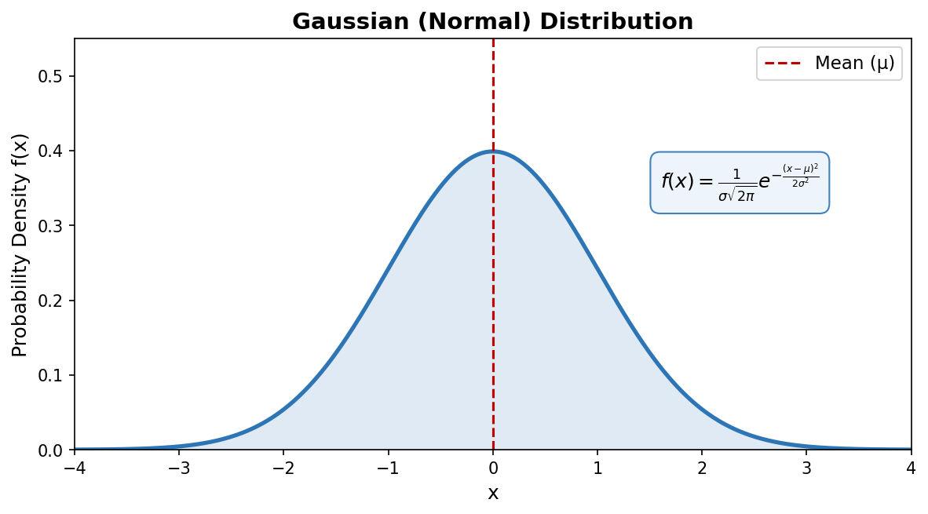
Formula: f(x) = (1 / σ√(2π)) × e^[−(x−μ)² / 2σ²]

3b. Log-Normal Distribution

A distribution where the logarithm of the variable follows a normal distribution. It is right-skewed and used when values are always positive.
Key properties:
- Defined only for x > 0.
- Right-skewed (positively skewed).
- Common in stock prices, income distribution, city sizes.

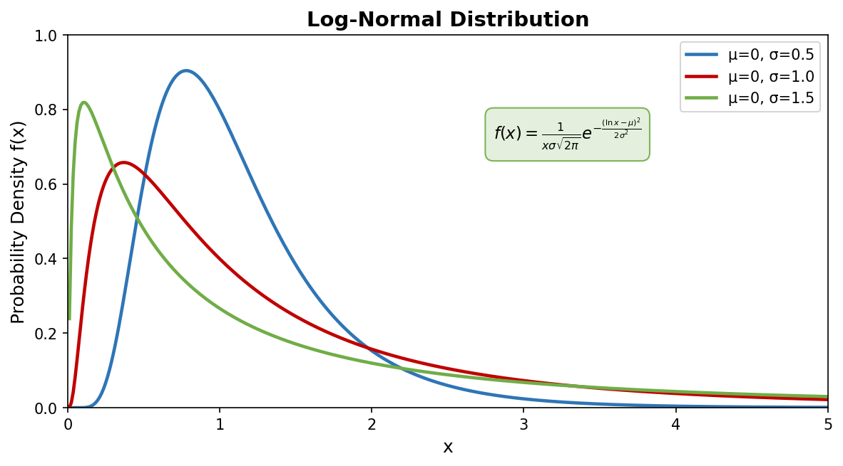
Formula: f(x) = (1 / xσ√(2π)) × e^[−(ln x − μ)² / 2σ²] (x > 0)

3c. 3-Sigma Rule (Empirical Rule)

For any normal distribution, almost all data falls within 3 standard deviations of the mean. This rule is used to detect outliers and set quality control limits.

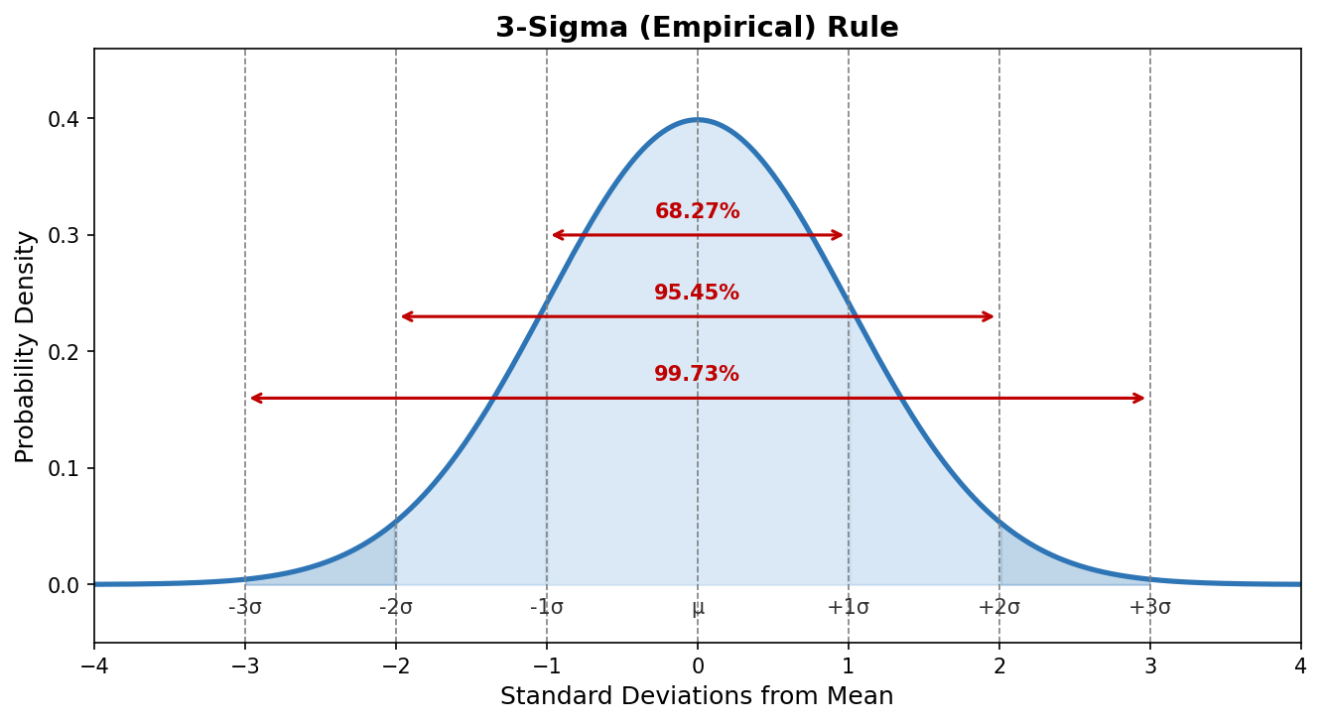

±1σ (68.27%) | ~68% of all data falls within 1 standard deviation of the mean.
±2σ (95.45%) | ~95% of all data falls within 2 standard deviations.
±3σ (99.73%) | ~99.7% of all data falls within 3 standard deviations. Values outside are outliers.

3d. Percentiles

A percentile indicates the value below which a given percentage of observations fall. Percentiles divide data into 100 equal parts.
Example: A student scoring at the 90th percentile scored higher than 90% of all test takers.

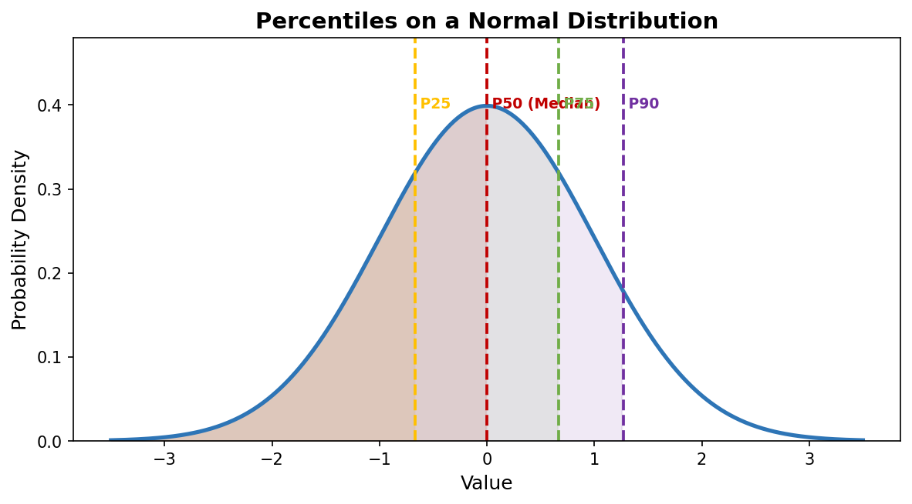
Pth Percentile Position: L = (P / 100) × n
Where P = desired percentile, n = total number of data points.

3e. Quartiles & Five-Number Summary

Quartiles split sorted data into four equal parts (each 25%). The Five-Number Summary describes the overall spread of a dataset concisely.

Q0 (Min) | Smallest value in the dataset.
Q1 (25th %ile) | 25% of data lies below this point. Called the Lower Quartile.
Q2 (50th %ile) | Median — 50% of data lies below. Middle Quartile.
Q3 (75th %ile) | 75% of data lies below. Called the Upper Quartile.
Q4 (Max) | Largest value. IQR = Q3 − Q1 (Inter-Quartile Range).

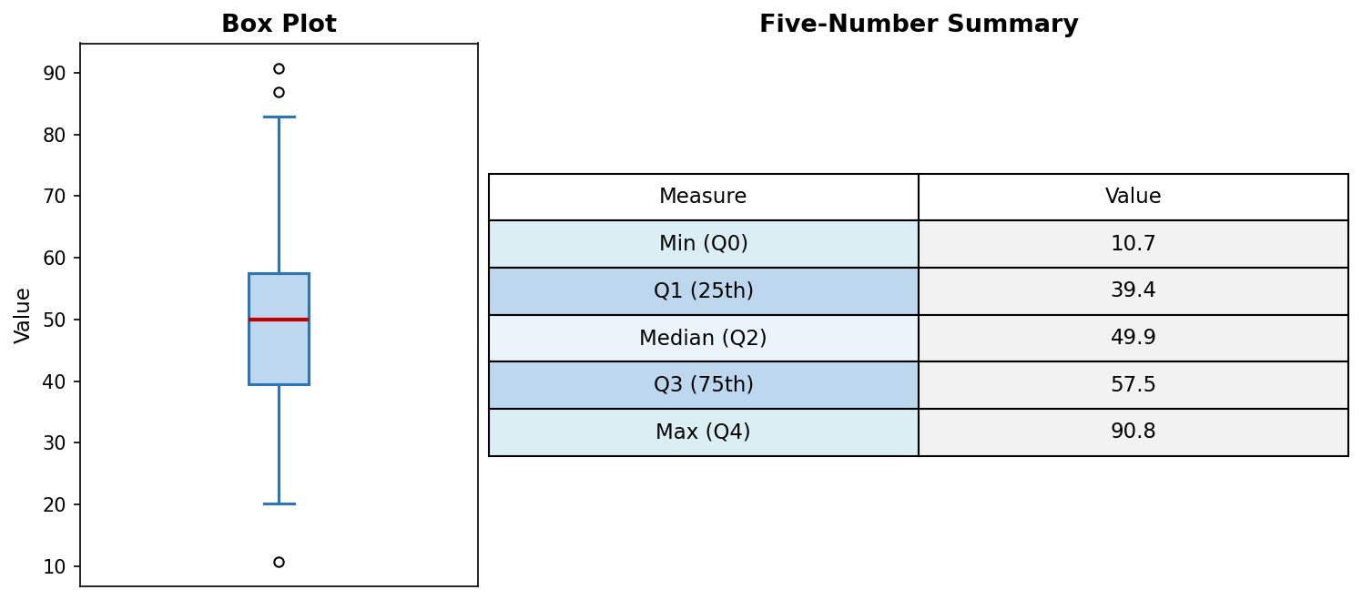
IQR = Q3 − Q1
Data points below Q1 − 1.5×IQR or above Q3 + 1.5×IQR are considered outliers.

3f. Skewness

Skewness measures the asymmetry of a distribution. A symmetric distribution has zero skewness; skewed distributions have their tail pulled to one side.

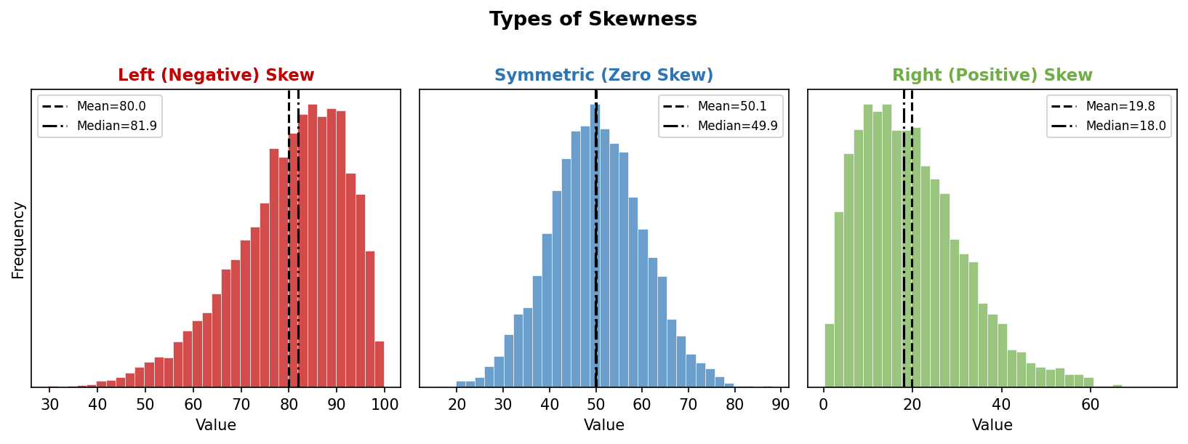

Negative (Left) Skew | Tail is on the left. Mean < Median < Mode. Example: Age at retirement.
Zero Skew (Symmetric) | Perfectly balanced. Mean = Median = Mode. Example: Normal distribution.
Positive (Right) Skew | Tail is on the right. Mean > Median > Mode. Example: Income distribution.

Pearson's Skewness: Sk = 3(Mean − Median) / σ

3g. Kurtosis

Kurtosis measures the sharpness of the peak and the heaviness of the tails of a distribution compared to a normal distribution.

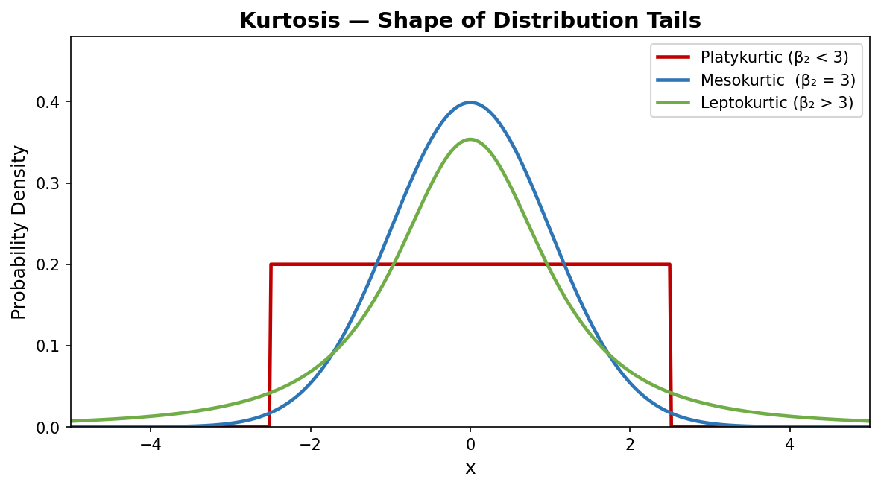

Platykurtic (β₂ < 3) | Flat, wide peak — lighter tails than normal. Example: Uniform distribution.
Mesokurtic (β₂ = 3) | Normal peak and tails. Baseline reference — the normal distribution.
Leptokurtic (β₂ > 3) | Tall, sharp peak — heavier tails (more outliers). Example: Financial returns.
Kurtosis (β₂) = E[(X − μ)⁴] / σ⁴ | Excess Kurtosis = β₂ − 3

— End of Part A —

