PIMPRI CHINCHWAD EDUCATION TRUST’S
PIMPRI CHINCHWAD COLLEGE OF ENGINEERING
DEPARTMENT OF INFORMATION TECHNOLOGY

LABORATORY REPORT OF BIG DATA ANALYTICS
STAYSCOPE
AIRBNB LISTING ANALYTICS USING BIG DATA
Academic Year 2026–2027
Prepared by:
Name | PRN
Shruti Jadhav | 123B1F035
Divya Kathane | 123B1F042
Guided by: Dr. Jaya Dewan

ABSTRACT
StayScope — Airbnb Listing Analytics Using Big Data is a Big Data Analytics laboratory mini-project that demonstrates dataset inspection, distributed storage, grouped aggregation, and interactive visualization of Airbnb-style listing data. The implementation uses Python and Pandas for local data handling, Hadoop Distributed File System (HDFS) for input storage, a PySpark script for grouped summaries, a Java MapReduce word-count example, and Streamlit with Plotly for dashboard presentation.
The supplied dataset is a cleaned CSV of Airbnb-style listings with ten fields. The dashboard reported 500 listings matched, an average listed price of 938.06, an average rating of 1.82/5, and 22 states represented. HDFS verification confirmed /airbnb/input/airbnb_cleaned.csv at approximately 53.2 KB with one live DataNode. The dashboard demand forecast is explicitly labelled as synthetic data, not actual booking records. The existing /output/part-r-00000 is word-count output, not Airbnb-specific analytics, and the latest PySpark run failed because of a Java version incompatibility, so a successful end-to-end Spark run is not confirmed.
The project is an academic batch-analysis demonstration. Dataset provenance has not been independently verified, and the application does not use a live Airbnb feed. These limitations are considered when interpreting the results.
Keywords: Big Data Analytics; Airbnb Listings; Pandas; Hadoop HDFS; MapReduce; Apache Spark; Streamlit; Plotly
1. INTRODUCTION
1.1 Overview
Short-stay listing data contains indicators such as price, room type, location, guest capacity, and rating. Aggregating these fields by state, room type, and guest capacity demonstrates how raw listing rows can be transformed into summaries that are easier to explore. StayScope combines data processing scripts and an interactive web interface for a BDA laboratory workflow.
1.2 Problem Statement
Inspecting raw listing rows makes it difficult to compare properties and identify market patterns. This project presents the supplied listing data through grouped analytics, filters, charts, and a map, and records which processing steps were and were not verified.
1.3 Objectives
- To inspect the cleaned Airbnb listing CSV.
- To store and verify the input dataset in Hadoop HDFS.
- To use PySpark DataFrame operations for grouped summaries.
- To present patterns through an interactive Streamlit dashboard.
- To provide search, filters, charts, map views, and result downloads.
- To clearly distinguish dataset analysis from synthetic forecasting.
1.4 Scope of the Project
The project covers batch processing of a supplied cleaned CSV, state, room-type, and guest-capacity summaries, HDFS storage verification, and dashboard visualization. It does not include a live Airbnb feed, real booking records, a production booking platform, or a validated predictive model.
2. DATASET DESCRIPTION
2.1 Dataset Overview
The project directory contains airbnb_cleaned.csv and final_data.csv. The HDFS input copy is /airbnb/input/airbnb_cleaned.csv. The figures below describe the available project dataset, not all Airbnb listings in India. The dataset source and collection method have not been independently verified; it is therefore described as the supplied demonstration dataset rather than an official Airbnb release.
Property | Observed value
Listings in dashboard selection | 500
Fields (columns) | 10
HDFS file size | Approx. 53.2 KB
Price range | 129.00 – 36,079.00
States represented | 22
Average listed price | 938.06
Average rating | 1.82 / 5
Project data files | airbnb_cleaned.csv, final_data.csv

2.2 Dataset Attributes
Attribute | Description
name | Listing title
location | City or locality of the listing
state | State grouping used for comparisons
country | Country label
latitude, longitude | Coordinates used for map plotting
roomType | Room or property category
numberOfGuests | Guest capacity of the listing
price | Listed price
stars | Rating on a 5-point scale

2.3 Data Preparation
The input is the cleaned CSV supplied with the project. The project record does not include a separate data-quality audit script or report. The room-type output contains a blank roomType group with 3 rows, which indicates that some categorical values are missing.
A cleaned file is not necessarily authentic or representative. The supplied screenshots and terminal output do not establish the original data source, collection date, completeness, or representativeness; results are therefore described as analysis of the available project dataset only.
3. TECHNOLOGIES USED
3.1 Python and Pandas
Python is used for project scripts and dashboard application logic. Pandas supports local CSV manipulation and summary calculations; the precise role of every script should be confirmed from its source.
3.2 Hadoop Distributed File System (HDFS)
HDFS stores the cleaned CSV in the configured Hadoop environment at /airbnb/input/airbnb_cleaned.csv. The NameNode manages filesystem metadata and DataNodes store data blocks. The hdfs dfsadmin -report output showed one live DataNode.
3.3 Hadoop MapReduce
The project contains WordCount.java and wordcount.jar. The inspected /output/part-r-00000 contains counts for words such as “big”, “data”, and “hadoop”. This confirms a word-count example output, not an Airbnb-specific price aggregation. Airbnb-specific MapReduce results should not be claimed unless that job is implemented and verified.
3.4 Apache Spark / PySpark
spark_analytics.py creates a SparkSession in local mode (master local[*]) and reads the local relative path airbnb_cleaned.csv. It prints the schema and sample rows, groups average price and property count by state, counts room types, displays the ten highest-priced properties, and groups average price by guest capacity. It writes state-price and room-type summaries under spark_results/. The recorded run failed first because PySpark was missing and later because Java 11 was active while the installed Spark launcher required Java 17. Successful completion is not confirmed.
3.5 Streamlit, Plotly and Map Visualization
Streamlit provides the dashboard and Plotly supports interactive charts. The dashboard presents headline metrics, state-wise average price, room-type distribution, a listing map, price-versus-capacity patterns, a 3D listing view, property cards, demand forecasting, and pricing recommendations. The initial launch showed a missing Plotly dependency, so the application must run in an environment with all required packages installed.
3.6 Optional Integration
The dashboard labels Cassandra as not configured. It is an optional integration and should not be described as active storage.
4. SYSTEM ARCHITECTURE AND METHODOLOGY
4.1 System Architecture
Stage | Component | Responsibility
1 | CSV dataset | Provides the cleaned listing records (airbnb_cleaned.csv).
2 | Hadoop HDFS | Stores the input CSV at /airbnb/input.
3 | PySpark script | Intended to compute state, room-type, top-price, and capacity summaries; reads a local CSV in the supplied code.
4 | spark_results/ | Receives exported CSV summaries when the script completes.
5 | Java MapReduce | Separate word-count example writing to /output; not Airbnb-specific.
6 | Streamlit + Plotly + map | Displays metrics, filters, charts, map, and property cards.

4.2 Processing Workflow
Cleaned CSV → HDFS storage and verification → PySpark script (reads a local CSV in the supplied code) → CSV summaries in spark_results/ → Streamlit visualization. A separate MapReduce word-count example writes to /output. Current evidence does not establish one fully verified HDFS-to-Spark-to-dashboard pipeline.
4.3 HDFS Verification
Commands used in Ubuntu/WSL included start-dfs.sh, jps, hdfs dfs -ls /, hdfs dfs -ls /airbnb/input, hdfs dfs -cat /airbnb/input/airbnb_cleaned.csv | head -n 5, hdfs dfs -du -h /airbnb/input, hdfs dfs -cat /output/part-r-00000, and hdfs dfsadmin -report. NameNode, DataNode, and SecondaryNameNode appeared in jps. The Airbnb CSV was present at about 53.2 KB and one live DataNode was reported.
4.4 PySpark Workflow
The script starts Spark in local mode, reads the local airbnb_cleaned.csv, prints row and column counts and the schema, displays sample records, aggregates by state, roomType, and numberOfGuests, displays the ten most expensive properties, and writes two summaries to spark_results/price_by_state and spark_results/room_type_counts.
4.5 Dashboard Development
The StayScope dashboard has a sidebar for search and for filters on state, room type, and price range, with a main panel of headline metrics, charts, a listing map, a 3D listing landscape, budget and top-rated picks, and property cards. From the project folder, activate the correct Python environment and run python -m streamlit run app.py. Dashboard dependencies must be installed in the same environment used to launch it.

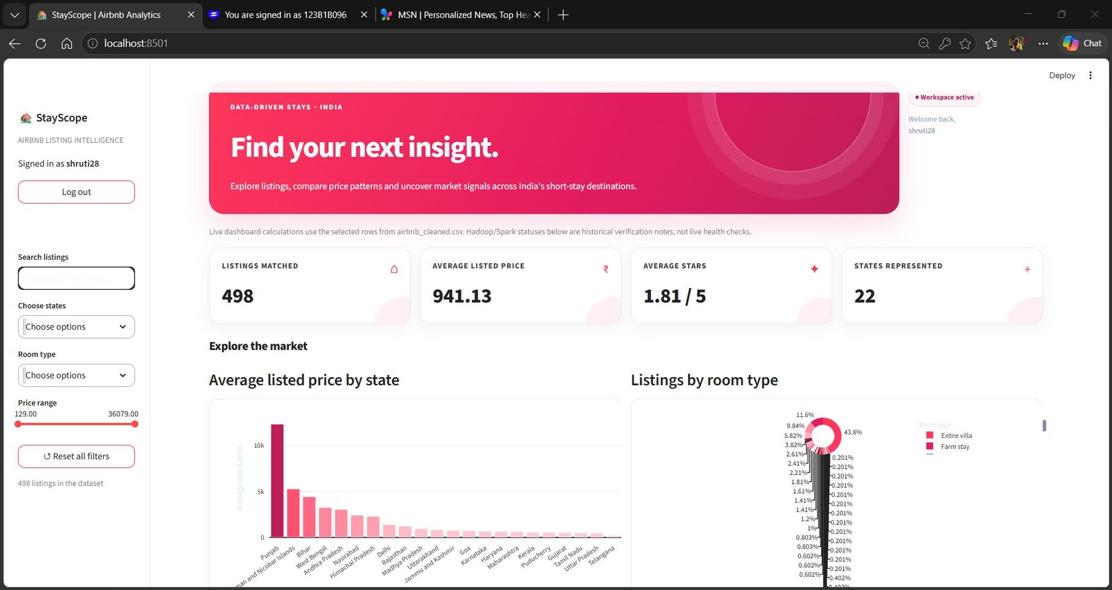
Figure 1. StayScope dashboard overview
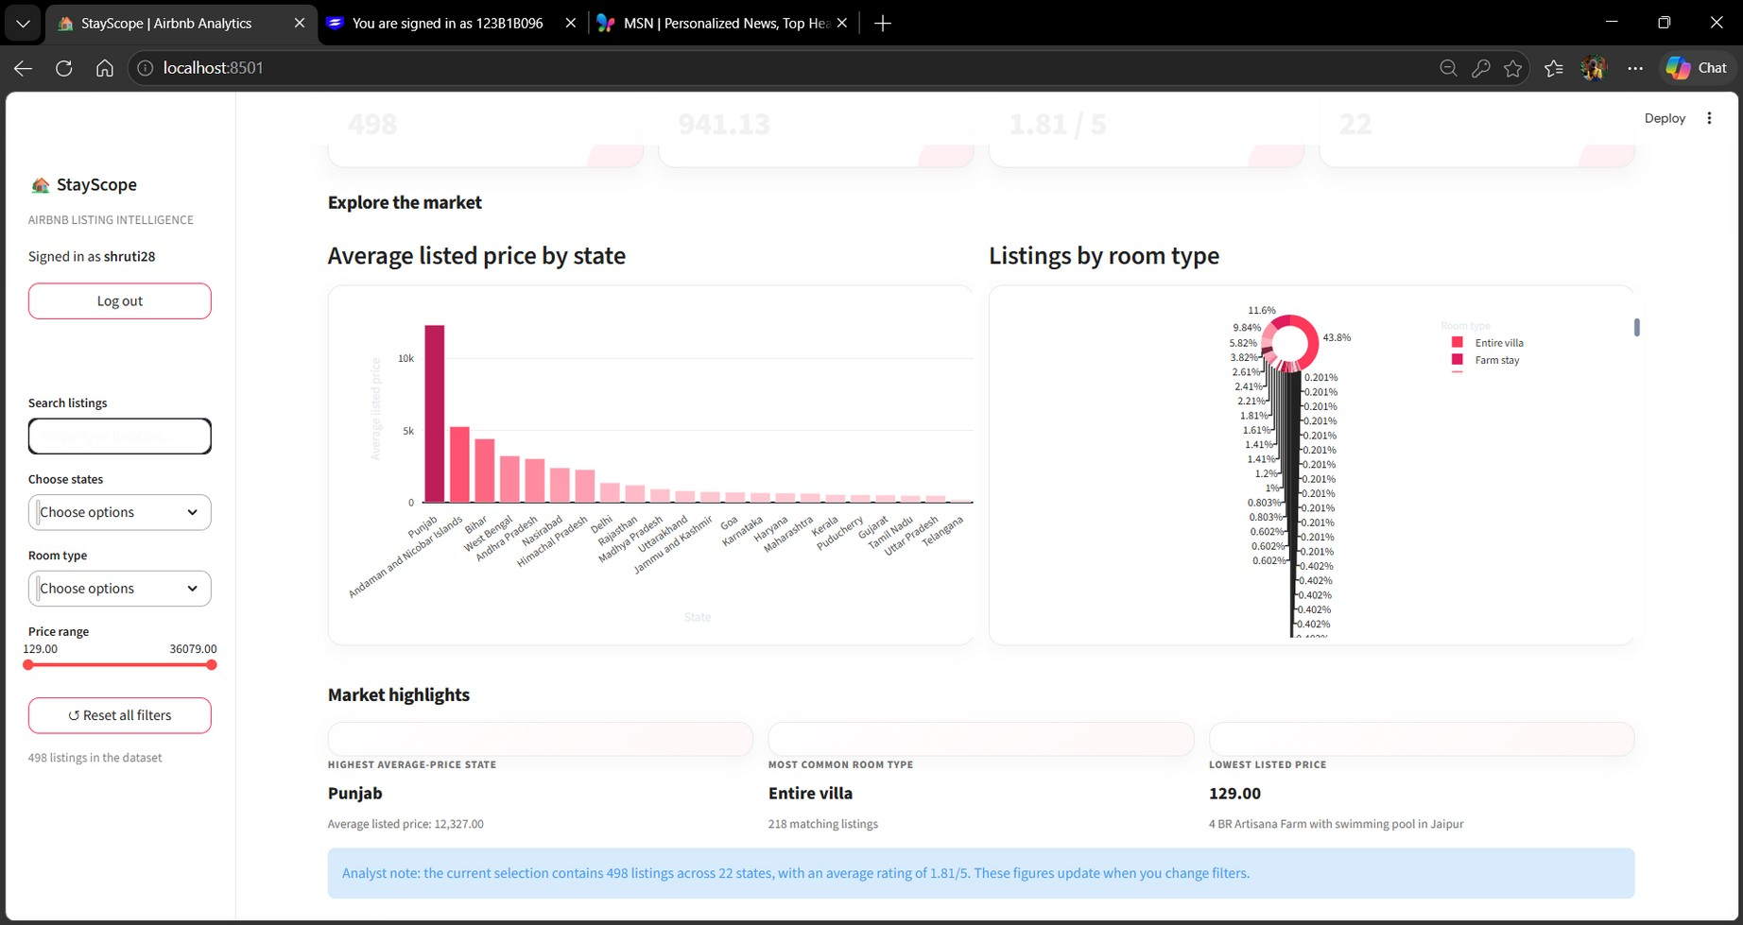
Figure 2. Market comparison and highlights
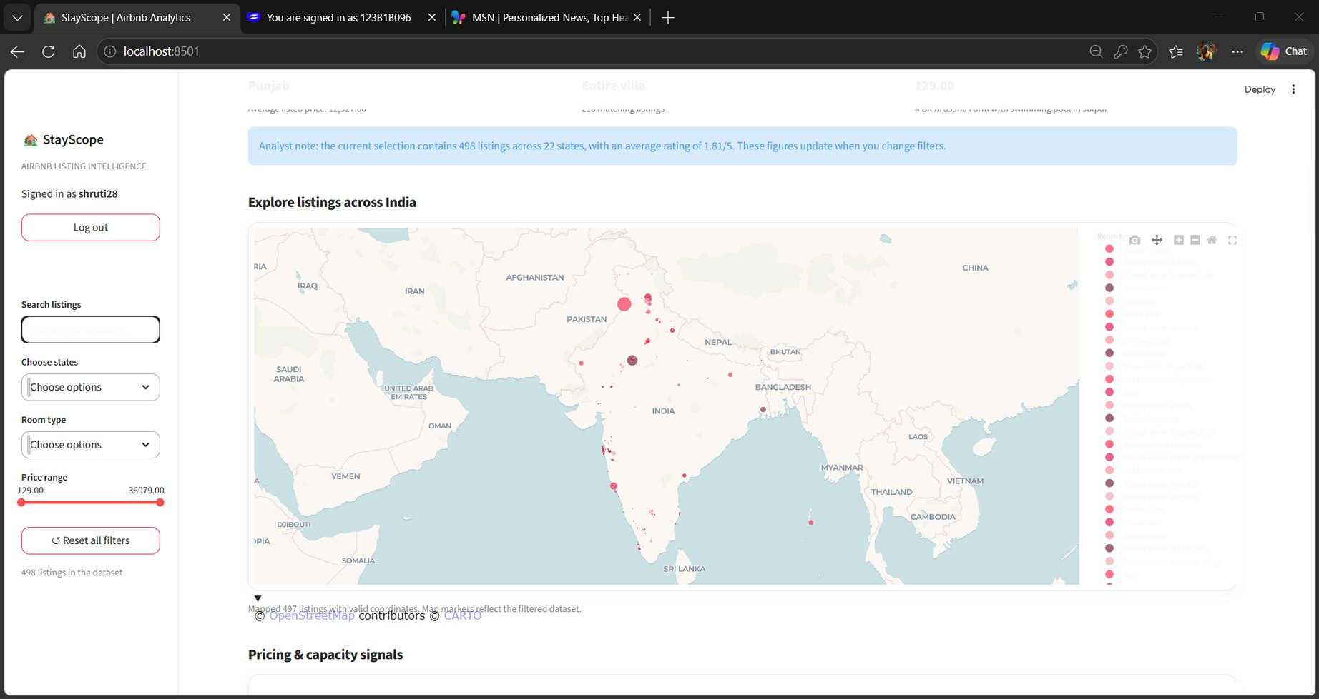
Figure 3. Geographic distribution of listings

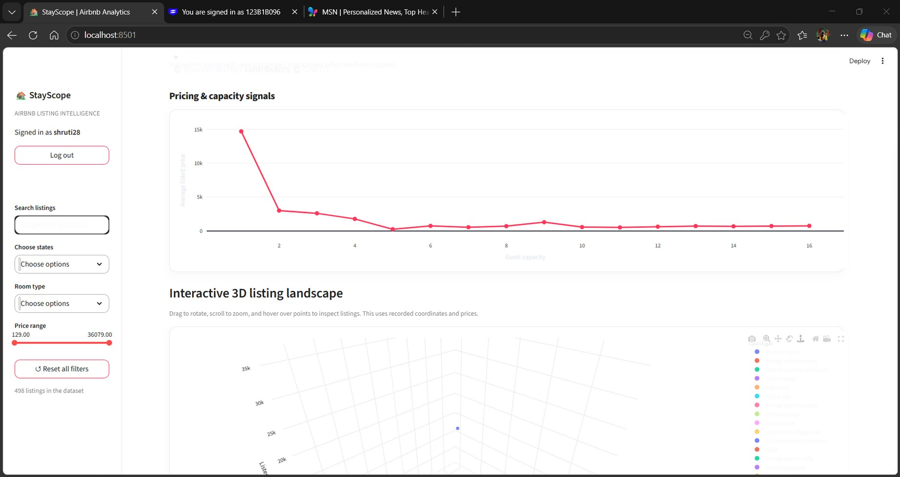
Figure 4. Pricing and guest-capacity analysis
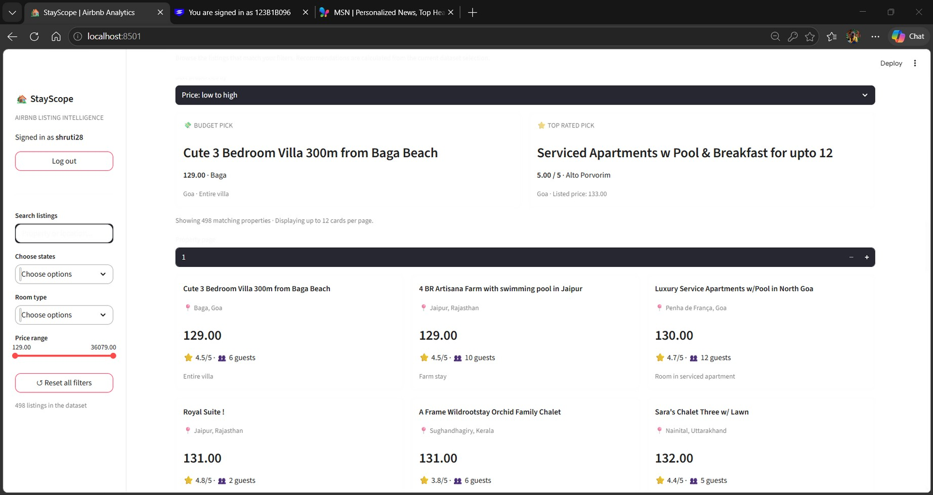
Figure 5. Listing recommendations and property cards

5. RESULTS AND DISCUSSION
5.1 Dashboard Snapshot
Indicator | Dashboard-reported value
Listings matched | 500
Average listed price | 938.06
Average stars | 1.82 / 5
States represented | 22
Highest average-price state | Punjab (12,327.00)
Most common room type | Entire villa (220 listings)
Lowest listed price | 129.00

These are dashboard-reported values. The screenshots in Figures 1–5 were captured at a slightly different filter state or dataset version (498 listings, average price 941.13, average rating 1.81/5), so both sets should be treated as indicative of the same dataset rather than identical captures.
5.2 Room-Type Summary
The inspected CSV in spark_results/room_type_counts listed the counts below. It also contained a blank roomType group with 3 rows. This earlier output file exists, but the later full Spark run did not complete successfully.
Room type | Listings
Entire villa | 220
Farm stay | 58
Entire home | 49
Entire bungalow | 29
Room in hotel | 19
Private room in resort | 13
Room in boutique hotel | 12
Private room in villa | 11
Private room in bed and breakfast | 9
Entire condo | 8

Entire villa is the most common category in this dataset by a wide margin.
5.3 State-Level Pricing
State | Listings | Average price | Median price | Avg. suggested price
Goa | 171 | 715.18 | 549 | 620.21
Maharashtra | 101 | 634.95 | 498 | 571.23
Rajasthan | 38 | 1,207.76 | 492.5 | 1,157.03
Uttarakhand | 34 | 812.24 | 481 | 795.32
Kerala | 27 | 539.59 | 534 | 523.37

These values have not been independently validated as market prices. Rajasthan’s average is well above its median, which suggests a few high-priced listings pull the mean upward.
5.4 Pricing and Demand Features
The pricing section displayed 500 listings analysed, an average listed price of 938.06, and an average suggested price of 856.91. Suggested prices are benchmark estimates, not guaranteed prices. The demand chart uses synthetic data and is not a validated predictive model.
5.5 HDFS and MapReduce Status
HDFS storage is verified: the input CSV exists and one live DataNode was reported. The current /output/part-r-00000 contains word-count output, so Airbnb-specific MapReduce aggregation is not verified.
5.6 Spark Status
The provided source describes the planned calculations. The captured run failed because of Java-version incompatibility, and the inspected price_by_state output directory was empty. Successful current execution of all Spark analyses and exports remains unverified.
5.7 Dashboard Visualization
The screenshots (Figures 1–5) show the overview metrics and filters, the state-wise price and room-type charts with market highlights, the India listing map, the price-versus-guest-capacity chart with the 3D listing landscape, and the budget and top-rated property cards.
6. TESTING AND VALIDATION
Component | Validation performed | Recorded outcome
Data-quality audit | Not performed as a separate script | Not available; blank roomType group of 3 rows observed
HDFS | Listed /airbnb/input, checked size, ran dfsadmin -report | Input CSV present (about 53.2 KB); one live DataNode
Java MapReduce | Inspected /output/part-r-00000 | Word-count output only; Airbnb aggregation not verified
Apache Spark | Ran spark_analytics.py | Latest run failed (Java 11 vs required Java 17); price_by_state empty
Cross-framework checks | None configured | Not available
Streamlit dashboard | Visual checks of charts, map, and cards | Dashboard rendered; Plotly dependency had to be installed

Recommended final check: install Java 17, rerun spark_analytics.py, confirm both output directories contain files, and capture fresh screenshots of each dashboard page and successful terminal outputs for final submission.
7. CONCLUSION
StayScope demonstrates a Big Data Analytics laboratory workflow for a supplied listing dataset. HDFS stores and verifies the cleaned CSV, a PySpark script defines the intended grouped summaries, and the Streamlit dashboard makes the results accessible through interactive charts, filters, a map, property cards, pricing recommendations, and a synthetic demand-forecast chart.
HDFS started successfully, the cleaned CSV was verified under /airbnb/input, and one live DataNode was reported. The latest Spark execution was blocked by Java compatibility, and the inspected MapReduce output is a word-count example rather than Airbnb-specific analytics. The conclusions remain limited by unverified dataset provenance, the use of batch CSV data rather than a live feed, and the fact that no cross-framework verification has been performed. Resolving Spark compatibility, verifying the exported files, and explicitly connecting the processing steps to HDFS would strengthen reproducibility.
8. LIMITATIONS AND FUTURE SCOPE
8.1 Limitations
- The dataset source and representativeness have not been independently verified.
- The dashboard does not show a live Airbnb feed or real-time booking data.
- Demand forecasting is explicitly based on synthetic data.
- The current MapReduce output is word-count output, not Airbnb-specific aggregation.
- The latest Spark run failed due to Java compatibility.
- Cassandra is listed as optional but is not configured.
8.2 Future Scope
- Use a documented, verifiable, appropriately licensed listing dataset.
- Resolve Java and Spark compatibility, and verify all output files.
- Implement an Airbnb-specific MapReduce job if required.
- Read from HDFS explicitly where intended.
- Validate forecasting with real historical data.
- Add automated data-quality checks and cross-implementation verification.

REFERENCES
- Apache Software Foundation, Apache Hadoop Documentation: https://hadoop.apache.org/docs/
- Apache Spark Documentation: https://spark.apache.org/docs/latest/
- PySpark API Reference: https://spark.apache.org/docs/latest/api/python/
- Python Software Foundation, Python Documentation: https://docs.python.org/3/
- Streamlit Documentation: https://docs.streamlit.io/
- Plotly Python Documentation: https://plotly.com/python/
APPENDIX A. PROJECT FILES
Path | Purpose
airbnb_cleaned.csv | Cleaned listing input.
final_data.csv | Additional dataset file in the project folder.
spark_analytics.py | PySpark analytics and CSV export script.
WordCount.java | Java MapReduce word-count source.
wordcount.jar | Compiled word-count JAR.
app.py | StayScope Streamlit application.
spark_results/room_type_counts/ | Room-type output observed in terminal.
spark_results/price_by_state/ | Empty during the inspected session.
/airbnb/input/airbnb_cleaned.csv | HDFS input verified by terminal.
/output/part-r-00000 | Existing word-count output; not Airbnb analytics.

Reproducibility
Run commands from the project root. Launch the dashboard using python -m streamlit run app.py. Hadoop commands run in the configured WSL Ubuntu Hadoop environment. Spark requires a compatible Java runtime; the recorded error indicates Java 17 is needed for the installed Spark version. Verify output files after rerunning the script before claiming a successful Spark run. Do not format HDFS during routine reruns.

