Artificial and Computational Intelligence Assignment
Artificial and Computational Intelligence – Assignment 2 Part 1
Group 43

1. Introduction
This document presents the implementation of a three-player 9x9 Tic-Tac-Toe game using the Minimax algorithm, along with the decision tree rules implemented in Prolog. The assignment also includes an interactive expert system built using Prolog.

2. Tic-Tac-Toe Game Implementation

2.1 Problem Statement
The objective is to design a 3-player Tic-Tac-Toe game where players place their markers (A, B, C) on a 9x9 grid. A player wins by aligning at least five consecutive markers in a row, column, or diagonal. The game follows these rules:
- Players take turns sequentially: A → B → C → A...
- Moves must be placed in unoccupied cells.
- If the board fills without a winner, the game ends in a draw.

2.2 Minimax Algorithm
The AI players use the Minimax Algorithm with Alpha-Beta Pruning to determine the best move. The algorithm evaluates possible moves by assigning scores based on:
- Potential winning sequences.
- Blocking opponent moves.
- Maximizing chances of creating five consecutive markers.

Static Evaluation Function
The evaluation function assigns scores as follows:
- +100 points for four consecutive markers.
- +500 points for five consecutive markers (winning move).
- -100 points if an opponent has four in a row (to prioritize blocking).

2.3 Python Code Execution
The game is implemented using Python with the following components:
- Board Representation – 9x9 matrix.
- Move Validation – Ensures only valid moves are made.
- Game Flow Control – Players alternate turns dynamically.
- Minimax AI Implementation – The AI determines the best move.

2. 4 Screenshots of Game Execution
Case 1: Player A (Human) Wins – User inputs (1,1), (2,2), (3,3), (4,4), (5,5)
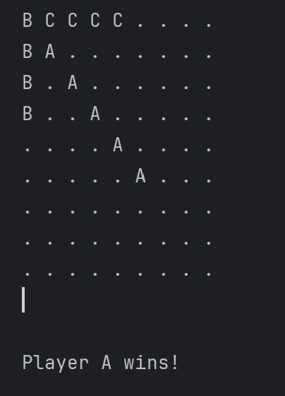
Case 2: Human Player A loses, AI Player B wins – User inputs random steps
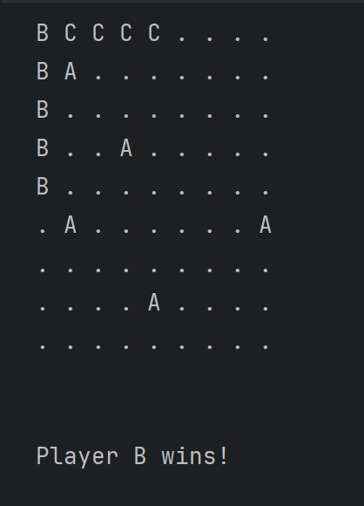

3. Conclusion
This assignment successfully implements a three-player Tic-Tac-Toe game with an AI using Minimax, a Prolog-based decision tree, and an interactive expert system.

Appendices
- Full Python Code Execution Output- .ipynb file attached
- Prolog Implementation Details - .pl file attached

Artificial and Computational Intelligence Assignment PART 2

Graduate Admission Prediction Report

1. Introduction
The purpose of this project is to predict the success of student admission based on several academic and profile-related factors using a decision tree model. The dataset used includes attributes such as GRE scores, TOEFL scores, University Rating, SOP strength, LOR strength, CGPA, and research experience.

2. Dataset Description
The dataset consists of the following attributes:
1. GRE Score (out of 340)
2. TOEFL Score (out of 120)
3. University Rating (out of 5)
4. Statement of Purpose (SOP) Strength (out of 5)
5. Letter of Recommendation (LOR) Strength (out of 5)
6. Undergraduate CGPA (out of 10)
7. Research Experience (0 = No, 1 = Yes)
8. Chance of Admission (ranging from 0 to 1)

3. Methodology
• Data Preprocessing: The dataset was cleaned, and the column names were corrected.
• Feature Selection: The target variable 'Chance of Admit' was converted into a binary classification problem (Admit: 1, Reject: 0).
• Model Training: A Decision Tree Classifier was trained on the dataset.
• Evaluation: The model's accuracy was measured using test data.
• Rule Extraction: Decision rules were derived from the decision tree and used to build an interactive Prolog expert system.
• User Interaction: Users can input their details and receive admission predictions directly in the Python notebook.

4. Implementation Details
1. Loads the dataset from a user-specified path.
2. Trains a Decision Tree Classifier.
3. Displays the extracted decision rules.
4. Provides an interactive prompt for students to enter their academic details.
5. Uses the trained model to predict and display the admission outcome.

5. Decision Tree Rules
| |--- GRE Score > 317.50
| | |--- Research <= 0.50
| | | |--- SOP <= 3.25
| | | | |--- class: 0
| | | |--- SOP > 3.25
| | | | |--- class: 1
| | |--- Research > 0.50
| | | |--- CGPA <= 8.45
| | | | |--- class: 1
| | | |--- CGPA > 8.45
| | | | |--- class: 1

6. Prolog Knowledge Base
A Prolog expert system was implemented using these rules, allowing for an interactive admission prediction system. The Prolog script asks users for their academic scores and provides an admission decision based on the learned rules.

7. Results and Evaluation
• The trained model achieved an accuracy of 81.00%.
• The interactive system allows students to enter their credentials and receive real-time admission predictions.
• The Prolog expert system provides a rule-based prediction mechanism for admission success.

8. Conclusion
This project successfully demonstrates the use of machine learning and expert systems for graduate admission prediction. The decision tree model provides an accurate and interpretable way to classify students based on their academic and research credentials.

9. Future Enhancements
• Implementing a more complex model such as Random Forest or Neural Networks for improved accuracy.
• Enhancing the Prolog expert system with more detailed rules and explanations.
• Integrating a web-based user interface for ease of use.

10. Screenshots and Appendices
(Include screenshots of Python notebook execution, decision tree visualization, and Prolog rule execution here.)
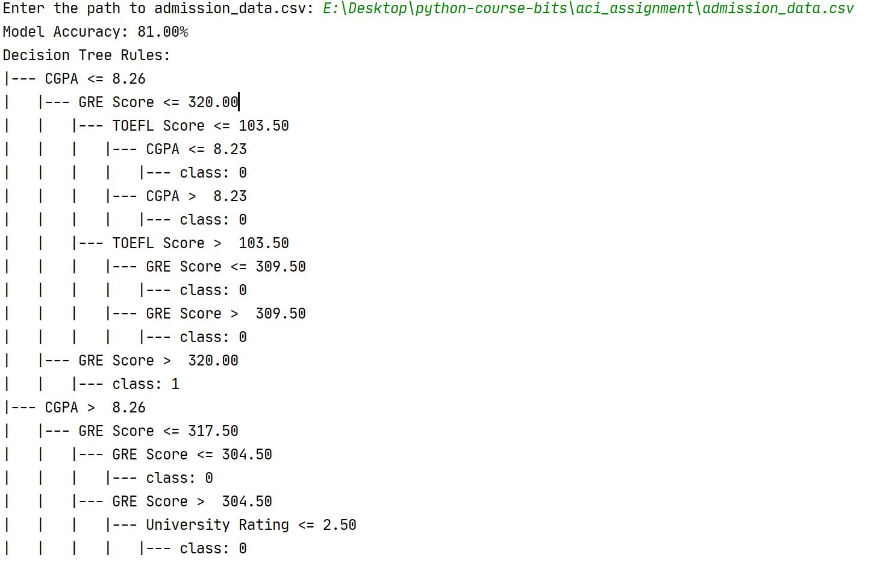
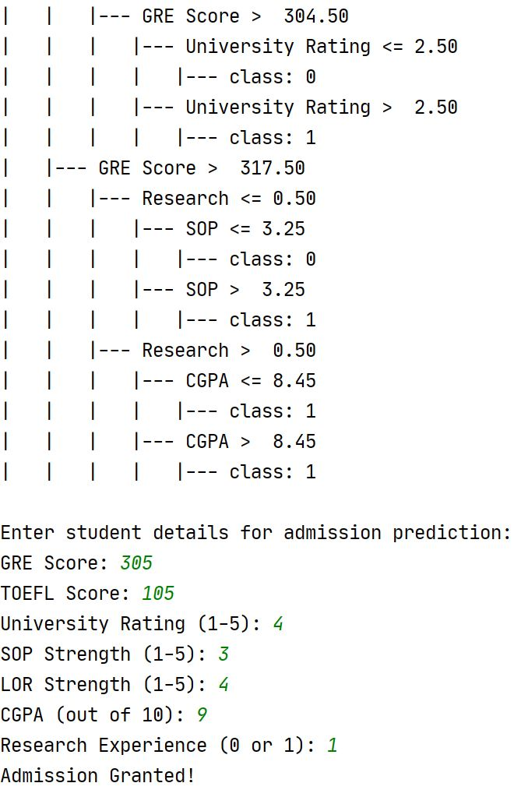

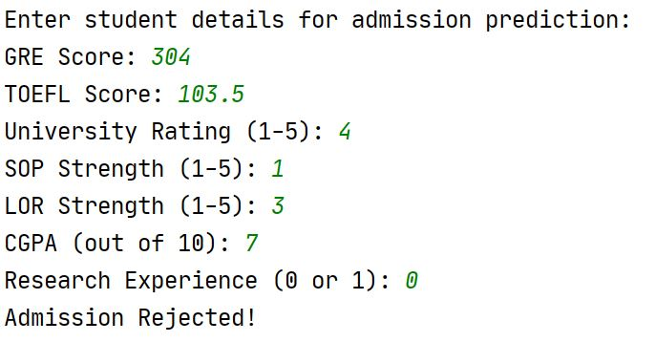
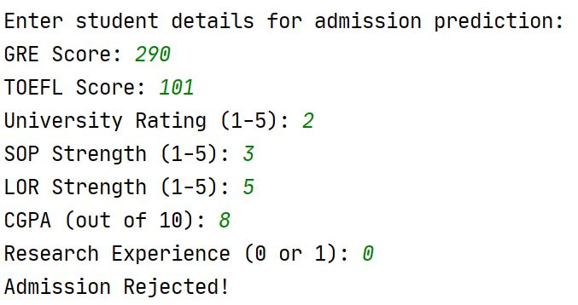
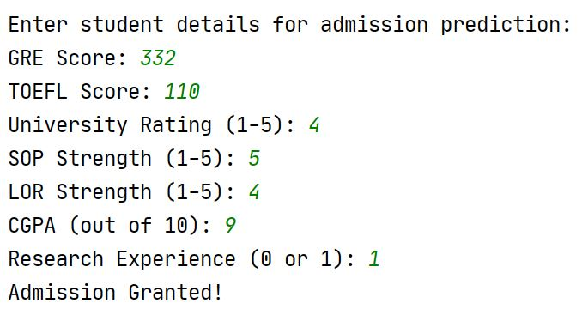

11. Team Members
BITS ID | Name | Contribution
2024AA05181 | Jagadi Shruti Chanabasappa | 100%
2024AA05182 | Prathyusha Devi K | 100%
2024AA05183 | A. Rohit Sai | 100%
2024AA05184 | Sarwajit Kumar Mishra | 100%
2024AA05185 | G V Ramya Sai | 100%

