**Rplus: Evaluation of Axure RP and MockPlus**

**Abstract**

Mockplus and Axure RP are prototyping tools used to create prototypes. They are commonly drag and drop techniques widely used in the contemporary era to support mobile web and desktop applications. The tools are focused on developing prototyping tools for UX/UI designer, developer, project manager and other IT professional. The study was to compare the degree of discomfort and inconvenience and the time complexity between two interfaces. Our results suggest that Axure was difficult to use and required more time to have an activity completed. About half of the set users found prototyping in Mockplus either easier than or equally difficult to Axure while less than 20% users found prototyping more difficult.

Shruti Jain   
University of Massachusetts  
Lowell, M.A.  
[shruti_jain1@student.uml.edu](mailto:shruti_jain1@student.uml.edu)

Snehitha Ramasahayam  
University of Massachusetts  
Lowell, M.A.  
snehitha_ramasahayam@student.uml.edu

**Author Keywords**  
Evaluation, Human Computer Interaction, MockPlus, Axure

**INTRODUCTION**   
  
Prototyping is often discussed as a propitious means of communication or expression of creation of products much faster and effectively. They establish and provide a practical exhibition and explanation of one’s ideas. This occasionally leads to an exchange of new ideas or modifications to the ones that exists. In contemporary era, with digitization, and the world revolving around user interactivity, clients and customers look forward to prototypes that provide a two-way flow of information.

With a plenteous prototypes available in the market to provide a user with an overview of design, interactions and ideas, we chose MockPlus and Azure Rp for evaluation on time complexity and the difficulty level.

**MockPlus**MockPlus is a prototyping and collaboration tool that focuses on developing rapid prototyping for User Experienced And User Interface designs and for the all the creative aspects of various fields.

**AxureRp**Axure Rp is similar to MockPlus only that it provides wire framing, documentation and specification software tool aimed at diverse application platform.

**METHODS**

**Evaluation**The primary goal of the study was to evaluate Mockplus and Axure Rp. Efficiency and Difficulty level of the tools were the two topics of examination. Efficiency determines the time taken to complete a task in each of the tools and difficulty level determines the ease of completion of a task.

With no experience in either of the tools, the transition to the use is challenging process. To determine the time complexity and

ease of use the following were the two hypothesis for the study. *H1: Prototyping in one tool is quicker than another tool.*

*H2: Prototyping in either of tools is hard or difficult  than other tool.*

**Participants**Participants in this study included 7 students from University of Massachusetts and a good ratio from UMass Lowell. Participants included all female between the ages of 18 and 26.

All participants in this study were volunteers and had no experience with the prototyping tools. Some participants were recruited from the University of Massachusetts, Boston. The participants were diverse and identified themselves as Indian. The total duration for the study was about four weeks.

**Materials**

Informed consent forms were used containing information about procedures, benefits and risks of participating, an explanation on the availability of research assistants, screen recording, voluntary participation, and contact information of the researchers.   
  
During the study, the approach to tasks was recorded. Additional materials included a self-compiled survey (see appendix). The survey included four questions about the knowledge and degree of knowledge of the tools. The survey also included a section in which the participant was asked to rate their emotions during and after the study. Additionally, the survey asked the extent of competition of the task. This survey was a Likert scale in which there were 7 adjective pairs. The participants were asked to select the number along the scale that most closely describes their emotions or their preferences.

**Procedure**

Testing for UMass Lowell students happened in a classroom environment that was reasonably distraction-free. On arrival, the participants completed consent forms and were reminded that they could abandon the experiment at any time. Participants received instructions orally and the tasks in writing. We also gave the video demo to the participants to get the feel of the tasks.  
The screen recording was turned on before the initiation of the testing of our hypothesis. For task 1 15 – 20 minutes was given to perform the task.. During the task, the questions asked by the users were noted and so was the behavior of the user. This was followed by the second task which was to be completed in ten minutes. However the participants took more time to perform the tasks After completion of the tasks, the participants had the opportunity to discuss how they felt during and after the study. They were provided with a post survey to answer a few questions.

**ANALYSIS**

We collected the data from the post survey and the screen recording from the recording we took the quantitative information of the time for the task 2 for our analysis. As we added the Likert scale in post survey we collected the responses in the quantitative form for the qualitative questions.

Below are the few questions of the post survey.

* The task was easy to implement
* I will recommend the MockPlus/AxureRp to others
* I was frustrated while performing the task
* I enjoyed while performing the task in tool
* I felt pressured while doing the task

We collected the data from all the participants on a scale of 1 – 7.1- Difficulty 7- Easy. We gathered the data related to difficulty level responses and plotted the graph as in Fig 1 for MockPlus vs Axure. color.

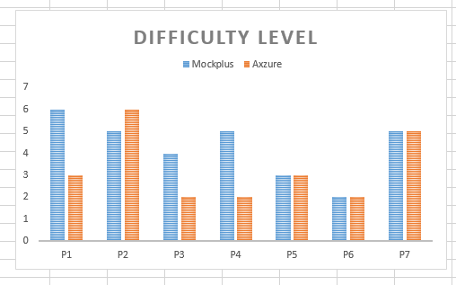Fig1. Mockplus vs Axure Difficultly level plot.

We collected the difficulty levels for each tool from survey and summed up to calculate the percentage of the difficulty level of the participants on both tools and found that

* **42% users found prototyping in Mockplus either easier than or equally difficult to Axure.**
* **14% users found prototyping in Axure more difficult than Mockplus.**

From the hypothesis 2 want to evaluate the time complexity to perform the tasks in both the prototyping tools. We collected the time while the users are performing the tasks. We specifically took the time duration for the task 2 in both the tools Mockplus and Axure Rp. Plotted the graph as below in the figure 2.

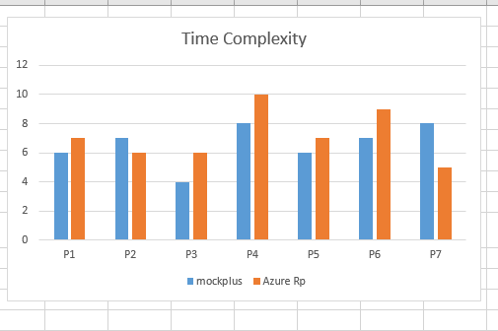

fig2. Time vs participants

We went through the screen recordings to see mouse movement and how well the users are searching in the correct location in the protoyping tools for the required tools, icons, search box etc.

**Results**

**Post Survey Results**

On the personal views like “recommendation” and emotions “Frustrated”, “Enjoyed” of the subjects on both the tools as in fig.4 and fig .5. We observed that

* Less frustrated after doing the task in Mockplus than Axure.
* Frustration was proportional to Recommendation.
* Enjoyed working with Axure more than Mockplus.

There were different levels of feeling for different users in our study. Infact one of the user noted that “though the level of frustration is more in Mock plus they would recommend it to others”.

**Screen Recording observation results**

In the screen recording overall users are exploring to find out what they need. we observed that

* High use of ‘Search Box’ or ‘Search Tool.
* Widgets/icons are difficult to locate.
* Link button is less easily visible.
* Unable to perform specific search by selecting the select boxes.

*We found that the time complexity is high in the Azure than MockPlus.*

**Statistical Tests**

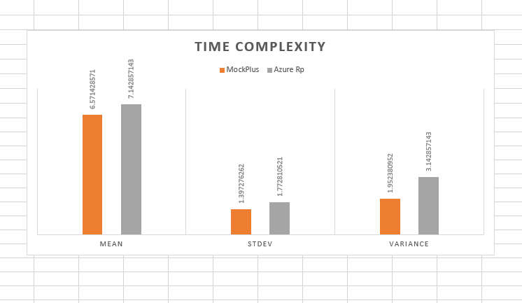

fig3. Mean,Variances and std.dev

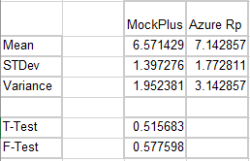fig4. Mean and variances for time complexity.

We performed the statistical test ref fig4. to determine if there is a significant distance between the two groups. We calculated the mean standard deviation variance for both the tools and did a t- test in t-test with data analysis tool in excel. We got the p value 0.515683. From the t- test this is considered to be not statistically significant.

We also performed the post survey analysis to capture the frustration level, completion time, satisfaction, recommendation and enjoyment. We plotted the various graphs from the data we collected from the post survey and obtained the results.

|  |  |  |
| --- | --- | --- |
| **Participant** | **Task2-MockPlus time** | **Ttask2- Axure RP time** |
| 1 | 6 | 7 |
| 2 | 7 | 6 |
| 3 | 4 | 6 |
| 4 | 8 | 10 |
| 5 | 6 | 7 |
| 6 | 7 | 9 |
| 7 | 8 | 5 |

**Overall Results from the study**

* Difficulty Level: High in Axure, Low in MockPlus
* Time Complexity: High in Axure, Low in Mockplus.

We found from the study that the users overall felt Mockplus as easy to use tool over Azure RP and it also took less time in Mockplus over the Axure.

**DISCUSSION, LIMITATIONS AND FUTURE WORK**

The study provided an insight into the evaluation of prototyping tools. This study found that novices or beginner though that completing tasks in Axure was difficult and consumed a relavitely high amount of time. Even though with less ease and high time complexity, users enjoyed working with Axure but showed a certain kind of discomfort during the process.

Indeed, the completion of tasks required building a prototype for a mobile application. The prototyping required using of widgets which led users to use the search box. Interestingly the tools were hard to locate which also, led to increase in time to complete a task in a prototype. Thereby, leading to use of more time in Azure .One of the limitations of this research study was the sample size. Having a large pool of students from diverse backgrounds would have funded the study richness and more data to be analyzed. With the p value considered not to be statistically significant, one of the other limitations of the study has been the random factors affecting the studies like, users state of emotion, rate of activeness, willingness to complete the task.

From the tools perspective we had few limitations with the free trial usage of the tools. Educational researchers need to continue conducting empirical research to ascertain the factors that contribute to statistically insignificant value of the p. First, researchers should identify the diverse and high volume of users to be recruited.

Second, researchers should determine what types of factors and attributes contribute to the study in an effective way. Finally, experimental research should be conducted to test various to determine which strategies are most effective

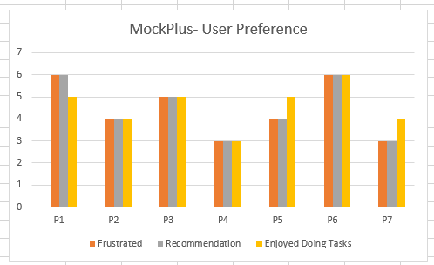

**fig.4 User Preferences participant vs Scale**

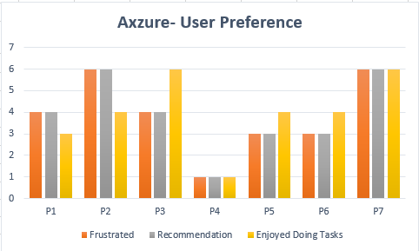

**fig.5 User Preferences participant vs Scale**

Above pictures are plotted from the post survey data we collected on the Likert scale of 1 – 7 for the frustration, recommendation and enjoyment in performing the tasks.

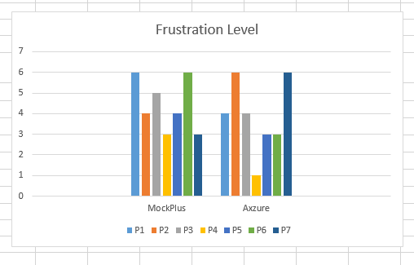

**fig.6 Frustration levels of participants**

**Appendices**

**Appendix [A]:** This appendix highlights the consent form. The list of all the consent forms is listed in the folder. 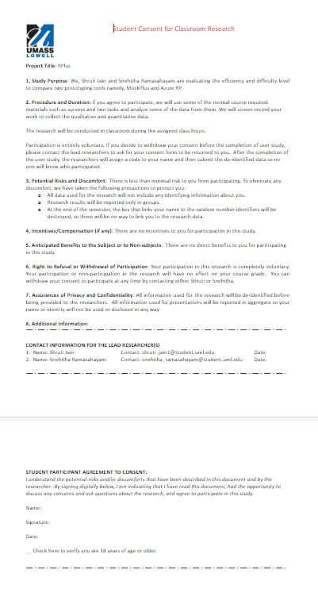

**Appendix [B]:** This appendix highlights the post-survey forms. The list of all the post-survey forms is listed in the folder.

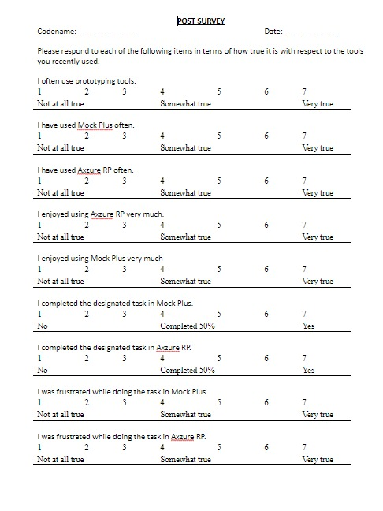

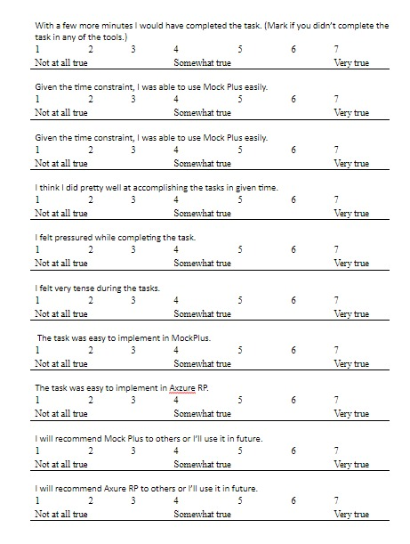

**Appendix [C]:** This appendix depicts the screen recordings.