Test plan for
XML BASED FEED FORMAT

ChangeLog

Version | Change Date | By | Description
version number | Date of Change | Name of person who made changes | Description of the changes made
001 | 7.11.23 | Raj Aryan | Initial Draft

1 Introduction 2
1.1 Scope 2
1.1.1 In Scope 2
1.1.2 Out of Scope 2
1.2 Quality Objective 2
1.3 Roles and Responsibilities 2
2 Test Methodology 3
2.1 Overview 3
2.2 Test Levels 3
2.3 Bug Triage 3
2.4 Suspension Criteria and Resumption Requirements 3
2.5 Test Completeness 4
3 Test Deliverables 4
4 Resource & Environment Needs 4
4.1 Testing Tools 4
4.2 Test Environment 4
5 Terms/Acronyms 5

Introduction
The XML to RSS Feed Converter Engine project is a software solution designed to facilitate the transformation of data stored in XML format into RSS (Rich Site Summary or Really Simple Syndication) feeds. RSS feeds are widely used for distributing and aggregating content from websites, blogs, and other sources in a standardized and easily consumable format.
The XML to RSS Feed Converter Engine project requires a comprehensive testing approach to ensure that the software operates reliably, accurately transforms XML data into RSS feeds, and meets the project's objectives. The testing approach for the XML to RSS Feed Converter Engine project should be thorough, considering the complexity of data transformation and the need for accurate, reliable, and high-performance conversion. It's essential to balance manual testing with automation to achieve comprehensive coverage and maintain software quality throughout the project's development and maintenance phases.

Scope

In Scope

Functional Requirements:
- XML Parsing:
  - The software must accurately parse XML data from various sources, handling different XML structures and formats.
- Mapping Rules:
  - The system should allow users to define and apply mapping rules to transform XML elements into RSS feed elements (e.g., mapping XML titles to RSS item titles).
- RSS Feed Generation:
  - The software should generate valid RSS feeds (e.g., conforming to RSS 2.0 standards) from the parsed XML data.
- Customization:
  - Users must be able to configure and customize the conversion process, specifying mapping rules, feed elements, and output format.
- User Interface:
  - The user interface should be intuitive and user-friendly, enabling users to interact with the converter, configure settings, and monitor the conversion process.
- Automation:
  - The system should support the automation of common tasks, such as scheduling regular XML to RSS conversions.
- Error Handling:
  - The software must handle errors gracefully and provide informative error messages when conversion issues occur.
Non-Functional Requirements:
- Performance:
  - The system should be able to handle conversions efficiently, even with a large volume of XML data, without significant performance degradation.
- Scalability:
  - The software must be scalable to accommodate an increasing number of users, sources, and conversions.
- Security:
  - The system should ensure the security of XML data during parsing and RSS feed generation, including protection against malicious XML content.
- Reliability:
  - The software should be highly reliable, minimizing downtime and ensuring that conversions consistently produce accurate results.
- Compatibility:
  - The generated RSS feeds must be compatible with a wide range of RSS feed readers and aggregators, ensuring that they can be consumed without issues.
- Usability:
  - The user interface should be designed with usability in mind, making it easy for users to configure and manage the conversion process.
- Maintainability:
  - The software should be maintainable, with clear and well-documented code, making it easy to update and enhance in the future.

Out of Scope

Functional Requirements:
- XML Data Creation:
  - The project will not involve testing the creation of XML data. The focus is on the conversion process from existing XML sources to RSS feeds.
- XML Schema Management:
  - The project does not encompass testing the creation or management of XML schemas. It assumes that XML data sources adhere to predefined schemas.
- RSS Feed Reader Development:
  - Testing and development of RSS feed reader or aggregator software are not part of this project.
- Data Validation and Cleaning:
  - Extensive data validation and data cleaning are not tested. Data quality assurance is primarily the responsibility of the data providers.
- Data Source Management:
  - The project does not involve creating or managing XML data sources, which are assumed to be external to the system.
Non-Functional Requirements:
- Advanced Security Measures:
  - Advanced security features, such as encryption of RSS feeds or advanced access control mechanisms, are not part of this project.
- RSS Feed Storage or Database Integration:
  - Storing or integrating RSS feeds into databases or other storage solutions is not tested or developed as part of this project.
- Non-Functional Testing Beyond Performance:
  - Extensive non-functional testing (e.g., security, scalability, compliance with advanced standards) is considered out of scope, unless explicitly required by project stakeholders.
- Advanced Load Testing:
  - While load and performance testing are part of the project's scope, advanced load testing that simulates extremely high loads beyond typical use is not within scope.
- XML Data Source Creation or Management:
  - The creation or management of XML data sources is not part of the project, and testing of such capabilities is not conducted.

Quality Objective

- Ensure the Application Under Test Conforms to Functional and Non-Functional Requirements:
  - One of the primary testing objectives is to verify that the XML to RSS Feed Converter Engine adheres to both its functional and non-functional requirements. Functional testing ensures that the software accurately converts XML data into RSS feeds, allowing users to customize the process. Non-functional testing, on the other hand, assesses the system's performance, security, reliability, and other non-functional attributes. This objective ensures that the software meets the specified criteria for functionality and quality.
- Ensure the AUT Meets the Quality Specifications Defined by the Client:
  - Quality specifications, often set by the client or project stakeholders, encompass various aspects of the software, such as usability, reliability, performance, and security. Testing should validate that the XML to RSS conversion engine aligns with these quality specifications. For example, usability testing ensures that the user interface is user-friendly, while performance testing ensures that the system can handle conversions efficiently. This objective emphasizes delivering a product that meets the client's quality expectations.
- Bugs/Issues are Identified and Fixed Before Go Live:
  - A critical objective of testing is to identify and address defects or issues in the software before it is deployed for actual use. This includes identifying functional issues, usability problems, performance bottlenecks, and security vulnerabilities. By uncovering and addressing these problems during the testing phase, the project aims to ensure that the software is robust and stable when it goes live. This objective helps in preventing post-deployment issues and enhancing the overall user experience.

Roles and Responsibilities
Detail description of the Roles and responsibilities of different team members like
- QA Analyst – Raj Aryan
- Test Manager – Prof. Abhishek Goyal
- Configuration Manager- Prof. Akansha Mishra
- Developers – Raj Aryan , Rajveer Mishra , Monika Sharma
- Installation Team- Raj Aryan ,Rajveer Mishra , Monika Sharma

Test Methodology

Overview

Agile methodologies, such as Scrum or Kanban, promote adaptive planning, evolutionary development, and quick responses to change. Agile involves frequent iterations, collaboration, and flexibility. Agile could be suitable for ensuring a high-quality and adaptable XML to RSS converter engine.

Test Levels

For the XML to RSS Feed Converter Engine project, several testing levels are suitable to ensure the software's quality and reliability. The choice of testing levels should be based on the project's objectives, complexity, and the need to verify different aspects of the software. Here are the testing levels that are suitable for this project:
- Unit Testing:
  - Suitability: Highly suitable
  - Rationale: Unit testing involves testing individual components or functions in isolation. In the case of the XML to RSS converter engine, unit testing can ensure that the parsing, mapping, and RSS feed generation functions work correctly. It is a fundamental level of testing for verifying the core functionality.
- Integration Testing:
  - Suitability: Highly suitable
  - Rationale: Integration testing verifies the interaction between different components or modules. In this project, it is essential to test the integration of XML parsing, mapping, and RSS feed generation to ensure that these components work seamlessly together and that data is transferred correctly between them.
- System Testing:
  - Suitability: Highly suitable
  - Rationale: System testing assesses the entire system to validate its compliance with requirements. It is crucial to verify that the XML to RSS conversion engine functions as a whole, including the user interface, customization features, and the ability to handle a variety of XML data sources.
- User Acceptance Testing (UAT):
  - Suitability: Highly suitable
  - Rationale: UAT involves end-users or stakeholders validating whether the software meets their needs and expectations. For this project, UAT is essential to ensure that the generated RSS feeds align with user requirements and are user-friendly.

Test Completeness
Here you define the criterias that will deem your testing complete.
For instance, a few criteria to check Test Completeness would be
- 100% test coverage
- All Manual & Automated Test cases executed
- All open bugs are fixed or will be fixed in next release

Test Deliverables

Description |  |  |  |  |  |  | Test Steps | Expected Result | Pass/Fail
Launch RSS Feed Viewer |  |  |  |  |  |  | 1. Open the RSS Feed Viewer. | 2. The application starts without errors, and the user interface is displayed. | Pass
Add a New RSS Feed |  |  |  |  |  |  | 1. Click on the "Add Feed" button. 2. Enter a valid RSS feed URL. 3. Click "Add." | 4. The RSS feed is added to the list of subscribed feeds. | Pass
Display RSS Feeds |  |  |  |  |  |  | 1. Open the application with subscribed feeds. | 2. All subscribed RSS feeds are displayed in a list. | Pass
View RSS Feed Items |  |  |  |  |  |  | 1. Click on a subscribed RSS feed. | 2. The feed items for the selected feed are displayed. | Pass
Load XML File |  |  |  |  |  |  | 1. Open the application. 2. Load a valid XML file. | 3. The XML file is loaded without errors. | Pass
Display XML Data |  |  |  |  |  |  | 1. Open an XML file. 2. Display the XML data in tabular form. | 3. The XML data is presented in a structured tabular format. | Pass
Display Elements and Attributes |  |  |  |  |  |  | . Open an XML file with elements and attributes. 2. Display the XML data in tabular form. | . Elements and their attributes are displayed in the table, showing hierarchical structure. | Pass
Invalid XML File |  |  |  |  |  |  | 1. Open an invalid XML file (e.g., missing closing tag). 2. Attempt to display the data. | 3. The application identifies the XML parsing error and provides an error message. | Pass

Equivalence Classes:
- Well-Formed XML: Equivalence classes for well-formed XML could include valid XML files with different structures, elements, and attributes. Each class represents a category of valid XML documents.
- Malformed XML: Equivalence classes for malformed XML include XML files with errors such as missing closing tags, invalid characters, or incorrect structure. Each class represents a category of common XML errors.
- Empty XML: This class includes XML files that are empty or contain no data.
- Large XML Files: Equivalence classes for large XML files, which can be categorized based on file size, to test the converter's performance with varying data volumes.
- Valid RSS Feed: Equivalence classes for valid RSS feeds include well-formed XML data that should result in correctly generated RSS feeds.
- Customized Mapping: Test cases for customized mapping rules, where users define specific mappings for their XML data, can be categorized based on the complexity and variety of mappings.
Decision Table :

Condition: XML Element Type | Condition: RSS Feed Element Type | Action: Mapping Rule
Element A | RSS Title | Map Element A to RSS Title
Element B | RSS Description | Map Element B to RSS Description
Element C | RSS Item Title | Map Element C to RSS Item Title
Element D | RSS Item Description | Map Element D to RSS Item Description
Element E | RSS Link | Map Element E to RSS Link
Element F | RSS Pub Date | Map Element F to RSS Pub Date
Default (Catch-All) | Default | Use Default Mapping Rule

Test Case Output Images

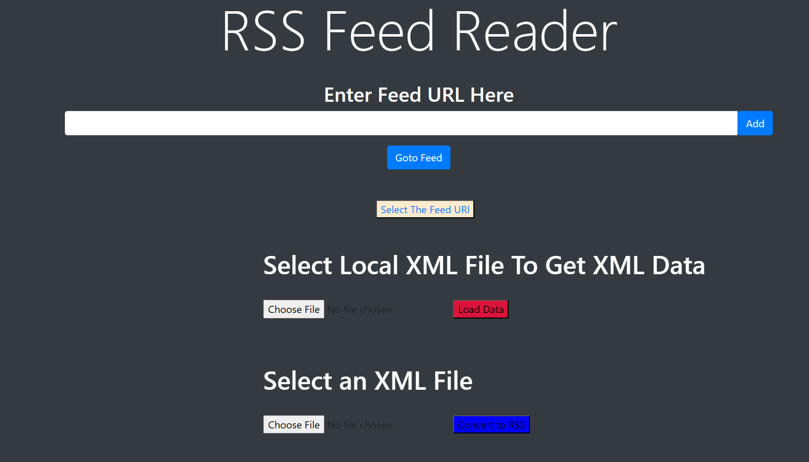
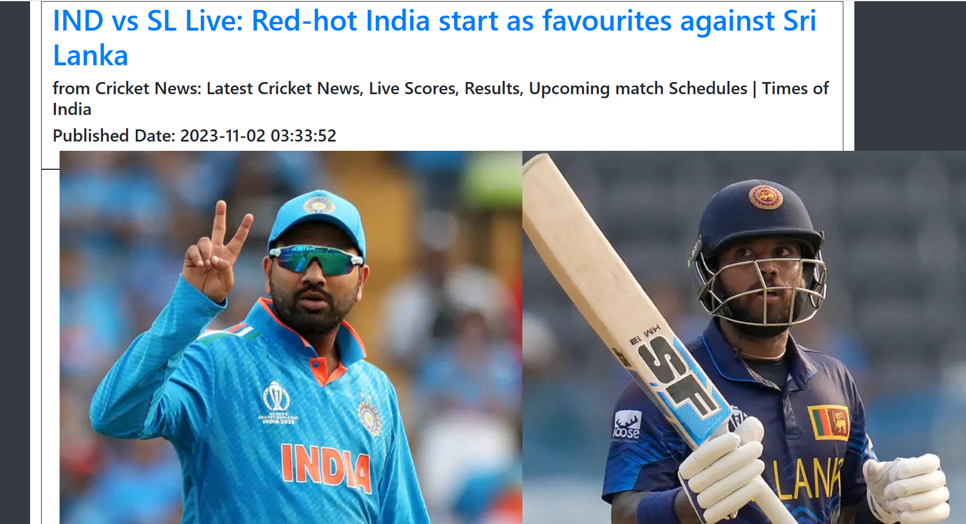

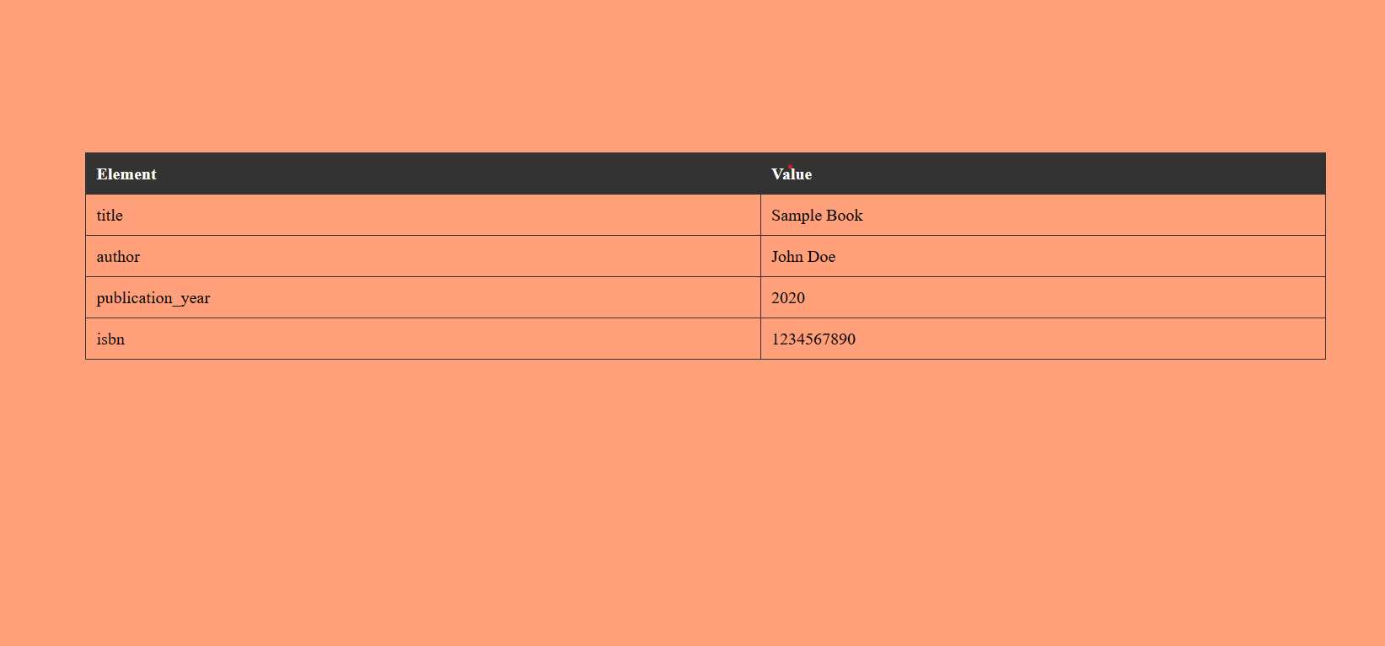

Resource & Environment Needs

Testing Tools

Requirements Tracking Tool:
- JIRA: JIRA by Atlassian is a versatile tool for tracking project requirements, managing tasks, and handling project management. It allows you to create and manage requirements as well as link them to test cases.
Bug Tracking Tool:
- Mantis Bug Tracker: Mantis is an open-source bug tracking system known for its simplicity and ease of use. It's suitable for tracking and managing software defects.
Automation Tools:
- Selenium: Selenium is a popular open-source tool for automating web applications. It's suitable for automating the testing of the XML to RSS conversion engine's user interface.
- Postman: Postman is an excellent tool for testing APIs. It can be used to automate the testing of RESTful APIs or web services integrated with your XML to RSS converter.

Test Environment
It mentions the minimum hardware requirements that will be used to test the Application.

Following software’s are required in addition to client-specific software.

- Windows 10 and above
- Office 2013 and above
- Vs Code
- I3 or more processor

Terms/Acronyms
Make a mention of any terms or acronyms used in the project

TERM/ACRONYM | DEFINITION
API | Application Program Interface
AUT | Application Under Test

Prof . Abhishek Goyal Prof. Anurag Mishra

(Testing Lab Faculty) (Project Guide)

Submitted To: Prof . Neha Shukla

