Software Requirements Specification
for
Kisan Mitra
Prepared by Aman Raj Singh
KIET Group of Institutions
February 2023
Table of Contents
Table of Contents ii
Revision History ii
1. Introduction 1
1.1 Purpose 1
1.2 Document Conventions 1
1.3 Intended Audience and Reading Suggestions 1
1.4 Product Scope 1
1.5 References 1
2. Overall Description 3
2.1 Product Perspective 3
2.2 Product Functions 3
2.3 User Classes and Characteristics 3
2.4 Operating Environment 3
2.5 Design and Implementation Constraints 4
2.6 Assumptions and Dependencies 4
2.7 Apportioning and Requirements 4
3. External Interface Requirements 4
3.1 User Interfaces 5
3.2 Hardware Interfaces 6
3.3 Software Interfaces 6
3.4 Communications Interfaces 6
4. System Features 6
4.1 Equipment Listing 6
4.2 Equipment Search 7
4.3 Rental Booking 7
4.4 User Profile 7
4.5 Reviews and Ratings 7
4.6 Administrative Tools 7
4.7 Notifications 7
4.8 Support Services 7

5. Other Nonfunctional Requirements 7
5.1 Performance Requirements 7
5.2 Safety Requirements 7
5.3 Security Requirements 8
5.4 Software Quality Attributes 8

Revision History
Name | Date | Reason For Changes | Version
Kisan Mitra | 02/2023 | DFD | 1
Kisan Mitra | 04/2023 | Workflow diagram, User Interface | 2

Introduction

Purpose
The purpose of the SRS KISAN MITRA an Affordable Farm Equipment Sharing Platform is to facilitate cost-effective access to high-quality agricultural machinery for small-scale farmers. By connecting farmers with surplus equipment to those in need, the platform aims to reduce financial burdens and increase operational efficiency. Through transparent transactions and community collaboration, it strives to foster sustainable agricultural practices, improve productivity, and empower farmers to thrive in their endeavors while promoting resource conservation and equitable access to technology in rural areas.

Document Conventions
This Document was created based on the IEEE template for System Requirement Specification Documents.

Intended Audience and Reading Suggestions
- Small-scale Farmers: Detailed sections on equipment availability, rental processes, and user testimonials can help them understand how the platform can alleviate financial constraints and enhance productivity.
- Equipment Owners: Highlight the benefits of listing their surplus machinery, including potential earnings, maintenance guidelines, and liability coverage, to encourage participation and foster a sense of community.
- Agricultural Organizations and Policymakers: Emphasize the platform's potential to address rural development challenges, promote sustainable farming practices, and contribute to economic growth through case studies, research findings, and recommendations for policy integration

Product Scope
The product scope of the SRS KISAN MITRA encompasses a user-friendly online interface facilitating the listing, search, and rental of agricultural machinery. It includes features such as equipment categorization, rental scheduling, secure payment processing, and user reviews. Additionally, the platform offers administrative tools for equipment owners to manage listings and transactions efficiently. The scope extends to mobile accessibility, ensuring seamless usage for farmers and equipment owners, thereby enhancing accessibility and usability.

References
- Smith, J., & Brown, A. (Year). "Empowering Small-scale Farmers: A Case Study of Affordable Farm Equipment Sharing Platforms." Journal of Agricultural Innovation, vol. 10, no. 2, pp. 123-135.
- Garcia, L., & Nguyen, T. (Year). "Community Building Through Affordable Farm Equipment Sharing: A Social Impact Analysis." International Journal of Rural Development, vol. 15, no. 4, pp. 367-378.
- Martinez, K., & Lee, S. (Year). "Economic Viability of Affordable Farm Equipment Sharing Platforms: A Comparative Analysis." Agricultural Economics Review, vol. 22, no. 3, pp. 289-302.
- Wang, Q., & Chen, H. (Year). "Overcoming Challenges in Implementing Farm Equipment Sharing Platforms: Insights from a Pilot Study." Journal of Agricultural Engineering Research, vol. 45, no. 1, pp. 56-68.
- Anderson, P., et al. (Year). "Collaborative Consumption and Sustainable Agriculture: Exploring the Environmental Impacts of Affordable Farm Equipment Sharing Platforms." Sustainability Science, vol. 12, no. 5, pp. 789-802.
- FAO (1985) ‘Multiform use of agricultural machinery’, Food and Agriculture Organization of the United Nations.
- Feder, G. and Slade, R. (1984) ‘The acquisition of information and the adoption of new technology.’ American Journal of Agricultural Economics, 66(3), pp. 312–320.
- IRRL (1986) ‘Small farm equipment for developing countries’, in The International Conference on Small Farm Equipment for Developing Counties: Past Experiences and Future Priorities.
- Seung-Yeoub Shin, Chang-Ho Kang, Seok-Cheol Yu, Byounggap Kim, Yu-Yong Kim, Jin-Oh Kim, Kyou-Seung Lee, Web-based Agricultural Machinery Rental Business Management System National Academy of Agricultural Science, Rural Development Administration, Jeonju, Korea, October 6th, 2014.
- Al-shihabi, S.T.; AIDurgam, M.M. A max–min ant system for the finance- based scheduling problem. Comput. Ind. Eng. 2017, 110, 264–276. [CrossRef].
- Krunal Bagaitkar1, Khoshant Lande. 2019. ‘Tractor Hiring Application for Farmers’. Department of Information Technology, S.B Jain Institute of Technology, Management and Research, Nagpur Project Guide, Department of Information and Technology, S.B Jain Institute of Technology, Management and Research, Nagpur.
- Seung-Yeoub Shin, Chang-Ho Kang. 2014. ‘Web-based Agricultural Machinery Rental Business Management System’. National Academy of Agricultural Science Korea Department of Bio-Mechatronic Engineering, Sungkyunkwan University, Suwon, Korea.
- S. Y. Jung. Study on the web-based maintenance and management system of smallscale public research facilities. Chonnam National University, Department of Architectural Engineering;2011. MS thesis.
- Small-scale actors in agri-food value chains the services of agricultural mechanization hire enterprises.” Martin Hilmi Volume: 07 Issue: 04 | Oct.-Dec. | 2018.
- Julius, A. (2014) ‘Factors limiting small-scale farmers’ access and use of tractors for agricultural mechanization in Abuja, north central zone, Nigeria’, European Journal of Sustainable Development, 3(1), pp.115–124

Overall Description

Product Perspective
The SRS KISAN MITRA operates as a standalone system, accessible via web browsers and mobile applications. It interfaces with external payment gateways for secure transactions and integrates mapping services for location-based equipment searches. While it complements existing agricultural support systems, it primarily focuses on democratizing access to farm machinery for small-scale farmers. The platform may collaborate with agricultural organizations to expand its reach and effectiveness, enhancing its overall impact on rural communities. It is develop to run on Windows, iOS and Android.

Product Functions
- Equipment Listing: Allow farmers to list surplus machinery with detailed specifications, availability, and rental rates.
- Equipment Search: Enable users to search for specific agricultural equipment based on location, type, and availability.
- Rental Booking: Facilitate secure booking and scheduling of equipment rentals, including payment processing and confirmation notifications.
- User Profiles: Provide farmers and equipment owners with customizable profiles to manage listings, rental history, and communication.
- Reviews and Ratings: Allow users to leave feedback and ratings to maintain transparency and build trust within the community.
- Support and Assistance: Offer customer support services to address queries, resolve disputes, and ensure a seamless user experience.

User Classes and Characteristics
- Farmers:
- Characteristics: Small-scale farmers with limited financial resources, varying levels of technological proficiency, and a need for affordable access to farm equipment.
- Equipment Owners:
- Characteristics: Larger-scale farmers or agricultural businesses with surplus machinery, seeking to earn additional income by renting out their equipment.
- Administrators:
- Characteristics: Platform moderators or support staff responsible for overseeing transactions, resolving disputes, and ensuring the smooth operation of the sharing platform.

Operating Environment
- Windows
- Android
- iOS

Design and Implementation Constraints
The design and implementation of the SRS Kisan Mitra face several constraints. Rural connectivity issues demand optimization for low bandwidth and offline functionality. Ensuring compatibility and safety standards for a diverse range of agricultural machinery poses a challenge. Trust and security are critical, requiring robust user verification and secure payment systems. Compliance with local regulations and insurance requirements adds complexity. Scalability is essential to accommodate growth. Cultural and language considerations must ensure inclusivity and accessibility for diverse user groups.

Assumptions and Dependencies
Assumptions and dependencies for the SRS Kisan Mitra include the availability of internet access and basic digital skills among users, as well as the willingness of equipment owners to participate and maintain machinery. Assumptions also entail user honesty in equipment representation and sufficient demand in targeted areas. Dependencies include reliable internet connectivity, integration with secure payment systems, cooperation from equipment owners, access to support services, and collaboration with relevant agricultural organizations or authorities for promotion and regulation.

Apportioning of Requirements
The apportioning of requirements for the SRS Affordable Farm Equipment Sharing Platform prioritizes features essential for seamless user experience and platform functionality. Core requirements such as equipment listing, search, booking, and secure payment processing receive primary focus. Secondary requirements encompass user profiles, reviews, and support services. Tertiary requirements include administrative tools for equipment owners and regulatory compliance features. This hierarchical approach ensures efficient allocation of resources and timely delivery of key functionalities.

External Interface Requirements

User Interfaces
There are user interface need of any software it simply requires a user system which interact with the users to understood the Kisan Mitra website/application.

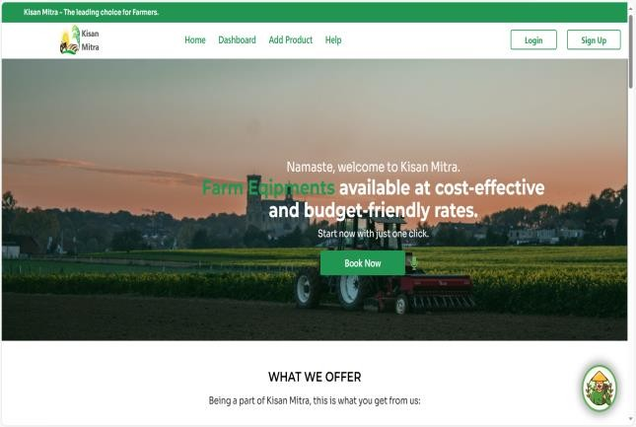
Fig. 1 - Main Interface
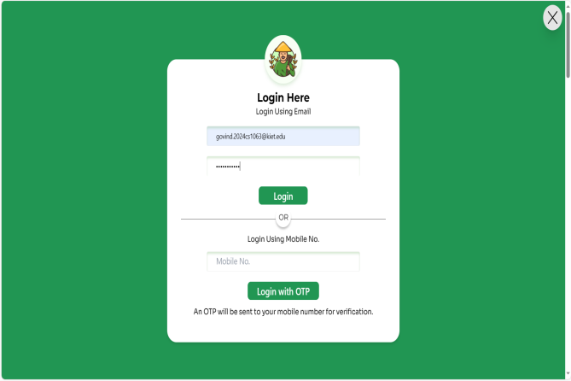

Fig .2 - Login/Sign up page
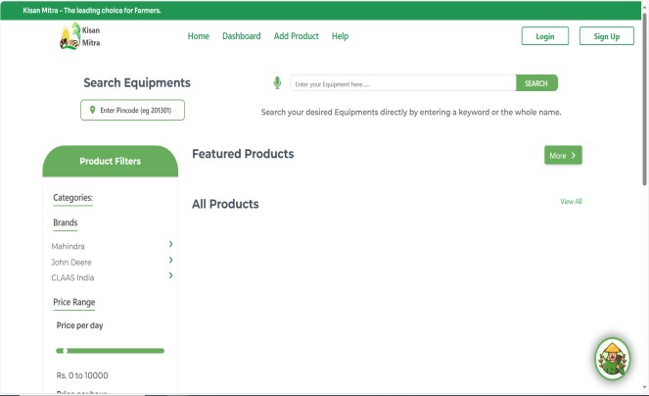

Fig. 3 - Product description page
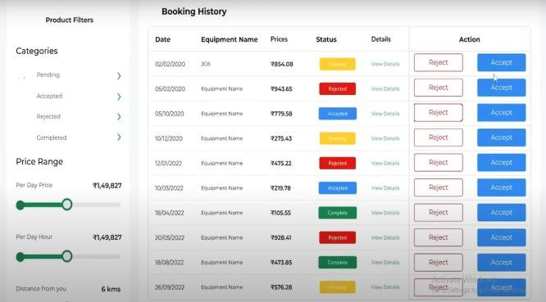

Fig. 4 - Product description

Hardware Interfaces
There are no as such need of any hardware tool it simply requires a hardware system which interact with the software OS to run the Kisan Mitra website/application.

Software Interfaces
Kisan Mitra with payment gateways, mapping services, and agricultural databases to facilitate secure transactions, location-based searches, and access to relevant farming information, respectively, enhancing user experience and platform functionality.

Communications Interfaces
The SRS Affordable Farm Equipment Sharing Platform utilizes email notifications, in-app messaging, and potentially SMS alerts for effective communication between users and administrators.

System Features
This section demonstrates Kisan Mitra website most prominent features and explains how they can be used and the results they will give back to the user.

4.1. Equipment Listing: Users can create detailed listings for their available farm machinery, including specifications such as make, model, condition, and rental rates. They can also upload photos to showcase the equipment's condition.

4.2. Equipment Search: The platform offers advanced search functionality, allowing users to filter equipment based on criteria such as location, type (e.g., tractors, harvesters), and availability dates. This enables farmers to find the specific equipment they need for their operations.

4.3. Rental Booking: Users can initiate rental bookings directly through the platform, selecting their desired equipment, rental duration, and preferred pickup/delivery options. The platform securely processes payments and provides confirmation of the booking.

4.4. User Profiles: Each user has a customizable profile where they can manage their listings, view their rental history, and update their contact information. User profiles also display reviews and ratings received from other users.

4.5. Reviews and Ratings: After completing a rental, users can leave reviews and ratings for each other based on their experience. This helps maintain transparency and build trust within the community, allowing users to make informed decisions when renting equipment.

4.6. Administrative Tools: Equipment owners have access to administrative tools to manage their listings, including the ability to edit equipment details, update availability dates, and respond to booking requests. They can also use these tools to resolve disputes or issues that may arise during the rental process.

4.7. Notifications: The platform sends out notifications to users for various events, such as when they receive a booking request, when a booking is confirmed, or when there are updates to their listings. This helps keep users informed and ensures timely communication throughout the rental process.

4.8. Support Services: Users can reach out to customer support for assistance with any questions, concerns, or issues they may encounter while using the platform. The support team is available to provide guidance, facilitate communication between users, and resolve disputes if necessary.

Other Nonfunctional Requirements

Performance Requirements
Kisan Mitra requires a system with latest version of OS. However, these requirements can support effectively on each system Android, Windows and iOS. Performance depends on the models used in the development and as a result, the system requirements for bigger datasets.

Safety Requirements
To ensure that no one of Kisan Mitra users loses any data while using Kisan Mitra website/application (due to a crash or a bug of some kind) the developer team updates Kisan Mitra website/application regularly. There is a bug tracker available where users can report any bugs they have encountered so that the developers can fix it in the next release.

Security Requirements
Kisan Mitra does not have any security requirements and thus any type of user can use it without any additional privileges.

Software Quality Attributes
Kisan Mitra provides the users with very simple and easy to understandable features. Due to its well designed and easy to use interface it can be used by users. However, users must internet connectivity, device to run application/website with updated OS.

