A Project Report
On
XML Based Feed Creation Engine
submitted for partial fulfillment of the requirements
for the award of the degree of
Bachelor of Technology in
Computer Science
Submitted by
Rajveer Mishra (2000290120125)
Raj Aryan (2000290120124)
Monika Sharma (2000290120097)
Under supervision of
Prof. Anurag Mishra

KIET Group of Institutions, Ghaziabad
Dr. A.P.J. Abdul Kalam Technical University, Lucknow
May 2024
TABLE OF CONTENTS | Page No.
DECLARATION……………………………………………………………………. | ii
CERTIFICATE……………………………………………………………………… | iii
ACKNOWLEDGEMENTS…………………………………………………………. | iv
ABSTRACT……………………………………………………………………….... | v
LIST OF FIGURES…………………………………………………………………. | ix
LIST OF TABLES…………………………………………………………………… | xi
LIST OF ABBREVIATIONS………………………………………………………. | xii
CHAPTER 1 INTRODUCTION PAGE NO.
1.1 INTRODUCTION TO PROJECT
1.2 PROJECT CATEGORY(INTERNET BASED, APPLICATION OR SYSTEM DEVELOPMENT, RESEARCH BASED ,INDUSTRY AUTOMATION, NETWORK OR SYSTEM ADMINISTRATION)
1.3 OBJECTIVES
1.4 PROBLEM FORMULATION
1.5 PROPOSED SYSTEM
1.6 UNIQUE FEATURES OF THE SYSTEM

CHAPTER 2. REQUIREMENT ANALYSIS AND SYSTEM SPECIFICATION
2.1 FEASIBILITY STUDY (TECHNICAL, ECONOMICAL, OPERATIONAL)
2.2 SOFTWARE REQUIREMENT SPECIFICATION DOCUMENT WHICH MUST INCLUDE THE FOLLOWING:
(DATA REQUIREMENT, FUNCTIONAL REQUIREMENT, PERFORMANCE REQUIREMENT
, MAINTAINABILITY REQUIREMENT, SECURITY REQUIREMENT)
2.3 SDLC MODEL TO BE USED

CHAPTER 3. SYSTEM DESIGN
3.1 DETAIL DESIGN
3.2 SYSTEM DESIGN USING DFD LEVEL 0 AND LEVEL 1
3.3 USE CASE DIAGRAM
3.4 DATABASE DESIGN
3.4.1 ER DIAGRAMS

CHAPTER 4. IMPLEMENTATION, TESTING, AND MAINTENANCE
4.1 INTRODUCTION TO LANGUAGES,TOOLS AND TECHNOLOGIES USED FOR IMPLEMENTATION
4.2 TESTING TECHNIQUES AND TEST CASES USED

CHAPTER 5. RESULTS AND DISCUSSIONS
5.1 USER INTERFACE REPRESENTATION (OF RESPECTIVE PROJECT)
5.1.1 BRIEF DESCRIPTION OF VARIOUS MODULES OF THE SYSTEM
5.2 SNAPSHOTS OF SYSTEM WITH BRIEF DETAIL OF EACH
5.3 BACK ENDS REPRESENTATION (DATABASE TO BE USED )
5.3.1 SNAPSHOTS OF DATABASE TABLES WITH BRIEF DESCRIPTION
CHAPTER 6. CONCLUSION AND FUTURE SCOPE

REFERENCES( REFERENCES SHOULD BE IN IEEE STANDARD)

DECLARATION
We hereby declare that this submission is our own work and that, to the best of our knowledge and belief, it contains no material previously published or written by another person nor material which to a substantial extent has been accepted for the award of any other degree or diploma of the university or other institute of higher learning, except where due acknowledgment has been made in the text.

Signature
Name: - Rajveer Mishra (2000290120125)
Name: - Raj Aryan (2000290124)
Name: - Monika Sharma (2000290120097)
Date: - 02-04-2024

CERTIFICATE

This is to certify that Project Report entitled “XML Based Feed Creation Engine” which is submitted by Rajveer Mishra, Raj Aryan and Monika Sharma in partial fulfillment of the requirement for the award of degree B. Tech. in Department of Computer Science of Dr. A.P.J. Abdul Kalam Technical University, Lucknow is a record of the candidates own work carried out by them under my supervision. The matter embodied in this report is original and has not been submitted for the award of any other degree.
.

Date: 02-04-2024 Supervisor
Anurag Mishra (Professor)

ACKNOWLEDGEMENT

It gives us a great sense of pleasure to present the report on the B. Tech Project undertaken during B. Tech. Final Year. We owe a special debt of gratitude to Professor Anurag Mishra, Department of Computer Science, KIET, Ghaziabad, for his/her constant support and guidance throughout the course of our work. His/Her sincerity, thoroughness and perseverance have been a constant source of inspiration for us. It is only his cognizant efforts that our endeavors have seen the light of the day.
We also take the opportunity to acknowledge the contribution of Dr. Ajay Kumar Srivastava, Head of the Department of Computer Science, KIET, Ghaziabad, for his full support and assistance during the development of the project. We also do not want to miss the opportunity to acknowledge the contribution of all the faculty members of the department for their kind assistance and cooperation during the development of our project.
Finally, we acknowledge our friends for their contribution to the completion of the project.
Date : 02-04-2024
Signature: Signature:
Name : Rajveer Mishra Name: Raj Aryan
Roll No.: 2000290120125 Roll No.:2000290120124
Name: Monika Sharma
Roll No.: 2000290120097

ABSTRACT

RSS is a powerful technology which helps us to access web content. The main objective of this research paper is to deliver XML-based RSS feed format that helps the user to get a summary of a website on a single web page we will discuss about the core component of RSS reader and its history which is used in the online world by the end of this paper you will have a complete understanding of how it’s going on and what is significance in the digital area. Furthermore, the research paper sheds light on the essentials of RSS, delineating the process of creating and reading RSS feeds at its core, RSS relies on a structured XML format, providing a consistent framework across versions. The RSS document, initiated by the element, encapsulates crucial metadata within the element, delineating the feed's title, associated links, and a brief description. The element forms the nucleus of the feed, housing content with titles, URLs, and descriptions. This XML-based architecture ensures systematic content distribution, enhancing user experiences by delivering relevant information without overwhelming clutter.as a valuable resource, this research paper serves to enlighten readers on the intricacies of XMLbased RSS feed formats and their pivotal role in shaping the digital information landscape.

LIST OF FIGURES

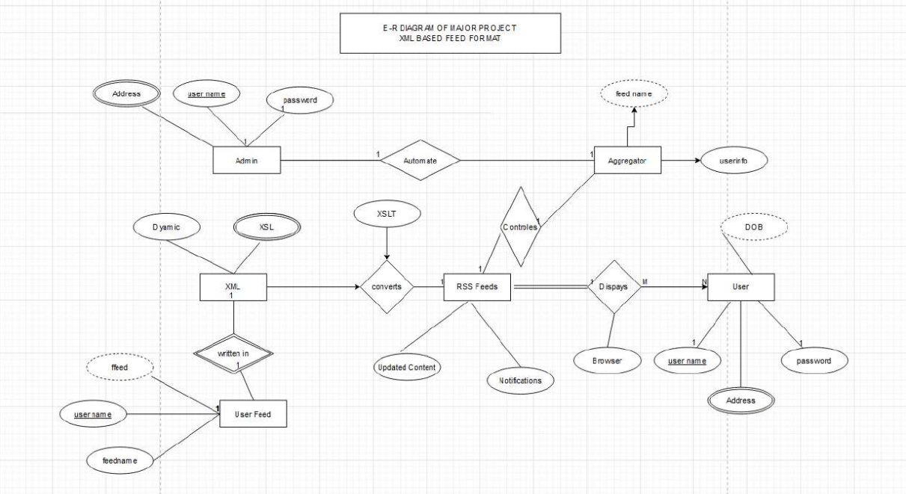

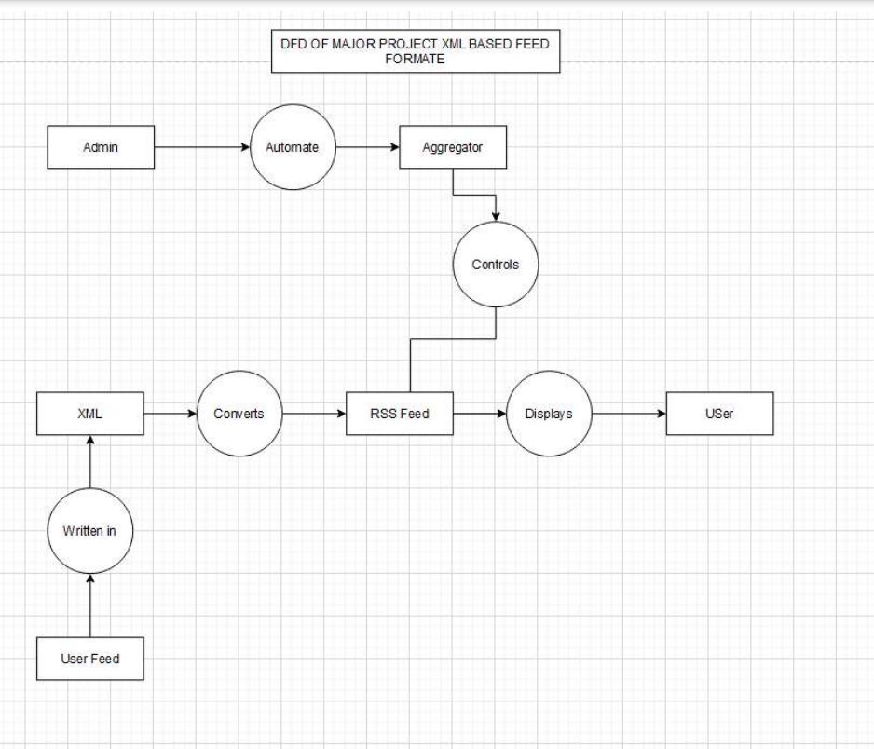
CHAPTER-1
INTRODUCTION
1.1 INTRODUCTION
Now the internet completely changes the way how to access information. In the digital area, it's essential to stay updated with the latest news, not for the individual but also for the organization and website everyone wants to stay updated with time. It's not easy to manual website visits because it's a very time-consuming and often overwhelming process. However, a solution exist in the form of RSS (really simple syndication) and XML based RSS feed format that simplify and accelerate content distribution for information professional specially those responsible for managing large volume of content the challenge lie in efficiently deliver fresh information.
RSS, often expanding to "Really Simple Syndication" or "Rich Site Summary," stands as a simple yet immensely powerful technology that empowers internet users to effortlessly monitor and retrieve updates from their favorite websites, blogs, news sources, and more. It eliminates the need for users to continually revisit websites to check for new content, making it a compelling tool for staying informed in a time-efficient manner. RSS, in its essence, serves as a bridge between publishers who share valuable content and users who seek to access that content without the hassle of manual exploration. The adoption of RSS goes beyond simplifying content consumption. It offers multifaceted advantages to both publishers and users.
Publishers can promptly notify their audience about fresh additions to their website, enhancing user engagement and retention. Additionally, RSS technology promotes the syndication of content to multiple websites simultaneously, a practice commonly referred to as "news on your desktop. Users, meanwhile, benefit from the convenience of aggregated content in a single location, saving time and effort.

1.2 PROJECT CATEGORY

The project described involves the development of an "XML Based Feed Creation Engine" for the purpose of efficiently managing and distributing web content using RSS technology. This falls under the realm of advanced web technologies and information management, where the focus is on leveraging cutting-edge techniques to streamline content dissemination and access.
Within this category, the project encompasses various facets such as XML parsing, RSS feed generation, and content aggregation, all of which are integral components of modern web-based information systems. It addresses the challenges associated with content distribution in the digital age and proposes a solution that harnesses the power of structured data (XML) to facilitate seamless information retrieval and consumption.

1.3 OBJECTIVES

The project aims to develop a robust converter tool that facilitates the seamless transformation of data stored in a database into RSS (Really Simple Syndication) format. This conversion process will enable users to receive timely notifications and access summaries of new posts from their favorite websites, such as blogs or online magazines. The overarching objectives of the project are multifaceted and encompass various aspects of technology integration and implementation.
Drawing upon the principles of XML, XSL and XSLT. The project seeks to design and develop a robust architecture for the converter tool. This architecture will encompass data retrieval mechanisms, XML schema definitions, and XSLT transformation processes, ensuring seamless conversion of database records into well-structured RSS feeds.
Key objectives include the implementation of sophisticated data retrieval mechanisms capable of extracting pertinent information from the database, including post titles, summaries, publication dates, and URLs. These extracted data elements will then be organized and formatted according to predefined XML schemas, facilitating the generation of coherent and standardized RSS feeds.

1.4 PROBLEM FORMULATION

In today's digital landscape, staying updated with the latest content from favorite websites, including blogs and online magazines, is essential for individuals and organizations alike. RSS (Really Simple Syndication) feeds serve as a convenient solution, allowing users to receive timely notifications and access summaries of new posts without the need for manual exploration. However, despite the widespread adoption of RSS technology, a significant challenge persists in efficiently generating RSS feeds from database-stored data.
The problem at hand revolves around the absence of an effective mechanism to convert data stored in databases into RSS format, hindering users from accessing timely updates and summaries of content. Current approaches often rely on manual methods or rudimentary scripts, which are labor-intensive, error-prone, and lack the flexibility to accommodate diverse data sources and formats.
Furthermore, existing solutions may not adequately address the specific requirements and preferences of users, such as the ability to customize feed parameters or ensure the accuracy and consistency of converted content. Technical constraints, including compatibility issues with different database systems and scalability concerns, further complicate the development of a robust and reliable converter tool.
The importance of addressing this problem cannot be overstated. By streamlining the process of converting database-stored data into RSS feeds, individuals and organizations can enhance their ability to stay informed and up to date with the latest content from their preferred online sources. Moreover, a well-designed converter tool has the potential to improve user experiences, promote wider adoption of RSS technology, and facilitate seamless content distribution across various platforms.

1.5 PROPOSED SYSTEM

The proposed system entails an advanced RSS Feed Creation Engine designed to simplify the process of generating, storing, and updating RSS feeds from various online sources. At its core, the system offers an intuitive online RSS feed generator, allowing users to effortlessly create feeds by providing the target URL and selecting desired content blocks through a visual interface. With the system handling the extraction and formatting tasks, users can obtain their customized RSS feeds within seconds, eliminating the need for manual coding or scripting.
Once generated, the RSS feeds are securely stored in the user's cloud-based account, each assigned a unique URL for easy access and integration into websites or RSS readers. Notably, the system employs an automated content update mechanism, ensuring that feeds are dynamically refreshed whenever new content is detected on the source web pages. This feature enhances the timeliness and relevance of the information delivered through RSS feeds, streamlining the user's browsing experience.
Furthermore, the system extends its functionality to include the generation of RSS feeds from popular social networks like Facebook and Twitter. By simply inputting the URL of a social media profile or page, users can instantly create RSS feeds containing the latest posts and updates. This capability simplifies the aggregation of social media content, enabling users to stay informed about relevant social media activity with minimal effort.

1.6 UNIQUE FEATURES OF THE SYSTEM

RSS Feed Creation Engine boasts unique features designed to revolutionize the generation and management of RSS feeds. Firstly, it offers a user-friendly visual RSS feed builder, allowing users to customize feeds by selecting content blocks from target web pages effortlessly. This intuitive interface eliminates the need for manual coding, making the process accessible to users of all skill levels.
Additionally, the system incorporates an automated content update mechanism, continually monitoring source web pages for new content. When updates are detected, the system refreshes the corresponding RSS feed in real-time, ensuring users receive the latest information without delay.
Moreover, the system utilizes cloud-based storage to securely store generated RSS feeds, providing users with a unique URL for easy access and integration into websites or RSS readers. This cloud-based approach offers scalability, reliability, and accessibility, enhancing the overall user experience.
Furthermore, the system extends its functionality to include RSS generation from popular social networks such as Facebook and Twitter. Users can input social media URLs to instantly create feeds containing the latest posts and updates, simplifying the aggregation of social media content alongside web-based sources.
Overall, these features collectively streamline the RSS feed generation process, providing users with a seamless and efficient solution for managing content from a variety of online sources.

CHAPTER - 2
REQUIREMENT ANALYSIS AND SYSTEM SPECIFICATION

Functional Requirements:
a. RSS Feed Generation:
The system should allow users to input the target URL of a web page.
Users should be able to select desired content blocks from the web page using a visual interface.
The system should extract and format the selected content to generate an RSS feed.
b. Cloud-Based Storage:
Generated RSS feeds should be securely stored on cloud servers.
Each RSS feed should be assigned a unique URL for access and integration.
c. Automated Content Updates:
The system should monitor source web pages for new content updates.
Whenever new content is detected, the system should automatically refresh the corresponding RSS feed.
d. Social Media RSS Generation:
Users should have the option to generate RSS feeds from social media platforms such as Facebook and Twitter.
The system should support input of social media profile URLs to create feeds containing the latest posts and updates.

Non-Functional Requirements:

a. Usability:
The system should feature an intuitive and user-friendly interface for ease of use.
Users should be able to create RSS feeds with minimal effort and technical knowledge.
b. Reliability:
The system should ensure the reliability and accuracy of generated RSS feeds.
Content updates should be promptly reflected in the feeds to maintain timeliness and relevance.
c. Performance:
The system should be capable of handling multiple concurrent requests for feed generation and updates.
Response times for feed generation and content updates should be optimized to minimize user wait times.

System Specification:
a. Technology Stack:
Frontend: HTML, CSS, JavaScript
Backend: Node.js, JAVA

b. Architecture:
The system will follow a client-server architecture, with a web-based frontend for user interaction and a backend server for data processing and storage.
c. User Interface:
The user interface should feature a visually appealing design with intuitive controls for inputting URLs, selecting content blocks, and managing RSS feeds.
Error messages and notifications should be provided to guide users through the feed generation process.
d. Integration:
The system should support integration with HTML websites, CMS platforms, and RSS readers through standard RSS feed URLs.
APIs may be provided for programmatic access to feed generation and content updates.
e. Scalability:
The system architecture should be designed for scalability to accommodate increasing user demand and growing data volumes.
Horizontal scaling techniques such as load balancing and auto-scaling may be employed to ensure system performance under heavy loads.

