Grocery Store

A website that provides all the household essentials to your door.

--------------------------------------------------------------------------------------------------------------------

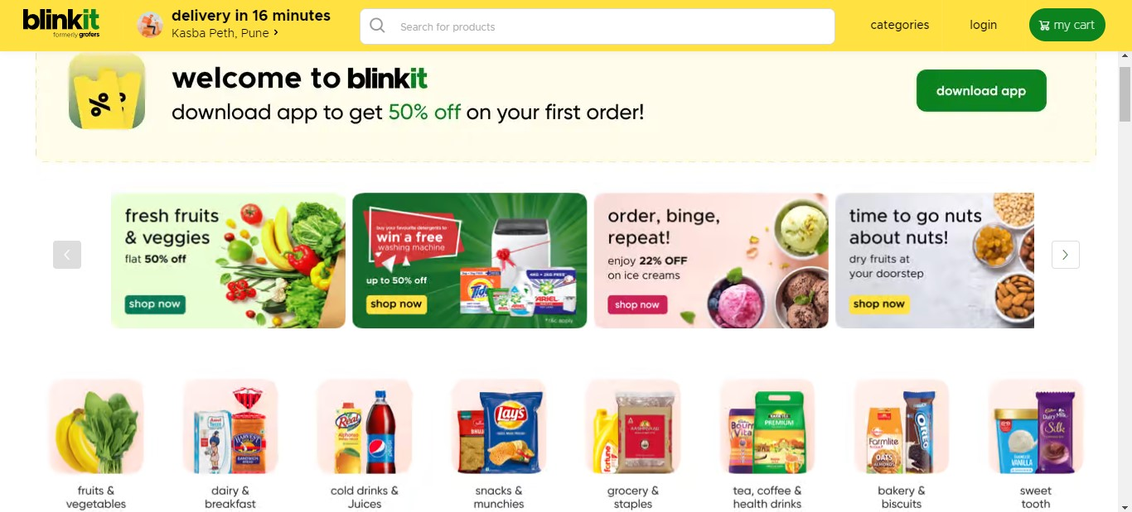

**Navigation Bar:**

* Company Name
* Search Bar
* Buttons (Login/Register)
* My Cart

# Categories:

Under Menu bar there will be Categories section

**Filters:**

* Short By Price
* Popular Brands
* Discount
* And Many More....

# Technologies Used:

* + Html
  + CSS
  + Bootstrap
  + React
  + JavaScript

**Database:**

* + MongoDB
  + Json data

**Tools:**

* + Visual Studio Code
  + Git Bash
  + Git Hub
  + Node.js

# Links:

* Repo-Link: <https://shrutijpatel.github.io/grocery-store/>
* Project Reference : https://blinkit.in/