**Name: Shrutika Pote**

**PRN:86**

1. Initialize your local git repository with working angular project

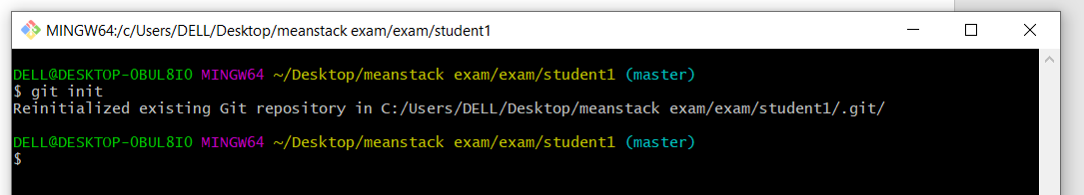

1. Create Github repository with your angular project name

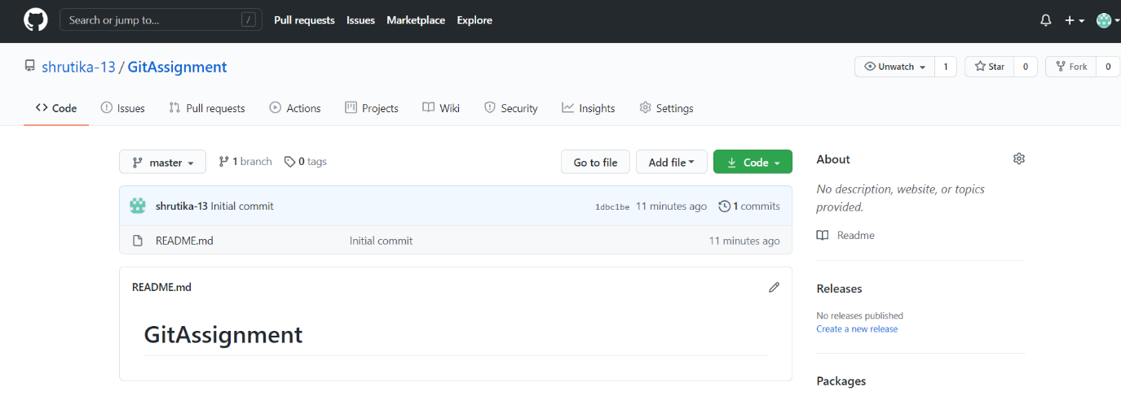

1. Setup a remote repository link with your local repository

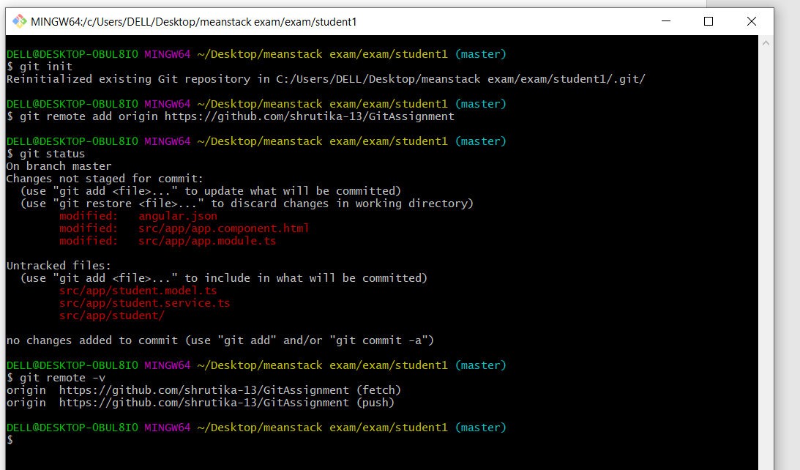

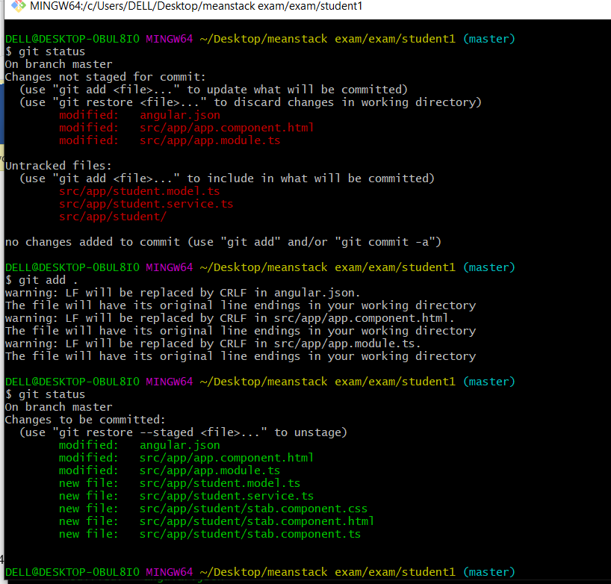

1. Push the project to remote repository without node_modules

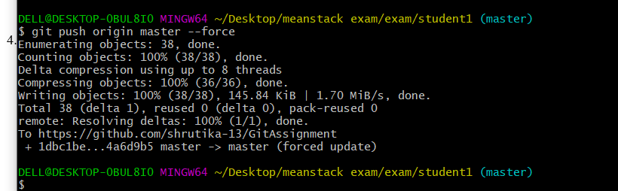

1. Create a branch in github repository

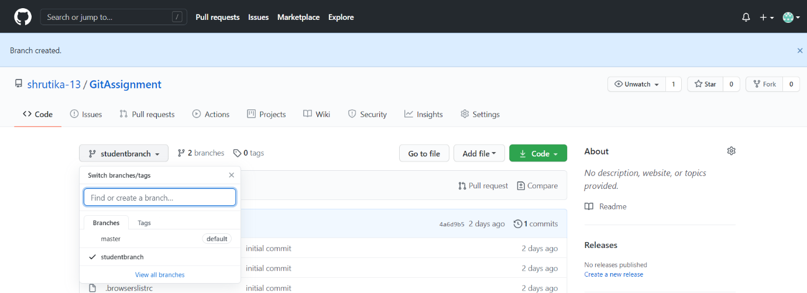

1. Make some changes in the component files

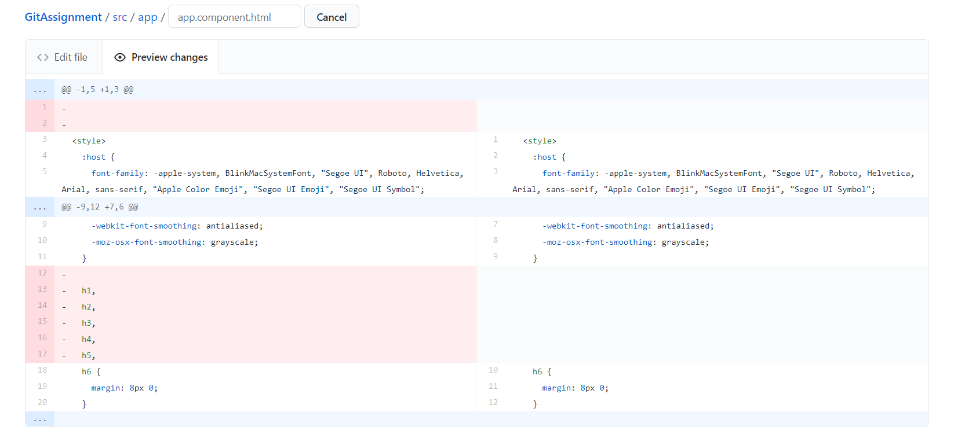

1. Create pull request and merge it with the master branch

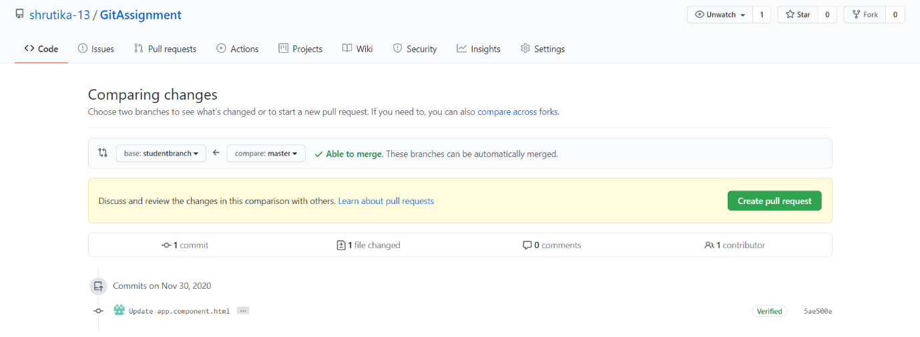

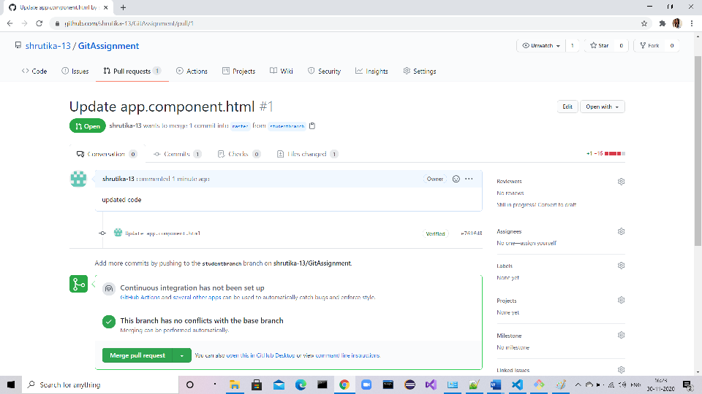

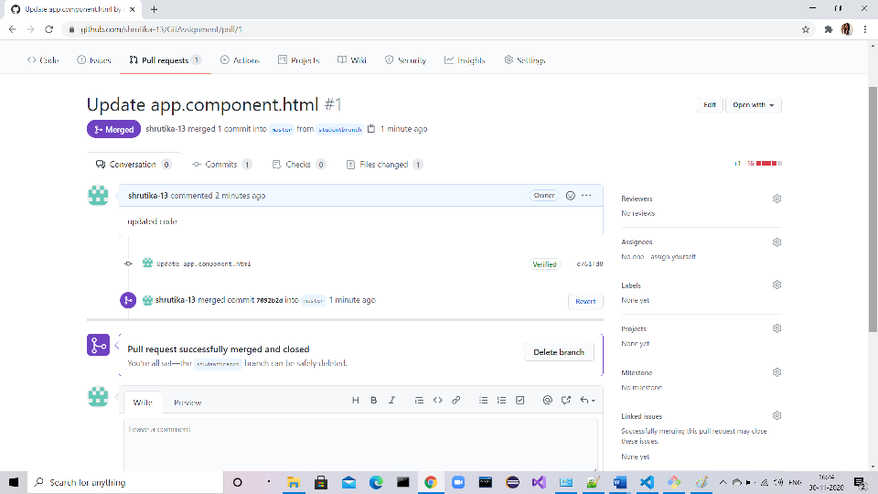

1. Pull the updated project in your local repository

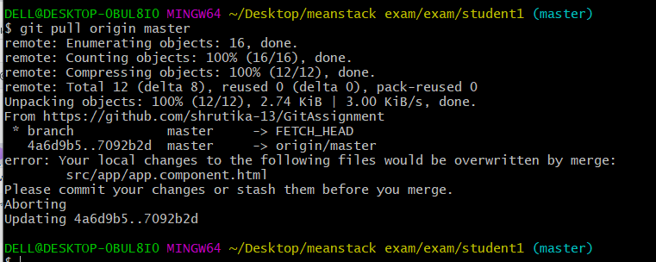

1. Install the dependencies
2. Run the project and check if the changes are being reflected or not

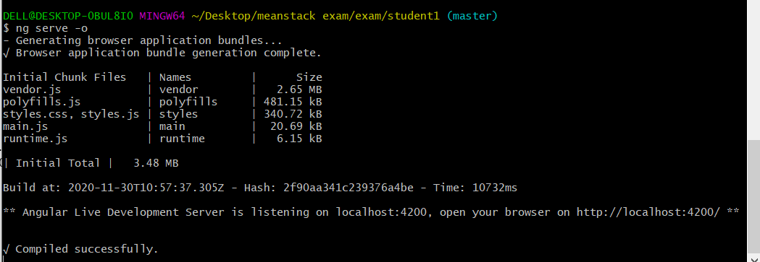

1. Execute commands for checking git status

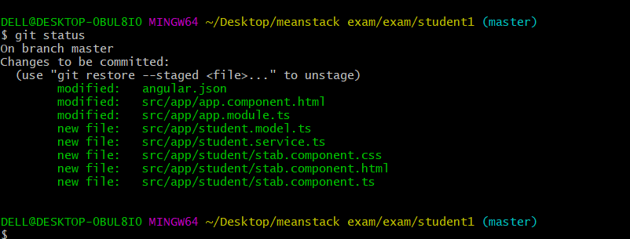

1. Execute log commands

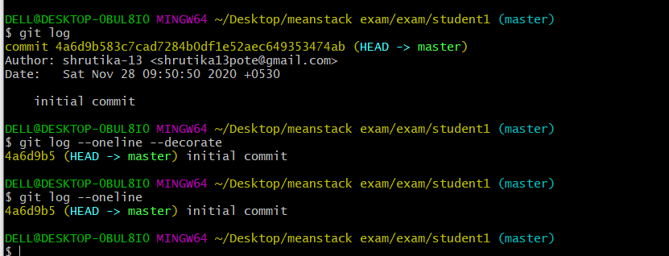

1. Delete the github branch where the changes were made

