AIM:- Mining block via Postman

import hashlib
import json
from time import time
from flask import Flask,jsonify

class Blockchain:
def __init__(self):
self.chain=[]
self.current_transactions=[]
#Create the genesis block(very first block)
self.create_block(proof=100,previous_hash='1')
def create_block(self,proof,previous_hash):
block={
'index':len(self.chain)+1,
'timestamp':time(),
'transactions':self.current_transactions,
'proof':proof,
'previous_hash':previous_hash or self.hash(self.chain[-1]),
}
self.current_transactions=[]
self.chain.append(block)
return block

@property
def last_block(self):
return self.chain[-1]

@staticmethod
def hash(block):
#Hashes a block
block_string=json.dumps(block,sort_keys=True).encode()
return hashlib.sha256(block_string).hexdigest()

def proof_of_work(self,last_proof):
#Simple Proof of Work Algorithm:
#Find a number p' such that hash(pp') contains 4 leading zeroes
proof=0
while self.valid_proof(last_proof,proof)is False:
proof+=1
return proof

@staticmethod
def valid_proof(last_proof,proof):
guess=f'{last_proof}{proof}'.encode()
guess_hash=hashlib.sha256(guess).hexdigest()
return guess_hash[:4] == "0000" #Difficulty level: 4 zeroes

#Initialize Flask web application
app = Flask(__name__)
blockchain=Blockchain()

@app.route('/mine',methods=['GET'])
def mine():
#1.Run the proof of work algorithm to get the next proof
last_block = blockchain.last_block
last_proof = last_block['proof']
proof = blockchain.proof_of_work(last_proof)

#2.Offer a reward for finding the proof(Miner reward Transaction)
blockchain.current_transactions.append({
'sender': "0", #"0" signifies that this node has mined a new coin
'recipient' : "miner_wallet_address_xyz",
'amount' : 1,
})

#Forge the new Block by adding it to the chain
previous_hash = blockchain.hash(last_block)
block = blockchain.create_block(proof,previous_hash)

response={
'message' : "New Block Mined Successful!",
'index' : block['index'],
'transactions' : block['transactions'],
'proof' : block['proof'],
'previous_hash' : block['previous_hash'],
}
return jsonify(response),200

@app.route('/chain',methods=['GET'])
def full_chain():
response = {
'chain' : blockchain.chain,
'length' : len(blockchain.chain),
}
return jsonify(response),200

if __name__ == '__main__':
app.run(host = '0.0.0.0',port=5000)
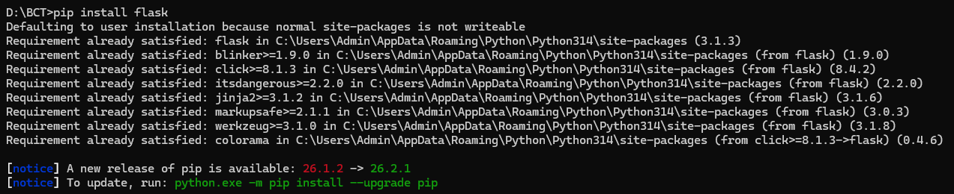

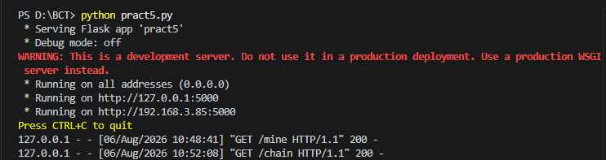

http://localhost:5000/mine

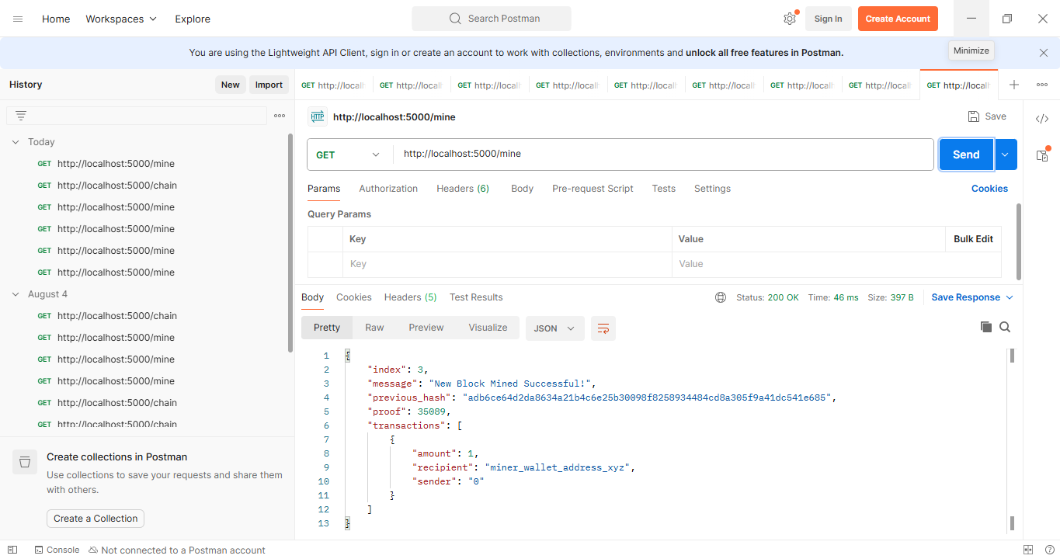
{
"index": 3,
"message": "New Block Mined Successful!",
"previous_hash": "adb6ce64d2da8634a21b4c6e25b30098f8258934484cd8a305f9a41dc541e685",
"proof": 35089,
"transactions": [
{
"amount": 1,
"recipient": "miner_wallet_address_xyz",
"sender": "0"
}
]
}

http://localhost:5000/chain
{
"chain": [
{
"index": 1,
"previous_hash": "1",
"proof": 100,
"timestamp": 1785993515.4677792,
"transactions": []
},
{
"index": 2,
"previous_hash": "a189c34fdfaa1d3afcddb93dca70c2c45339c012f662358a6a89d0b1fbb96342",
"proof": 35293,
"timestamp": 1785993521.4556925,
"transactions": [
{
"amount": 1,
"recipient": "miner_wallet_address_xyz",
"sender": "0"
}
]
}
],
"length": 2
}

