// 1. Import the Web3 library
const { Web3 } = require('web3');

async function sendTransactionDemo() {
// 2. DEFINE A MULTI-ENDPOINT FALLBACK LIST
// If one public node blocks or drops the connection, the code jumps to the next one instantly!
const fallbackRPCs = [
'https://1rpc.io',
'https://ankr.com',
'https://ethereum-sepolia-rpc.publicnode.com',
'https://endpoints.omniatech.io/v1/eth/sepolia/public'
];

let web3;
let successfulURL = '';

console.log('--- Establishing Secure Blockchain Connection ---');

// Cycle through endpoints until a working JSON response is received
for (const url of fallbackRPCs) {
try {
const tempWeb3 = new Web3(url);
// Quick check to see if the endpoint natively returns numbers instead of HTML text pages
await tempWeb3.eth.getBlockNumber();
web3 = tempWeb3;
successfulURL = url;
break;
} catch (e) {
console.log(`⚠️ Route skipped: ${url} (Connection blocked or invalid response)`);
}
}

if (!web3) {
console.error('\n❌ CRITICAL: All public routes are blocked by your local network or firewall.');
console.log('💡 TIP FOR TEACHER: Turn off your network VPN or switch to a mobile hotspot to clear local restrictions.');
return;
}

console.log(`✅ Connection Established via: ${successfulURL}\n`);

// 3. Setup your funded wallet credentials
const senderPrivateKey = '0xc5e399e91edb742a2f1a991c7d9ada86e4eeb66fb8360e075deb7f4424a8b712';

// Derive parameters cleanly
const account = web3.eth.accounts.privateKeyToAccount(senderPrivateKey);
const senderAddress = account.address;
const receiverAddress = '0x742d35Cc6634C0532925a3b844Bc454e4438f44e';

console.log(`Sender Address: ${senderAddress}`);
console.log(`Receiver Address: ${receiverAddress}\n`);

try {
console.log('Fetching blockchain network metrics...');
const txCount = await web3.eth.getTransactionCount(senderAddress);
const networkGasPrice = await web3.eth.getGasPrice();

console.log(`Current Account Nonce: ${txCount}`);
console.log(`Current Network Gas Price: ${networkGasPrice} Wei`);

// 4. Build the Clean Transaction Object
const txObject = {
nonce: txCount,
to: receiverAddress,
value: web3.utils.toWei('0.001', 'ether'),
gasLimit: 21000,
gasPrice: networkGasPrice,
chain: 'sepolia'
};

console.log('\n--- Prepared Transaction Structure ---');
console.log(txObject);

// 5. Sign the Transaction locally
console.log('\nSigning transaction structure...');
const signedTx = await web3.eth.accounts.signTransaction(txObject, senderPrivateKey);

// 6. Broadcast the Transaction to the Test Network
console.log('Broadcasting transaction to the blockchain...');
const receipt = await web3.eth.sendSignedTransaction(signedTx.rawTransaction);

console.log('\n🎉 SUCCESS! TRANSACTION PASSED THE EVM!');
console.log(`===================================================`);
console.log(`Transaction Hash: ${receipt.transactionHash}`);
console.log(`Block Number: ${receipt.blockNumber}`);
console.log(`View Status On: https://etherscan.io{receipt.transactionHash}`);
console.log(`===================================================`);
} catch (error) {
console.error('\n❌ Execution failed:', error.message);
}
}sendTransactionDemo();

https://vanity-eth.tk/
Step 1 – Open the Ethereum Vanity Address Generator
First, open the Ethereum Vanity Address Generator shown below. This page is used to generate an Ethereum-style address for the practical. After opening the page, start the address-generation process and wait for the result.
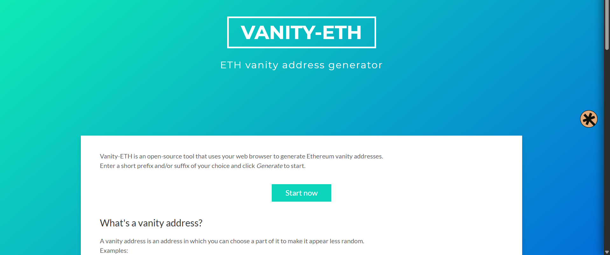

Step 2 – Check the Generated Address / Faucet Page
After generating the required address, check the displayed result carefully. Keep the generated address available because it will be used while setting up the sender/receiver details for the test transaction.
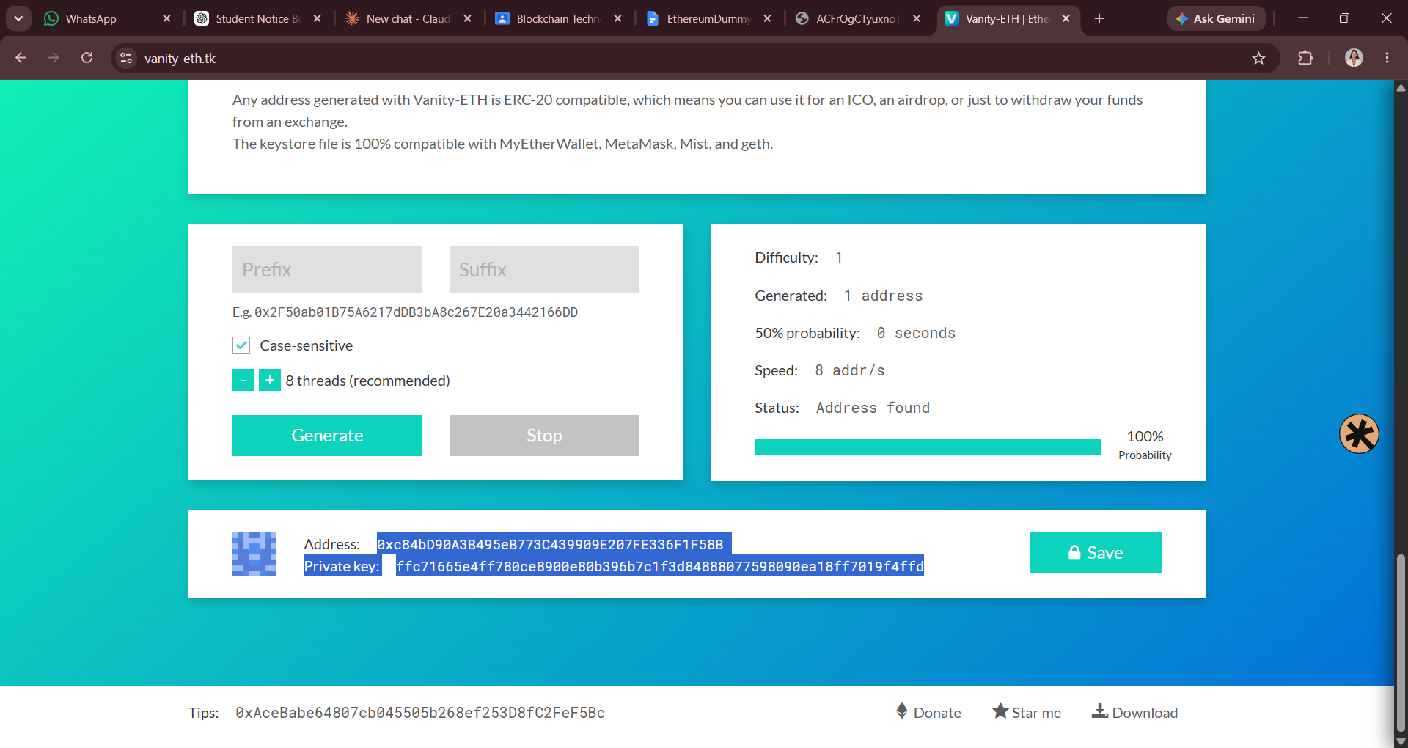
Step 3 – Generate / Select the Required Test Address
On this screen, use the available Generate option and wait for the address-generation process to complete. Once an address is displayed, note it down for the next steps.
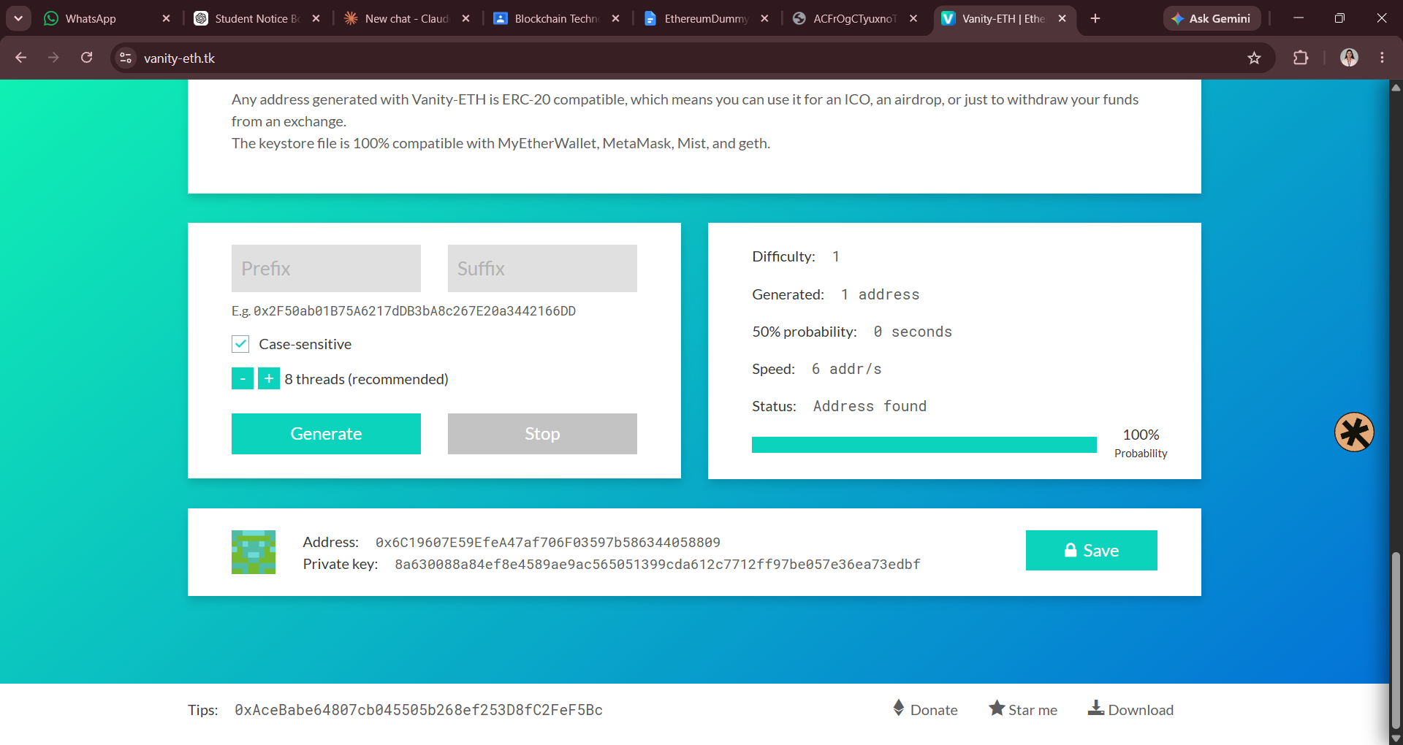
Step 4 – Note the Sender and Receiver Details
Before running the transaction, verify the sender and receiver information. The sender address is the account from which the test ETH will be sent, while the receiver address is the account that will receive the transaction.
Recever:
https://cloud.google.com/application/web3/faucet/ethereum/sepolia
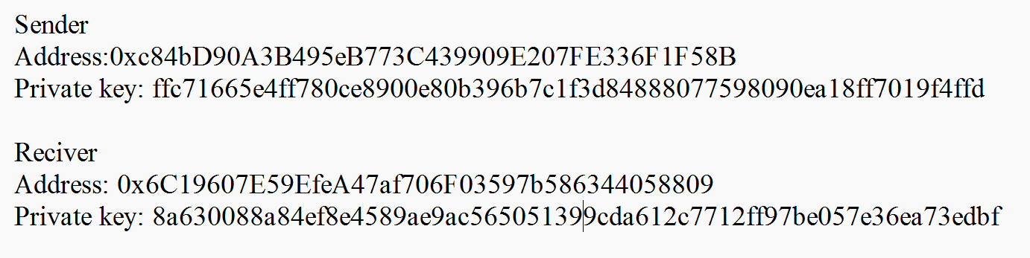
Copy sender address and add into the wallete
Step 5 – Open the Ethereum Sepolia Faucet
Open the Ethereum Sepolia Faucet. Select the Sepolia network if required and enter the sender wallet address in the faucet. Then request the test ETH needed to perform the transaction.
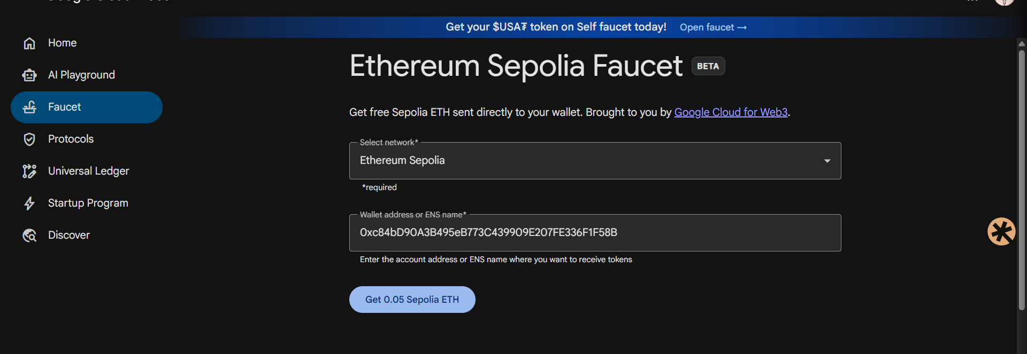

Step 6 – Confirm the Sepolia Test ETH
After requesting the tokens, check the faucet response and wallet balance. Make sure the sender account has received Sepolia test ETH before running the transaction program.
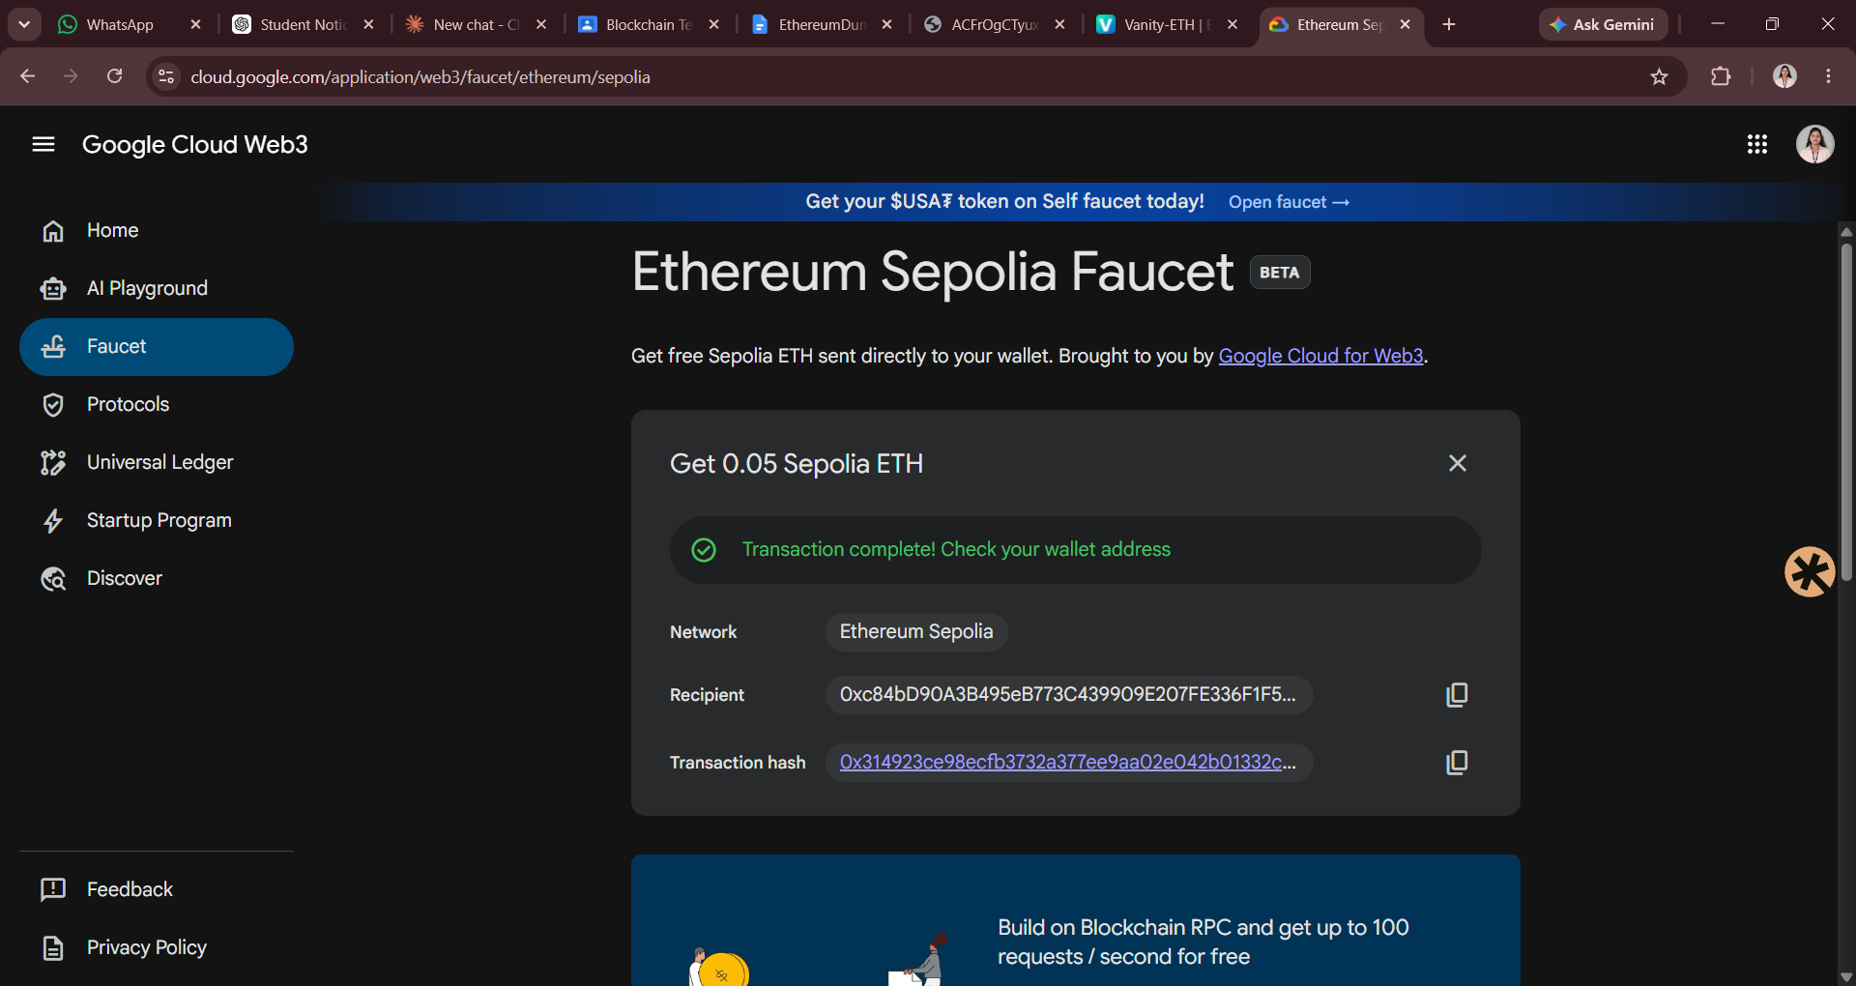

Click on transaction hash :
Step 7 – Run the Web3.js Transaction Program
Open the project folder in the terminal and run the JavaScript file using Node.js. The program connects to a working Sepolia RPC endpoint, prepares the transaction, signs it, and broadcasts it to the test network.
CHANGE THESE IN THE CODE:
const senderPrivateKey = 'ffc71665e4ff780ce8900e80b396b7c1f3d84888077598090ea18ff7019f4ffd'; change sender pr ate in key in code
change in the link to view status on
console.log(`View Status On: https://sepolia.etherscan.io/{receipt.transactionHash}`);
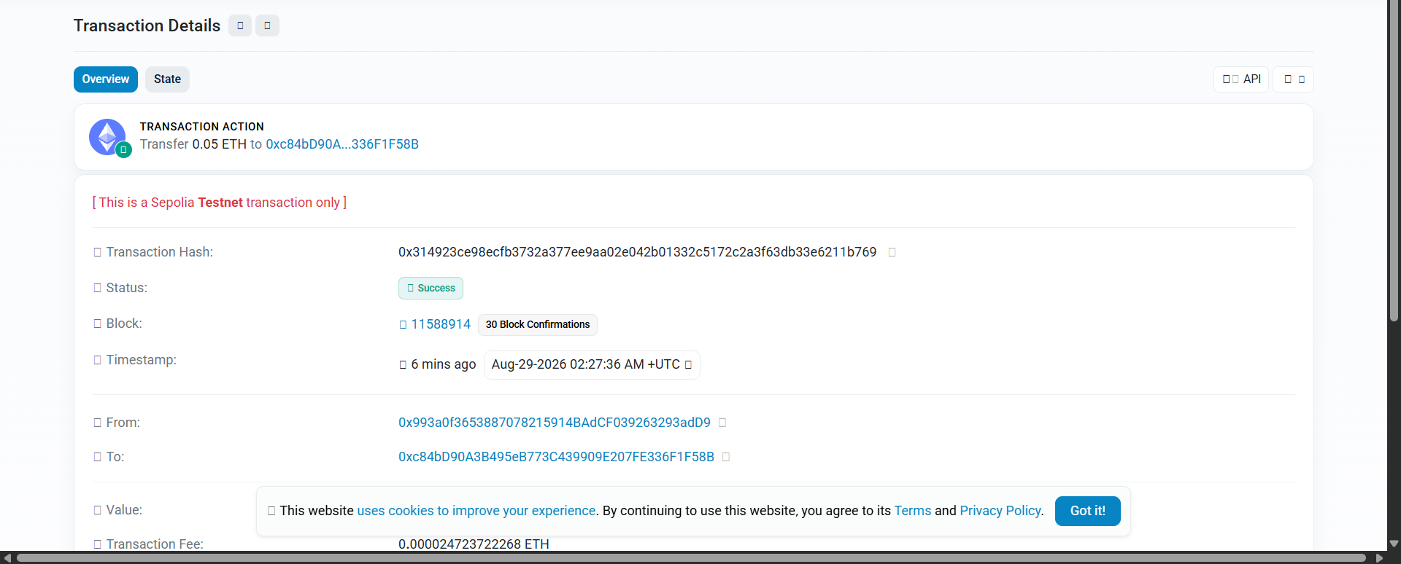
Step 8 – Copy the Transaction Hash
After the program completes successfully, look at the terminal output and find the Transaction Hash. Copy this hash because it is used to verify the transaction on Sepolia Etherscan.
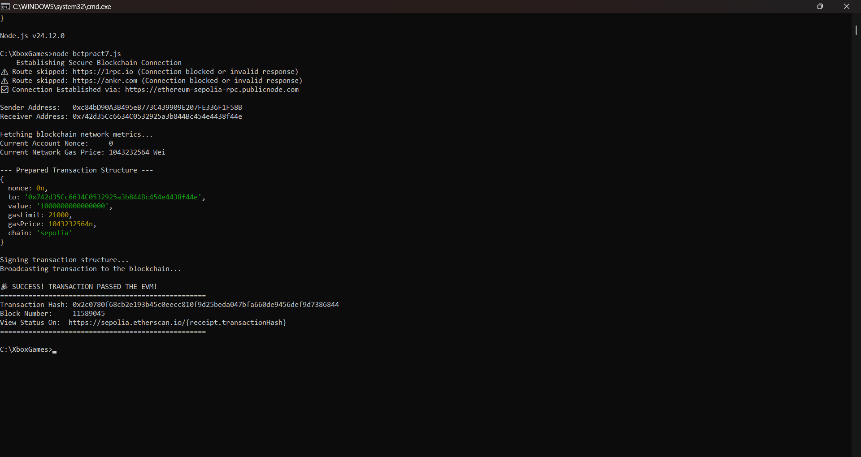

Step 9 – Verify the Transaction on the Sepolia Network
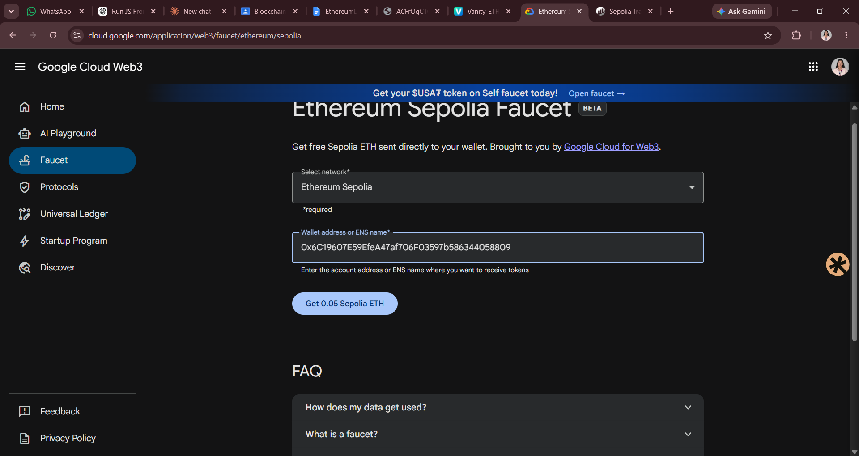
Open the Sepolia Etherscan explorer and search using the transaction hash. Check the transaction status and confirm the sender, receiver, value, and block information shown by the explorer.

