Practical-9
Q) Simulate a blockchain application for supply chain management or any other applications.

CODE: Server2.js
const express = require('express');
const SupplyChainBlockchain = require('./blockchain');

const app = express();
const PORT = 3000;

// Replaced body-parser with native express parser
app.use(express.json());
// Initialize the blockchain network instance
const supplyChain = new SupplyChainBlockchain();

// Endpoint: View Full Chain Ledger
app.get('/blockchain', (req, res) => {
res.status(200).json({
chainLength: supplyChain.chain.length,
chain: supplyChain.chain
});
});

// Endpoint: Stage Custody Transaction (Passes through Smart Contract)
app.post('/transaction', (req, res) => {
const { itemId, sender, receiver, status, location, telemetry } = req.body;

if (!itemId || !sender || !receiver || !status || !location) {
return res.status(400).json({ error: "Missing required fields." });
}
try {
const tx = supplyChain.addTransaction(itemId, sender, receiver, status, location, telemetry);
res.status(201).json({
message: "Transaction verified by smart contract and staged.",
transaction: tx
});
} catch (error) {
// Correctly catches the 'CONTRACT VIOLATION' errors thrown by your smart contract
res.status(400).json({
status: "REJECTED BY SMART CONTRACT",
reason: error.message
});
}
});

// Endpoint: Mine Blocks
app.post('/mine', (req, res) => {
try {
const newBlock = supplyChain.minePendingTransactions();
if (!newBlock) {
return res.status(400).json({ message: "No pending transactions to mine." });
}
res.status(200).json({
message: "Staged transactions secured into block.",
block: newBlock
});
} catch (error) {
res.status(500).json({ error: "Mining failed.", reason: error.message });
}
});

// Endpoint: Audit and Trace Asset Timeline
app.get('/trace/:itemId', (req, res) => {
const history = supplyChain.getItemHistory(req.params.itemId);
if (!history || history.length === 0) {
return res.status(404).json({ error: "No records found for this item ID." });
}
res.status(200).json({ itemId: req.params.itemId, events: history });
});

// Endpoint: Verify Ledger Cryptographic Health
app.get('/validate', (req, res) => {
const isValid = supplyChain.isChainValid();
res.status(200).json({
secure: isValid,
msg: isValid ? "Ledger is valid and untampered." : "CRITICAL WARNING: Tampering detected!"
});
});
app.listen(PORT, () => {
console.log(` Supply Chain Ecosystem live at http://localhost:${PORT}`);
});

CODE: blockchain.js
const crypto = require('crypto');
const SupplyChainSmartContract = require('./contract');

class Block {
constructor(index, timestamp, transactions, previousHash = '') {
this.index = index;
this.timestamp = timestamp;
this.transactions = transactions;
this.previousHash = previousHash;
this.nonce = 0;
this.hash = this.calculateHash();
}
calculateHash() {
const blockString = JSON.stringify({
index: this.index,
timestamp: this.timestamp,
transactions: this.transactions,
previousHash: this.previousHash,
nonce: this.nonce
});
return crypto.createHash('sha256').update(blockString).digest('hex');
}
mineBlock(difficulty) {
const target = '0'.repeat(difficulty);
while (this.hash.substring(0, difficulty) !== target) {
this.nonce++;
this.hash = this.calculateHash();
}
}
}
class SupplyChainBlockchain {
constructor() {
this.chain = [];
this.pendingTransactions = [];
this.difficulty = 2;
this.smartContract = new SupplyChainSmartContract();
this.createGenesisBlock();
}
createGenesisBlock() {
const genesisBlock = new Block(0, Date.now(), [{ info: "Genesis Block - System Initialized" }], "0");
this.chain.push(genesisBlock);
}
getLatestBlock() {
return this.chain[this.chain.length - 1];
}
addTransaction(itemId, sender, receiver, status, location, telemetry = {}) {
const newTx = { itemId, sender, receiver, status, location, telemetry, timestamp: Date.now() };
// Execute smart contract rules
this.smartContract.execute(newTx, this.chain);

this.pendingTransactions.push(newTx);
return newTx;
}
minePendingTransactions() {
if (this.pendingTransactions.length === 0) return null;
const newBlock = new Block(
this.chain.length,
Date.now(),
this.pendingTransactions,
this.getLatestBlock().hash
);
newBlock.mineBlock(this.difficulty);
this.chain.push(newBlock);
this.pendingTransactions = [];
return newBlock;
}
getItemHistory(itemId) {
let history = [];
for (const block of this.chain) {
for (const tx of block.transactions) {
if (tx.itemId === itemId) {
history.push({ blockIndex: block.index, ...tx });
}
}
}
return history;
}
isChainValid() {
for (let i = 1; i < this.chain.length; i++) {
const current = this.chain[i];
const previous = this.chain[i - 1];
if (current.hash !== current.calculateHash()) return false;
if (current.previousHash !== previous.hash) return false;
}
return true;
}
}
module.exports = SupplyChainBlockchain;

CODE: contract.js
class SupplyChainSmartContract {
constructor() {
this.productRules = {
"VACCINE-BATCH": { maxTemperature: 8.0 },
"PERISHABLE-FOOD": { maxTemperature: 4.0 }
};
}
execute(transaction, currentChain) {
console.log(`\n📜 Smart Contract: Verifying Item ${transaction.itemId}...`);

// Rule 1: Temperature Safeguard
if (transaction.telemetry && transaction.telemetry.temperature !== undefined) {
const temp = transaction.telemetry.temperature;
for (const [key, rules] of Object.entries(this.productRules)) {
if (transaction.itemId.startsWith(key) && temp > rules.maxTemperature) {
throw new Error(`CONTRACT VIOLATION: Temperature (${temp}°C) exceeded limit (${rules.maxTemperature}°C) for ${key}!`);
}
}
}
// Rule 2: Custody Chain Enforcement
if (transaction.sender !== "ORIGIN") {
const currentOwner = this.findCurrentOwner(transaction.itemId, currentChain);
if (!currentOwner) {
throw new Error(`CONTRACT VIOLATION: Item ${transaction.itemId} has no recorded origin.`);
}
if (currentOwner !== transaction.sender) {
throw new Error(`CONTRACT VIOLATION: Unauthorized Transfer! '${transaction.sender}' does not own this item. Current custodian is '${currentOwner}'.`);
}
}
console.log("✅ Smart Contract: Passed validation.");
return true;
}
findCurrentOwner(itemId, chain) {
let currentOwner = null;
for (const block of chain) {
for (const tx of block.transactions) {
if (tx.itemId === itemId) {
currentOwner = tx.receiver;
}
}
}
return currentOwner;
}
}
module.exports = SupplyChainSmartContract;

Output:

Step 1: Make sure all of the 3 are in same folder
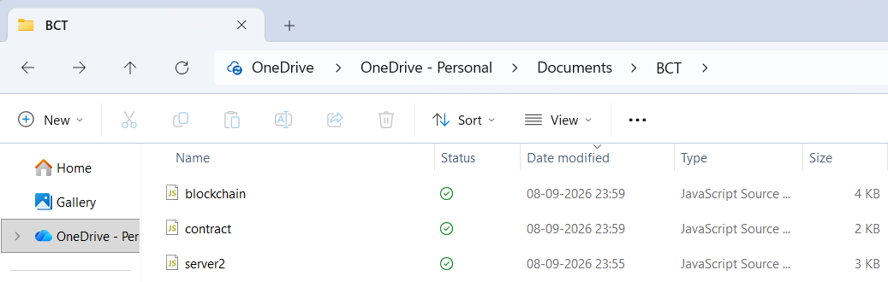

Step 2: Open CMD and run this commands
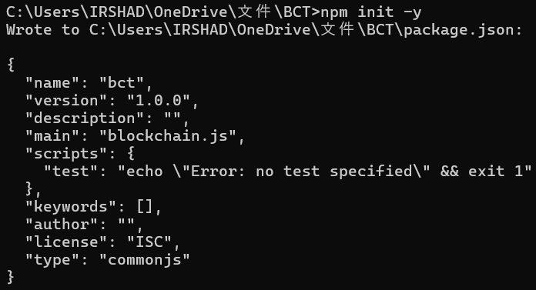
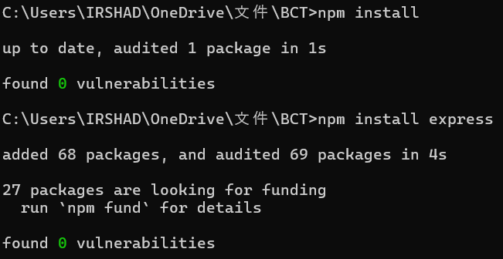
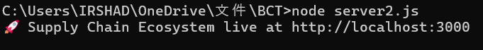

Step 3: Open POSTMAN and type the localhost link in GET Request and create a Sample JSON in the body
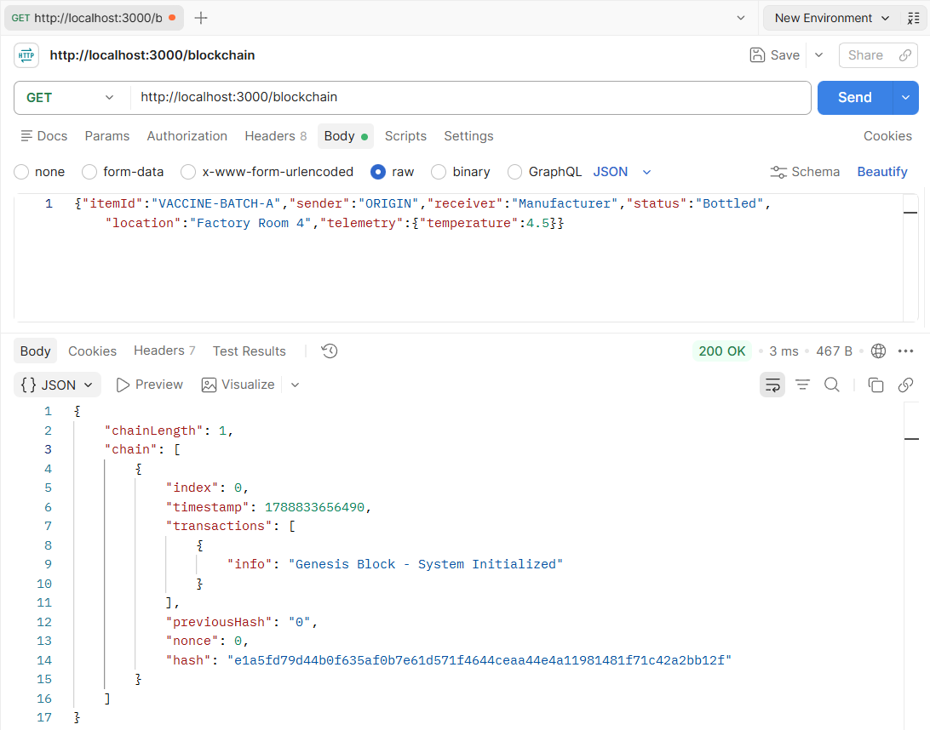
Output:

Now, POST Request: http://localhost:3000/mine and create a Sample JSON in the body
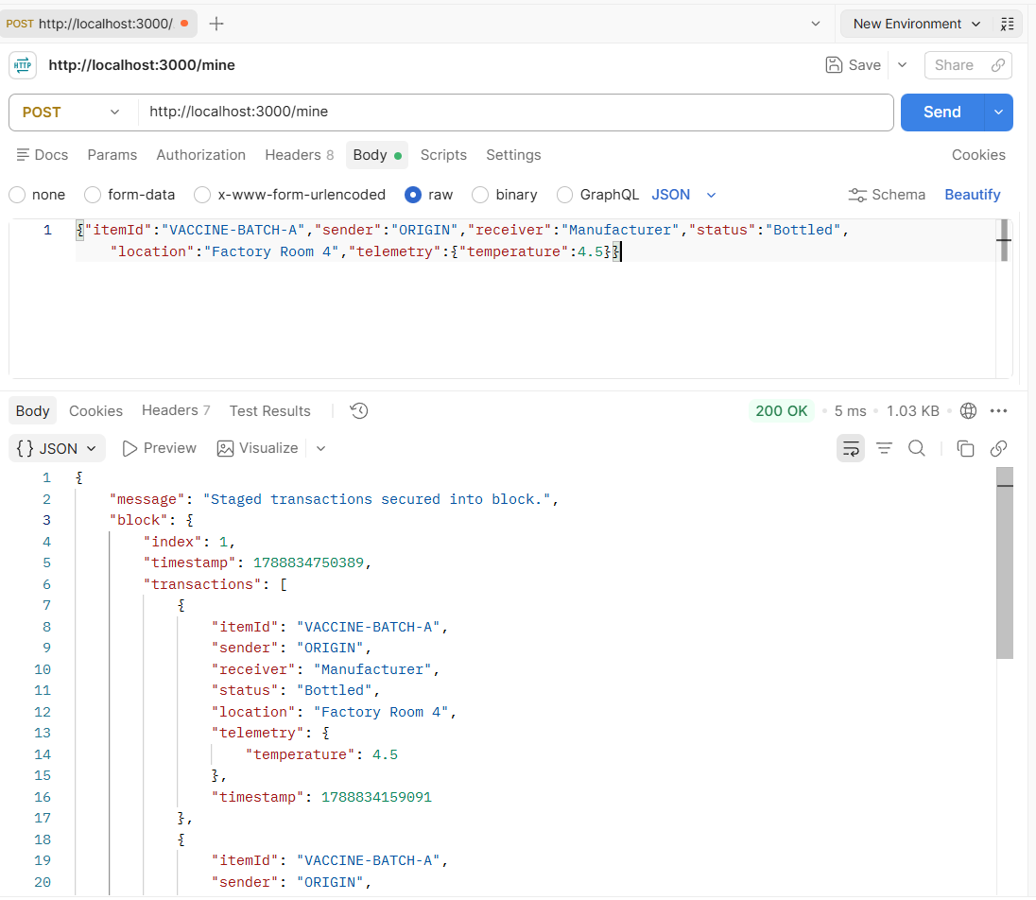
Output:
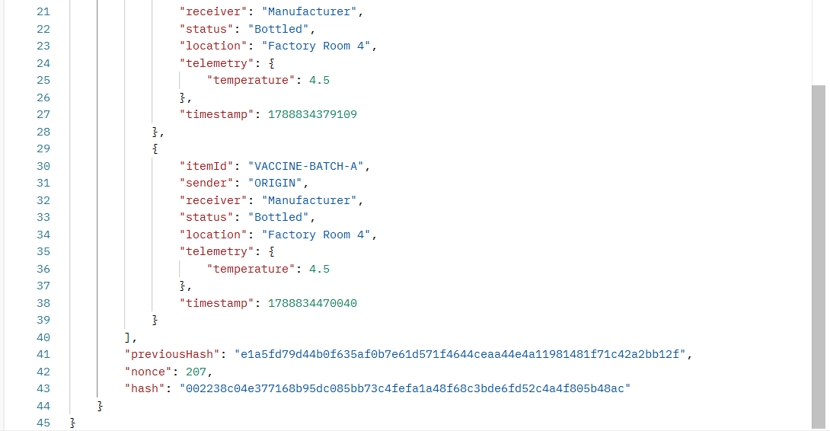

Now, POST Request: http://localhost:3000/transaction and a sample JSON in the body
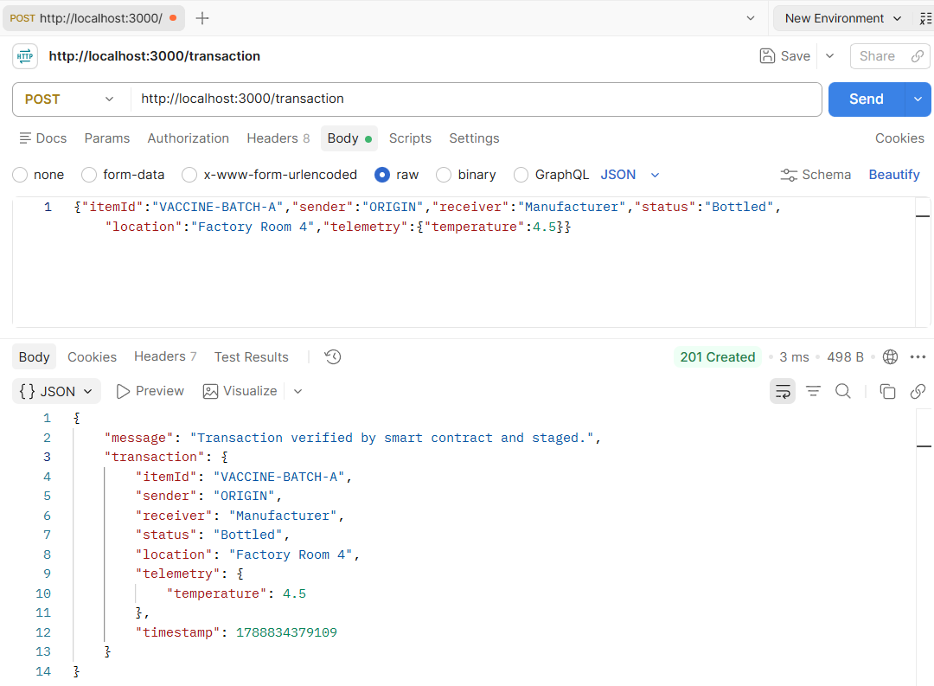
Output:

Now, let's test a bad request by violating the smart contract rules. Use a POST request and change a value in the JSON body to a value outside the allowed limit defined in the code.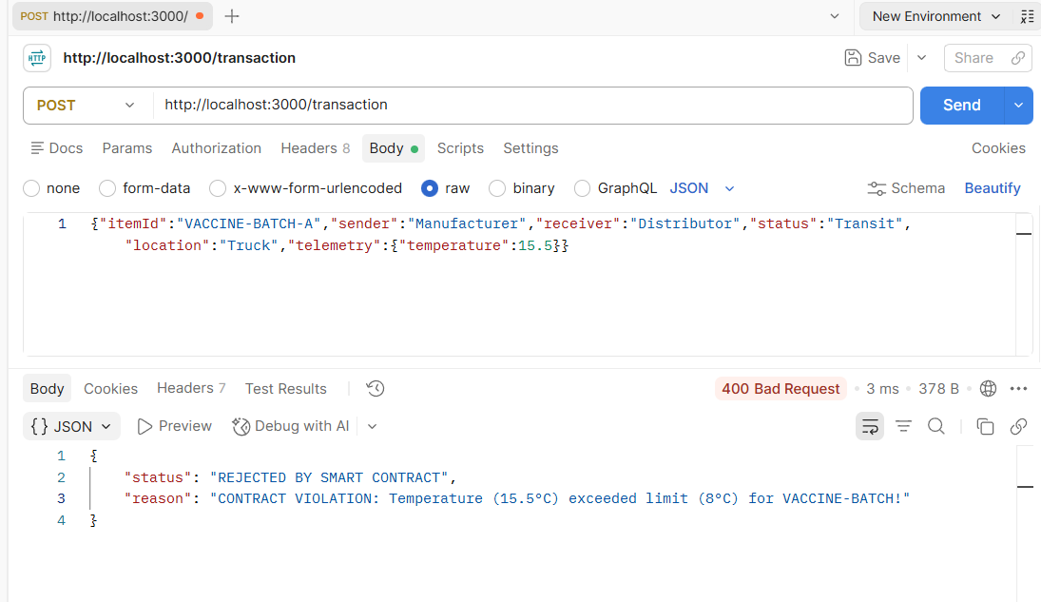
Output:

Now, GET Request: http://localhost:3000/trace/VACCINE-BATCH-A with a sample JSON in the body
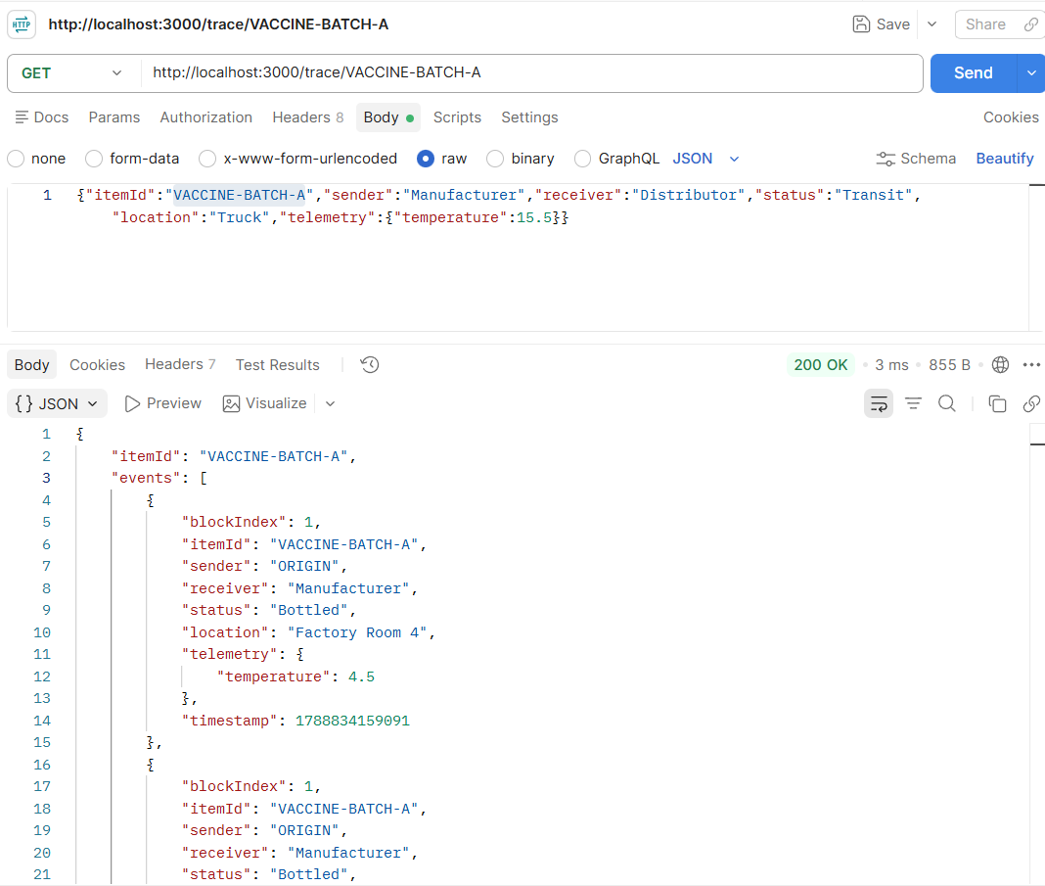
Output:
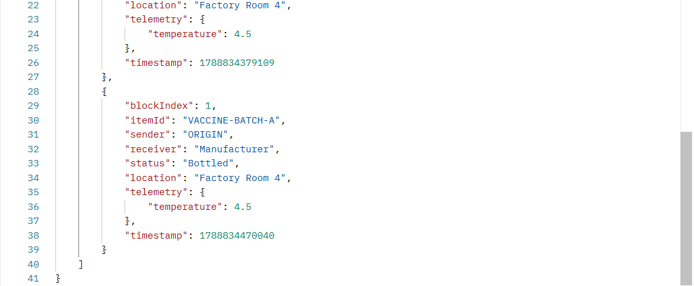

Now, GET Request: http://localhost:3000/Blockchain with a Sample JSON in the Body
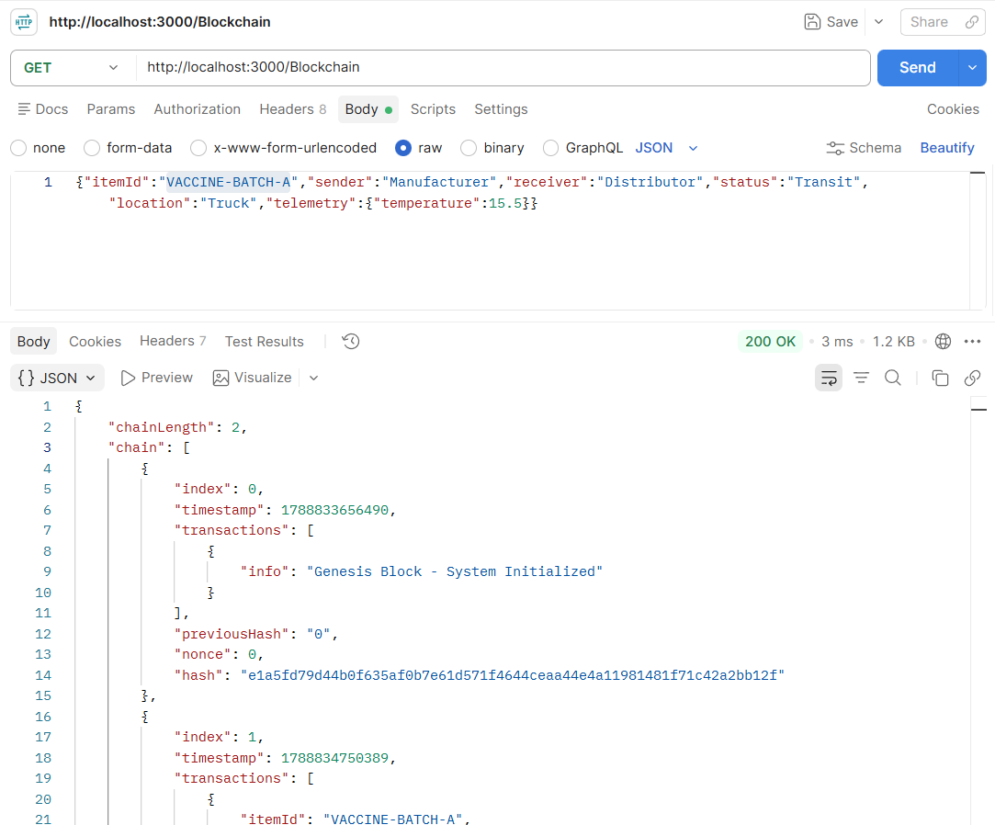
Output:
