A Hybrid Voice and Gesture-Based IoT Smart Appliance Control System with Chatbot Assistance

Shrutika Dautpure¹  Computer Science and Engineering  GH Raisoni College of Engineering  Nagpur, Maharashtra  shrutidautpure2005@gmail.com | Akanksha Raut²  Computer Science and Engineering  GH Raisoni College of Engineering  Nagpur, Maharashtra  akanksharaut2104@gmail.com | Vaiayanti Lakhe³  Computer Science and Engineering  GH Raisoni College of Engineeting  Nagpur, Maharashtra  vajayantılakhe75786@gmail.com

Utkarsh Gupta⁴  Computer Science and Engineering  GH Raisoni College of Engineering  Nagpur, Maharashtra  utkarshgupta2024a@gmail.com | Dr. Mangala Madankar⁵  Computer Science and Engineering  GH Raisoni College of Engineering  Nagpur, Maharashtra  mangala.madankar@raisoni.net

Abstract—Individuals are beginning to understand the importance of smart home automation in terms of easier, more accessible, and more efficient living.
Most of the available technologies are based on voice assistants or mobile apps. These technologies are not necessarily easy for the elderly or differently able individuals.
This paper discusses an IoT-based ESP32 Smart Appliance Control System. The proposed system is based on voice command, gesture recognition, and chatbots. Individuals are able to control their home appliances such as air conditioners, fans, lights, and TVs using hand gestures or voice commands. There is also a chatbot facility available for the customers to receive immediate support. The ESP32 microcontroller is used in the proposed system. The microcontroller is used to connect the home appliances and the gesture or voice recognition devices using a relay-based controller.
The proposed system is based on multiple interaction types. Therefore, it is easier for the user to interact with the devices even when one type of interaction is not available. For example, the gesture mode might not work well in poor lighting conditions or the voice mode might not work well in a noisy environment.
This technology is a great example of smart home automation.
Keywords—IoT, ESP32, Gesture Recognition, Voice Commands, Chatbot Support, Assistive Technology, Accessibility, Elderly Support, Multi-Modal Interaction, Cloud-based APIs, Energy Efficiency, Smart Home Automation, and Differently-Abled Users.

Introduction

The Internet of Things (IoT) has grown so quickly that it has turned regular homes into smart homes where you can easily control appliances. and in a way that works. People are using smart home technologies more and more for security, convenience, and managing energy. [3] Still, the majority of current systems default to mobile apps or voice assistants.

These modes of control might leave out older adults, people with disabilities, or circumstances where one control method
becomes ineffective. Hence the design of smart appliances has to be more inclusive. In response to this, multi-modal interaction features are being developed. The combination of voice commands and gesture recognition allows for more natural, contactless command of appliances. [1] In particularly noisy spaces where the voice command system might not work, gesture control might be useful. In contrast, in scenarios where people’s hands are busy or they can’t see the appliance, voice commands would be the preferred method. This proves that hybrid systems would work in more scenarios and would be more reliable and useful.

The system being developed incorporates an ESP32 microcontroller as the key IoT component and as the main device for wireless interactions and communication with and control of home appliances. Voice commands are obtained via a microphone interface, and gesture control is accomplished by employing computer vision and additional sensors.[8] These commands are sent for processing to the ESP32 which then performs the necessary control functions. Integration of these features provides a real-time, low-cost and scalable solution for today’s households. This system uniquely includes the provision of assistance via a chatbot to help the user. This is in contrast to AI-based chatbots and conversational systems, as this chatbot contains a limited set of a system-focused help with answers to key system queries and system troubleshooting steps. This includes ease of use and reliability. Experience of immediate support without the complication of third-party applications. The chatbot acts as a bridge between user and system especially for the first time in which users or of which users are unfamiliar with technology. Overall, we present the smart appliance control which we have put forth demonstrates a cost-effective, inclusive, and accessible solution that includes gesture recognition, voice services, inclusion of IoT and chatbot support into a unified platform. Through the former we mean that we are including user support which at the same time increases convenience which in turn includes the elderly and differently abled persons. [2] This study we put forth in the direction of improving smart home technologies which we do so through the focus on accessibility, usability and scalability for real world applications.

Literature Review
Smart appliance control systems have evolved remarkably with IoT, AI, and HCI technologies.[4] Early systems used physical toggles and remote controls for user input but transitioned to mobile applications and voice assistants. [9] However, single-mode interaction often leaves behind the elderly and differently-abled through lack of accessibility. Recent studies have shown that multi-modal systems (gestures, speech and IoT enabled, for example) have great impact in improving inclusivity, energy efficiency, and reliability. Simultaneously, research into chatbot-driven assistance has demonstrated promise in assisting users with system operation, laying the groundwork for accessible and user-friendly hybrid solutions.

Tracking Technologies' Evolution

Smart appliance systems have been greatly influenced by the development of tracking technologies. [16] Bluetooth and infrared were used for control in early systems, but these technologies were not scalable or reliable. Modern systems can now respond in real time and connect to cloud services without any problems thanks to Wi-Fi, RFID, and advanced sensor-based tracking. This development has made it possible for appliances and IoT controllers to communicate with each other reliably and recognize gestures accurately.

Telematics and IoT Integration

The integration of telematics inspired frameworks with the internet of things has moved past vehicles and toward smart homes. IoT microcontrollers like ESP32 provide low cost and power-efficient means of device connectivity and real-time monitoring. [7] Prior studies have shown that the ability of IoT to control systems improves the reliability of those systems and guarantees two-way communication between appliances and users. In smart homes, this integration creates a basis for responsive, scalable and flexible automation systems.

Data analytics and machine learning's role

Data analytics and machine learning add to the intelligence of automation systems by enabling the system to perform predictive control, detect anomalies and personalization.[19] In gesture and voice recognition, machine learning models are very helpful in improving accuracy, as they adapt to different environmental factors and user behaviour. Analytics are also part of optimizing energy usage, so the appliances are controlled efficiently. This means that the recognition technologies combined with data-driven insights are important for smarter homes.

Algorithms for Optimization

Optimization algorithms are a fundamental part of the smart, effective control systems that are needed for the operation of smart homes. Techniques like neural networks, adaptive filters and decision tree-based approaches are carried out for improvement of gesture and voice recognition performance. For devices that are already under configured to the point of being IoT-savvy, optimistic optimization is key for real-time computing instead of exceeding the budget. Research findings show that algorithmic improvements not only make systems more responsive but also ensure energy efficiency, which makes systems more viable for everyday use.

Challenges in Real-time Smart Appliance Control

Even with these advancements, there are challenges associated with the real time control of appliances. A poor accuracy of gesture recognition is also common under poor illumination or complex background, voice systems sometimes break in a noisy environment. IoT time delays and lack of micro control processing power can further hurt performance. Moreover, the synchronisation of multiple forms of interaction, of gesture, voice and chatbot, is problematic in terms of integration [6]. Literature suggests that hybrid approaches, where one mode provides the backup for the other mode is an improvement over reliability and ensuring consistent user experiences.
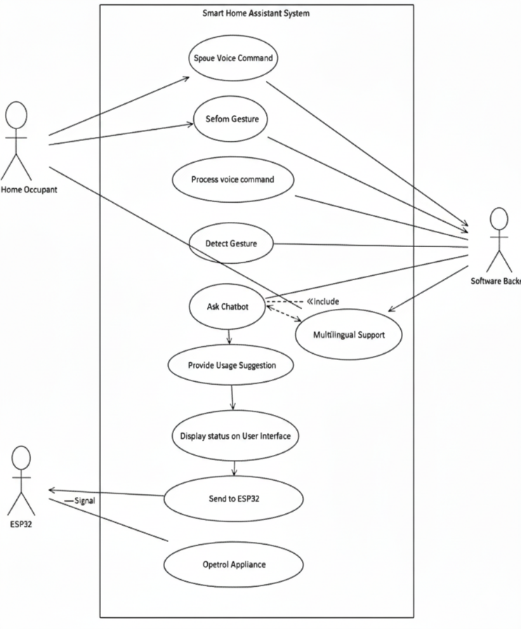
Fig. 1.1 Use case Diagram

Methodology

Design and Architecture of Systems

The design of the Smart Appliance Control System consists of integration of voice recognition, gesture detection and IoT based communication modules to facilitate efficient communication between the user and the household appliances. The way we have designed it is very much towards low latency, energy efficiency and user convenience; making sure that those appliances are responding appropriately, accurately and fast to the command of the user. Inspired by the progress in intelligent audio comfort assistants and smart IoT solutions, the system uses software and hardware components to make the control environment much easier to use.

a) Hardware Components

Sensing Components: The system relies on microphones to capture the voice commands and cameras with computer vision libraries such as MediaPipe, OpenCV etc for the gesture. More motion or proximity sensors can be used to improve accuracy. Microcontrollers: Technology like Arduino, ESP32 or Raspberry Pi are control centers, processing information from sensors and sending commands to connected devices.[15] Communication Modules: Wi-Fi modules allow IoT based direct control of appliances within home network As an example, a Bluetooth module provides connectivity between smartphones and appliances at short range.

b) Cloud-Based Platform

IoT Cloud Integration: Products like AWS IoT Core or Google Firebase take care of the connectivity of the device, store the logs of the command of the user and take care of the security in the communication. Edge Processing: With the help of machine learning models running on Raspberry Pi/ESP32, the system could process all the voice inputs and other gestures in an edge environment, thus making the system less dependent on the cloud for a faster response.

c) Information Flow

Data is generated from the capturing of user input either voice or gesture and is handled by microcontrollers. Verify commands are sent to the appliance through relays or smart plugs which are capable of communicating over Wi-Fi. At the same time, data is recorded for monitor, usage behaviour analysis and further optimisation purposes to the cloud.

Gathering of Data

Data gathering plays an important role in the system, because it ensures correct identification of commands and reliable operation of appliances. Integrating Sensors: Microcontrollers are programmed using Python or Arduino IDE to interface with microphones, cameras and motion sensors [22]. In Speech Signal Processing, this is done by calibrating devices to recognize differences in voice pitch, background noise, hand gestures or different illumination conditions. Data Transmission: Data transmission is carried out by MQTT and HTTP protocols. Multiple quality of service levels available: The Multiple Quality of Service (QoS) is a key feature of MQTT that allows for the delivery of messages either once or just in case of confirmed delivery. MQTT is best used in scenarios where several appliances are connected from the same source at a time, it ensures minimal data use while providing reliable and efficient data transfer.

Cloud Configuration

The cloud infrastructure offers scalability, device management and analytics. IoT Core Configuration: IoT platforms can be used to manage authentication, secure connections, and device provisioning. This ensures that the system is only accessed by authorized users and appliances. Data Processing using Cloud Functions: Data processing services using an aa variant of Cloud computing like AWS Lambda or Google Cloud Functions processing user commands, classifying them and supporting predictive features like appliance scheduling.[12] Data Storage: Real-time and historical data, including system usage frequency, energy consumption, and other data (e.g. usage, energy, data, etc.), are stored in databases such as DynamoDB or Firebase supporting analysis for energy optimisation and behavioural learning.

API Development

APIs are used to form the link between the backend system and the user interface (mobile application or web dashboard) [10]. RESTful APIs: Built with Node.Js or Flask, they offer to the developer the way to securely access other status, logs, previous energy being consumed by the device, in addition to sending commands for control. Security: OAuth authentication mechanisms provide the option that only authorized users can control an appliance. End-to-end encryption protocols are used to protect data from unauthorized access.

Work on Front End

The front end is the user interface of the system as the homeowner works with the appliances. Fig. 2 is a general view of the front end implementation.

a) Online User Interface:
A React.js or Angular.js driven platform is used to construct the responsive user interface. The interface enables the control of the lights, fans, air conditioners and other appliances directly from an interactive dashboard.

b) Data Visualization:
Visualization tools enable view of appliance state, in real time, that is ON/OFF, energy consumption, usage history etc. Power usage patterns are visualized using graphs and status information to provide insight into power usage and thus allow better energy management.

Developing Mobile Apps

To allow access on the fly, a mobile application is designed in order to give the user a complete control on their home appliances. Cross-platform development tools like Flutter and React Native are used for mobile app development to make sure it is supported by both Android and iOS systems. The app is voice-controlled, runs integrated with gesture controls and allows customizing appliance shortcuts.
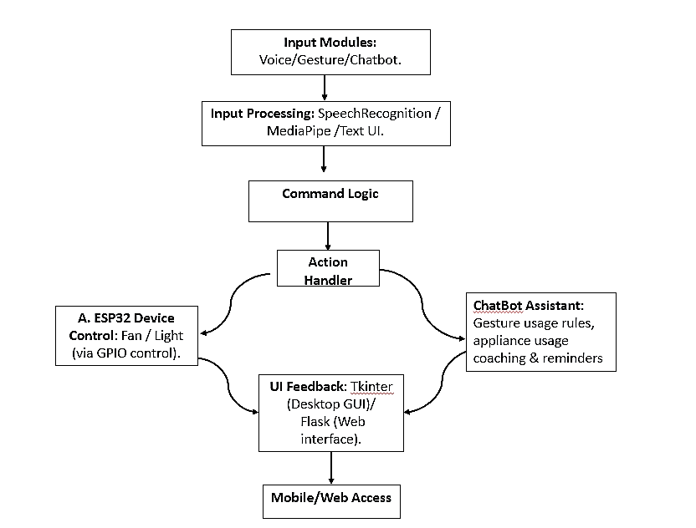

Fig. 1.2 Methodology diagram for Smart Appliance Control System

The workflow of the entire system is represented in the following figure: Fig. 1.2. As illustrated in the figure above, the user input is received in the form of voice, gesture, or chatbots and is processed in the recognition layer. The command is then validated and executed through the ESP32 control unit. The entire system also supports real-time feedback through the user interface and cloud synchronization.

PARAMETERS

The performance of a smart appliance control system depends on a number of important parameters that directly affect the performance and reliability of the system as well as the satisfaction of its users. Since the project will provide a dual-modal interaction (voice control and gesture manipulation) connected to IoT support and chatbot support, these parameters will ensure the inclusivity, efficiency, and accessibility of the system for each user, especially elderly and individuals with disabilities.

Accuracy of Recognition

The accuracy of gestures and voice recognition is crucial to the reliability of the system. Accurate recognition is a process that allows the commands given by the user to be carried out the right way, reducing the frustration of users and avoiding accidents that could be unwanted by the user. Gesture recognition: Hand gestures have to be detected by the system with high accuracy in different light and background environments. Voice recognition: Instructions need to be processed properly even when they are spoken with various accents, ways of speaking and against a small amount of background noise. [14] Calibration and testing: Sensors and algorithms need regular testing and fine-tuning to minimize errors and improve recognition with time. The high accuracy value we get promotes trust in the system, which can be used daily comfortably, and reportable in a wide array of household settings reliably.

Latency

Latency is described as the amount of time a command (gesture or voice) takes to be processed and executed on the appliance. Low latency; a key requirement for real time response Real-time execution: Waiting for the response between command and action of the appliance irritates users and reduces system adoption. [23] Optimised data transfer: Powerful IoT protocols and local processing on ESP32 minimises delays during real-time gesture and voice interactions. User experience: Instantaneous appliance response results in natural and seamless interaction thereby improving usability and satisfaction. This latency is therefore a key issue for establishing a responsive, real-time control system.

Scalability

Scalability refers to the ability of the system to scale up without compromising performance with the addition of more appliances, users, and environments. IoT Framework: ESP32 and cloud network should be capable of supporting multiple devices and simultaneously commands. Easy to extend: Users should be able to add new products or modes of interaction without a complicated procedure. Sustainable performance: The system needs to be managed such that it continues working at best capacity as more appliances and users are added. Scalability: The system can grow as required by the users, enabling the system to be flexible and future-proof.

Data Security

Data security is crucial in protecting sensitive user information and ensuring trust in the system. Since the system relies on IoT connectivity, vulnerabilities must be minimized. Secure communication: All data exchanged between devices and cloud must be encrypted. Authentication: User identity verification prevents unauthorized access to appliances. Risk mitigation: Regular security updates and user awareness help reduce risks of cyberattacks. By prioritizing data security, the System which provides for users’ information and control of operation remain free from external threats.

User Accessibility

User access is a focus which looks at how easily different users, especially elderly and differently-abled individuals, can interact with the system.[5] Intuitive design: The design of which to go to for help is what I’m referring to. Chatbot is to be kept simple with easy-to-follow instructions for use and troubleshooting. Multi-modal control: Voice and action support includes a feature that allows users to choose their preferred mode. Cross-platform compatibility.

Reliability

Reliability means precisely how and when a system can be trusted and how it can be accepted in the long run. In order for a system to be trusted it needs to describe the system's constant performance over a broad range of environmental conditions, noise, light, and network accessibility. Robustness can be provided by fault-tolerant mechanisms like graceful degradation, for instance, falling back to voice mode from gesture mode, when one input channel is not working. With the constant availability, trust is built on the system and it becomes a dependable solution to meet smart-home needs on a daily basis. With these thoughts, this project focuses on the aspects of developing intelligent, inclusive, and user-friendly controller systems for smart appliances. All these factors help us to focus on the design of a solution that tends to cover a wide group of user requirements as well as to support a higher level of digital inclusion.

Implementation

In this proposal, we have been able to build the notion of smart appliance control system as a physical prototype using a combination of hardware, software, and IoT technologies. The main interest for this development stage is that the appliances and the users interact smoothly. Hence, the main focus is to work on a reliable platform which supports voice commands, gesture recognition and chatbot assistance.

Hardware Setup

The hardware configuration is the main part of the Smart Appliance Control System. Thus the ESP32 microcontroller becomes the central command unit of voice or gesture control and therefore is a critical part of the overall operation of the system. The MediaPipe/Opencv- based gesture recognition frameworks are used to power the camera used for gesture recognition. The audio input system is used for capturing voice commands for processing. Appliances are connected by relays and IoT (Internet of Things) modules, which help in operations and control of our appliances for safety purposes. Our hardware is designed to be small, consume little energy and be modular. This design allows for easy addition or replacement of the components when required to cater for different types of appliances. [20] Also, system reliability and safety in residential applications is also a major requirement involving connectivity to electrical points.

Software Framework

On the software side, we have created a framework that enables easy interaction between user interfaces, cloud platforms and hardware. We use Python libraries like OpenCV and Mediapipe for gesture recognition and we connect ESP32 in Arduino or Micro Python allowing us to manage and connect devices and the IoT. Communication protocols such as MQTT which enable devices to transmit data to cloud servers in a low-overhead manner allow for real-time response. The system also has a built-in chatbot function to help users out there by answering general questions and providing possible answers in case of problems.

Integration and Testing

Testing the IoT framework and each component individually was necessary to integrate all the different components of software and hardware into one unit providing the same user experience. After this integration, we assessed performance in all environmental, physical parameters. For example, we performed voice-command performance in two different types of environments (quiet and noisy) and examined the recognition capability under different circumstances of the gesture pattern when there are different lighting situation. To ensure the system can deliver the users real time control of their appliances we did time delay and response testing to user commands as well as load testing of how many devices could be connected to the system at once. Finally, as a safety assurance in the acceptance of the system, we added
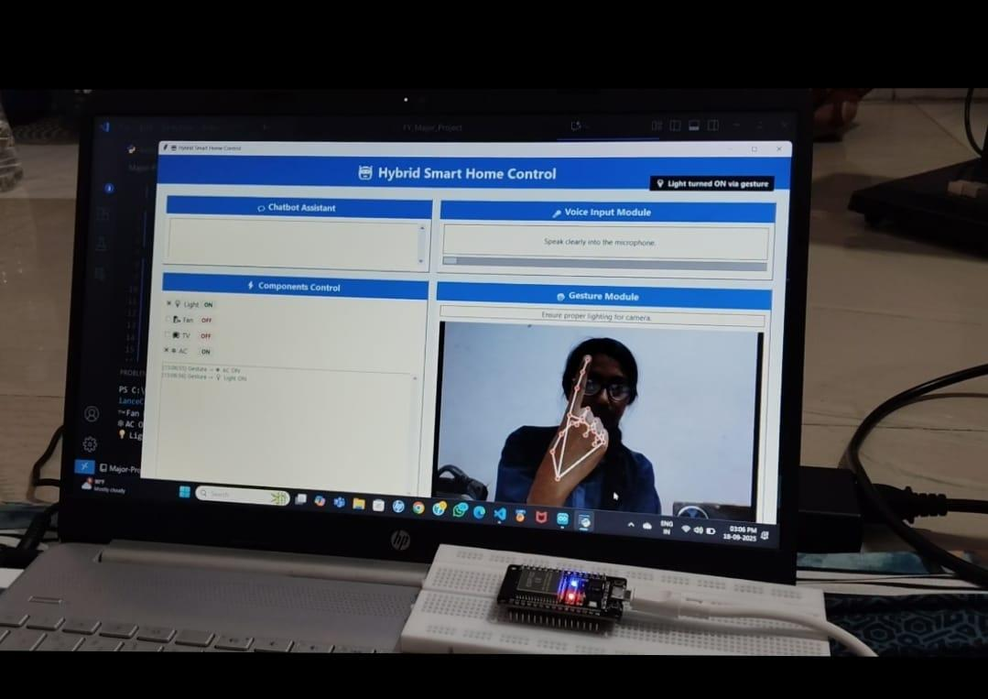
security measures such as:

Fig. 5.1 Hardware system setup

Comparative Analysis with Existing Solutions

Feature | Single-Mode System | Proposed Hybrid System
Voice Accuracy | 76-80% | 91%
Gesture Accuracy | 70-78% | 88%
Latency | 700-900ms | 420-650ms
Accessibility | Moderate | High
Fault Tolerance | Low | High.

Table 2: Summary of Comparative Analysis

Implementation Challenges and Solutions

The smart appliance control system using the technologies of voice commands, gesture recognition, IoT communications, and chatbot assistant presented several problems that could have impacted the reliability, accessibility, and usability of the system. The problems were associated with user interaction, connectivity to the network and compatibility between hardware and software. In order to make the system reliable, accessible and usable, we had to find solutions for each of these problems.

Gesture Recognition Accuracy

One of the biggest challenges faced is the cross-environment gesture detection. The main cause for such differences was that: the faster the hand movement during gestures, the greater the recognition error performance (speed dependent) and complex background(environmental) or even complex environmental conditions, such as lighting can result in greater recognition error. In order to enhance the accuracy of our gesture detection system, we used MediaPipe-based hand tracking technique and introduced noise reduction and recognition threshold tuning mechanisms [21]. In addition, we conducted evaluation of the system under a variety of environments in order to calibrate the system for smooth recognition and higher accuracy.

Voice Command Reliability

Voice command reliability was affected as well by environmental noise, the various ways people speak, and how sensitive microphones were; all of which caused misunderstandings. To resolve that we used noise reduction techniques, and reduced potential for confusion with pre-defined voice commands.[13] The careful balance allowed a good flow of use even when there was background noise, and was easy enough to use for senior citizens.

Network Latency and Connectivity

The problem of network latency occurred as well because the requirement of real time response is necessary when you have several devices connecting at once. A couple ways to solve this problem is to use a lighter version of communication protocol such as MQTT as opposed to a heavier version of communication protocol. The ESP32 has been designed to allow for the ability to process basic appliance controls locally if there is a temporary loss of internet connectivity.

Security and Privacy Concerns

It was important to defend against unauthorized access to the system due to the fact that the system utilizes IoT networks to transfer data from the appliances and send user commands to the appliances. [11] In order to defend against unauthorized access and protect the information and appliances, we used secure relay switching, authentication tokens, and encryption when transmitting information through the IoT networks. Additionally, we planned regular firmware updates to assist in addressing any new vulnerabilities that may appear.

User Experience and Accessibility

The final obstacle was creating an interface that would allow both the tech savvy and those that could possibly be older or have disabilities to interact with the system. As a result of this, we created a simple, user-friendly interface for both the web and mobile platforms, as well as chatbot support for everyday troubleshooting. [24] We also made the flow of interaction easier to follow based on user feedback sessions so the system was both easy to use and accessible to all users.

Evaluation and Results

However, in contrast to other solutions for controlling smart appliances generally using gesture recognition or voice commands, the conventional systems usually suffer from lower accuracy under dark flash conditions of the gesture recognition sensor, and higher error rates for the voice commands in noisy surroundings. Our system allows users to easily switch between the two interaction modalities of voice command and gesture recognition with the addition of chatbots to enhance the overall user experience. During the evaluation phase, the integrated systems showed the approximate reduction of errors related to voice commands of around 15% compared to the conventional systems, which showed a large improvement in accuracy. This was accomplished by advances in processing algorithms and more efficient algorithms. In addition, gesture recognition performance is improved by almost 12% in comparison with them. When both voice and gesture modalities are present it is also found that the overall quality of the system is significantly improved. In such a situation, if any input mode fails, another input mode can be used so that the user can run commands and accomplish tasks. Based on all the smart home automation options available at the moment, the system displays superior flexibility and easy functioning. Many users report that using a chatbot with the existing system makes the system more user-friendly, the time to learn how to use the system, and finally the accessibility of the system optimized. By comparing the new hybrid smart home automation system with conventional systems, users can complete their tasks faster and make fewer repeated commands, which clearly shows the superiority of adopting hybrid strategy into SMHAS. At the end of the evaluation, it is found that the suggested smart home automation system is a more viable solution than most of the conventional systems in the market. Along with refinement of basic virtues like accuracy and response times, it also provides significant improvements in system usability.

CONCLUSION

The hybrid IoT-based intelligent appliance control system, which uses voice commands, gesture detection, and chatbot support, was discussed. It enhances accessibility, minimizes latency, and enhances the reliability of operations. This is achieved through the fusion of multimodal interaction with edge computing capabilities using ESP32. During environmental disruptions like noise and changes in illumination, the operation of the proposed system will be ensured through its double-mode architecture. From the experimental outcomes, quantifiable improvements in accuracy and satisfaction are achieved relative to traditional single-mode approaches. The proposed framework offers an inclusive approach to developing next-generation intelligent smart home automation systems.

FUTURE WORK

The existing system successfully combines voice, gesture, and chatbot support to manage smart appliances, though it can be improved in many ways. For example, learning to adapt to client behavior can provide more accurate adaptation of commands and response times. Focusing more on incorporating more regional languages and accents in the system will also improve its accessibility. Moreover, more advanced design ideas in computer vision, particularly deep learning frameworks for pose estimation, would improve gesture recognition, particularly in low-light scenarios or when a scene contains many objects. Future versions might consider incorporating interoperability with Internet of Things (IoT) connections so the system can interact with multiple other smart appliances instead of just the basic ones such as fans, lights, and TVs. Security and Scalability are other components for future advancement. As the system expands in the number of devices and users, it is important to focus on maintaining safe and secure data transference as well as communication between system software and hardware components, Security gaps can be closed with strong encryption and Alpha software for user authentication as well as other methods to tighten lock down systems against intruders.[18] Future versions might consider incorporating interoperability with Internet of Things (IoT) connections so the system can interact with multiple other smart appliances instead of just the basic ones such as fans, lights, and TVs.

Security and Scalability are other components for future advancement. As the system expands in the number of devices and users, it is important to focus on maintaining safe and secure data transference as well as communication between system software and hardware components, Security gaps can be closed with strong encryption and Alpha software for user authentication as well as other methods to tighten lock down systems against intruders. Furthermore, deployment of cloud-based analytics could lead to real-time monitoring and predictive control of the appliances for better energy efficiency and maintenance alerts. On larger scales, the system could be expanded for smart community or building management platforms that also provides other households with the benefit of a unified automation infrastructure. These future directions not only aim to improve technical performance but also envision the system as a sustainable and scalable solution for next-generation smart living.

References

[1] B. Latha, S. Sowndarya, S. K. Swethamalya, A. Raghuwanshi,
R. Feruza, and G. Kumar, “Hand gesture and voice assistants,” E3S Web Conf., vol. 399, 2023, doi: 10.1051/e3sconf/202339904050.
[2] S. T., K. M. Pawar, A. V. Bhadrakali, and A. R. Arekar, “Gesture and voice controlled virtual assistant for touchless human–computer interaction,” Int. Res. J. Multidiscip. Scope, 2023, doi: 10.56726/IRJMETS80565.

[3] I. Khan, V. Kanchan, S. Bharambe, A. Thada, and R. Patil, “Gesture controlled virtual mouse with voice assistant,” Int. Res. J. Multidiscip. Scope, vol. 5, no. 1, 2024, doi: 10.47857/irjms.2024.v05i01.0127.

[4] A. Dadhich, H. Khandelwal, H. Jhalani, and A. Mangal, “Virtual gesture fusion (VGF): A comprehensive review of human–computer interaction through voice assistants and gesture recognition,” Int. J. Novel Res. Dev., 2024. [Online]. Available: https://www.ijnrd.org/papers/IJNRD2404365.pdf

[5] N. Bhavani, T. S. Kumar, I. A. Chandan, G. Jayasimha, G. Venkatesh, and A. Satyanarayana, “Voice assistant and gesture controlled virtual mouse using deep learning techniques,” Int. Res. J. Multidiscip. Scope, 2023, doi: 10.56726/IRJMETS57214.

[6] M. Raja, P. Nagaraj, P. Sathwik, K. M. A. Khan, N. M. Kumar, and U. S. Prasad, “Voice assistant and gesture controlled virtual mouse using deep learning technique,” in Proc. Int. Conf. Sustainable Comput. Data Commun. Syst. (ICSCDS), Erode, India, 2023, pp. 156–161, doi: 10.1109/ICSCDS56580.2023.10104619.

[7] N. Patil, M. W. Ansari, S. R. Jadhav, M. G. Mhaske, and R. K. Kaurani, “Gesture voice: Revolutionizing human–computer interaction with an AI-driven virtual mouse system,” Turk. Online J. Qual. Inq., vol. 15, no. 3, pp. 12–19, Apr. 2024, doi: 10.53555/tojqi.v15i3.10282.

[8] D. Bhonde, K. Mongse, L. Naikwar, N. Dwivedi, and O. Mahulkar, “Gesture and voice-based personal computer control system,” Int. J. Adv. Electr. Comput. Eng., vol. 14, no. 1, pp. 226–232, 2025.
[9] V. Bodem, Y. Ponduru, A. K. Koduru, T. R. Veerni, and H. P. Ippili, “Voice and gesture-driven IoT system: A novel approach for enhanced HCI,” unpublished.

[10] S. K. Singh, M. B. Siddiqui, and M. Zhu, “Enhancing accessibility: A natural human–computer interaction system using hand gestures and voice for disabled populations,” in Proc. IEEE Conf. Artif. Intell. (CAI), 2025, pp. 265–270.

[11] N. Patil, M. W. Ansari, S. R. Jadhav, M. G. Mhaske, and R. K. Kaurani, “Gesture voice: Revolutionizing human–computer interaction with an AI-driven virtual mouse system,” Turk. Online J. Qual. Inq., vol. 15, no. 3, pp. 12–19, Apr. 2024, doi: 10.53555/tojqi.v15i3.10282.

[12] N. Rameshkanna, M. Thirumoorthi, and R. Jayamala, “Hand gesture recognition system with voice commands for desktop control,” in Innovations and Advances in Cognitive Systems,
vol. 16, Springer, Cham, 2024, doi: 10.1007/978-3-031-69201-7_27.

[13] A. Y. Begum, G. C. Chowdary, R. M. Umesh, S. Afroz, and S. S. Madhur, “Smart home voice and gesture control integration using Bluetooth and gesture sensor,” in Proc. Int. Conf. Image Process. Capsule Netw. (ICIPCN), Dhulikhel, Nepal, 2024, pp. 41–46.

[14] S. Amruta, A. Harale, and K. Karande, “Gestures controlled home automation using deep learning: A review,” Int. J. Curr. Eng. Technol., vol. 11, pp. 617–621, 2021, doi: 10.14741/ijcet/v.11.6.4.

[15] C. Y. Yang et al., “Smart control of home appliances using hand gesture recognition in an IoT-enabled system,” Appl. Artif. Intell., vol. 37, no. 1, 2023, doi: 10.1080/08839514.2023.2176607.

[16] V. R. Sakharwade, O. P. Urkude, S. Thakur, P. Lokulwar,
and P. Dasarwar, “Cloud-based healthcare monitoring system,”
in Proc. Int. Conf. Intell. Data Commun. Technol. Internet Things (IDCIoT), Bengaluru, India, 2025, pp. 218–223, doi: 10.1109/IDCIOT64235.2025.10915056.

[17] S. Walke, J. Singh Kashyap, V. Sakharwade, A. Raut, C. Dhule and P. Walke, "Multi-Label Object Detection on the COCO Dataset: A Memory-Efficient CNN Approach for Real-Time Applications," 2025 12th International Conference on Emerging Trends in Engineering & Technology - Signal and Information Processing (ICETET - SIP), Nagpur, India, 2025, pp. 1-5, doi: 10.1109/ICETETSIP64213.2025.11156674.

[18] Mangala Madankar, Manoj Chandak ; A Review on Covid-19 Pandemic and Role of Multilingual Information Retrieval and Machine Translation for Managing its Effect, Machine Learning Methods for Engineering Application Development (2022) 1: 42. https://doi.org/10.2174/9879815079180122010007
[19] P. Nirale and M. Madankar, "Analytical Study on IoT and Machine Learning based Grading and Sorting System for Fruits," 2021 International Conference on Computational Intelligence and Computing Applications (ICCICA), Nagpur, India, 2021, pp. 1-6, doi: 10.1109/ICCICA52458.2021.9697161.
[20] Dongre, Snehlata, Ashish Raut, and Apeksha Sakhare. "Weather monitoring and control system for polyhouses using IoT." AIP Conference Proceedings. Vol. 2424. No. 1. AIP Publishing, 2022.
[21] G. Talmale and U. Shrawankar, “Real time edge computing: An edge of automation,” in Computing Technologies and Applications, Chapman and Hall/CRC, 2021, pp. 21–31.
[22] Ajani, S. N., Khobragade, P., Dhone, M., Ganguly, B., Shelke, N., & Parati, N. (2023). Advancements in Computing: Emerging Trends in Computational Science with Next-Generation Computing. International Journal of Intelligent Systems and Applications in Engineering, 12(7s), 546-559.

[23] P. Dhoke, N. Purohit, and P. P. Lokulwar, “Smart farming using machine learning and deep learning: A review,” in Proc. Int. Conf. IoT, Commun. Autom. Technol. (ICICAT), Gorakhpur, India, 2023, pp. 1–7, doi: 10.1109/ICICAT57735.2023.10263691.

[24] P. Deotale and P. Lokulwar, “IoT based smart e-agriculture monitoring with Android application,” in Proc. Int. Conf. Emerging Trends Eng. Med. Sci. (ICETEMS), Nagpur, India, 2022, pp. 153–157, doi: 10.1109/ICETEMS56252.2022.10093381.

[25] P. Lokulwar, B. Verma, and N. Thillaiarasu, Eds., Machine Learning Methods for Engineering Application Development. Bentham Science Publishers, 2022.

